# **Week 8 –** **Network Analysis**

# **Exercise: Centrality Analysis**

Given a undirected network as following:

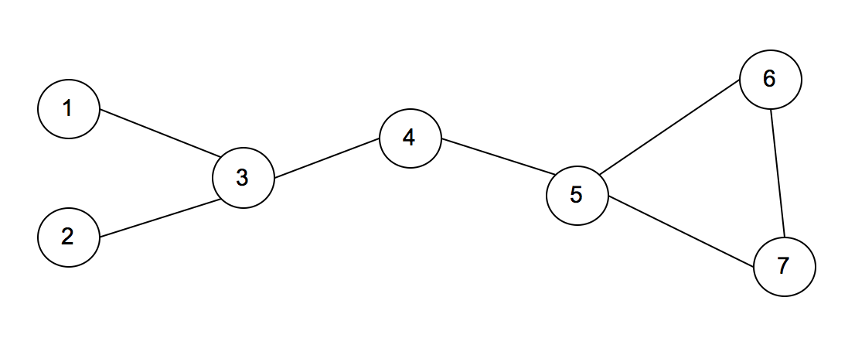

* Calculate Degree centrality scores of each node in the network above, and complete the table below

|  |  |
| --- | --- |
| **Node** | **Score** |
| 1 | 1 |
| 2 | 1 |
| 3 | 3 |
| 4 | 2 |
| 5 | 3 |
| 6 | 2 |
| 7 | 2 |

* Calculate Betweenness centrality scores of each node in the network above, and complete the table below

|  |  |  |  |  |  |  |  |  |  |  |
| --- | --- | --- | --- | --- | --- | --- | --- | --- | --- | --- |
| From | To | Geodesic |  | 1 | 2 | 3 | 4 | 5 | 6 | 7 |
| 1 | 2 | (1,3,2) |  | 0 | 0 | 1 | 0 | 0 | 0 | 0 |
| 1 | 3 | (1,3) |  | 0 | 0 | 0 | 0 | 0 | 0 | 0 |
| 1 | 4 | (1,3,4) |  | 0 | 0 | 1 | 0 | 0 | 0 | 0 |
| 1 | 5 | (1,3,4,5) |  | 0 | 0 | 1 | 1 | 0 | 0 | 0 |
| 1 | 6 | (1,3,4,5,6) |  | 0 | 0 | 1 | 1 | 1 | 0 | 0 |
| 1 | 7 | (1,3,4,5,7) |  | 0 | 0 | 1 | 1 | 1 | 0 | 0 |
| 2 | 3 | (2,3) |  | 0 | 0 | 0 | 0 | 0 | 0 | 0 |
| 2 | 4 | (2,3,4) |  | 0 | 0 | 1 | 0 | 0 | 0 | 0 |
| 2 | 5 | (2,3,4,5) |  | 0 | 0 | 1 | 1 | 0 | 0 | 0 |
| 2 | 6 | (2,3,4,5,6) |  | 0 | 0 | 1 | 1 | 1 | 0 | 0 |
| 2 | 7 | (2,3,4,5,7) |  | 0 | 0 | 1 | 1 | 1 | 0 | 0 |
| 3 | 4 | (3,4) |  | 0 | 0 | 0 | 0 | 0 | 0 | 0 |
| 3 | 5 | (3,4,5) |  | 0 | 0 | 0 | 1 | 0 | 0 | 0 |
| 3 | 6 | (3,4,5,6) |  | 0 | 0 | 0 | 1 | 1 | 0 | 0 |
| 3 | 7 | (3,4,5,7) |  | 0 | 0 | 0 | 1 | 1 | 0 | 0 |
| 4 | 5 | (4,5) |  | 0 | 0 | 0 | 0 | 0 | 0 | 0 |
| 4 | 6 | (4,5,6) |  | 0 | 0 | 0 | 0 | 1 | 0 | 0 |
| 4 | 7 | (4,5,7) |  | 0 | 0 | 0 | 0 | 1 | 0 | 0 |
| 5 | 6 | (5,6) |  | 0 | 0 | 0 | 0 | 0 | 0 | 0 |
| 5 | 7 | (5,7) |  | 0 | 0 | 0 | 0 | 0 | 0 | 0 |
| 6 | 7 | (6,7) |  | 0 | 0 | 0 | 0 | 0 | 0 | 0 |
|  |  |  | Sum | 0 | 0 | 9 | 9 | 8 | 0 | 0 |

* Denominator: (7-1)(7-2)/2=15

|  |  |
| --- | --- |
| **Node** | **Score** |
| 1 | 0 |
| 2 | 0 |
| 3 | 9/15 |
| 4 | 9/15 |
| 5 | 8/15 |
| 6 | 0 |
| 7 | 0 |

* Calculate PageRank centrality scores of each node in the network above, and complete the table below

|  |  |  |
| --- | --- | --- |
| **Node** | **Score** | **Rank** |
| 1 | 0.0904 | 5 |
| 2 | 0.0904 | 5 |
| 3 | 0.1698 | 2 |
| 4 | 0.1665 | 3 |
| 5 | 0.1956 | 1 |
| 6 | 0.1441 | 4 |
| 7 | 0.1441 | 4 |

* Suppose the above network refers to friendship network.  Each node represents a person, and each edge represents friendship between the persons at ends.  If you are interested in finding the most popular person in the network, which centrality measure is the most appropriate?  Give the answer with reasons why it is the most appropriate.
* To find very connected individuals, popular individuals, I think **Degree Centrality** should be the most appropriate measure because we can find out how many connections/relationships of any individual/person. Specifically, node 3 and 5 with the most connections to them are the most popular ‘person’.
* Suppose the above network refers to information flow network of an organization. If you are interested in finding the section that can most frequently control information flow in the network, which centrality measure is the most appropriate?  Give the answer with reasons why it is the most appropriate.
* **Betweenness Centrality** (BC) measures the number of times a node lies on the shortest path between other nodes so this measure should be the choice. From the exercise, node 3 and 4 take the biggest BC score so these ‘sections’ can most frequently control information flow in the network.