# **Week 8 –** **Network Analysis**

# **Exercise: Centrality Analysis**

Given a undirected network as following:

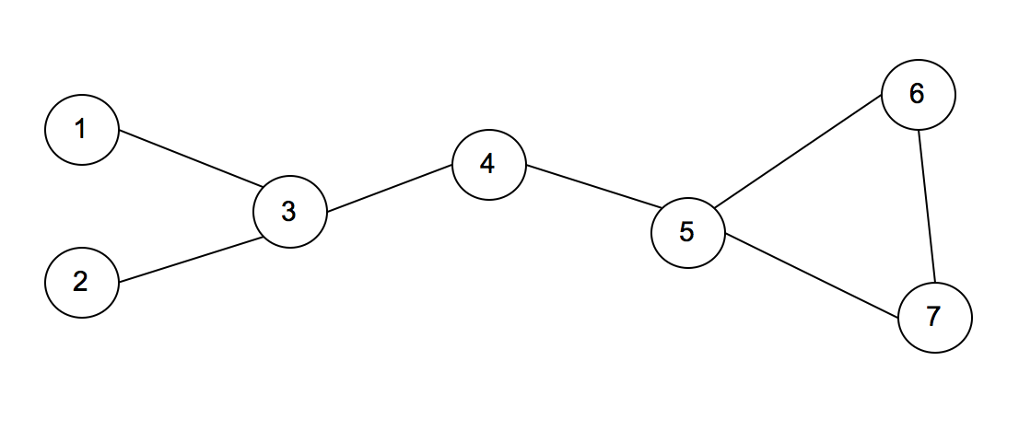

* Calculate Degree centrality scores of each node in the network above, and complete the table below

|  |  |
| --- | --- |
| **Node** | **Score** |
| 1 | 1 |
| 2 | 1 |
| 3 | 3 |
| 4 | 2 |
| 5 | 3 |
| 6 | 2 |
| 7 | 2 |

* Calculate Betweenness centrality scores of each node in the network above, and complete the table below

|  |  |
| --- | --- |
| **Node** | **Score** |
| 1 | 0 |
| 2 | 0 |
| 3 | 9 |
| 4 | 9 |
| 5 | 8 |
| 6 | 0 |
| 7 | 0 |

* Calculate PageRank centrality scores of each node in the network above, and complete the table below

|  |  |
| --- | --- |
| **Node** | **Score** |
| 1 | 0.0904 |
| 2 | 0.0904 |
| 3 | 0.1697 |
| 4 | 0.1665 |
| 5 | 0.1955 |
| 6 | 0.1441 |
| 7 | 0.1441 |

* Suppose the above network refers to friendship network.  Each node represents a person, and each edge represents friendship between the persons at ends.  If you are interested in finding the most popular person in the network, which centrality measure is the most appropriate?  Give the answer with reasons why it is the most appropriate.

- To obtain information, one should be near from everyone. In this sense, the node in the nearest position on average can most efficiently obtain information. Thus, closeness centrality is the most appropriate.

* Suppose the above network refers to information flow network of an organization. If you are interested in finding the section that can most frequently control information flow in the network, which centrality measure is the most appropriate?  Give the answer with reasons why it is the most appropriate.
* To control information flow, a node should be between other nodes because the node can interrupt infromation flow between them. Thus, betweenness centrality is the most appropriate measure.