I. Write a program to enter a number of rows h and print out:

1. Full Pyramid of \*

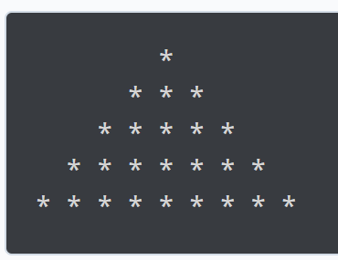

1. Inverted full pyramid of \*

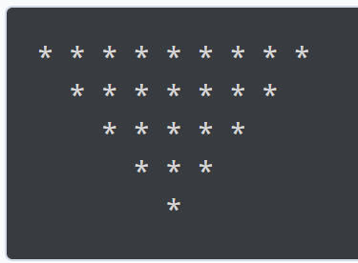

1. Half pyramid of \*

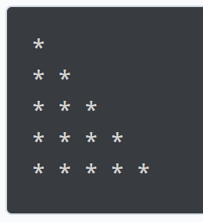

1. Inverted half pyramid of \*

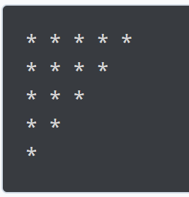

1. Full Pyramid of Numbers

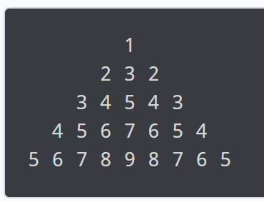

1. Half Pyramid of Numbers

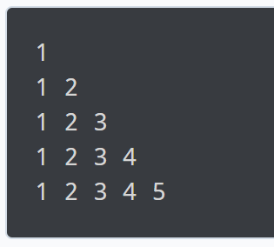

1. Inverted half pyramid of numbers

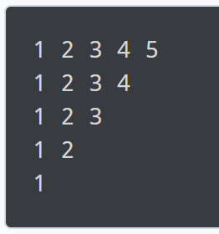

1. Pascal's Triangle

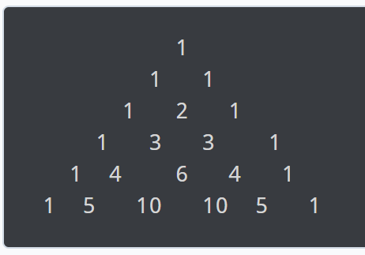

1. Floyd's Triangle

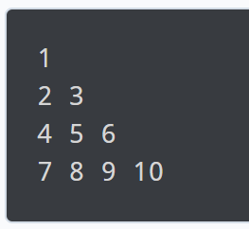

1. Unfilled pyramid of \*

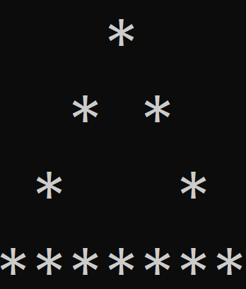

1. Unfilled half pyramid of \*

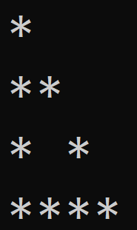

1. Inverted unfilled pyramid of \*
2. Inverted unfilled half pyramid of \*

II. Write a program to enter 2 numbers m and n as a width and a height of the rectangle, and print out:

1. Filled rectangle of \*

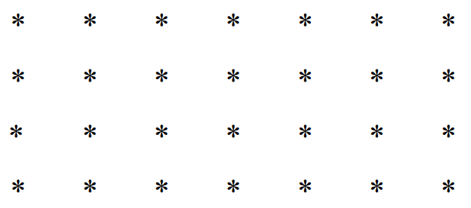

1. Unfilled rectangle of \*

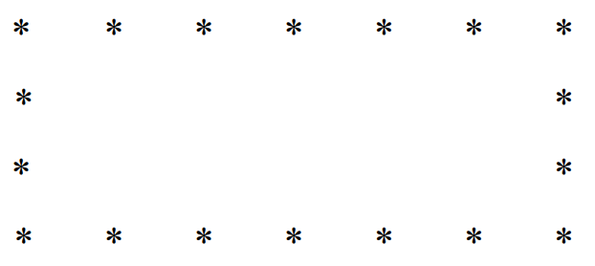

III. Write a program to enter an uppercase you want to print in the last row and print out the half pyramid of Alphabets.

