PFC - Workshop 05

Question 1 (2.5 marks): Write a program to perform these tasks:
- Creating a list in Python
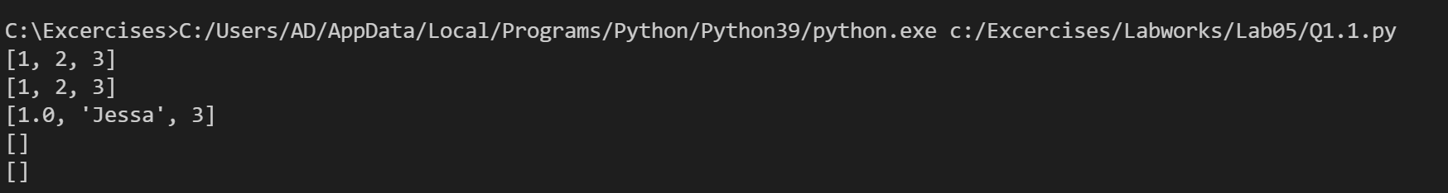
- Concatenate two lists index-wise
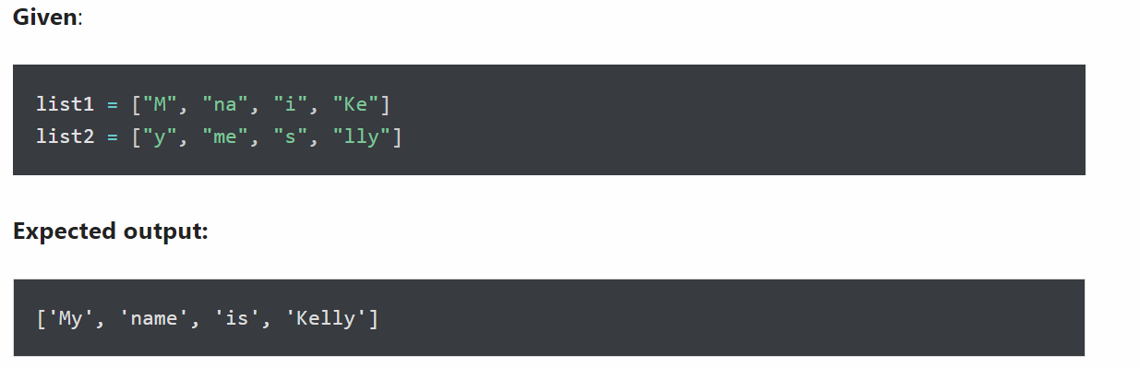

Question 2 (2.5 marks): Write a program to perform these tasks:
- Turn every item of a list into its square
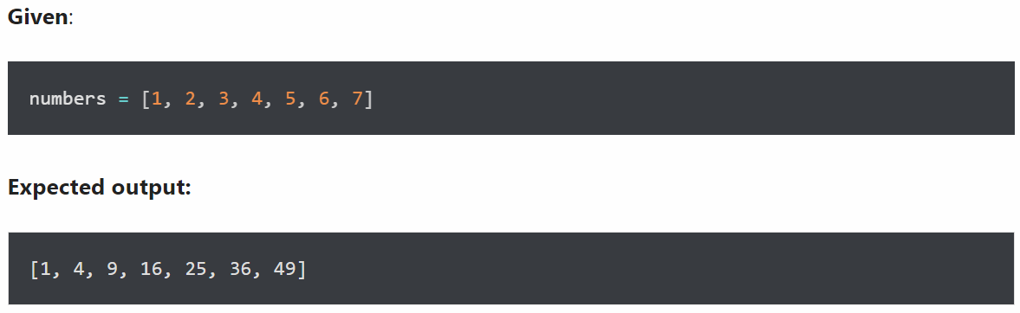
- Concatenate two lists in the following order
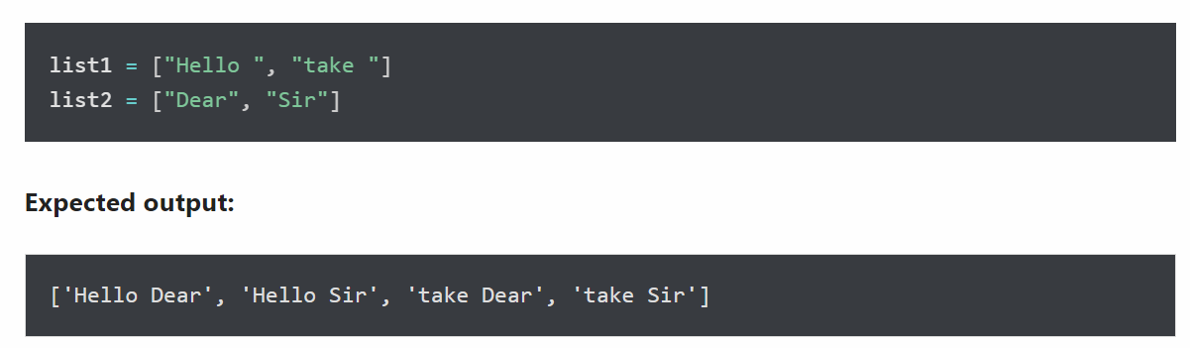
Question 3 (2.5 marks): Write a program to perform these tasks:
- Merge two Python dictionaries into one
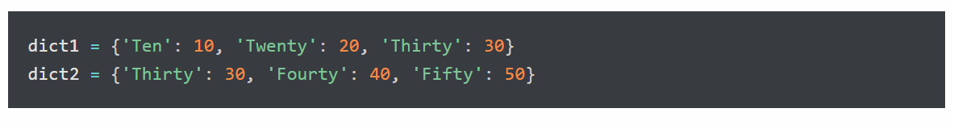
- Print the value of key ‘history’ from the below dict
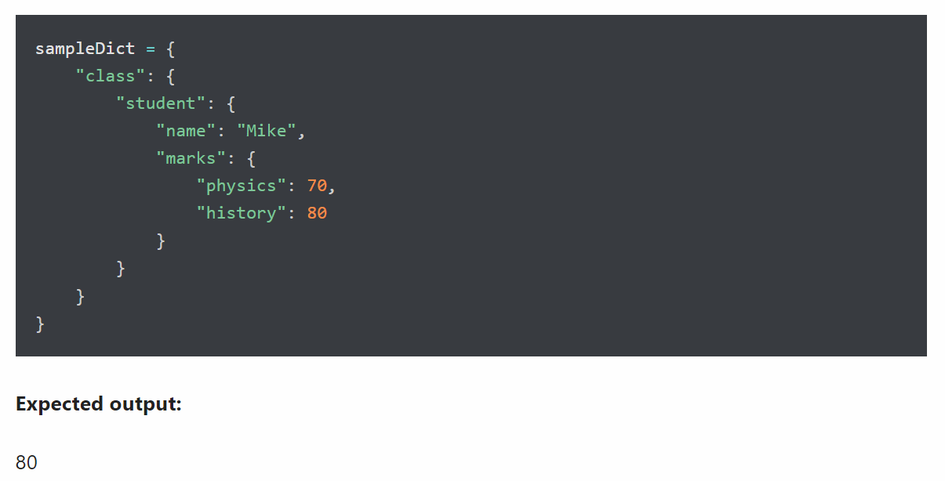
- Initialize dictionary with default values
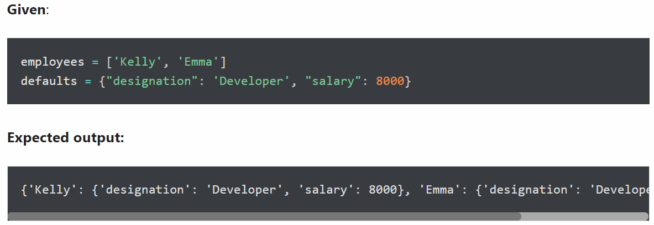

Question 4 (2.5 marks): Write a program to perform these tasks:

- Access value 20 from the tuple
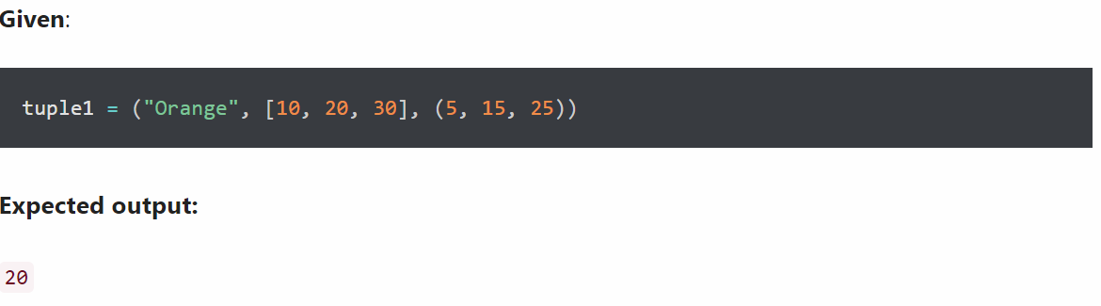
- Unpack the tuple into 4 variables
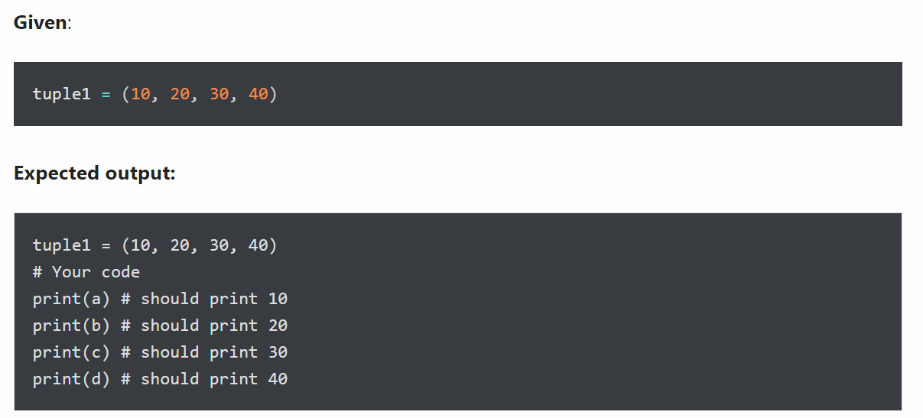
- Swap two tuples in Python
