### Question 1: What is the total weight of the minimum spanning tree produced by the graph below:



Select one:

a. 15

b. 16

c. None of the other choices is correct

d. 14

e. 19

### Question 2: Consider the directed graph G with the adjacency matrix (in the order of vertices A, B, C, D)



|  |  |
| --- | --- |
| The in-degree of D is 5 | Answer 1: True \ No |
| The out-degree of B is 3 | Answer 2: True \ No |
| The graph has 3 loops | Answer 3: True \ No |

### Question 3: Given two graphs. Choose the correct statement.

d e

a b c

3 4

1 2

### 

(5)

Select one:

a. They are not isomorphic because they do not have the same number of circuits of length 3

b. None of the other choices is correct

c. They are not isomorphic because they do not have the same number of connected components

d. They are isomorphic

e. They are not isomorphic because they do not have the same degrees

Isomorphic: trùng số đỉnh, cùng bậc, cùng số cạnh, cùng số thành phần liên thông => Hai ma trận kề tương ứng với đồ thị này trùng nhau.

### Question 4: Choose correct statements. (i) In an undirected graph, an edge is a cut edge if and only if it does not belong to any simple circuit. (ii) Any non-empty undirected graph has cut vertices.

Select one:

a. (ii)

b. (i)

c. None of the other choices is correct

d. (i) and (ii)

### Question 5: Given the graph. Choose correct statement.

Select one:

a. The graph has Euler paths but no Euler circuits

b. The graph has Euler circuits

c. The graph does not have Euler paths

### Question 6: Given a weighted graph. What is the next vertex to be chosen after choosing **a** and **d** when using Dijkstra algorithm to find the shortest path from **a** to **c**?



Select one:

a. The vertex f

b. None of the other choices is correct

c. The vertex b

d. The vertex c

Question 7: Are these graphs isomorphic?

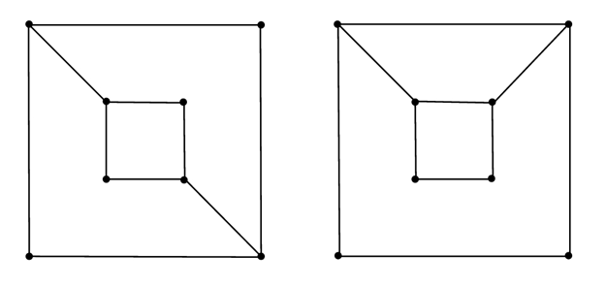

|  |
| --- |
| 1. Two graphs are not isomorphic because the graph on the right has a circuit consists of vertices of degree 3, and the graph on the left does not have that property |
| 1. Two graphs are not isomorphic because they do not have the same number of vertices of degree 2 |
| 1. Two graphs are not isomorphic because they do not have the same number of vertices of degree 3 |
| 1. Two graphs are isomorphic |
| 1. None of the other choices is correct |

### Question 8: Given the graph. Determine if the statement is True.

|  |  |
| --- | --- |
| Deg(A) = 4 | Answer True/ False |
| This is an undirected multigraph. | Answer True/ False |
| Deg(B) = 3 | Answer True/ False |

### ;

### Question 9: Consider the undirected graph G with the incidence matrix (in the order of vertices A, B, C, D and of edges e1, e2, e3, e4, e5).

### Determine if the statement is True.

|  |  |
| --- | --- |
| There are 2 loops | Answer No\Yes |
| Deg(A) = 2 | Answer No\Yes |
| There are no multiple edges | Answer No\Yes |

### Question 10: Given the graph. Determine if the statement is correct.

|  |  |
| --- | --- |
| There are 2 cut edges | Answer 1: True / False |
| G is a cut vertex | Answer 2: True / False |
| C is a cut vertex | Answer 3: True / False |

### Question 11: Given the graph. Choose correct statement.

Select one:

a. The graph has Hamilton paths but no Hamilton circuits

b. The graph has Hamilton circuits (CEFGDABC)

c. The graph does not have Hamilton paths

Question 12: Given a weighted graph. Find the shortest distance from A to J.



### A: 8

### B: 9

### C: 10

### D:11

### Question 13: Determine the type of this graph.

### Loop = mutil edge



Select one:

a. Undirected multigraph: cạnh bội

b. Pseudograph: cạnh bội, khuyên

c. Simple undirected graph: không có cạnh bội, không có khuyên

Question 14: Given two graphs. Choose the correct statement.  
  


Select one:

a. They are isomorphic

b. They are not isomorphic because they do not have the same number of connected components

c. They are not isomorphic because they do not have the same degrees

d. None of the other choices is correct

e. They are not isomorphic because they do not have the same number of circuits of length 4

### Question 15: Given the graph. Determine if the statement is correct.

|  |  |
| --- | --- |
| A is a cut vertex | Answer 1: No / Yes |
| There are 2 cut vertices | Answer 2: No / Yes |
| There is only 1 cut edge | Answer 3: No / Yes |

### Question 16: Given the graph. Choose correct statement.

Select one:

a. The graph has Hamilton circuits

b. The graph has Hamilton paths but no Hamilton circuits

c. The graph does not have Hamilton paths

### Question 17:

Given a weighted graph. What is the next vertex to be chosen after choosing **a** and **d** when using Dijkstra algorithm to find the shortest path from **a** to **c**?



Select one:

a. None of the other choices is correct

b. The vertex c

c. The vertex f

d. The vertex b

Question 18: Given a simple graph G, the *complementary graph* of G, denoted by G’, is the graph on the same vertices, and two vertices are adjacent in G’ if and only if they are not adjacent in G.

Given the following graphs. Which graph is isomorphic to its complementary graph?

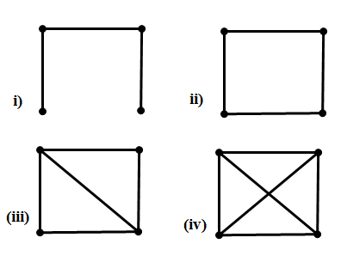

|  |
| --- |
| 1. (i) |
| 1. (ii) |
| 1. (iii) |
| 1. (iv) |

Question 19: How many strongly connected components does this graph have?

C D



F

E

|  |
| --- |
| A. 3 A B |
| B. 1 |
| C. 2 |
| D. 4 |
| E. None of the other choices is correct |

Question 20:



|  |
| --- |
| 1. 2 |
| 1. 4 |
| 1. 5 |
| 1. 7 |
| 1. None of the other choices is correct |

Question 21. Choose an Euler circuit



|  |
| --- |
| 1. The graph has no Euler circuits |
| 1. d - e - f - b - e - i - j - f - c - a - d - h - g - c - a - d |
| 1. a - d - e - b - f - e - d - c - f - j - i - e - d - h - g - c - a |
| 1. a - d - e - b - f - j - i - e - f - c - d - h - g - c - a |
| 1. None of the other choices is correct |

Question 22: Find the length of a shortest path from A to F.

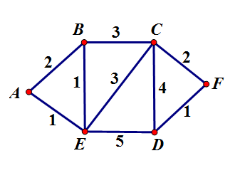

|  |
| --- |
| 1. 6 C. 8 |
| 1. 7 D. 9 |

### 

|  |  |  |  |  |  |
| --- | --- | --- | --- | --- | --- |
| Bước | a | B | c | d | f |
| 0 | [0,0] | [2,a] | [vc,a] | [1,a] | [3,a] |
| 1 | ----- | [2,a] | [3,d] | ----- | [3,a] |
| 2 | ----- | -------- |  |  |  |
| 3 | ----- |  |  |  |  |

### 

### 

### 