**Q1.**

*Context Diagram:*

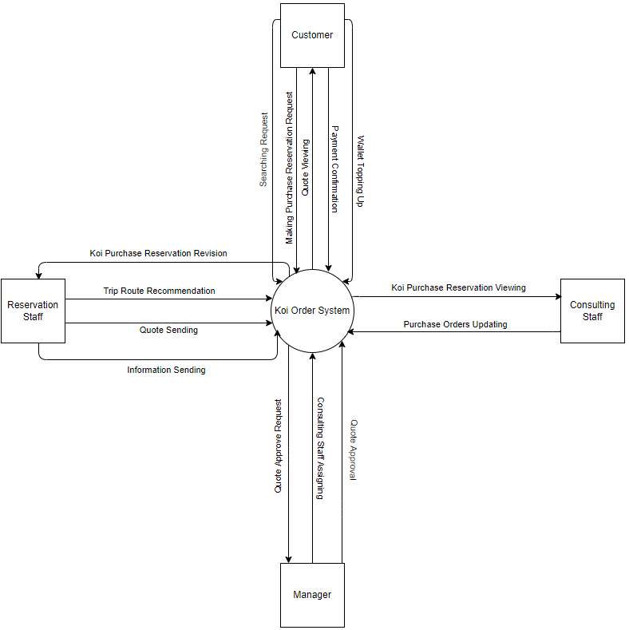

**Q2.**

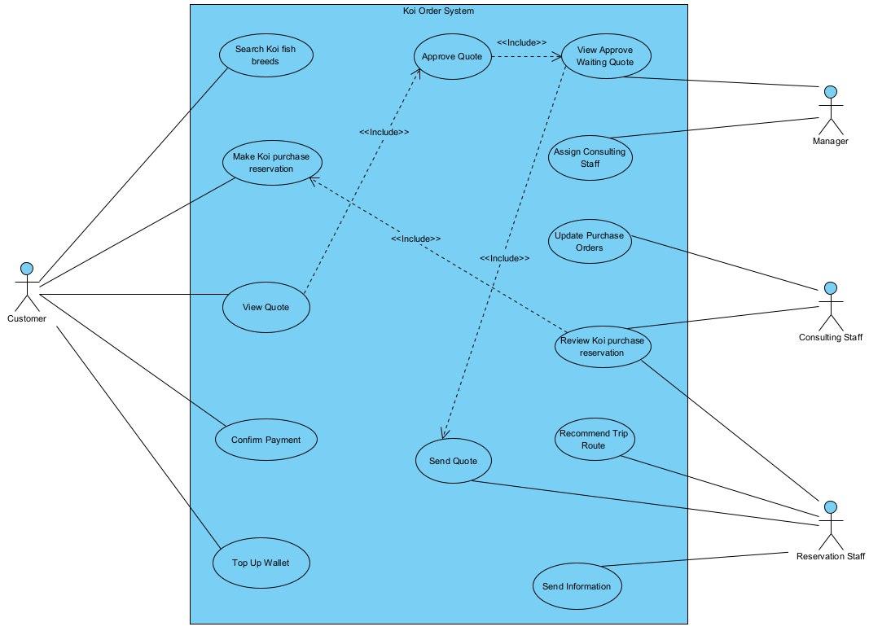

|  |  |  |
| --- | --- | --- |
| **#** | **Actor** | **Description** |
| 01 | Customer | The customer can perform all tasks related to purchasing and placing orders. |
| 02 | Manager | The manager can handle tasks related to approving content and assigning specific roles for certain actions. |
| 03 | Consulting Staff | The consulting staff can manage tasks related to customer orders and purchase reservations. |
| 04 | Reservation Staff | The reservation staff can assist with providing information to customers. |

|  |  |  |  |
| --- | --- | --- | --- |
| **#** | **Use Case** | **Actors** | **Description** |
| UC-01 | Search Koi fish breeds | Customer | Customer can search for Koi fish breeds (Kohaku, Showa, Ogon, ...) raised by each Koi farm in Japan, with reference selling prices for each breeds, size, age. |
| UC-02 | Make Koi purchase reservation | Customer | Customer has the ability to make Koi purchase reservation to buy fish at Japanese farms with desired proposals (breeds, farm, expected departure date, total expected budget). |
| UC-03 | View quote | Customer | Customer can view quote that reservation staff created. |
| UC-04 | Confirm payment | Customer | The customer needs to confirm the quote and pay the cost through the CHPay online payment system. |
| UC-05 | Top up wallet | Customer | If the amount of money in the wallet is not enough, the customer needs to top up the wallet through the function in the system. |
| UC-06 | Assign consulting staff | Admin | The manager has the function of assigning the consulting staff to be in charge of the Koi purchase reservation. |
| UC-07 | View approves waiting quote | Admin | View quote from reservation staff to approve. |
| UC-08 | Update purchase orders | Consulting Staff | During a trip to visit Koi farms in Japan, the consulting staff updates customer's fish purchase orders after finalizing the purchase price with the farm owner into the system. |
| UC-09 | Review Koi purchase reservation | Consulting Staff, Reservation Staff | The consulting staff can only view the Koi purchase reservation assigned to him by the manager.  The reservation staff reviews the Koi purchase reservation. |
| UC-10 | Recommend trip route | Reservation Staff | Recommends a suitable trip route through the farms |
| UC-11 | Send quote | Reservation Staff | Send a quote to the customer |
| UC12 | Send information | Reservation Staff | After the customer has made payment, the system allows the reservation staff to send specific information (airfare, hotel, etc.) to the customer. |

**Q3.**

|  |  |  |
| --- | --- | --- |
| **ID** | **Rule Definition** | **Use Cases** |
| BR-01 | The payment must be completed using the CHPay online payment system. | UC-04 |
| BR-02 | Once the customer completes the payment. | UC-12 |
| BR-03 | The customer can cancel the Koi purchase reservation but will be responsible for covering the airfare and hotel costs. | UC-02 |
| BR-04 | The customer is required to make a deposit of 30% of the fish's total value. | UC-02 |

**Q4.**

