**Q1.***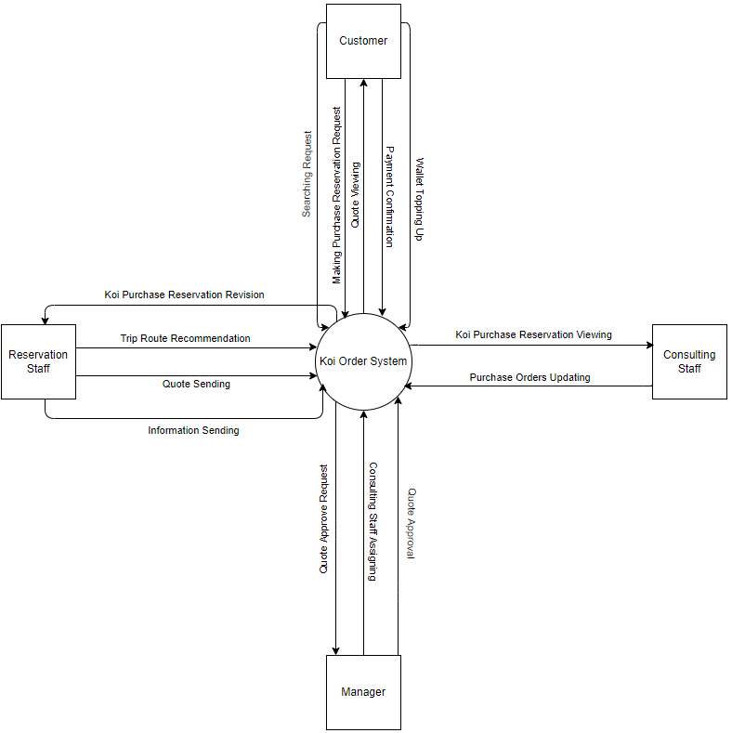*

**Q2.**

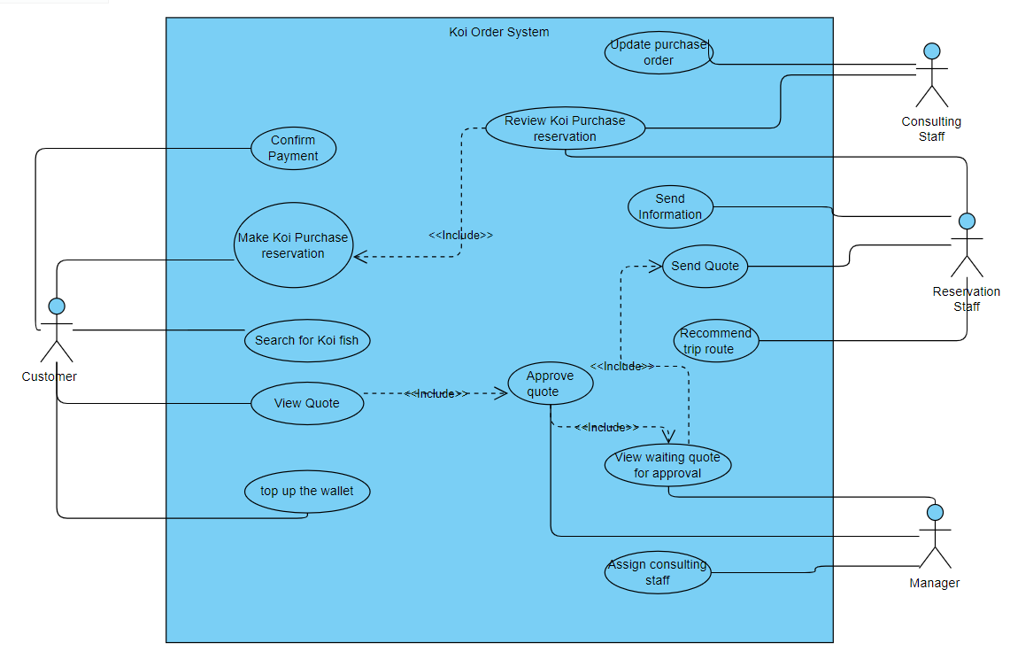

|  |  |  |
| --- | --- | --- |
| **#** | **Actor** | **Description** |
| 01 | Customer | The customer can perform all tasks related to purchasing and placing orders. |
| 02 | Manager | The manager can handle tasks related to approving content and assigning specific roles for certain actions. |
| 03 | Consulting Staff | The consulting staff can manage tasks related to customer orders and purchase reservations. |
| 04 | Reservation Staff | The reservation staff can assist with providing information to customers. |

|  |  |  |  |
| --- | --- | --- | --- |
| **#** | **Use Case** | **Actors** | **Description** |
| UC-01 | Search Koi fish breeds | Customer | The customer can search for different Koi fish breeds (e.g., Kohaku, Showa, Ogon) available at various Koi farms in Japan, along with details such as reference selling prices, size, and age. |
| UC-02 | Make Koi purchase reservation | Customer | The customer can make a reservation to purchase Koi fish from Japanese farms, specifying preferences like breed, farm, desired travel date, and estimated budget. |
| UC-03 | View quote | Customer | The customer can access and view the quote prepared by the reservation staff. |
| UC-04 | Confirm payment | Customer | The customer must confirm the provided quote and complete the payment using the CHPay online payment system. |
| UC-05 | Top up wallet | Customer | If the wallet balance is insufficient, the customer can use the system's top-up function to add funds. |
| UC-06 | Assign consulting staff | Admin | The manager has the ability to assign consulting staff members to handle specific Koi purchase reservations. |
| UC-07 | View approves waiting quote | Admin | The manager can review and approve quotes submitted by the reservation staff. |
| UC-08 | Update purchase orders | Consulting Staff | During visits to Koi farms in Japan, the consulting staff updates the customer's purchase orders in the system after negotiating the final price with the farm owner. |
| UC-09 | Review Koi purchase reservation | Consulting Staff, Reservation Staff | The consulting staff can only access the Koi purchase reservations assigned by the manager, while the reservation staff reviews all Koi purchase reservations. |
| UC-10 | Recommend trip route | Reservation Staff | The reservation staff suggests an optimal travel route through the Koi farms. |
| UC-11 | Send quote | Reservation Staff | The reservation staff sends the finalized quote to the customer. |
| UC12 | Send information | Reservation Staff | Once the customer has made the payment, the reservation staff can provide specific details such as airfare and hotel information to the customer through the system. |

**Q3.**

|  |  |  |
| --- | --- | --- |
| **ID** | **Rule Definition** | **Use Cases** |
| BR-01 | The payment must be completed using the CHPay online payment system. | UC-04 |
| BR-02 | Once the customer completes the payment. | UC-12 |
| BR-03 | The customer can cancel the Koi purchase reservation but will be responsible for covering the airfare and hotel costs. | UC-02 |
| BR-04 | The customer is required to make a deposit of 30% of the fish's total value. | UC-02 |

**Q4.**

