**Q1:**

**Explain the difference between connectionless unacknowledged service and connectionless acknowledged service. How do the protocols that provide these services differ?**

Solution:.

Connection Less:

-- > Connectionless service comes with a single free-standing data unit for all transmissions.

-- > In this, each unit contains all of the protocols that control information necessary for delivery perspective, but this also contains no provision for sequencing or flow control.

>> Acknowledged:

-- > This is achieved by the use of ACK and NAK control messages.

-- > These types of protocols are well suited for communication over the network, where high layers are very sensitive to loss and can have a significant probability of error in these underlying networks.

Example: HDLC, which offers for unnumbered acknowledgment service(setup and release).

>> Unacknowledge:

-- > This comes with a very simpler version and provides faster communication for networks, which are inherently reliable or provide service to a higher layer, that can tolerate loss in the information, or which has built-in error control/recovery feature.

**Q2:**

**Explain the difference between connection-oriented acknowledged service and connectionless acknowledged service. How do the protocols that provide these services differ?**

Solution:

Less & Oriented:

>> Connection-oriented:

-- > In this type of service, a setup phase will be initialized between sender and receiver, to establish a context for transferring the information

-- > This connection is provided to the sender for all SDUs.

-- > This service requires a stateful protocol, which is used to keep track of sequence numbers, and timers.

>> ConnectionLess:

-- > Here, there will be no prior context provided for transferring the information between sender and receiver.

-- > The sender will pass its SDU to an underlying layer without any notice.

-- > And in this, the sender requires an acknowledgment of SDU delivery.

-- > The protocols are very different in these services

-- > this service also does not require transmitting protocols to track the acknowledgment of PDU.

-- > After receiving the PDU, the receiver needs to send acknowledgment, If not received in time, then it will return failure.

**Q3 : : Explain the differences between PPP and HDLC.**

Solution :

HDLC is a short form of High-level Data Link Control that does the data encapsulation. PPP is an acronym for Point-to-Point Protocol that can be used by different devices without any data format change.

A few major differences are as below:

For communication through HDLC, a bit-oriented protocol is used for point-to-point links as well as for multipoint link channels. However, PPP uses a byte-oriented protocol for point-to-point links at the time of communication.

HDLC does the encapsulation for synchronous media only whereas PPP can do the encapsulation for synchronous as well as for asynchronous media.

HDLC can be used only for CISCO devices whereas PPP can be easily used for other devices.

**Q4:**

**A 1.5 Mbps communications link is to use HDLC to transmit information to the moon.  What is the smallest possible frame size that allows continuous transmission?  The distance between earth and the moon is approximately 375,000 km, and the speed of light is 3 x 108 meters/second.**

Solution :

|  |  |  |
| --- | --- | --- |
|  | Maximum Send Window Size in Default HDLC Frame | Maximum Send Window Size in Extended HDLC Frame |
| Go-Back-N | 7 | 127 |
| Selective Repeat | 4 | 64 |

D (Distance) = 375,000 km = 375 x 106 m

c (Speed of Light) = 3 x 108 m

Then, we can calculate Round Trip Propagation Delay (Trì hoãn do quãng đường) by this formula

2 =

We know that

In which, is Possible Frame Size (bits), Mbps is the number of Megabyte Per Second.

R = 1,5 Mbps so that R = 1,5 x 106 bps.

Substitute to (*) then we have

Go-Back-N:

If N = 7 :

If N = 127:

Selective Repeat:

If N = 4 :

If N = 64 :

**Q5:**

**Suppose HDLC is used over a 1.5 Mbps geostationary satellite link. Suppose that 250-byte frames are used in the data link control. What is the maximum rate at which information can be transmitted over the link?**

Solution :

R = 1.5 Mbps or R = 1,5 x 106 bps, and nf =250 bytes or 2000 bits (250 x 8).

The distance that the information must travel is the earth-to-satellite distance, or D ≈ 36,000 km = 3,6 x 107m .

The speed of light c is 3 x 108 . We can calculate the propagation delay and processing rate as follows:

We can use either Go-Back-N or Selective Repeat ARQ. The default window size is N = 7 (with a 3- bit sequence number).



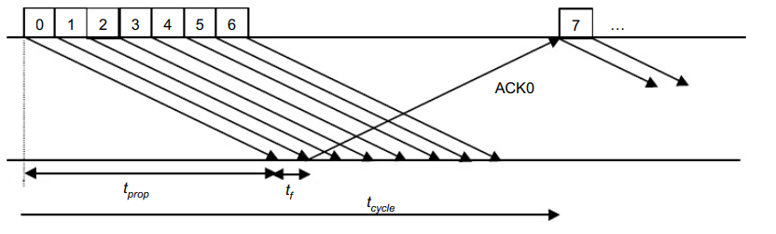

The maximum information rate is achieved with no error, and hence, no retransmission.

= minimum time to transmit a group of N packets

= + 2 = 1.33 + 2 x 120 = 241.33 ms

In which, is the minimum time to transmit a group of N packets.

n = no. of bits transmitted in a cycle = N.= 7 x 2000 = 14000 bits

= no. of bits sent in a cycle / minimum cycle time = n / = 58 kbps

In which, is number of bits transmitted in a cycle, is number of bits sent in a cycle / minimum cycle time.

If the extended sequence numbering option (7-bit) is used, the maximum send window size would be N = 27– 1 = 127, and hence, the maximum information rate is:

**Q6:**

**Suppose that a multiplexer receives constant-length packet from N = 60 data sources. Each data source has a probability p = 0.1 of having a packet in a given T-second period. Suppose that the multiplexer has one line in which it can transmit eight packets every T seconds. It also has a second line where it directs any packets that cannot be transmitted in the first line in a T-second period. Find the average number of packets that are transmitted on the first line and the average number of packets that are transmitted in the second line.**

Solution :

Firstly, we find out the probability of the k packets that have reached the T- second. It can be computed with the help of binomial distribution that has parameters as N=60 and shows the probability of p=0.1.

The average number for the arrivals of the packets can be given as Np=6. Now, calculate the average number of packets received through the first line as below:

X=

Now, the average number of packets received is 4.59 that gets transmitted through the first line. The remaining will get transmitted by the second line. Now, the average number of packets transmitted through the second line per T second can be obtained as below:

Y= Np – X = 6 – 4,59 = 1,41

Therefore, it will transmit 1.41 packets on average per T second from the second line.

**Q7:**

**Consider the transfer of a single real-time telephone voice signal across a packet network. Suppose that each voice sample should not be delayed by more than 20 ms.**

1. **Discuss which of the following adaptation functions are relevant to meeting the requirements of this transfer: handling of arbitrary message size; reliability and sequencing; pacing and flow control; timing; addressing; and privacy, integrity and authentication.**
2. **Compare a hop-by-hop approach to an end-to-end approach to meeting the requirements of the voice signal.**

Solution

a/Message size is important because in real-time signals of voice it is necessary to transfer a fixed packet size of that holds no more than 20 ms of the speech signal. The handling of arbitrary message size is not as important as long as the desired packet size for voice can be handled.

Sequencing is essential because each packet needs to arrive in the same sequence that it was generated. Reliability is moderately important since voice transmission can tolerate a certain level of loss and error.

Pacing and flow control are not as important because the synchronous nature of the voice signal implies that the end systems will be matched in speed.

Timing, for real-time voice transfer, is important because this adaptation function helps to control the jitter in the delivered signal.

Addressing is only during the connection setup phase if we assume some form of virtual circuit packet switching method.

Privacy, integrity, and authentication have traditionally not been as important as the other issues discussed above.

b/If the underlying network is reliable then the end-to-end approach is better because the probability of error is very low so processing at the edge suffices to provide acceptable performance.

If the underlying network is unreliable then the hop-by-hop approach may be required. For example, if the probability of error is very high, as in a wireless channel, then error recovery at each hop may be necessary to make effective communication possible.

**Q8 :**

**Consider the Stop-and-Wait protocol as described. Suppose that the protocol is modified so that each time a frame is found in error at either the sender or receiver, the last transmitted frame is immediately resent.**

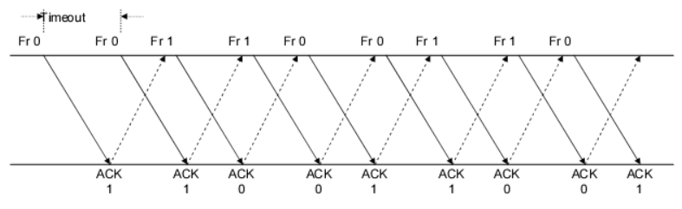

1. **Show that the protocol still operates correctly.**
2. **Does the state transition diagram need to be modified to describe the new operation?**
3. **What is the main effect of introducing the immediate-retransmission feature?**

Solution:

a/The sender in the stop-and-wait protocol described in the chapter retransmits a frame when an acknowledgment is not received in time. The modified protocol says that the frame is retransmitted every time the sender or receiver sees an error.

Therefore, the only difference is that frames are retransmitted sooner. So, the protocol will work correctly.

b/ No. The state transition diagram will stay the same.

c/ The error recovery process will be faster with this modified protocol.

**Q9**

**Suppose that two peer-to-peer processes provide a service that involves the transfer of discrete messages. Suppose that the peer processes are allowed to exchange PDUs that have a maximum size of M bytes including H bytes of header. Suppose that a PDU is not allowed to carry information from more than one message.**

Solution :

1. Develop an approach that allows the peer processes to exchange messages of arbitrary size .

To exchange messages of arbitrary size, large messages must be segmented into parts of M-H bytes

each in length to be transmitted in multiple PDUS. Small messages must be placed in a single PDU.

b. What essential control information needs to be exchanged between the peer processes?

The peer processes need to communicate information that allows for the reassembly of messages at

the receiver. For example, the first PDU may contain the message length. The last PDU may contain

and end-of-message marker. Sequence numbers may also be useful to detect loss in connection

oriented networks and to help in reconstruction of the messages in connectionless networks. Lastly,

since variable size PDUS are permitted, the size of the PDU must be transmitted in the PDU header.

c. Now suppose that the message transfer service provided by the peer processes is shared by several message source-destination pairs. Is additional control information required, and if so, where should it be placed?

In this case, in addition to all of the header information mentioned in b), each PDU must be labeled

with a stream ID, so that the receiver can treat each stream independently when reassembling

messages.

**Q10 :**

**A 1 Mbyte file is to be transmitted over a 1 Mbps communication line that has a bit error rate of p = 10-6.**

1. **What is the probability that the entire file is transmitted without errorsWe conclude that it is extremely unlikely that the file will arrive error free.**
2. **The file is broken up into N equal-sized blocks that are transmitted separately. What is the probability that all the blocks arrive correctly without error? Does dividing the file into blocks help?**
3. **Suppose the propagation delay is negligible, explain how Stop-and-Wait ARQ can help deliver the file in error-free form. On the average how long does it take to deliver the file if the ARQ transmits the entire file each time?**

Solution :

1Mbyte = 106 byte = 8 x bits because1 byte = 8 bits

The file length n = 8 x 106 bits, the transmission rate R = 1 Mbps = 106 bps and p = 10-6

1. Note : For n lagrge and p very small ,

P[no error in the entire file] = for n >> 1 , p << 1

= = 3.35 x

We conclude that it is extremely unlikely that the file will arrive error free

1. A subblock of length n/N is received without error with probability :

P[no error in subblock] =

A block has no errors if all subblocks have no errors, so

P[no error in block]= = =

So simply dividing the blocks does not help.

c.

Refer to the following figure for the discussion .

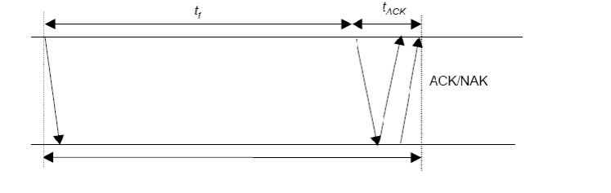

We assume the following:

* = basic time to send a frame and receive the ACK/NAK ttimeout
* = total transmission time until success
* = number of bits per ACK
* = number of transmissions
* = probability of frame transmission error

= = (

= (1 -

Given i transmissions : | = i *

E[] = P[] = = =

Here , = n >> thus = n/R ; and =

1

E[total] = n/R(1 - = 8 / (3.35 x 10-4) = 23847 seconds = 6,62 hours

The file gets through, but only after many retransmissions.

Q11

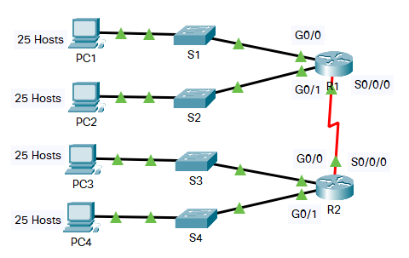

**In this activity, you are given the network address of 192.168.100.0/24 to subnet and provide the IP addressing for the Packet Tracer network. Each LAN in the network requires at least 25 addresses for end devices, the switch and the router. The connection between R1 to R2 will require an IP address for each end of the link.**

1. **Based on the topology, how many subnets are needed?**
2. **How many bits must be borrowed to support the number of subnets in the topology table?**
3. **How many subnets does this create?**
4. **How many usable hosts does this create per subnet?**

Solution:

a,

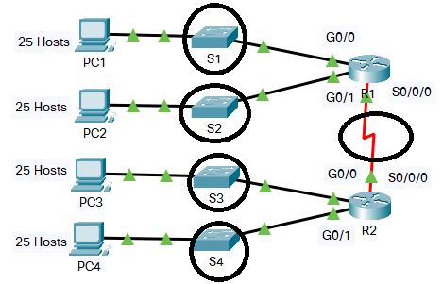

We saw that S1, S2, S3, S4, S0/0/0 are the subnets needed, so that there is 5 subnets are needed.

b,

We call N is the number of bits, then N is the smallest number that satisfies

Then we got N = 3.

(4 because 4 is subnet S1, S2, S3 , S4 not S0/0/0)

c,

We saw that number of bits N = 3, then the number of subnets does this create is

d.How many usable hosts does this create per subnet? 28-n – 2 = 28-3 – 2 = 30

**Q12:**

**Five stations (S1-S5) are connected to an extended LAN through transparent bridges (B1-B2), as shown in the following figure. Initially, the forwarding tables are empty. Suppose the following stations transmit frames: S1 transmits to S5, S3 transmit to S2, S4 transmits to S3, S2 transmits to S1, and S5 transmits to S4. Fill in the forwarding tables with appropriate entries after the frames have been completely transmitte**d.

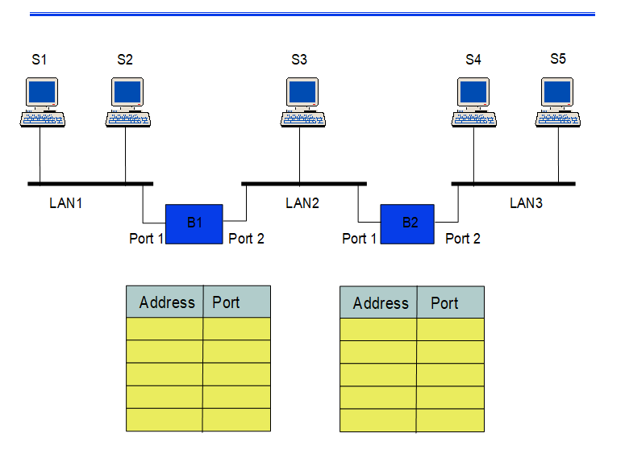

Solution :

Firstly, we know that we have 3 types of LAN, and each LAN is arranged follow BUS. Then, if a device sends data, it will send according to broardcast type (send to any device and internet port).

B1

|  |  |  |  |
| --- | --- | --- | --- |
|  |  | Address | Port |
| Step 1 | S1 => S5 | S1 | 1 |
| Step 2 | S3 => S2 | S3 | 2 |
| Step 3 | S4 => S3 | S4 | 2 |
| Step 4 | S2 => S1 | S2 | 1 |
| Step 5 | S5 => S4 |  |  |

B2

|  |  |  |  |
| --- | --- | --- | --- |
|  |  | Address | Port |
| Step 1 | S1 => S5 | S1 | 1 |
| Step 2 | S3 => S2 | S3 | 2 |
| Step 3 | S4 => S3 | S4 | 2 |
| Step 4 | S2 => S1 |  | 1 |
| Step 5 | S5 => S4 | S5 |  |

**Q13 :**

1. **Consider the network in Figure.**

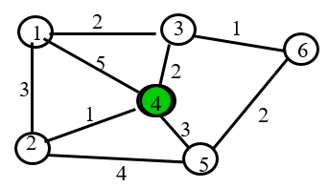

1. **Use the Dijkstra algorithm to find the set of shortest paths from node 4 to other nodes.**

**We call that node that have number N is V(N) (i.e the green one is V(4))**

**b, Find the set of associated routing table entries (Destination, Next Hop, Cost)**

|  |  |  |
| --- | --- | --- |
| **Destination** | **Cost** | **Next Hop** |

Solution:

a.

|  |  |  |  |  |  |  |
| --- | --- | --- | --- | --- | --- | --- |
| Iteration | N | D1 | D2 | D3 | D5 | D6 |
| Initial | {4} |  |  |  |  |  |
| 1 | {4,2} | (5,4) | (1, 4) | (2,4) | (3,4) |  |
| 2 | {4,2,3} | (4,2) | ______ | (2,4) | (3,4) |  |
| 3 | {4,2,3, 5} | (4,2) | ______ | ______ | (3,4) | (3,3) |
| 5 | {4,2,3,5,6} | (4,2) | ______ | ______ | ______ | (3,3) |
| 6 | {4,2,3,5,6,1} | (4,2) | ______ | ______ | ______ | ______ |

The shortest part from D4 to D1 is 4 and the path is D4 -> D2 -> D1

The shortest part from D4 to D2 is 1 and the path is D4 -> D2

The shortest part from D4 to D3 is 2 and the path is D4 -> D3

The shortest part from D4 to D5 is 3 and the path is D4 -> D5

The shortest part from D4 to D6 is 3 and the path is D4 -> D3 -> D6

b.

|  |  |  |
| --- | --- | --- |
| Destination | Cost | Next Hop |
| 1 (chính là D1) | 4 | 2 |
| 2 | 1 | 2 |
| 3 | 2 | 3 |
| 5 | 3 | 5 |
| 6 | 3 | 3 |

Q14 :

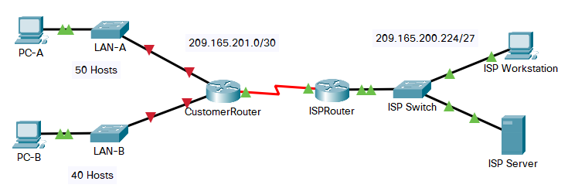

**You are a network technician assigned to install a new network for a customer. You must create multiple subnets out of the 192.168.12.0/24 network address space to meet the following requirements:**

* + **The first subnet is the LAN-A network. You need a minimum of 50 host IP addresses.**
  + **The second subnet is the LAN-B network. You need a minimum of 40 host IP addresses.**
  + **You also need at least two additional unused subnets for future network expansion.**

**Note: Variable length subnet masks will not be used. All of the device subnet masks should be the same length.**

**Answer the following questions to help create a subnetting scheme that meets the stated network requirements:**

1. **How many host addresses are needed in the largest required subnet?**
2. **What is the minimum number of subnets required?**
3. **The network that you are tasked to subnet is 192.168.12.0/24. What is the /24 subnet mask in binary?**
4. **The subnet mask is made up of two portions, the network portion, and the host portion. This is represented in the binary by the ones and the zeros in the subnet mask.**

**Questions:**

**In the network mask, what do the ones and zeros represent?**

1. **When you have determined which subnet mask meets all of the stated network requirements, derive each of the subnets. List the subnets from first to last in the table. Remember that the first subnet is 192.168.12.0 with the chosen subnet mask.**

|  |  |  |
| --- | --- | --- |
| **Subnet Address** | **Prefix** | **Subnet Mask** |

Solution :

a. How many host addresses are needed in the largest required subnet?

Soln: 50

b. What is the minimum number of subnets required?

Soln : According to the question , two subnet are required for LAN-A and LAN-B and two subnets are needed to be left for future use Therefor the total number of subnets are 4 .

c. The network that you are tasked to subnet is 192.168.12.0/24. What is the /24 subnet mask in binary?

Soln : /24 is prefix length.

1. In binary, it is 11111111.111111111.111111111.000000000

There are 24 bits 1. It means that the address left 24 first bits for network portion

d. The subnet mask is made up of two portions, the network portion, and the host portion. This is represented in the binary by the ones and the zeros in the subnet mask. In the network mask, what do the ones and zeros represent?

Soln : In the nerwork mask, the ones represent the network portion and the zeroes represent the host portion.

e. When you have determined which subnet mask meets all of the stated network requirements, derive each of the subnets. List the subnets from first to last in the table. Remember that the first subnet is 192.168.12.0 with the chosen subnet mask.

|  |  |  |
| --- | --- | --- |
| **Subnet Address** | **Prefix** | **Subnet Mask** |
| **192.168.12.0** | **/26** | **255.255.255.192** |
| **192.168.12.64** | **/26** | **255.255.255.192** |
| **192.168.12.128** | **/26** | **255.255.255.192** |
| **192.168.12.192** | **/26** | **255.255.255.192** |

**Câu 15:**

**Suppose that Selective Repeat ARQ is modified so that ACK messages contain a list of the next m frames that it expects to receive.**

**Solutions follow questions:**

**a. How does the protocol need to be modified to accommodate this change?**

**b. What is the effect of the change on protocol performance?**

Solution :

GIVENTHAT :

a) How does the protocol need to be modified ?

2 things are needed to be changed:-

The frame header needs to be modified to recieve the list of frames and Since the reciever explicitly indicates which frames are needed to be transmitted.

Change in transmitter operation is needed. If the recieved list contains m oldest frames that are yet to be recieved , then it can be used to skip retransmission of frames that have already been received.

b) What is the effect of change on protocol performance?

Performance will surely increase if the error rate is high or delay is high. A single frame can ask for the retransmission of several frames.

The complexity of the protocol will surely increase relative to the unchanged Selective repeat ARQ

**Q.1. (2 marks)**

**Suppose the size of an uncompressed text file is 1 megabyte**

**Note: Explain your answer in details.**

**a. How long does it take to download the file over a 32 kilobit/second modem?**

**b. How long does it take to take to download the file over a 1 megabit/second**

**modem?**

**c. Suppose data compression is applied to the text file. How much do the transmission**

**times in parts (a) and (b) change?**

solu:

Câu a)

(Đổi hết sang đơn vị bit và bit / second)

Size text file = 1 x 1024 x 1024 x 8 (bit)

Speed = 32 x 1000 (bit / second)

=> T (32k) = (1 x 1024 x 1024 x 8) / (32 x 1000) = 262.144 (seconds)

Câu b)

(Đổi hết sang đơn vị bit và bit / second)

Size text file = 1 x 1024 x 1024 x 8 (bit)

Speed = 1 x 1000 x 1000 (bit / second)

=> T (1M) = (1 x 1024 x 1024 x 8) / (1 x 1000 x 1000) = 8.38 (seconds)

Câu c)

(Đề kêu 1:6 thì chỉ việc nhân thêm cho 6 ở chỗ tốc độ là xong, nếu trường ra đề 1:10 thì nhân 10)

=> T (32k) = (1 x 1024 x 1024 x 8) / (32 x 1000 x 6) = 43.69 (seconds)

=> T (1M) = (1 x 1024 x 1024 x 8) / (1 x 1000 x 1000 x 6) = 1.4 (seconds)

***Solution:***

*a. How long does it take to download the file over a 32 kilobit/second modem?*

*b. How long does it take to download the file over a 1 megabit/second modem?*

*c. Suppose data compression is applied to the text file. How much do the transmission*

*times in parts (a) and (b) change?*

If we assume a maximum compression ratio of 1:6, then we have the following times for the 32 kilobit and 1 megabit lines respectively:

**Q2. (2 marks)**

**Let g(x)=x3+x+1. Consider the information sequence 1001. Find the codeword**

**corresponding to the preceding information sequence. Using polynomial arithmetic we obtain**

**Note: Explain your answer in details.**

Solu:

Step 1: Add 000 to data bits string. It will be 1001000

Step 2: Devide 1001000 to 1011 in modulo – 2 method.

g(x) = x3+x+1 -> 1011

Using polynomial arithmetic we obtain:

101

-----------------

1011 | 1001000

| 1011

---------------

001000

1011

---------------

00110

Codeword = 1 0 0 1 1 1 0

b.Suppose that the codeword has a transmission error in the first bit . what does the receiver obtain when its error checking

*b.*

0001 .

1011 **|**  0001110

**|**  1011 .

101

CRC calculated

**Q.4. (2 marks)**

**A router has the following CIDR entries in its routing table:**

**Address/mask Next hop**

**135.46.56.0/22 Interface 0**

**135.46.60.0/22 Interface 1**

**192.53.40.0/23 Router 1**

**default Router 2**

**(a) What does the router do if a packet with an IP address 135.46.63.10 arrives?**

**(b) What does the router do if a packet with an IP address 135.46.57.14 arrives?**

solu:

a)

Taking the first 22 bits of the above IP address as network address, we have 135.46.60.0.

It matches the network address of 135.46.60.0/22. So, the router will forward the packet to Interface 1.

b)

Taking the first 22 bits of the above IP address as network address, we have 135.46.56.0.

It matches the network address of 135.46.56.0/22. The packet will be forwarded to Interface 0.

(ko chep vao) Cách nhận biết:

Xét 135.46.63.10 có 135.46 giống Interface 0 và 1.

135.46.63 lớn hơn Interface 1 thì chọn Interface 1, ngược nếu ví dụ như đề câu b chỉ có 57 (lớn hơn 56 nhưng nhỏ hơn 60) -> chọn Interface 0.

Nếu đề hỏi khác nữa như cho 10.10.10.10 không giống cái nào ở Interface 0, 1 hay Router 1 thì mặc định chọn Default -> Router 2.

**Câu 15:**

**A Large number of consecutive IP address are available starting at 198.16.0.0.**

**Suppose four organizations, A, B, C, D request 4000, 2000, 4000, and 8000**

**addresses, respectively. For each of these organizations, give:**

**1. the first IP address assigned**

**2. the last IP address assigned**

**3. the mask in the w.x.y.z/s notation**

solu:

IP addresses will be allocated in blocks of power of 2. So the four organizations will be allocated IPs as A-4096, B-2048, C-4096 and D-8192. Remaining unused IPs are wasted. IPs will be allocated to the organizations contiguously

A has 2^12 hosts. So lower order 12 bits will denote host ID and higher order 32-12=20 bits denotes network ID

A's first IP=198.16.0.0 (Host IP part contains all Os)

A's last IP=11000110.00010000.00001111.11111111 (Host ID part contains all 1s=198.16.15.255)

A's Mask=198.16.15.255

------------------------------------------------------------------------------------------------------------

B has 2^11 hosts. So lower order 11 bits will denote host ID and higher order 32-11=21 bits denotes network ID

B's first IP=198.16.16.0

B's last IP=11000110.00010000.00010111.11111111=198.16.23.255

B's Mask=198.16.16.0/21

------------------------------------------------------------------------------------------------------------

C has 2^12 hosts. So lower order 12 bits will denote host ID and higher order 32-12=20 bits denotes network ID

C's first IP=198.16.24.0

C's last IP=11000110.00010000.00011111.11111111=198.16.31.255

C's Mask=198.16.24.0/20

--------------------------------------------------------------------------------------------------------------

D has 2^13 hosts. So lower order 13 bits will denote host ID and higher order 32-13=19 bits denotes network ID

D's first IP=198.16.32.0

D's last IP=11000110.00010000.00111111.11111111=198.16.63.255

D's Mask=198.16.32.0/19

**No.20)**

The ability to work with IPv4 subnets and determine network and host information based on a given IP address and subnet mask is critical to understanding how IPv4 networks operate. The first part is designed to reinforce how to compute network IP address information from a given IP address and subnet mask. When given an IP address and subnet mask, you will be able to determine other information about the subnet.

Fill out the tables below with appropriate answers given the IPv4 address, original subnet mask, and new subnet mask.

***Solution:***

|  |  |
| --- | --- |
| Find: | |
| Number of Subnet Bits | 5 |
| Number of Subnets Created | 32 |
| Number of Host Bits per Subnet | 3 |
| Number of Hosts per Subnet | 6 |
| Network Address of this Subnet | 192.135.250.176 |
| IPv4 Address of First Host on this Subnet | 192.135.250.177 |
| IPv4 Address of Last Host on this Subnet | 192.135.250.182 |
| IPv4 Broadcast Address on this Subnet | 192.135.250.183 |