**Lời đầu tiên, cảm ơn bạn đã tin tưởng và sử dụng source PE NWC203c của mình, mình có một số thông tin cần nói với các bạn, đó là source của mình soạn theo sample mới nhất của kỳ SUM23, các số liệu đã được cập nhật đầy đủ và mới nhất. Trong đó có câu số 20 và câu số 26 là mình tự thêm vào, 24 câu còn lại đều thuộc sample mới nhất bạn nhé, trong các câu này mình sẽ có một số note nhỏ giúp các bạn lưu ý và cẩn thận hơn khi làm bài, mình cần các bạn paraphrase lại các câu lý thuyết để đảm bảo an toàn cho chính các bạn (paraphrase ở đây là viết lại theo lời văn của bạn nhưng câu văn không được thay đổi nghĩa nhé), các câu bài tập thì mình đã có giải thích một số câu bên dưới nên các bạn vui lòng đọc đầy đủ giúp mình nhé, vì các số liệu có thể bị thay đổi (nhưng dạng câu hỏi thì ko nhé) nên các bạn cần hết sức cẩn thận.**

**Các câu lý thuyết trong source này đã được mình chỉnh sửa lại một ít và được quét AI plagiarism trên web zerogpt.com cho ra kết quả là 0% nên bạn hãy yên tâm nhé. Dù vậy, mình khuyến khích bạn vẫn nên tự paraphrase lại lời văn của bạn.**

**Source này chính là source hoàn chỉnh và đầy đủ nhất, nếu source cũ bạn đã paraphrase lại các câu lý thuyết thì bạn cứ copy các câu ấy và dán đè lên các câu lý thuyết trong đây nhé.**

**Đây là link một số bài final mà mình đã thu thập được nhé**

**https://drive.google.com/drive/folders/1iUjz9FGodIC8rVPHNe0PxiUdGt7Wkvpq?usp=sharing**

**Một lần nữa, cảm ơn bạn nhé.**

**----Hoapooh----**

1. Explain the difference between connectionless unacknowledged service and connectionless acknowledged service. How do the protocols that provide these services differ?

**Answer:**

* Connectionless unacknowledged service does not provide any reliability guarantees. The transmitter simply sends data and does not patiently await for the receiver to sign for reception. If the data is lost or distorted, the sender will be unaware. Applications like streaming media that can withstand data loss employ this kind of service.
* Connectionless acknowledged service provides a basic level of reliability by sending acknowledgments for each data packet. A packet will be resent by the sender if it doesn't get an acknowledgment the first time. File transfers, for example, are examples of applications that cannot tolerate data loss.

The protocols that provide these services differ in how they handle acknowledgments.

* Protocols that provide connectionless unacknowledged service do not send acknowledgments. The sender simply sends the data and does not wait for any response from the receiver. This type of protocol is simpler and faster than protocols that provide connectionless acknowledged service.
* Protocols that provide connectionless acknowledged service send acknowledgments for each data packet. The sender waits for an acknowledgment before sending the next packet. This type of protocol is more reliable than protocols that provide connectionless unacknowledged service, but it is also slower.

**2.** Explain the difference between connection-oriented acknowledged service and connectionless acknowledged service. How do the protocols that provide these services differ?

**Answer:**

* Connection-oriented acknowledged service establishes a connection between the sender and receiver before any data transmission takes place. This connection is used to track the sequence of data packets and to ensure that all packets are delivered reliably.
* Connectionless acknowledged service does not establish a connection before data transmission. Instead, each data packet is delivered separately, and the receiver acknowledges receipt of each packet individually. This service is less dependable than connection-oriented recognized service, but it is quicker

The protocols that provide these services differ in how they handle connections and acknowledgments.

* Protocols that provide connection-oriented acknowledged service establish a connection between the sender and receiver before any data transmission. The most common protocol that provides connection-oriented acknowledged service is the Transmission Control Protocol (TCP).
* Protocols that provide connectionless acknowledged service do not establish a connection before data transmission.

**3.** Explain the differences between PPP and HDLC

**Answer:**

HDLC is a short form of High-level Data Link Control that does the data encapsulation. PPP is an acronym for Point-to-Point Protocol that can be used by different devices without any data format change.

And below are few differences of HDLC and PPP:

* + Configuration type

HDLC is implemented by Point-to-point link configuration and also multi-point link configurations.

PPP is implemented by Point-to-Point configuration only.

* + Layer

HDLC works at layer 2 (Data Link Layer).

PPP works at layer 2 and layer 3 (Network Layer).

* + Media Type

HDLC is used in synchronous media.

PPP is used in synchronous media as well as asynchronous media.

* + Error detection

HDLC does not offer error detection.

PPP provides the feature of error detection using FCS (Frame Check Sequence) while transmitting data.

* + Authentication

HDLC does not provide link authentication.

PPP provides link authentication using protocols like PAP (Password Authentication Protocol) and CHAP (Challenge Handshake Authentication Protocol).

🡪In general, PPP is a more versatile and secure protocol than HDLC. However, HDLC is simpler and faster than PPP. The best protocol to use will depend on the specific needs of the application

4. A 1.5 Mbps communications link is to use HDLC to transmit information to the moon. What is the smallest possible frame size that allows continuous transmission? The distance between earth and the moon is approximately 375,000 km, and the speed of light is 3x108 meters/second

(câu này đáp án đã được trình bày công thức đầy đủ và chi tiết bên dưới, các bạn chỉ cần chú ý các con số khi ra thi để thay đổi khi cần thiết nhé)

**Answer:**

As Go-Back-N and Selective Repeat are required for both the Default HDLC Frame and Extended HDLC Frame, it can be described as follows.

|  |  |  |
| --- | --- | --- |
|  | **Maximum Send Window Size in Default HDLC Frame** | **Maximum Send Window Size in Extended HDLC Frame** |
| **Go-Back-N** | **7** | **127** |
| **Selective Repeat** | **4** | **64** |

As topic, we have Distance and Speed of Light:

**D** (Distance) = 375,000 km = 375 * 106 (m)

**c** (Speed of Light) = 3 * 108 (m)

Then, we can compute Round Trip Propagation Delay by this formula:

We know that:

In which, is Possible Frame Size (bits), Mbps is the number of Megabyte Per Second.

R = 1,5 Mbps so that R = 1,5 x 106 bps.

* **Go-back-N:**

Default HDLC Frame: N = 7, substitute to (*) then we have

Extended HDLC Frame: N = 127, substitute to (*) then we have

* **Selective Repeat**

Default HDLC Frame: N = 4, substitute to (*) then we have

Extended HDLC Frame: N = 64, substitute to (*) then we have

**5**. Suppose HDLC is used over a 1.5 Mbps geostationary satellite link. Suppose that 250-byte frames are used in the data link control. What is the maximum rate at which information can be transmitted over the link? (cần xem lại)

(chuẩn ko cần chỉnh anh em nha (sau rất nhiều lần chỉnh :>>), đọc kỹ đề giùm mình là ổn nhé)

**Answer:**

R = 1.5 Mbps or R = 1,5 x 106 bps, and nf =250 bytes or 2000 bits (250 x 8).

The distance that the information must travel is the earth-to-satellite distance, or D ≈ 36,000 km = 3,6 x 107m .

The speed of light c is 3 x 108 . We can calculate the propagation delay and processing rate as follows:

We can use either Go-Back-N or Selective Repeat ARQ.

|  |  |  |
| --- | --- | --- |
|  | Maximum Send Window Size in Default HDLC Frame | Maximum Send Window Size in Extended HDLC Frame |
| Go-Back-N | 7 | 127 |
| Selective ARQ | 4 | 64 |

The default window size is N = 7 (with a 3- bit sequence number).



The maximum information rate is achieved with no error, and hence, no retransmission.

= minimum time to transmit a group of N packets

= + 2 = 1.33 + 2 x 120 = 241.33 ms

In which, is the minimum time to transmit a group of N packets.

n = N x= 7 x 2000 = 14000 bits

= n / = 14000 / 241,33 ms = 14000 / ( 241,33 × 10-3) s = 58 kbps

In which, is number of bits transmitted in a cycle, is number of bits sent in a cycle / minimum cycle time.

If the extended sequence numbering option (7-bit) is used, the maximum send window size would be N = 27– 1 = 127, and hence, the maximum information rate is:

If using Selective Repeat which default HDLC Frame, then N = 4.

Then

If using Selective Repeat which extended HDLC Frame, then N = 64.

Then

**6.** Suppose that a multiplexer receives constant-length packet from N = 60 data sources. Each data source has a probability p = 0.1 of having a packet in a given second period. Suppose that the multiplexer has one line in which it can transmit eight packets every T seconds. It also has a second line where it directs any packets that cannot be transmitted in the first line in a T-second period. Find the average number of packets that are transmitted on the first line and the average number of packets that are transmitted in the second line.

(câu này bạn chú ý đến các số liệu trên đề bài là ổn bạn nhé, công thức đã có và bạn chỉ cần thế số là xong ạ, **Np chỉ đơn giản là N nhân với p** thôi bạn nhé)

**Answer:**

First, find out the probability of the k packets that have reached the T- second. It can be computed with the help of binomial distribution that has parameters as N = 60 and shows the probability of p = 0.1.

The average number for the arrivals of the packets can be given as Np = 6. Now, calculate the average number of packets received through the first line as below:

Now, the average number of packets received is 4.59 that gets transmitted through the first line. The remaining will get transmitted by the second line. Now, the average number of packets transmitted through the second line per T second can be obtained as below:

Tsecond = Np – Avg1 = 6 – 4.59 = 1.41

Therefore, it will transmit 1.41 packets on average per T second from the second line.

**7.** Consider the transfer of a single real-time telephone voice signal across a packet network.  
Suppose that each voice sample should not be delayed by more than 20 ms.  
a. Discuss which of the following adaptation functions are relevant to meeting the  
requirements of this transfer: handling of arbitrary message size; reliability and  
sequencing; pacing and flow control; timing; addressing; and privacy, integrity  
and authentication.  
b. Compare a hop-by-hop approach to an end-to-end approach to meeting the  
requirements of the voice signal.

**Answer:**

a)

• **Message size** is significant because real-time voice communications need the delivery of a fixed packet size that can only accommodate speech signals of 20 milliseconds or less. As long as the required speech packet size can be handled, it is not as crucial how arbitrary message sizes are handled.

• **Sequencing** is crucial as every packet must arrive in the order that it was generated. Because voice transmission can tolerate a certain amount of error and loss, reliability is only somewhat important.

• **Pacing and flow control** are less significant because the synchronous nature of the voice signal implies that the speed of the end systems will be matched.

• **Timing**, for real-time voice transfer is important because it helps in reducing the jitter of the supplied signal through its adaption function.

• **Addressing** is only when the connection is being set up, assuming some type of virtual circuit packet switching technique.

• **Privacy, integrity, and authentication** have not been as important as the previously mentioned issues.

b)

- If the underlying network is trustworthy, end-to-end is preferable since edge processing is sufficient to deliver respectable performance and the likelihood of mistake is very low.

- The hop-by-hop technique may be necessary if the underlying network is unstable. For instance, error recovery at each hop may be required to enable successful communication if the probability of error is very high, as it is in a wireless channel.**8. Consider the Stop-and-Wait protocol as described. Suppose that the protocol is modified so that each time a frame is found in error at either the sender or receiver, the last transmitted frame is immediately resent.**

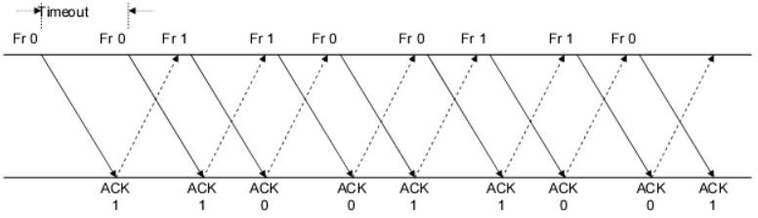

1. **Show that the protocol still operates correctly.**
2. **Does the state transition diagram need to be modified to describe the new operation?**
3. **What is the main effect of introducing the immediate-retransmission feature?**

**Answer:**

a/ In the chapter's discussion of the stop-and-wait protocol, the sender resends a frame if an acknowledgement is not received in a timely manner. Every time a transmitter or receiver detects an error, according to the updated protocol, the frame is sent again.

Since frames are retransmitted more frequently, it is the sole change. The protocol will thus operate as expected.

b/ No. The state transition diagram won’t change.

c/ With this modified protocol, the error recovery procedure will proceed more quickly.

**9.** Suppose that two peer-to-peer processes provide a service that involves the transfer of discrete messages. Suppose that the peer processes are allowed to exchange PDUs that have a maximum size of M bytes including H bytes of header. Suppose that a PDU is not allowed to carry information from more than one message

**Answer:**

a. Develop an approach that allows the peer processes to exchange messages of arbitrary size.

To convert arbitrary sizes, large contents must be split into bytes of each length that will be transmitted in multiple PDUs.

b. What essential control information needs to be exchanged between the peer processes?

Peer processes must exchange information that permits messages to be reassembled at the recipient. The message length, for example, could be included in the first PDU. A message end-of-message marker could be included in the last PDU. In connection-oriented networks, sequence numbers can be used to detect loss, while in connectionless networks, they can be used to aid in message reconstruction. Finally, because variable-size PDUs are allowed, the PDU size must be specified in the PDU header.

c. Now suppose that the message transfer service provided by the peer processes is shared by several message source-destination pairs. Is additional control information required, and if so, where should it be placed?

In this instance, each PDU must be identified with a stream ID in addition to all of the header information specified in (b), so that the receiver may treat each stream separately while reassembling messages.

10. A 1 Mbyte file is to be transmitted over a 1 Mbps communication line that has a bit error rate of p = 10-6.

a. What is the probability that the entire file is transmitted without errors? Note for n large and p very small, (1 − p)n ≈ e-np.

b. The file is broken up into N equal-sized blocks that are transmitted separately. What is the probability that all the blocks arrive correctly without error? Does dividing the file into blocks help?

c. Suppose the propagation delay is negligible, explain how Stop-and-Wait ARQ can help deliver the file in error-free form. On the average how long does it take to deliver the file if the ARQ transmits the entire file each time?

(Đây là một câu khó nên các bạn chú ý đọc kỹ đề và thay đúng số nếu đề có thay đổi số liệu nhé)

**Answer:**

The file length n = 1 Mbyte = 8 Mbit = 8*106 bits, the transmission rate R = 1 Mbps, and p = 10-6.

a.

P[no error in the entire file] = (1 – p)n ≈ e–np , for n >> 1, p << 1

= e-8 = 3.35 x 10-4

We conclude that it is extremely unlikely that the file will arrive error free.

b.

A subblock of length n/N is received without error with probability:

P[no error in subblock] = (1 – p)n/N

A block has no errors if all subblocks have no errors, so

P[no error in block] = P[no errors in subblock]N =((1 – p)n/N)N = (1 – p)n

So simply dividing the blocks does not help.

c.

We assume the following:

* t0 = basic time to send a frame and receive the ACK/NAK ≈ ttimeout
* ttotal = total transmission time until success
* nf = number of bits/frame
* na = number of bits per ACK
* nt = number of transmissions
* Pf = probability of frame transmission error

t0 = tf + tACK = nf / R + na / R (tprop ≈ 0).

P[nt = i ] = P[one success after i – 1 failure] = (1 – Pf) P i – 1

f

Ttotal | i transmissions = i.t0

E[ttotal] = = t0 (1 − Pf)

= t0(1–Pf )/(1–Pf)2 = t0/(1 - Pf)

Here, nf = n >> na thus t0 ≈ tf = n/R ; and Pf = 1 – P[ no error] = 1 - e-np

E[total] = n/R (1 – Pf) = n/[Re-np] = 8 / (3.35*10-4) = 23,880 seconds ≈ 6.63 hours!

The file gets through, but only after many retransmissions.

11.

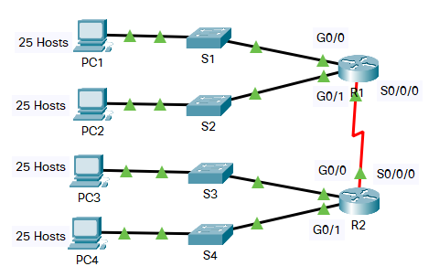

In this activity, you are given the network address of 192.168.1.0/24 to subnet and provide the IP addressing for the Packet Tracer network. Each LAN in the network requires at least 25 addresses for end devices, the switch and the router. The connection between R1 to R2 will require an IP address for each end of the link.

a. Based on the topology, how many subnets are needed?

b. How many bits must be borrowed to support the number of subnets in the topology table?

c. How many subnets does this create?

d. How many usable hosts does this create per subnet?

**Note**: If your answer is less than the 25 hosts required, then you borrowed too many bits.

(Câu này các bạn chỉ copy đáp án ra là ổn nhé, các bạn chú ý ra thi ko copy hình mình dán ở câu a. nhé, mình chỉ show cho các bạn cách nhận biết thôi ạ)

**Answer:**

a)

We saw that S1, S2, S3, S4, S0/0/0 are the subnets needed, so total we have a **5** Network so we needed **5** in subnets.

b)

The script itself they mentioned at least 25 addresses for the entry devices such as or router, so if you have to get this 25 addresses we have to borrow 3 bits

We call N is the number of bits, follow fomula below:

N is the smallest number that satisfies

* **We got N = 3.**

**Explain:** 4 because 4 is subnet S1, S2, S3 , S4 not S0/0/0

c)

We saw that number of bits N = 3, then the number of subnets created are :

**=> The number of subnets created is 8**

d)

The number of host is where N is the smallest number that satisfies:

**,**

* We saw that N = 5, so that number of hosts are

**12.** Five stations (S1-S5) are connected to an extended LAN through transparent bridges (B1- B2), as shown in the following figure. Initially, the forwarding tables are empty. Suppose the following stations transmit frames: S1 transmits to S5, S3 transmit to S2, S4 transmits to S3, S2 transmits to S1, and S5 transmits to S4. Fill in the forwarding tables with appropriate entries after the frames have been completely transmitted

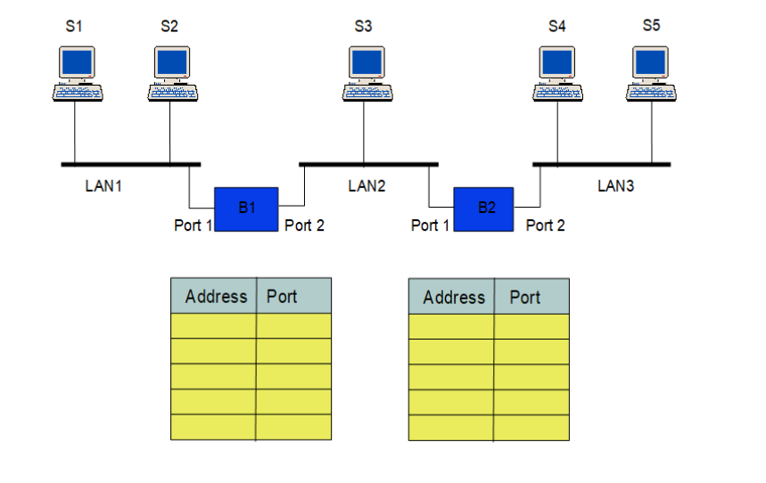

**(câu này đáp án đã là chuẩn nhất nên bạn ko cần chỉnh sửa gì nhé, những chỗ trống không phải mình làm sai hoặc thiếu mà là cái thằng station tại đó không tìm thấy bạn nhé)**

**Answer:**

|  |  |  |  |  |
| --- | --- | --- | --- | --- |
| B1 | | | | |
|  |  | Address | Port | Explaination |
| Step 1 | S1 => S5 | S1 | 1 | Because there is S1 sent. So B1 will receive this packet |
| Step 2 | S3 => S2 | S3 | 2 | Since S3 sends the broadcast, B1 receives  it. |
| Step 3 | S4 => S3 | S4 | 2 | Because after step 2, B2 knows that S3 is on port 2, it will forward the packet to port  2. And of course, both S3 and port 2 of B1 will also receive it. |
| Step 4 | S2 => S1 | S2 | 1 | Since S2 sends the broadcast, B1 receives  it. |
| Step 5 | S5 => S4 |  |  | B2 already knows that S4 is on network 3, so B2 will no longer forward the packet to networks 2 and 1. So this step B1 won't say  where S5 is |

|  |  |  |  |  |
| --- | --- | --- | --- | --- |
| B2 | | | | |
|  |  | Address | Port | Explaination |
| Step 1 | S1 => S5 | S1 | 1 | Because in the beginning, there is S1 sending S5. But both B1 and B2 do not know where S5 is, so the packet that S1 sends is a broadcast. B1 will also forward the packet because it doesn't know where S5 is => B2 will receive it and know that S1 is on port 1 |
| Step 2 | S3 => S2 | S3 | 1 | Because there is a session sending S3 to S2, but since S3 doesn't know where S2 is initially, it sends it as a broadcast. And so, B2 can also receive the packet of S3, so B2  can also understand that S3 is on its port 1. |
| Step 3 | S4 => S3 | S4 | 2 | Because S4 sent to S3 |
| Step 4 | S2 => S1 |  |  | After step 1, B1 already knows that S1 is on network 1, so it will not forward the packet anymore. So at this step, B2  doesn't know where S2 is. |
| Step 5 | S5 => S4 | S5 | 2 | Because S5 sends a broadcast |

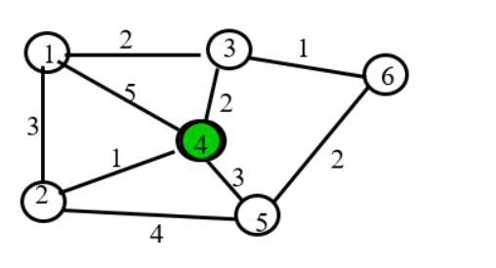**13.** Consider the network in Figure

**(câu này là chuẩn nhất nên các bạn cứ copy paste thoải mái nhé)**

**Answer:**

* 1. Use the Dijkstra algorithm to find the set of shortest paths from node 4 to other nodes.

|  |  |  |  |  |  |  |
| --- | --- | --- | --- | --- | --- | --- |
| **Iteration** | **N** | **D1** | **D2** | **D3** | **D5** | **D6** |
| Initial | {4} | ∞ | ∞ | ∞ | ∞ | ∞ |
| 1 | {4,2} | (5,4) | (1,4) | (2,4) | (3,4) | ∞ |
| 2 | {4,2,3} | (4,2) | --- | (2,4) | (3,4) | ∞ |
| 3 | {4,2,3,5} | (4,2) | --- | --- | (3,4) | (3,3) |
| 4 | {4,2,3,5,6} | (4,2) | --- | --- | --- | (3,3) |
| 5 | {4,2,3,5,6,1} | (4,2) | --- | --- | --- | --- |

* 1. Find the set of associated routing table entries (Destination, Next Hop, Cost)

|  |  |  |
| --- | --- | --- |
| Destination | Cost | Next Hop |
| D1 | 4 | D2 |
| D2 | 1 | D2 |
| D3 | 2 | D3 |
| D5 | 3 | D5 |
| D6 | 3 | D3 |

**14.** 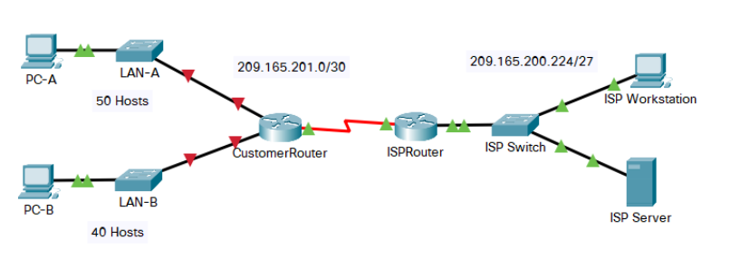

You are a network technician assigned to install a new network for a customer. You  
must create multiple subnets out of the 192.168.0.0/24 network address space to meet  
the following requirements:  
- The first subnet is the LAN-A network. You need a minimum of 50 host IP  
addresses.  
- The second subnet is the LAN-B network. You need a minimum of 40 host  
IP addresses.  
- You also need at least two additional unused subnets for future network  
expansion.  
**Note**: Variable length subnet masks will not be used. All of the device subnet masks  
should be the same length.  
Answer the following questions to help create a subnetting scheme that meets the stated  
network requirements:  
a. How many host addresses are needed in the largest required subnet?  
b. What is the minimum number of subnets required?  
c. The network that you are tasked to subnet is 192.168.0.0/24. What is the /24  
subnet mask in binary?  
d. The subnet mask is made up of two portions, the network portion, and the host  
portion. This is represented in the binary by the ones and the zeros in the subnet  
mask

In the network mask, what do the ones and zeros represent?  
e. When you have determined which subnet mask meets all of the stated network  
requirements, derive each of the subnets. List the subnets from first to last in the  
table. Remember that the first subnet is 192.168.0.0 with the chosen subnet mask

(trong câu này, đối với câu c. /?? subnet mask ở đây rất dễ để nhận biết trong giao thức IPv4, nó sẽ có phương thức hiển thị là w.x.y.z, mỗi vị trí ở trong đây tương đương với 8 bits trong binary, mình lấy ví dụ, nếu đề bài cho là **/12 subnet mask** thì mình sẽ có đáp án là **11111111.1111**0000.00000000.00000000, ở đây mình sẽ có **12 số 1 (hoặc 12 bits)** tương đương với **/12 subnet mask** và đối với trong bài này **/24 subnet mask** thì bạn hiểu đơn giản sẽ có **24 số 1 (24 bits)** và các vị trí trống ở sau toàn bộ đều là số 0 - **11111111.11111111.11111111**.00000000)

(đặc biệt đối với câu e, mình sẽ giải thích đơn giản cho các bạn hiểu về bước nhảy mạng, cách tìm số subnet, số host mà mỗi subnet có được:

trong bài này số subnet có được là 4 và chúng ta cần tìm là số bit phần Host cho phần Net mượn

* + số subnet có được: 2n (n: số bit phần Host cho phần Net mượn), đối với bài này ta đã biết số subnet có được là 2n = 4 🡪Ta sẽ tìm được n = 2, ban đầu các mạng này là /24 subnet mask, sau khi tìm được số bít phần Host cho phần Net mượn thì ta thêm 2 bit đó vào(2 bit được thêm vào bạn hiểu đơn giản là thay thế bằng số 1) và nó sẽ trở thành /26 subnet mask: 11111111.11111111.11111111.1100000000.
  + số host trong mỗi mạng con: 2m – 2 (m: là số bit 0 còn lại trong Subnet mask), trong bài mình sẽ còn lại 6 bit 0 thì mình sẽ có 26 – 2 = 64.
  + số bước nhảy: k = 28-n (n: số bit phần Host cho phần Net mượn), chúng ta sẽ tìm được k = 28-2 = 64.

và để hình thành ra cái bảng ở câu e, chúng ta chỉ cần điền subnet id đầu tiên vào, để tìm những subnet id tiếp theo bạn chỉ cần cộng tiếp với 64

subnet ID1: 192.168.0.0 / 26

subnet ID2: 192.168.0.64 / 26 (cộng thêm 64 từ subnet ID1)

subnet ID3: 192.168.0.128 / 26 (cộng thêm 64 từ subnet ID2)

subnet ID4: 192.168.0.192 / 26 (cộng thêm 64 từ subnet ID3)

**Answer:**

a)

**50 Hosts addresses** are needed in the largest required subnet.

b)

The requirements stated above specify two company networks for future expansion. So, there are a **4 minimum number of subnets required**.

c)

the /24 subnet mask in binary is **11111111.11111111.11111111.00000000** .

d)

Ones in the binary is represented the **network** portion.

Zeros in the binary is represented the **host** portion.

e)

|  |  |  |
| --- | --- | --- |
| Subnet Address | Prefix | Subnet Mask |
| 192.168.0.0 | /26 | 255.255.255.192 |
| 192.168.0.64 | /26 | 255.255.255.192 |
| 192.168.0.128 | /26 | 255.255.255.192 |
| 192.168.0.192 | /26 | 255.255.255.192 |

**15.** Suppose that Selective Repeat ARQ is modified so that ACK messages contain a list of the next m frames that it expects to receive.  
a. How does the protocol need to be modified to accommodate this change?  
b. What is the effect of the change on protocol performance?

**Answer:**

a. There are two things needed to be changes:

First, the frame header needs to be modified to accommodate the list of frames to receive. It can be a fixed or a variable number of slots. NAK won’t be necessary because the receiver explicitly indicates which frames need to be transmitted. Second, the transmitter operation must change to retransmit frames according to the received list. If the list contains the m oldest frames that are yet to be received, then the list can be used to skip retransmissions of frames that have already been received.

b. Performance will surely increase if the error rate is high or delay is high. A single frame can ask for the retransmission of several frames

The performance will increase in cases with high error rate or in cases where the delay is high. A single frame can ask for the retransmission of several frames. The drawback is the overhead in the header and the increased protocol complexity relative to pure Selective-Repeat ARQ.

**16.** Suppose the size of an uncompressed text file is 1 megabyte  
***Note: Explain your answer in details.***a. How long does it take to download the file over a 32 kilobit/second modem?  
b. How long does it take to take to download the file over a 1 megabit/second  
modem?  
c. Suppose data compression is applied to the text file. How much do the transmission  
times in parts (a) and (b) change?

If we assume a maximum compression ratio of 1:6, then we have the following times for the 32 Kb and Mb lines respectively

trong câu này, mình đưa ra cho bạn 2 lựa chọn

* + đối với câu trả lời số 1, đơn vị megabyte, megabit và kilobit sẽ được mình làm tròn đến con số thông dụng nhất, ở đây mình sẽ lấy 1 **megabytes = 1,000,000 bytes** và chuyển từ byte sang bits thì mình nhân với 8 **(1 byte = 8 bits)**
  + đối với câu trả lời số 2, mình sẽ lấy chuẩn đơn vị đo lường quốc tế bạn nhé, mình sẽ có **1 megabytes = 1,048,576 bytes** và chuyển từ byte sang bits thì mình nhân với 8 **(1 byte = 8 bits)**

Bạn có thể lựa chọn 1 trong 2 cách đều được nhé, mình thì recommend đáp án số 2 nhé.

**Answer:**

To calculate the download time, we need to convert the file size from megabytes to kilobits.

a. Download time over a 32 kilobit/second modem:

* File size: 1 megabyte = 1,000,000 bytes = 8,000,000 bits = 8,000 kilobits
* Download speed: 32 kilobits/second
* Download time = File size / Download speed = 8,000 kilobits / 32 kilobits/second = 250 seconds

b. Download time over a 1 megabit/second modem:

* File size: 1 megabyte = 1,000,000 bytes = 8,000,000 bits = 8 megabits
* Download speed: 1 megabit/second
* Download time = File size / Download speed = 8 megabits / 1 megabit/second = 8 seconds

c. If we assume a maximum compression ratio of 1:6, then we have the following times for the 32 kilobit and 1 megabit lines respectively:

Then 1 megabyte will be compressed into 1/6 megabyte.

1 megabyte = 1,000,000 bytes = 8,000,000 bits = 8,000 kilobits = 8 megabits

T32K = 8000 kilobits / (6*32) kilobits/second ≈ 41,67 secconds.

T1M = 8 megabits / (6 * 1) megabits ≈ 1,33 seconds.

**Second Answer:**

To calculate the download time, we need to convert the file size from megabytes to kilobits.

a. Download time over a 32 kilobit/second modem:

* File size: 1 megabyte = 1,048,576 bytes = 8,388,608 bits = 8,388.608 kilobits
* Download speed: 32 kilobits/second
* Download time = File size / Download speed = 8,388.608 kilobits / 32 kilobits/second = 262.144 seconds

b. Download time over a 1 megabit/second modem:

* File size: 1 megabyte = 1,048,576 bytes = 8,388,608 bits = 8.388608 megabits
* Download speed: 1 megabit/second
* Download time = File size / Download speed = 8.388608 megabits / 1 megabit/second = 8.388608 seconds

c. If we assume a maximum compression ratio of 1:6, then we have the following times for the 32 kilobit and 1 megabit lines respectively:

Then 1 megabyte will be compressed into 1/6 megabyte.

1 megabyte = 1,048,576 bytes = 8,388,608 bits = 8,388.608 kilobits = 8.388608 megabits

T32K = 8,388.608 kilobits / (6*32) kilobits/second ≈ 43,69 secconds.

T1M = 8.388608 megabits / (6 * 1) megabits ≈ 1,39 seconds.

**17.** Let g(x)=x3+x+1. Consider the information sequence 1001. Find the codeword  
corresponding to the preceding information sequence. Using polynomial arithmetic we obtain

trong bài này G là generator polynomial (đa thức sinh) và D là chuỗi Data)

* + các bạn lưu ý, đa thức sinh (G) phải có độ dài bé hơn hoặc bằng độ dài của chuỗi Data (D), phải bắt đầu và kết thúc bằng bit 1. ví dụ G = 10011 (đúng), G = 11010 (sai vì bit cuối khác 1).

thêm bao nhiêu số ko vào cuối chuỗi Data (D) thì bạn sẽ lấy số lượng bit trong đa thức sinh (G) – 1, trong bài này, mình gọi n là số lượng bit trong G 🡪 mình sẽ có n = 4, và sẽ bit 0 mình cần thêm vào cuối chuỗi Data (D) là n – 1 = 4 – 1 = 3.

Lúc chia thì bạn chia bit Data mới (new D) cho G.

**Answer:**

G = x3+x+1 or we can write in binary is 1011.

D = 1001.

Step 1: Add 000 to data bits string. It will be 1001000

Step 2: Devide 1001000 to 1011 in modulo – 2 method.

1001000 1011

⊕

1011 1010

-----

001000

⊕

1011

-----

00110 🡪 110 is FCS

So the codeword = 1001110

**18**. A router has the following CIDR entries in its routing table:*Address/mask Next hop*135.46.56.0/22 Interface 0  
135.46.60.0/22 Interface 1  
192.53.40.0/23 Router 1  
default Router 2  
(a) What does the router do if a packet with an IP address 135.46.63.10 arrives?  
(b) What does the router do if a packet with an IP address 135.46.57.14 arrives?

trong câu này bạn đổi tất cả các con số ra dạng nhị phân nhé

đối với máy 570VN 🡪 Bạn bấm mode rồi bấm số 4 để vào dạng chuyển đổi decimal và binarry nhé, bạn quan tâm 2 cái này cho mình là được

đối với máy 580VN 🡪 Bạn bấm menu rồi bấm số 3

để chuyển đổi decimal qua binary thì bạn chú ý các nút trên máy tính cầm tay nhé (trên máy tính cầm tay các bạn tìm giùm mình những nút DEC HEX BI OCT gần nhau là được nhé), bấm số bên decimal sau đó bấm dấu “=” rồi bấm qua binary là được nhé

sau khi đã đổi hết số sang binary, bạn sẽ dùng phép so sánh AND

0 và 0 là 0

1 và 0 là 0

0 và 1 là 0

1 và 1 là 1

trong bài này thì bạn so sánh /23 subnet mask trước (vì nó lớn nhất), khi chuyển đổi xong bạn so sánh với các con số có sẵn trong đề bài có trùng hay không, nếu ko có trong /23 thì bạn so sánh tiếp với /22 là được bạn nhé. Trong bài thì câu a) so sánh với /23 thì cho ra kết quả ko trùng với đề bài còn /22 thì trùng với Interface 1 và cứ so sánh như vậy với câu b) là được bạn nhé.

**Answers:**

a)

First, the router will check the routing entry starting with the longest prefix (/23)

135.46.63.10 AND 255.255.254.0 = 135.46.62.0 != 192.53.40.0 therefore this entry does not match.

Next longest prefix is 22: 135.46.63.10 AND 255.255.252.0 =135.46.60.0. Therefore this packet will routed out over Interface 1.

b)

Similarly, the router will check the routing entry starting with the longest prefix

(/23) 135.46.57.14 AND 255.255.254.0 = 135.46.56.0 != 192.53.40.0 therefore this entry does not match.

Next longest prefix is 22: 135.46.57.14 AND 255.255.252.0 = 135.46.56.0 Therefore this packet will routed out over Interface 0.

**CHATGPT:**

(a) If a packet with an IP address 135.46.63.10 arrives:

* The router first looks for the longest prefix match in its routing table.
* Among the given CIDR entries, the longest prefix that matches the destination IP address 135.46.63.10 is 135.46.60.0/22.
* Therefore, the router forwards the packet to Interface 1.

(b) If a packet with an IP address 135.46.57.14 arrives:

* Again, the router looks for the longest prefix match in its routing table.
* Among the given CIDR entries, the longest prefix that matches the destination IP address 135.46.57.14 is 135.46.56.0/22.
* Therefore, the router forwards the packet to Interface 0.

**19.** A Large number of consecutive IP address are available starting at 198.16.0.0.  
Suppose four organizations, A, B, C, D request 4000, 2000, 4000, and 8000 addresses, respectively. For each of these organizations, give:  
1. the first IP address assigned  
2. the last IP address assigned  
3. the mask in the w.x.y.z/s notation  
The start address, the ending address, and the mask are as follows:

(câu này mình hướng dẫn khá kỹ và có công thức trong câu trả lời nên các bạn cần chú ý các số liệu nhé)

**Answers:**

**Organization A (4000 IP addresses)**

**Host ID:** 12 bits (212= 4096 >=4000)

**-> Network ID** = 20 bits

**The first IP address:**

11000110.00010000.0000**0000.00000000 ->** 198.16.0.0

**The last IP address:**

11000110.00010000.0000**1111.11111111 - >**198.16.15.255

**The mask:** 198.16.0.0/20 (The first IP address + “/” + Network ID)

**Organization B (2000 IP addresses)**

**Host ID:** 11 bits (211= 2048 >=2000)

**-> Network ID** = 21 bits

**The first IP address:**

11000110.00010000.00010**000.00000000 ->** 198.16.16.0 (Add 1 from the last IP of Organization A)

**The last IP address:**

11000110.00010000.00010**111.11111111 - >**198.16.23.255

**The mask:** 198.16.16.0/21 (The first IP address + “/” + Network ID)

**Organization C (4000 IP addresses)**

**Host ID:** 12 bits (212= 4096 >=4000)

**-> Network ID** = 20 bits

**The first IP address:**

11000110.00010000.0010**0000.00000000 ->** 198.16.32.0 (Add 1 from the last IP of Organization B)

**The last IP address:**

11000110.00010000.0010**1111.11111111 - >**198.16.47.255

**The mask:** 198.16.32.0/20 (The first IP address + “/” + Network ID)

**Organization D (8000 IP addresses)**

**Host ID:** 13 bits (213= 8192 >=8000)

**-> Network ID** = 19 bits

**The first IP address:**

11000110.00010000.010**00000.00000000 ->** 198.16.64.0 (Add 1 from the last IP of Organization C)

**The last IP address:**

11000110.00010000.010**11111.11111111 - >**198.16.95.255

**The mask:** 198.16.64.0/19 (The first IP address + “/” + Network ID)

20.The ability to work with IPv4 subnets and determine network and host information based on a given IP address and subnet mask is critical to understanding how IPv4 networks operate. The first part is designed to reinforce how to compute network IP address information from a given IP address and subnet mask. When given an IP address and subnet mask, you will be able to determine other information about the subnet.  
Fill out the tables below with appropriate answers given the IPv4 address, original subnet mask, and new subnet mask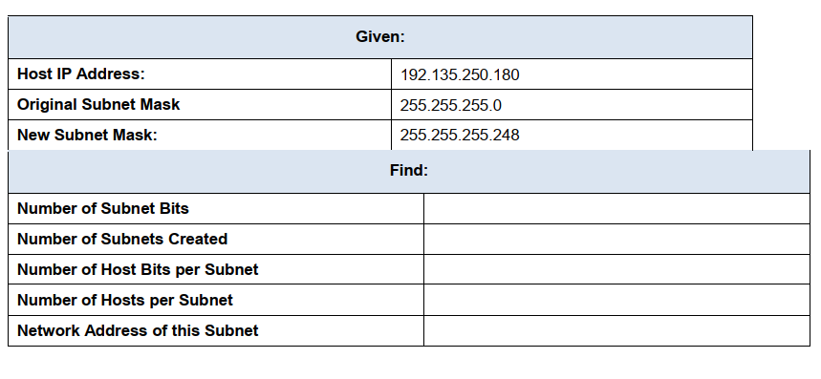

**(đây là câu mình tự thêm vào nên mang tính chất tham khảo là chính, nhưng bạn vẫn nên đọc hết cách làm của nó nhé)**

**Answer:**

**Number of subnet bits:**

Original Subnet Mask: 255.255.255.0 (24 bit-1s)

New Subnet Mask: 255.255.255.248 (29 bit-1s)

Number of Subnet bits: 5 (29 - 24)

**Number of subnet created:**

2number of subnet bits = 25 = 32

**Number of host bits per subnets**

32 – (number of network bits) – (number of subnet bits)

= 32 – 24 – 5 = 3

**Number of hosts per subnet**

2Host bits - 2= 23 - 2 = 6 (-2: Network address, Broadcast address)

**Network Address of this Subnet**

11000000.10000111.11111010.10110100 **(Host IP Address)**

11111111.11111111.11111111.11111000 **(New Subnet mask)**

(Host IP Address) AND (New Subnet mask)

* 11000000.10000111.11111010.10110000 = 192.135.250.176

Câu 21:

Suppose an application layer entity wants to send an L-byte message to its peer process, using an existing TCP connection. The TCP segment consists of the message plus 20 bytes of header. The segment is encapsulated into an IP packet that has an additional 20 bytes of header. The IP packet in turn goes inside an Ethernet frame that has 18 bytes of header and trailer. What percentage of the transmitted bits in the physical layer correspond to message information, if L = 100 bytes, 500 bytes, 1000 bytes.

(câu này thì bạn chú ý xem kỹ số liệu và đọc kỹ đề là được bạn nhé)

Anwser: Because the message overhead includes – TCP’s header: 20 bytes; IP packet’s header: 20 bytes and Ethernet frame’s header and trailer: 18 bytes.

Therefore, if an message consists of L byte length so that the total bytes of that message now is L + 20 + 20 + 18 = L + 58.

The percentage of the transmitted bits in the physical layer correspond to message information is p = [L/(L+58)]*100.

When :

+ L = 100 bytes 🡪 p ≈ 63.29%.

+ L = 500 bytes 🡪 p ≈ 89.61%.

+ L = 1000 bytes 🡪 p ≈ 94.52%.

Câu 22:

Consider the three-way handshake in TCP connection setup.

1. Suppose that an old SYN segment from station A arrives at station B, requesting a TCP connection. Explain how the three-way handshake procedure ensures that the connection is rejected.
2. Now suppose that an old SYN segment from station A arrives at station B, followed a bit later by an old ACK segment from A to a SYN segment from B. Is this connection

**Answer:**

a) In three-way handshake, to identify which connection is rejected or accepted, the initial sequence number is always unique. If B receives an old SYN segment form A, B will acknowledged the request base old sequence number. When A receives the acknowledge message from B, A will know B used the wrong initial sequence number and discard it then reset the connection.

b) First of all, B recieves an old SYN segment, B will send a SYN segment with its own unique sequence number set by B. If B receives the old ACK from A, B will inform A that the connection is invalid since the old ACK sequence numbers does not match the sequence number previously defined by B. Therefore, the connection is rejected.

Câu 23:

Suppose a header consists of four 16-bit words: (11111111 11111111, 11111111 00000000, 11110000 11110000, 11000000 11000000). Find the Internet checksum for this code.

trong câu này các bạn bấm máy tính nhé, bạn chuyển qua dạng chuyển đổi và tập trung vào binary giùm mình thôi nhé (cách chuyển đổi mình đã ghi ở câu 18), ở đây là checksum nên bạn cứ cộng hết vào cho mình, sau đó bạn sẽ ra đáp á giống như hình bên dưới, bạn chú ý giùm mình 2 dòng cuối nhé, khi cộng xong bạn cứ ghi hết tất cả các bit ra cho mình (giống như mình trình bày ở trong bài), bài này chỉ cho 16 bit nên bạn đếm từ cuối chuỗi đến con số thứ 16 là bạn dừng và lấy các con số đó, các số trước đó (carry bit – số mà mình bôi đỏ trong bài) thì bạn giữ lại (ko được tự ý bỏ đi) rồi tiếp tục cộng với chuỗi hiện tại. Để chắc cú thì bạn hãy bấm máy tính giùm mình nhé.

Tiếp đến, để tìm Internet checksum thì nó chỉ đơn giản là 1’s complement hay hiểu đơn giản là lật ngược chuỗi 🡪 0 đổi thành 1 và 1 đổi thành 0. Ví dụ: 1010 🡪 đổi thành 0101, 1001 🡪 0110.

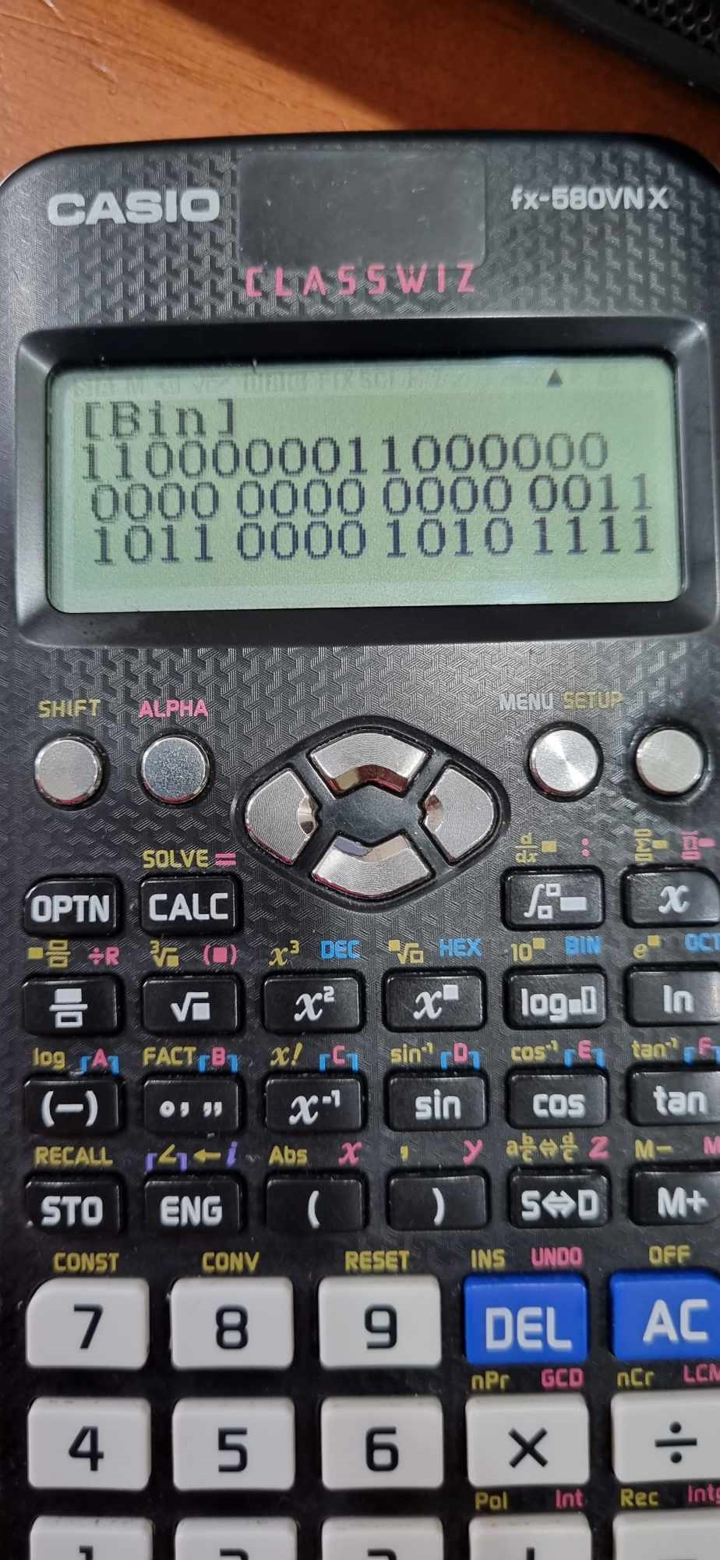

**Answer:**

11111111 11111111

+

11111111 00000000

+

11110000 11110000

+

11000000 11000000

-------------------------

1110110000 10101111

(here we have 11 is a carry-bit, so to maintain the bit string is 16 bit length, we need to add 11 to the current bit string 10110000 10101111). Let’s continue with the sum calculate:

10110000 10101111

+

11

-------------------------

10110000 10110010

And now to find the Internet checksum, we need to use 1’s complement for the above bit string.

10110000 10110010

1’s complement: 01001111 01001101

* So the Internet Checksum is: 01001111 01001101

Câu 24:

Consider the 7-bit generator, G=10011, , and suppose that D has the value 1001010101. What is the value of R? Show your all steps to have result.

(câu này giống như câu 17 bạn nhé) R ở đây là remainder (phần còn lại) bạn nhé, là cái giống mình làm trong bài nhé

G = 10011

D = 1001010101

* step 1: We need to add four 0 at the end of D => 10010101010000
* step 2: Now we divide new D to G

10010101010000 10011

⊕ 1000110000

10011

-------

000011010

⊕

10011

-------

010011

⊕

10011

-------

000000000 => Now we get the remain is : 0000

* So the value of R is 0000.

Câu 25:

Suppose two hosts, A and B, are separated by 20,000 kilometers and are connected by a direct link of R = 2 Mbps. Suppose the propagation speed over the link is 2.5 x 108 meters/sec.

a. Calculate the bandwidth-delay product, R_prop.

b. Consider sending a file of 800,000 bits from Host A to Host B. Suppose the file is sent continuously as one large message. What is the maximum number of bits that will be in the link at any given time?

(câu này công thức mình đã ghi rất chi tiết nên bạn cần chú ý đọc kỹ đề nhé, đối với câu b) thì bạn chỉ cần lấy giá trị của bandwidth-delay product điền vào là được, bài này mình tính ra 160000 bits thì ở câu b) mình đổi đơn vị và ghi thành 160 kilobits).

ANSWER:

distance between A and B: 2*107 m

tranmission rate: R = 2*106 bits/s

propagation delay: 2,5*108 m/s

1. R_dprop = distance / propagation delay = 2*107 / 2,5*108 = 0,08s

bandwidth-delay product = R * R_dprop = 2*106 * 0,08 = 160000 bits

1. Send a file from Host A to Host B: 800000 bits.

When you send a file from A to B, you need to split data into packets, each packets has 160 Kilobits.

Câu 26. (optional question) Sender A wants to send 100111010011011 to receiver B. This transmission uses CRC algorithm for error detection with generator polynomial bits string is 10111. What is bits string will be transmitted on the medium. Show your all steps to have result.

(bài này giống như bài 17 bạn nhé) – đây là câu mình tự thêm vào nên cũng chỉ mang tính chất tham khảo bạn nhé, nhưng bạn vẫn nên đọc để hiểu thêm nhé

First add 0000 to data bits string. It will be 1001110100110110000.

Next, we divide 1001110100110110000 to 10111 to get remainder.

1001110100110110000 10111

⊕

101010001000110

10111

-------

0010010

⊕

10111

-------

0010110

⊕

10111

-------

000010110

⊕

10111

--------

000011100

⊕

10111

-------

010110

⊕

10111

-------

000010

And here, we have our remainder is 10, but we need 4 bit string so it need to be 0010 🡪 FCS is 0010

Therefore, transmitted bits string is 1001110100110110010.