**Basic: (5 points)**

You are given a NetBeans template project (read more detail in the first page).

You are asked to build a web application using the given database.

User can type **/show** (/ represents your web application context path)to access Show Instructors Page (**0.5 point**).

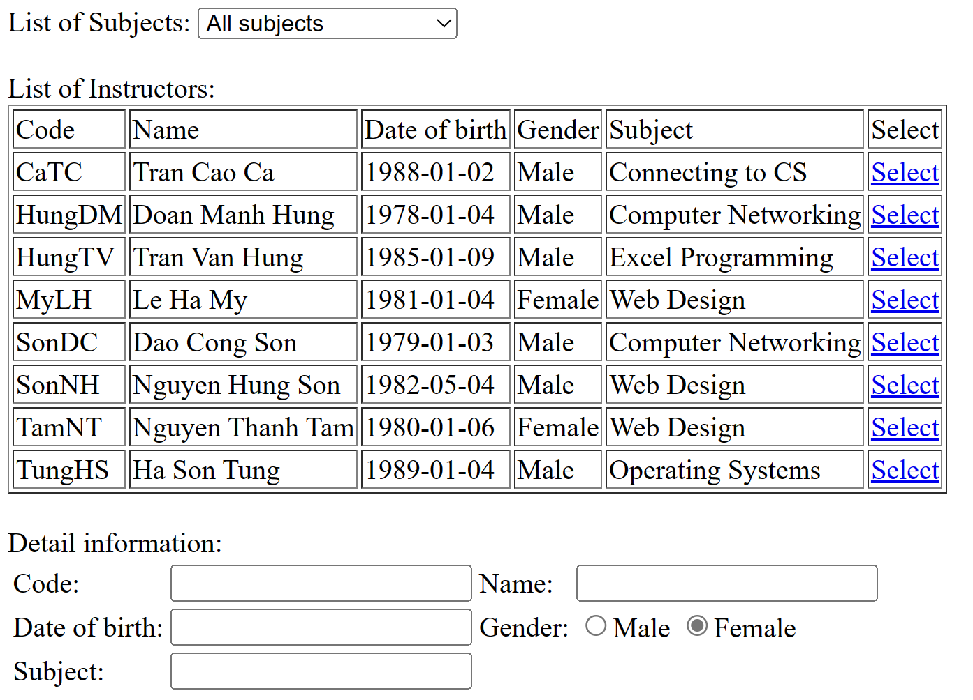

* The Subjects dropdown list must load data from [Subjects] table. (**1 point**)

**Reduce 1 point** if cannot display subjects (including All subjects option) to the dropdownlist.

* The table “List of Instructors” must load data from [Instructors] table. (**1 point**)

**Reduce 1 point** if cannot display instructors correctly to the table.

* When user selects a subject in [Subjects] dropdownlist, the list of Instructors that teach that subject will be displayed in the Table. (**1 point**)

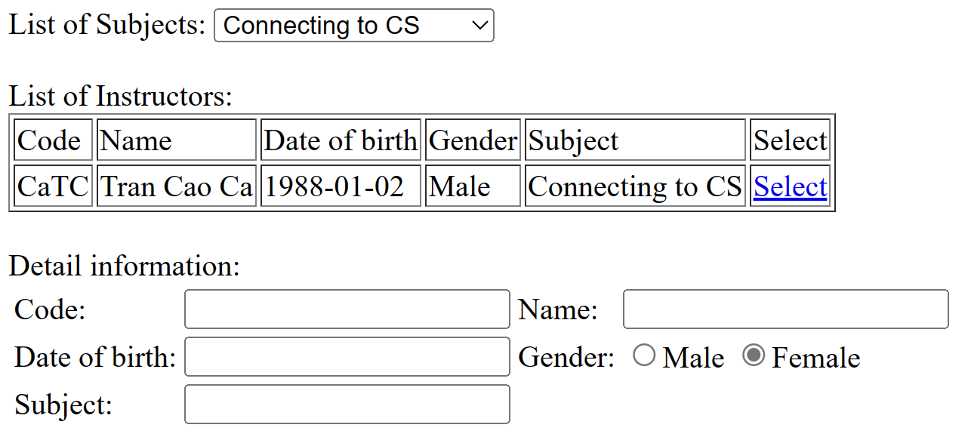

* When user clicks [Select] link, the Instructor information will be displayed in the Detail Information (**1.5 point**)

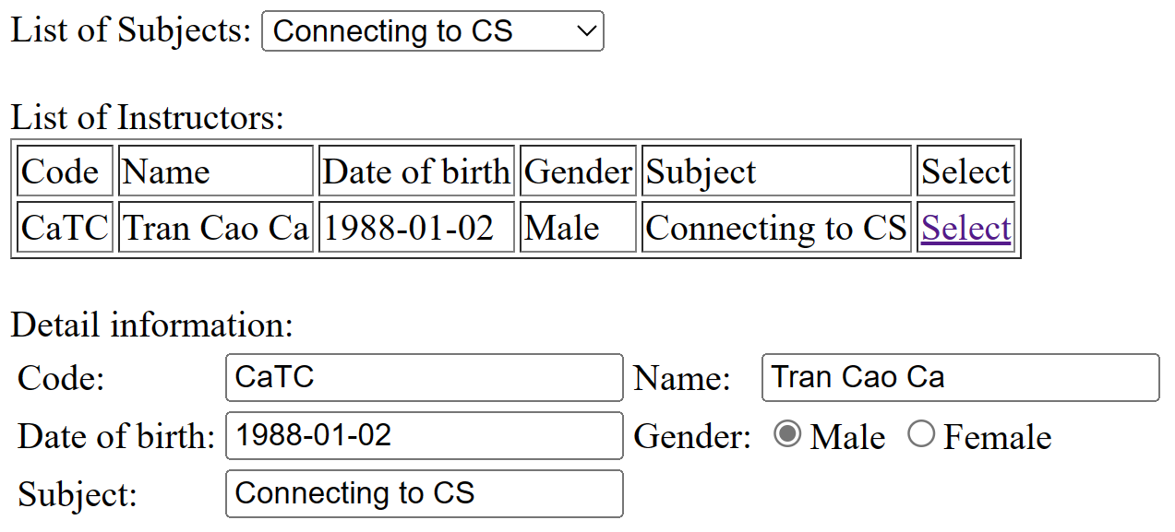

**Basic: (5 points)**

User can type **/students** (/ represents your web application context path)to access Show Students Page with these columns: StudentID, StudentName, BirthDate, Age, Gender, SubjectName, Modify (Edit, Delete) and a Create button to add a student to DB.

+ Contruct CRUD Operations with students (1 points).

+ Validate data when create or edit a student(2 points):

* StudentID must have 7 characters.
* Student's age is greater than 18 years old.
* The BirthDate is in YYYY-MM-dd format
* Show notification when the user enters the incorrect format.

+ Filter students with Gender (1 point)

+ Sort students with StudentID or Age (1 point)