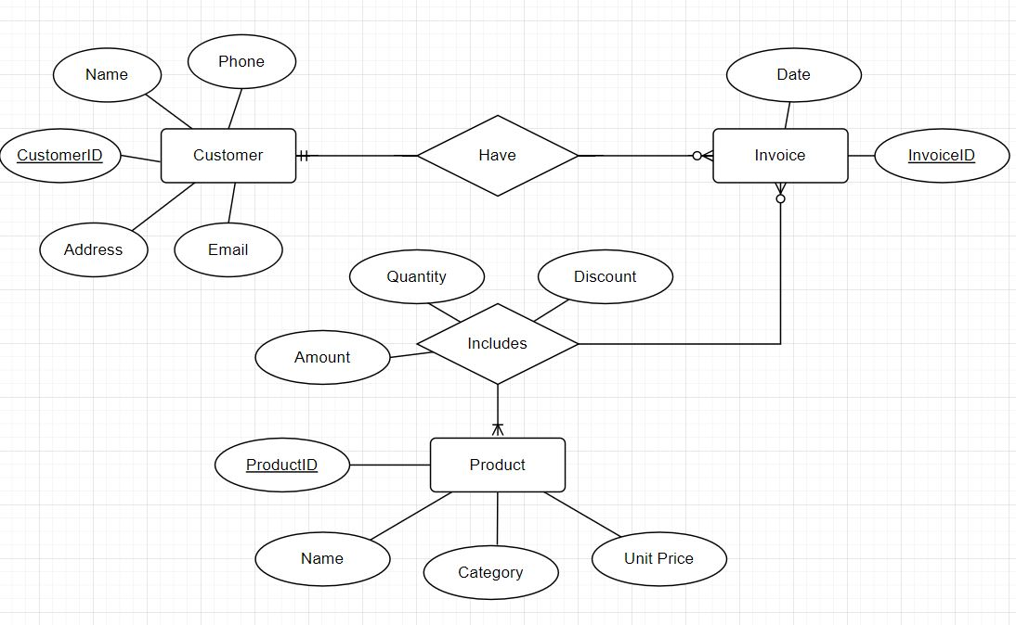a)

b) Convert from ER diagram to relational schema.

CREATE TABLE Customer(

CustomerID int IDENTITY(1,1) PRIMARY KEY,

Name nvarchar(100) NOT NULL,

Phone nvarchar(15) NOT NULL

Email nvarchar(100) NOT NULL

Address nvarchar(255) NOT NULL

);

CREATE TABLE Invoice (

InvoiceID nvarchar(50) PRIMARY KEY,

Date DATETIME NOT NULL,

CustomerID int,

CONSTRAINT FK_CustomerInvoice FOREIGN KEY (CustomerID)  
    REFERENCES Customer(CustomerID)

);

CREATE TABLE Product(

ProductID INT IDENTITY(1,1) PRIMARY KEY,

Name nvarchar(100) NOT NULL,

Category nvarchar(50) NOT NULL,

UnitPrice DECIMAL(20, 3)

);

CREATE TABLE InvoiceDetail(

InvoiceID INT NOT NULL,

ProductID INT NOT NULL,

Quantity int NOT NULL,

Discount DECIMAL(5,2) DEFAULT 0,

Amount DECIMAL(18,3),

PRIMARY KEY (InvoiceID, ProductID),

CONSTRAINT FK_DetailProduct FOREIGN KEY (ProductID)  
    REFERENCES Product(ProductID),

CONSTRAINT FK_DetailInvoice FOREIGN KEY (InvoiceID)  
    REFERENCES Invoice(InvoiceID)

);