Exercises Pointer
A. Lý thuyết
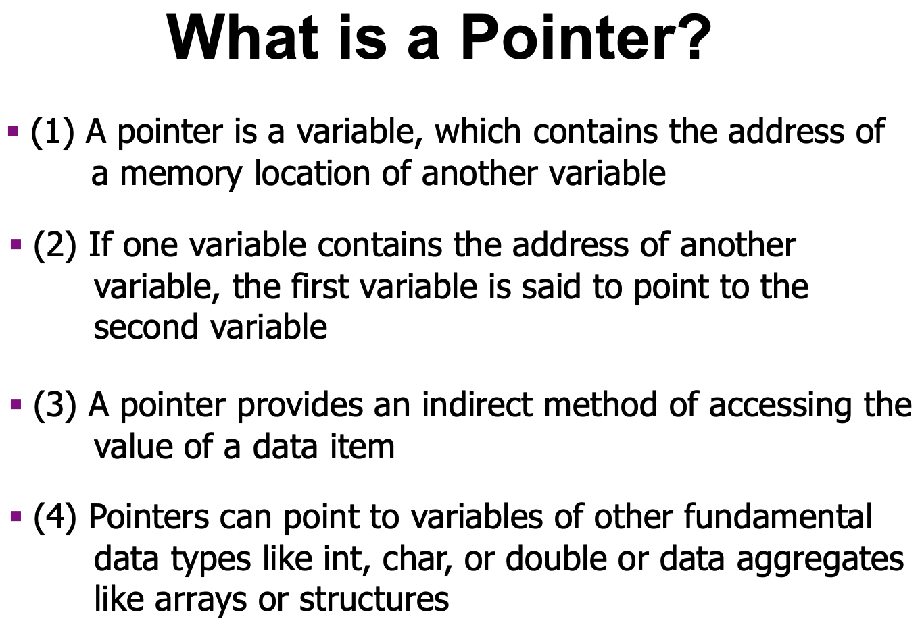

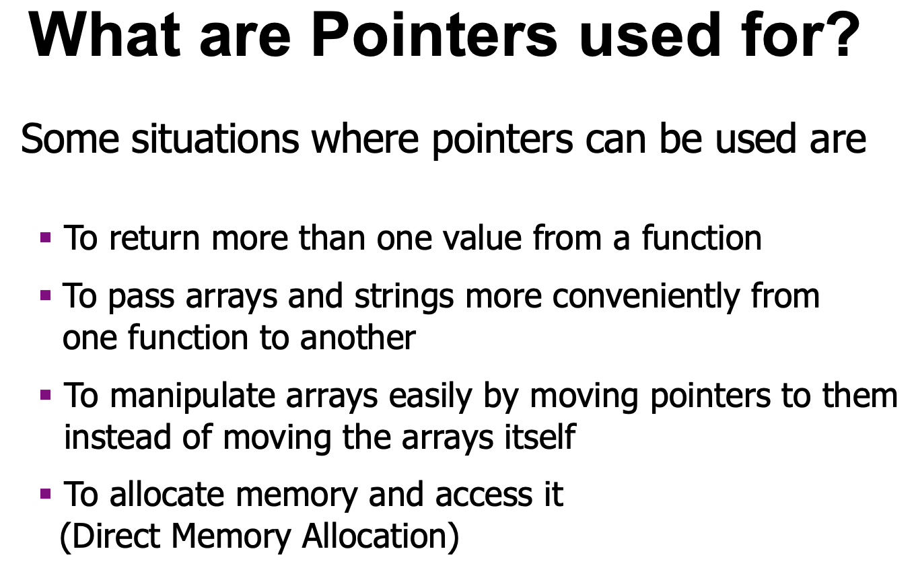

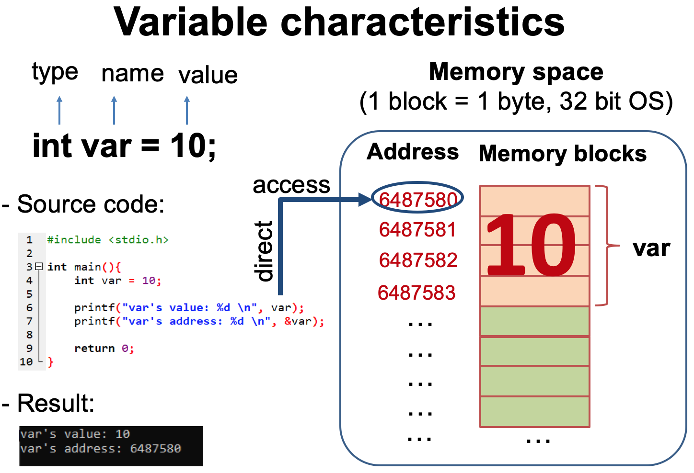

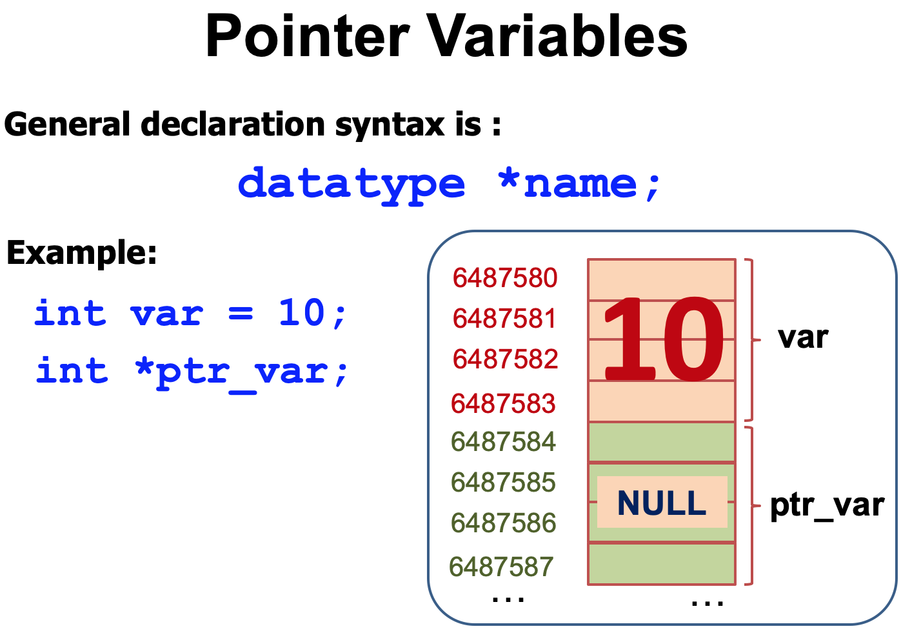

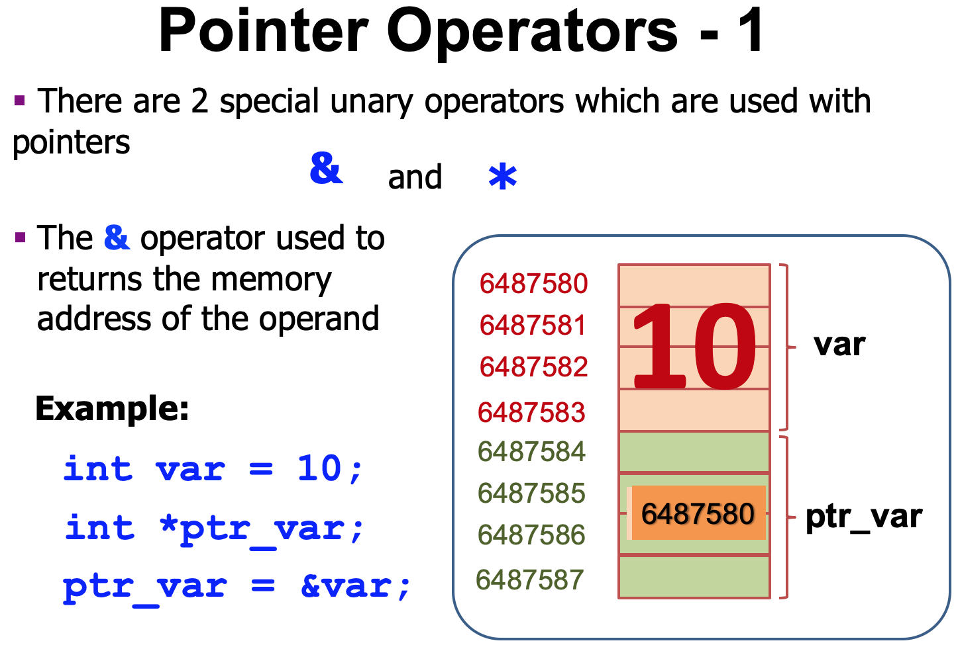

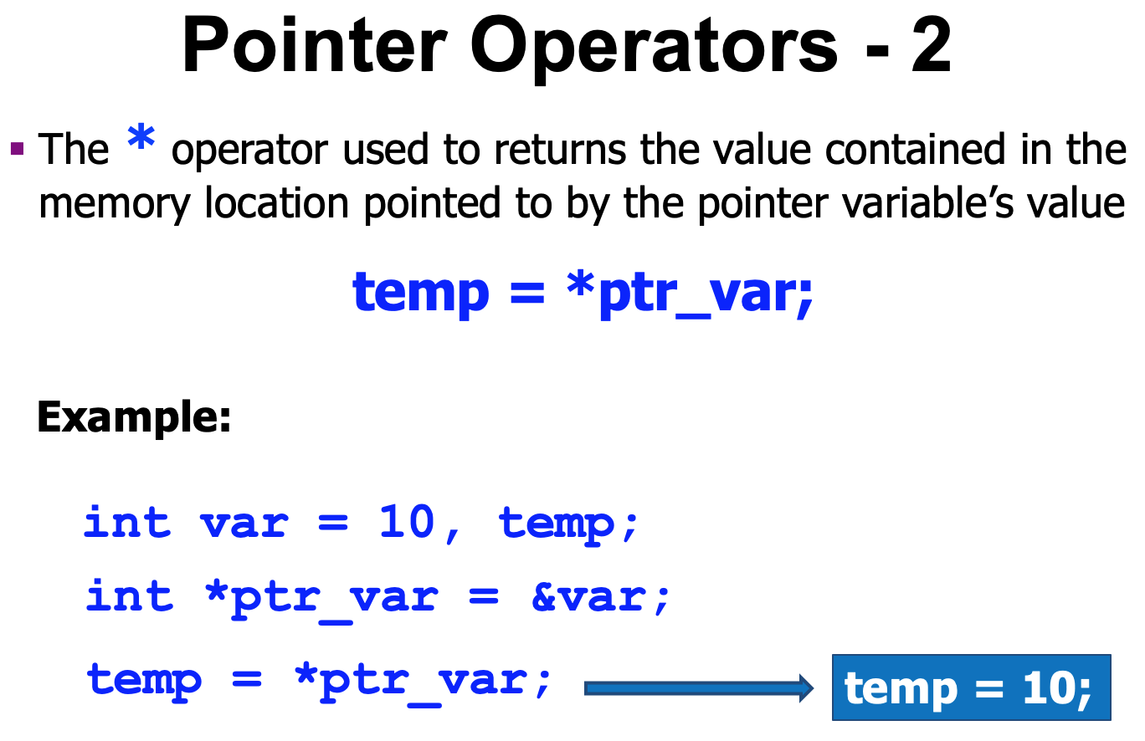

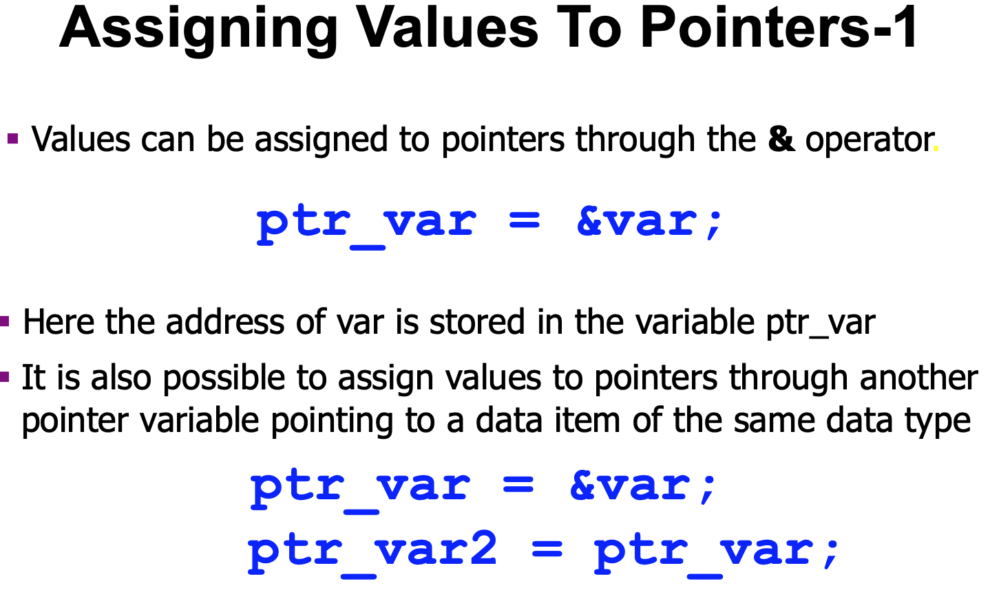

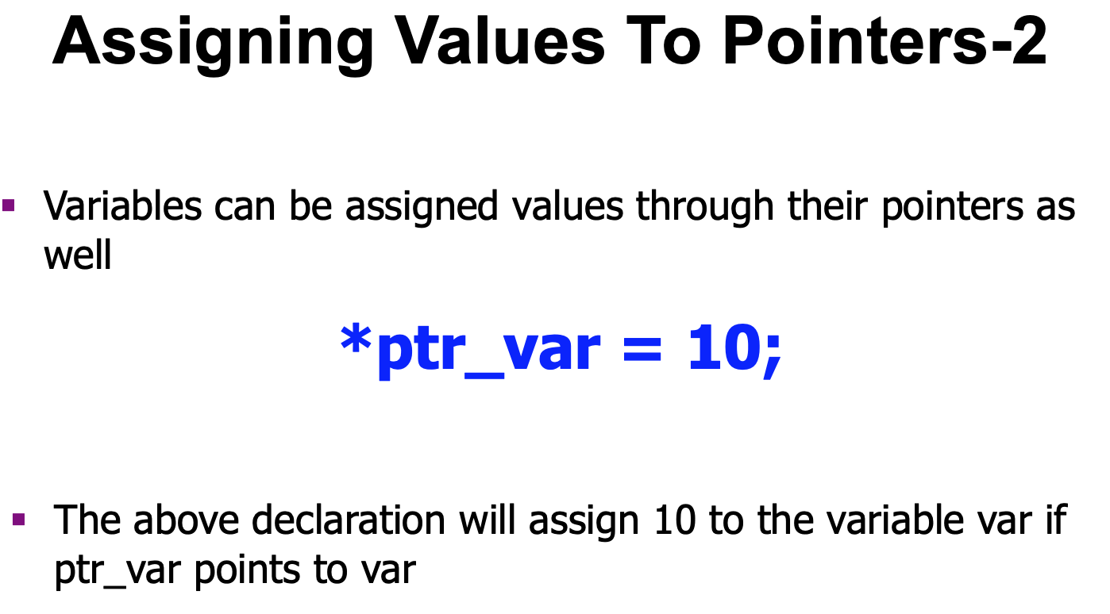

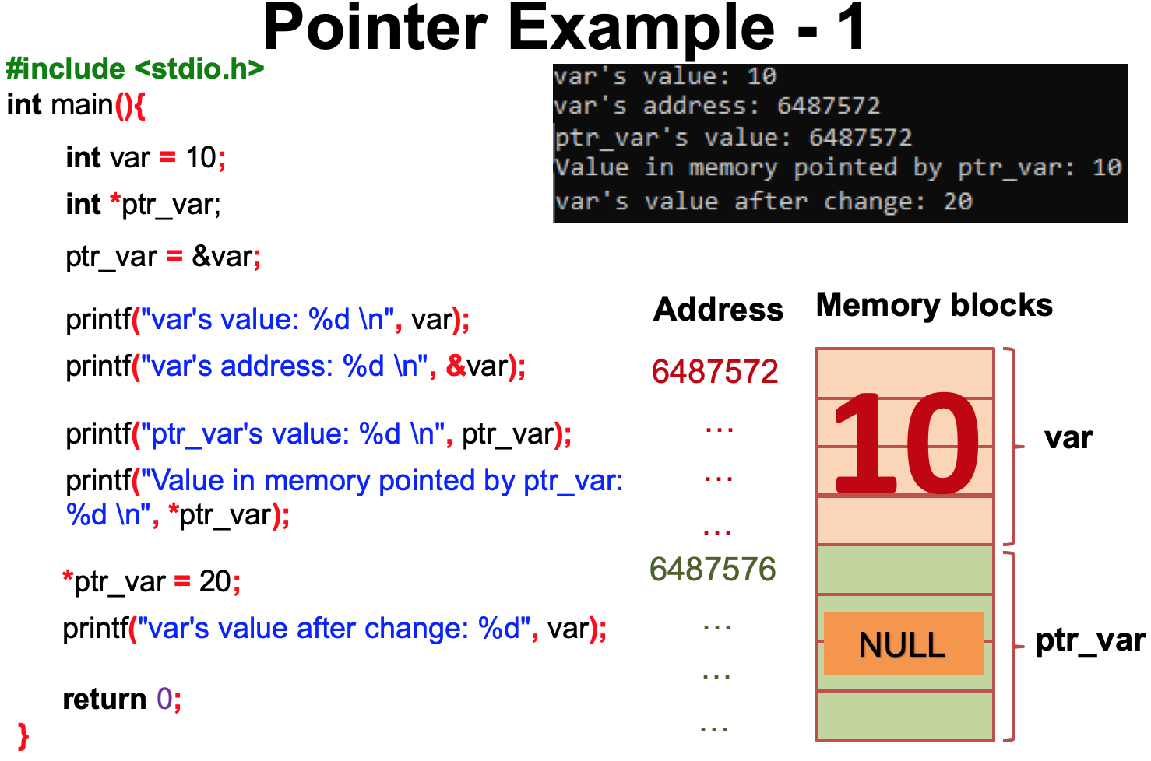

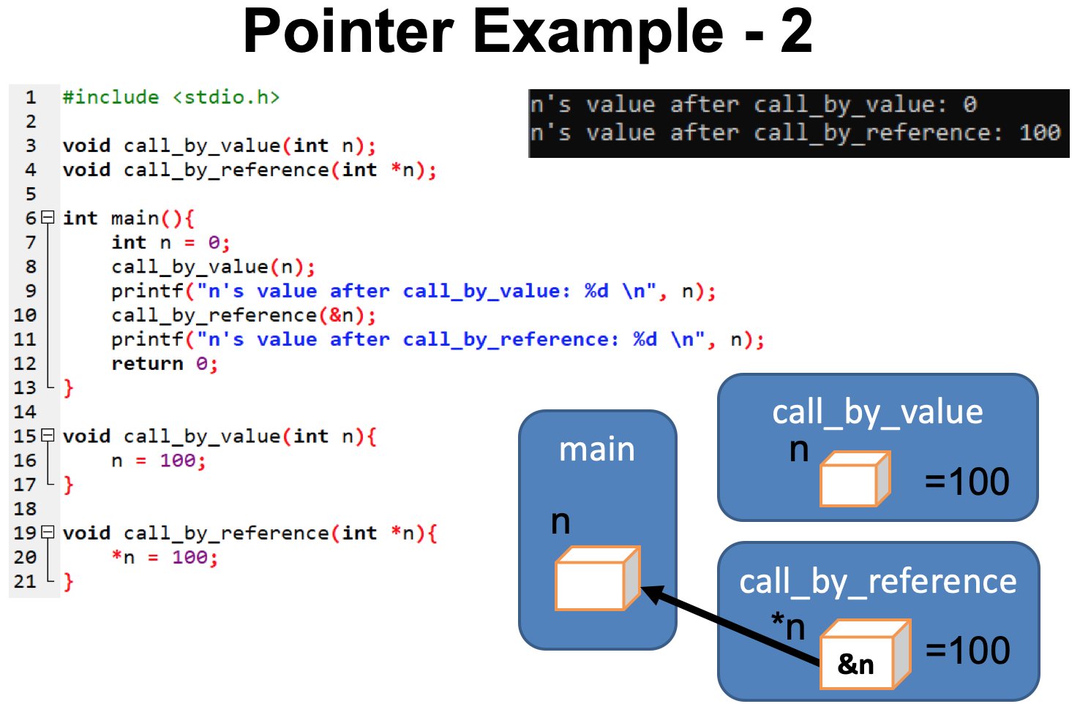

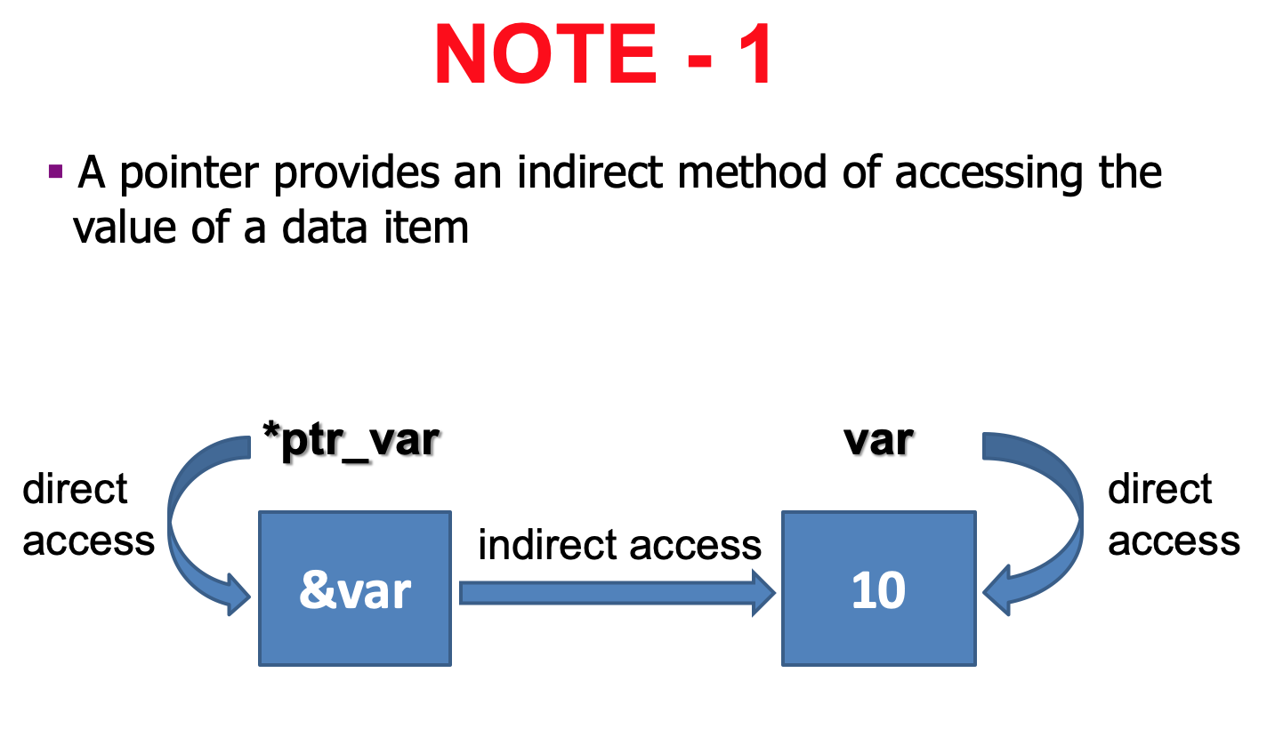

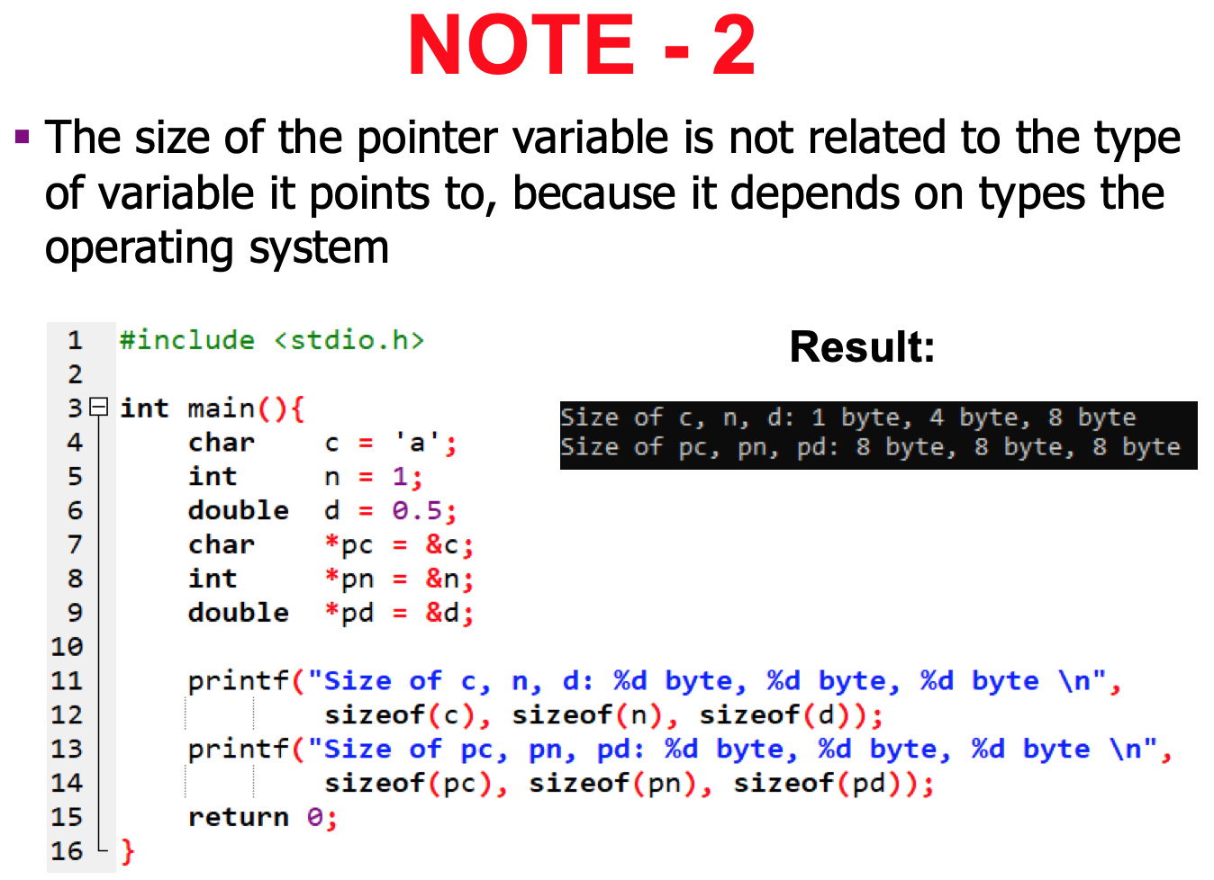

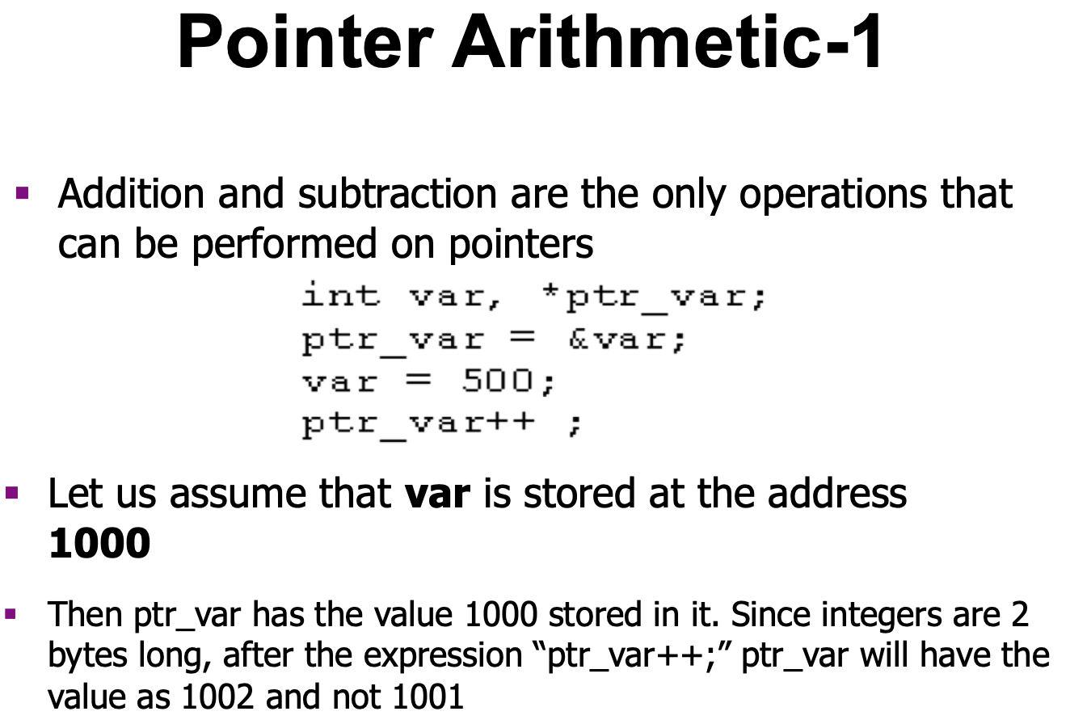

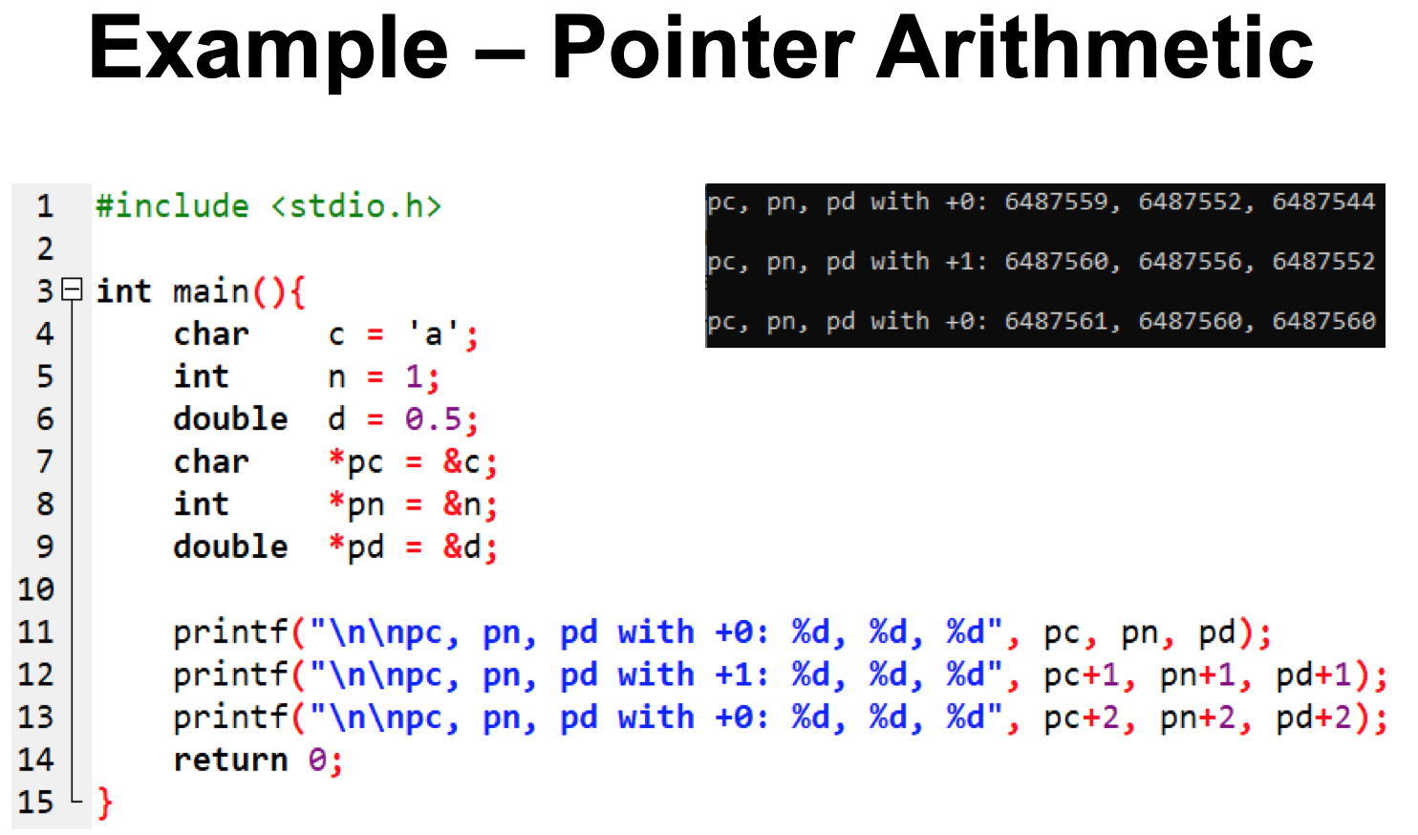

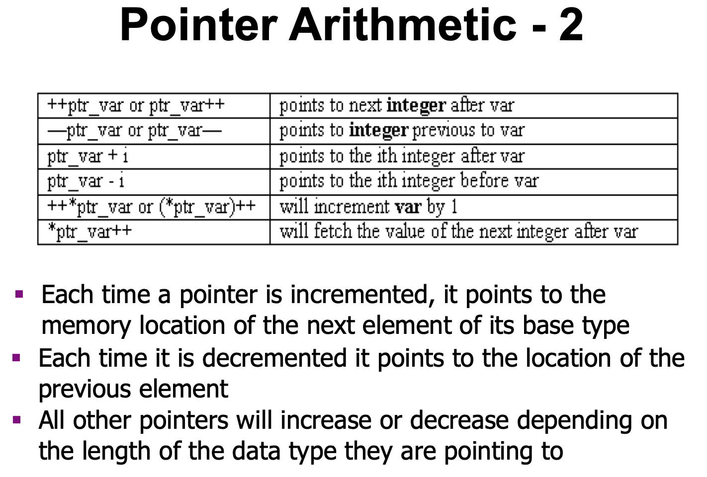

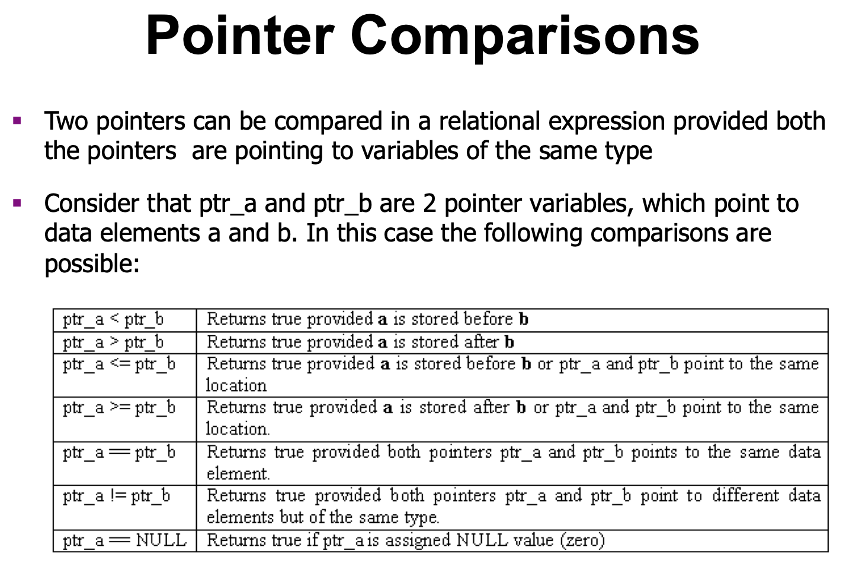

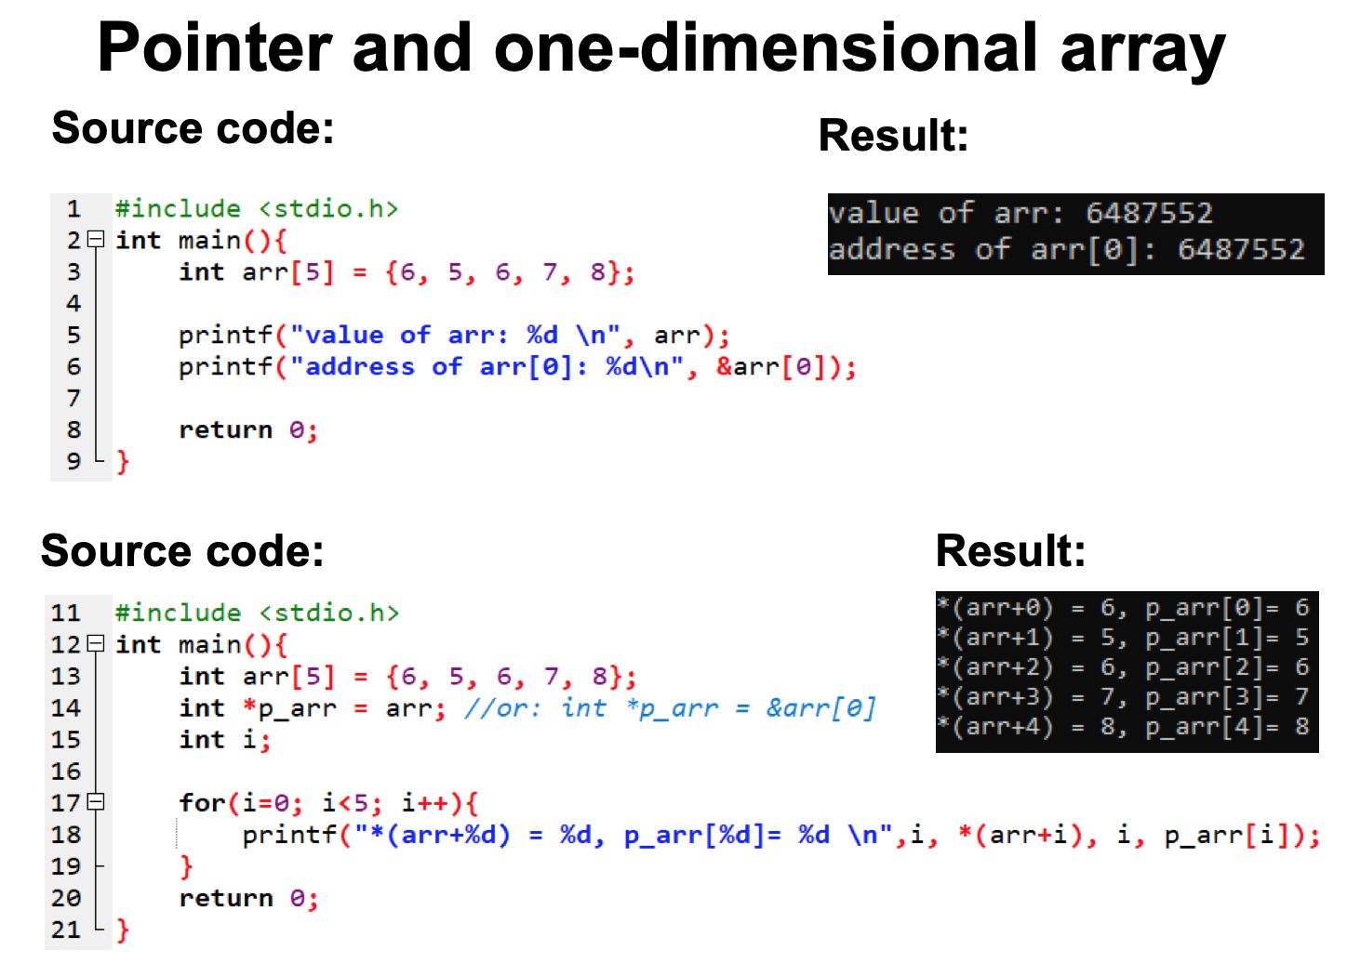

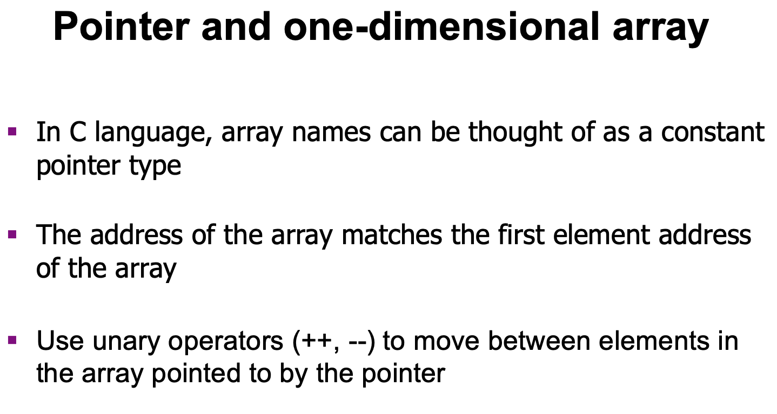

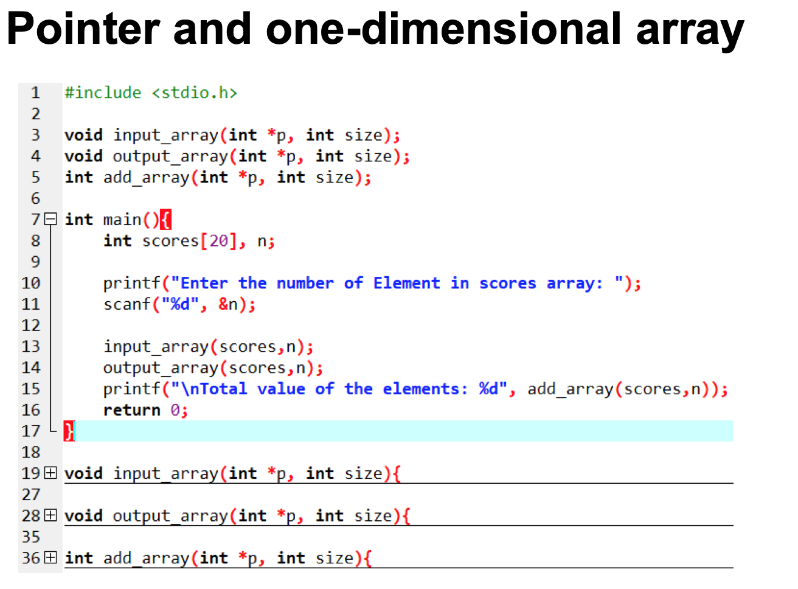

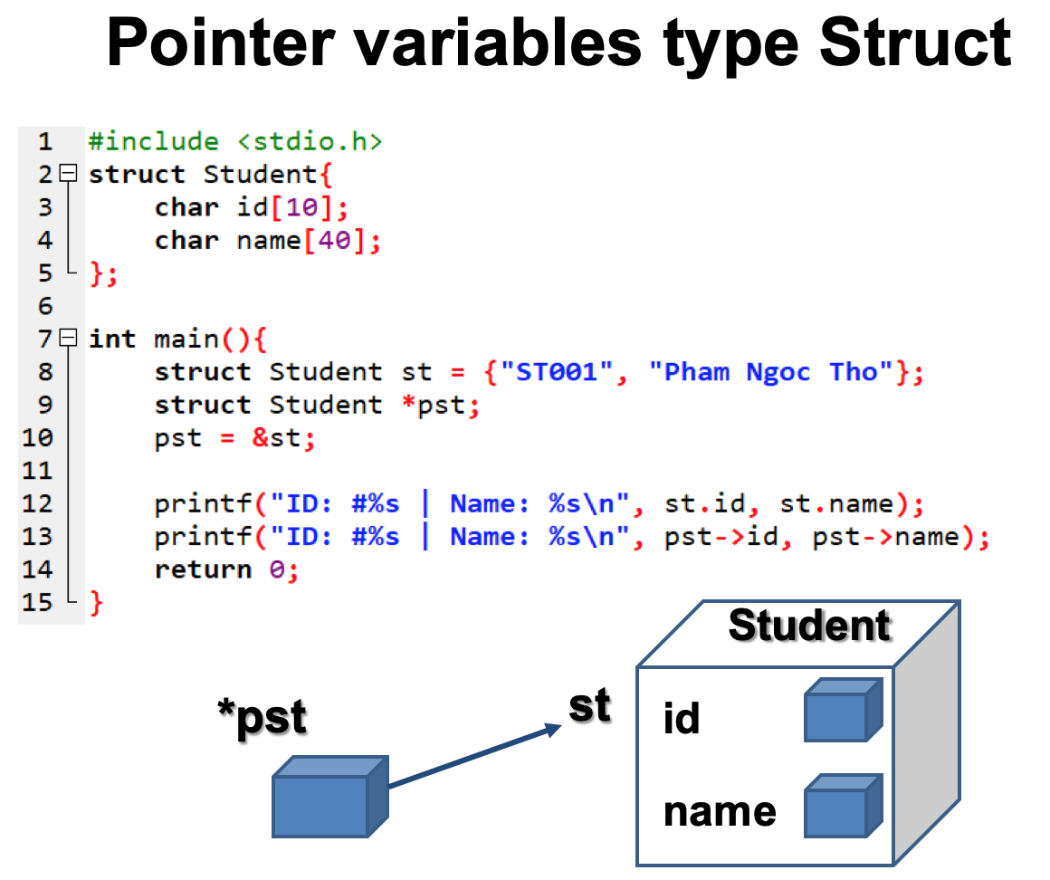

B. Bài tập
Ex1.
Write a short C program that declares and initializes (to any value you like) a double, an int, and a char. Next declare and initialize a pointer to each of the three variables. Your program should then print the address of, and value stored in, and the memory size (in bytes) of each of the six variables.

Use the “0x%x” formatting specifier to print addresses in hexadecimal. You should see addresses that look something like this: "0xbfe55918". The initial characters "0x" tell you that hexadecimal notation is being used; the remainder of the digits give the address itself.

Use “%f” to print a floating value. Use the memory size allocated for each variable.
sizeof operator to determine the

-----
Sample output:

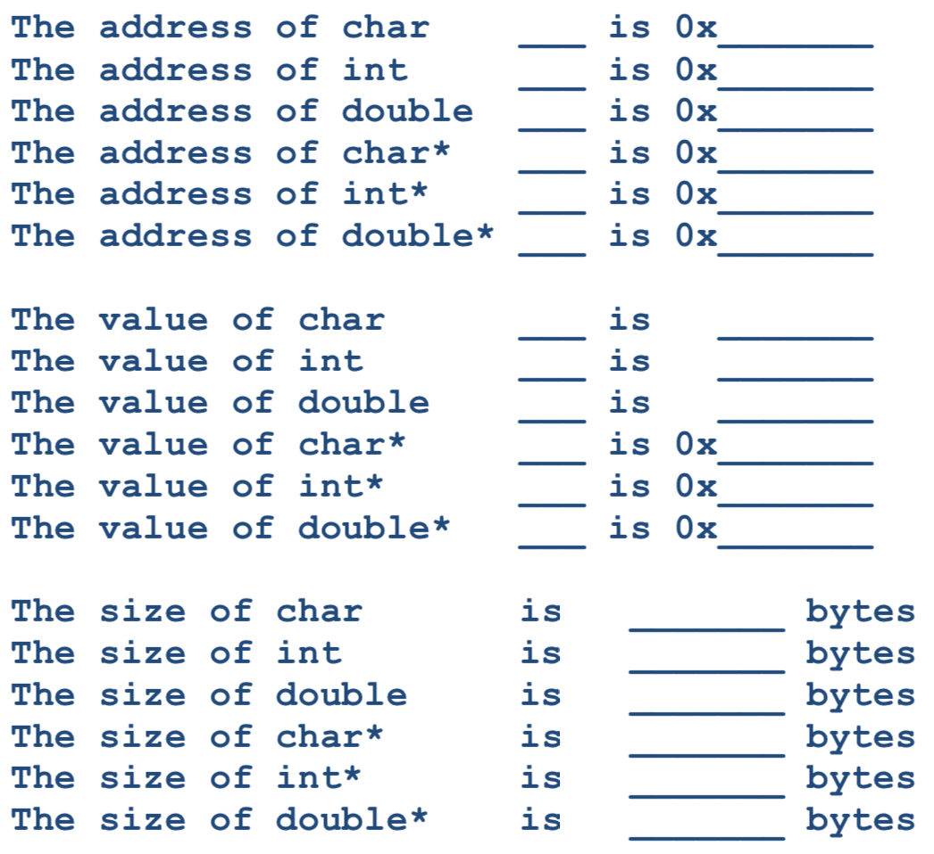

EX2.
Write a program in C to demonstrate how to handle the pointers in the program

-----
Pictorial Presentation:

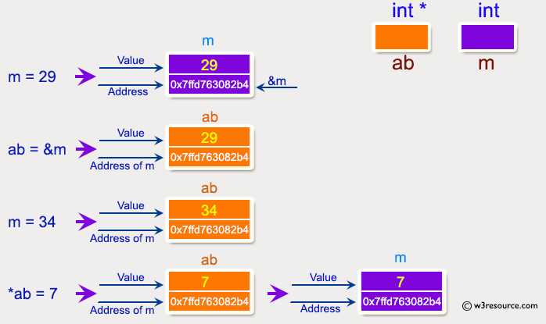

-----
Expected output:

Address of m : 0x7ffcc3ad291c
Value of m : 29
Now ab is assigned with the address of m.
Address of pointer ab : 0x7ffcc3ad291c
Content of pointer ab : 29
The value of m assigned to 34 now.
Address of pointer ab : 0x7ffcc3ad291c
Content of pointer ab : 34
The pointer variable ab is assigned with the value 7 now.
Address of m : 0x7ffcc3ad291c
Value of m : 7

Ex3.
swap_nums seems to work, but not swap_pointers. Fix it.

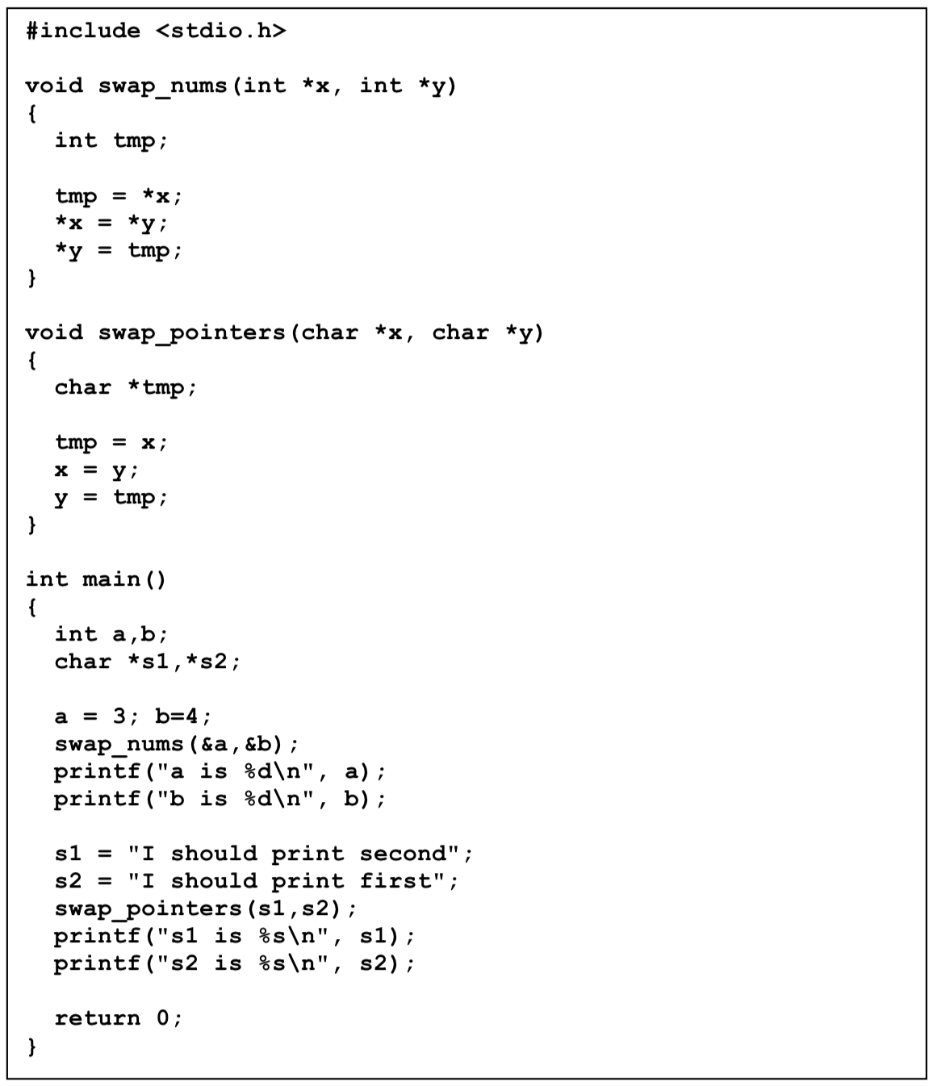

Ex4.
Write a program in C to add numbers using call by reference

-----
Pictorial Presentation:

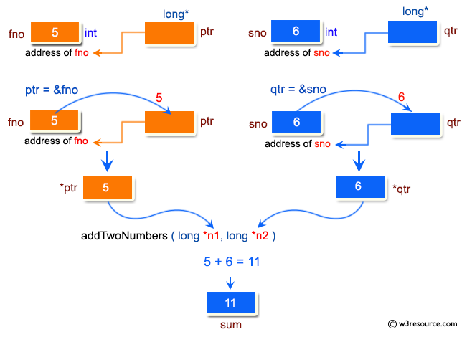

-----
Sample output:

Pointer : Add two numbers using call by reference:
-------------------------------------------------------
Input the first number : 5
Input the second number : 6
The sum of 5 and 6 is 11

EX5.
Write a program, use the pointer to enter a sequence of integers consist N element. Ouput to screen:
• Maximum value of the element in array
• Minimum value of the element in array
• Sum the elements in array

