Question 1
What is the height of spanning tree obtained from Wn by the breadth-first search, starting at the central vertex of Wn?
Select one:
a. n-1
b. n
c. None of the other choices is correct
d. 1

Question 2
What is the total weight of the minimum spanning tree produced by the graph below:
Select one:
a. None of the other choices is correct
b. 14
c. 19
d. 16
e. 15

Question 3
Let T be a tree with 1000 vertices. Deleting a vertex and all of its incident edges we obtain 3 trees T1, T2, T3. Assume that the number of edges of T1, T2, T3 form an arithmetic progression with difference 3. Find the number of edges of T3.

Question 4
How many leaves are there in a decision tree representing the sorting of a list of 5 elements? 5!=120

Question 5
Find the value of the prefix expression:
+ - * 4 3 5 2
+ - 12 5 2
+ 7 2
9

Question 6
Count the number of leaves in this tree.

Question 7
Given a message 15 letters A, 17 letters B, 18 letters C, 20 letters D, 30 letters E. Find the length of the bit string when encoding this message by a Huffman coding.

Question 8
What is the position of the letter D when using preorder traversal?

Question 9
Find the inverse Polish notation (postfix) for the expression
((x + y) ↑ 2) * (y - 3 ∕ x) + 4 (Infix)
Select one:
a. x y + 2 y ↑ 3 x ∕ − * 4 +
b. x y + 2 ↑ y 3 x ∕ − * 4 +
c. x y + 2 ↑ y 3 ∕ x− * 4 +
d. x + y 2 ↑ y 3 x ∕ − * 4 +

Question 10
Find the length of the bit string when encoding the message abbcccdddd by a Huffman coding.

Question 11
Find the value of the prefix expression
* + 4 + 4 ↑ 2 8 2

Question 12
Let T be a full 4-ary tree in which all leaves are at level 3. Find the number of vertices of T.
l=4^3
n=(m.l-1)/(m-1)=(4.4^3-1)/3=85
i=(l-1)/(m-1)=(4^3-1)/3=21

Question 13

Draw a binary search tree for the sentence
"mot long tho me kinh cha".
Then find the number of comparisons needed to locate the word "cha".

Question 14
Find the value of the prefix expression
* + 3+ 3 * 3 ↑3 – 3 3 3
27

Question 15
Find the value of the postfix expression
2 6 + 3 * 4 2 - 7 2 * - /
24 -12 /
-2

Question 16
Determine a Huffman coding for the characters
A: 0.45, B: 0.25, C: 0.2, D: 0.1
Select one:
a. A := 0 B:= 1 C:= 10 D:= 11
b. A := 0 B:= 11 C:= 110 D:= 111
c. A := 1 B:= 01 C:= 000 D:= 001
d. A := 0 B:= 11 C:= 01 D:= 00

Question 17
Find the value of the postfix expression

2 6 + 7 * 4 2 + 7 2 * - /
-7

Question 18
Let T be a tree with 1000 vertices. Deleting a vertex and all of its incident edges we obtain 3 trees T1, T2, T3. Assume that the number of edges of T1, T2, T3 form an arithmetic progression with difference 3. Find the number of edges of T1.

Question 19
How many leaves are there in a decision tree representing the sorting of a list of 4 elements?

Question 20

What is the position of the letter D when using preorder traversal? K,B,C,G,E,F,D,.H.I.A
What is the position of the letter D when using in-order traversal? C,B,G,,K,E,H,D,I,F,A
What is the position of the letter D when using postorder traversal? C,G,B,E,H,I,D,A,F,K

Question 21: Use Huffman coding to encode these symbols with given frequencies

A: 0.35 B: 0.2 C: 0.25 D: 0.15 E: 0.05

What is the average number of bits required to encode a character?

Question 22: Give the coding scheme

A: 001, B: 1011, C: 11, D: 0000, E: 0100, F: 011, G: 101001.

Find a and b such that we have a prefix code.

a)
b)

Question 23:
Find the postorder traversal of the tree (trái, phải,gốc)
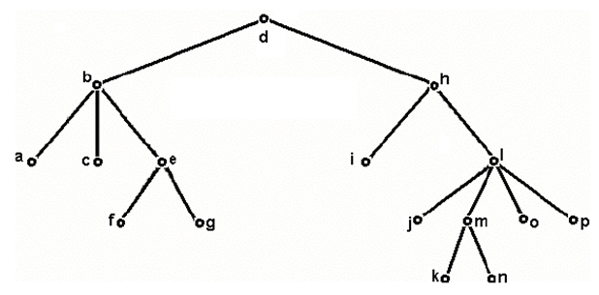
- a - c - f - g - e - b - i - j - k - n - m - o - p - l - h - d
- d - b - a - c - e - f - g - h - i - l - j - m - k - n - o - p
- a - b - c - f - e - g - d - i - h - j - l - k - m - n - o - p
- None of the other choices is correct
PREOEDER: d,b,a,c,e,f,g,h,I,l,j,m,k,n,o,p
In-order: a,b,c,f,e,g,d,I,h,,j,l,k,m,n,o,p

Question 24:
How many edges must be removed from the graph to get a spanning tree?
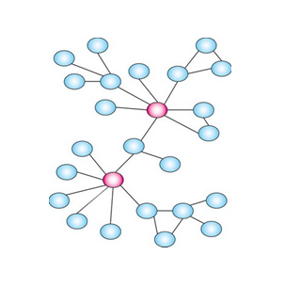
- 1
- 2
- 3
- 4
- None of the other choices is correct.

Câu 25: How many non-isomorphic trees of 4 vertices?
- 4
- None of the other choices is correct
- 3
- 2
- 1
Câu 26: How many edges in a full 3-ary tree with 101 leaves?
- 102
- 150
- None of the other choices is correct
- 101
- 97
N=3.101-1/2=151 => số cạnh=150

