Write a program that performs the following tasks:
- Create a function with variable length of arguments
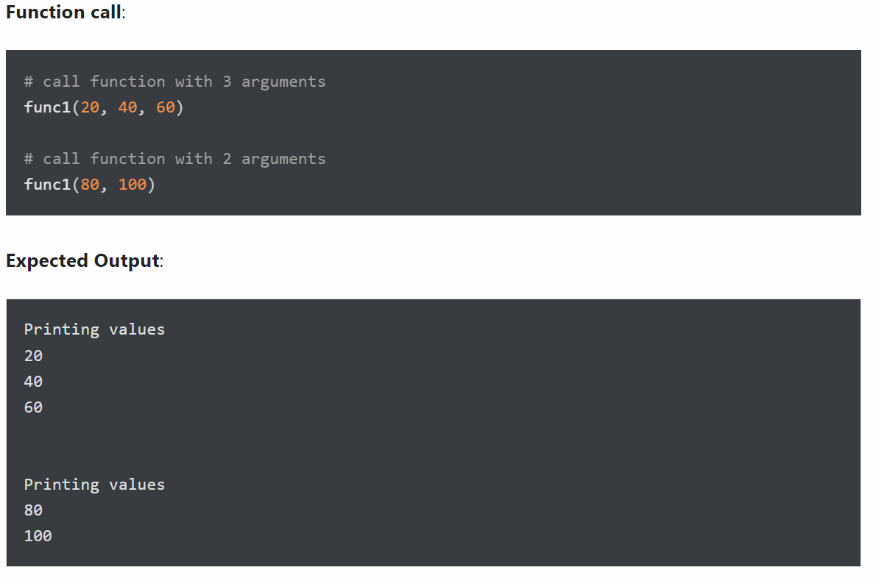
- Return multiple values from a function
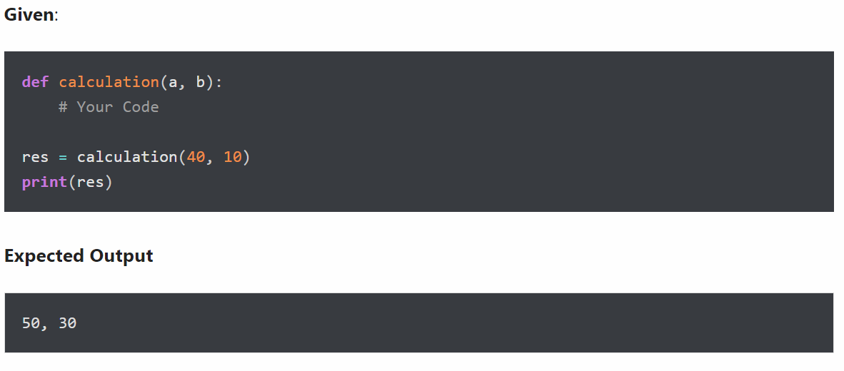
Write a program to accept 2 integer numbers m and n, then:
- Create a function with default argument
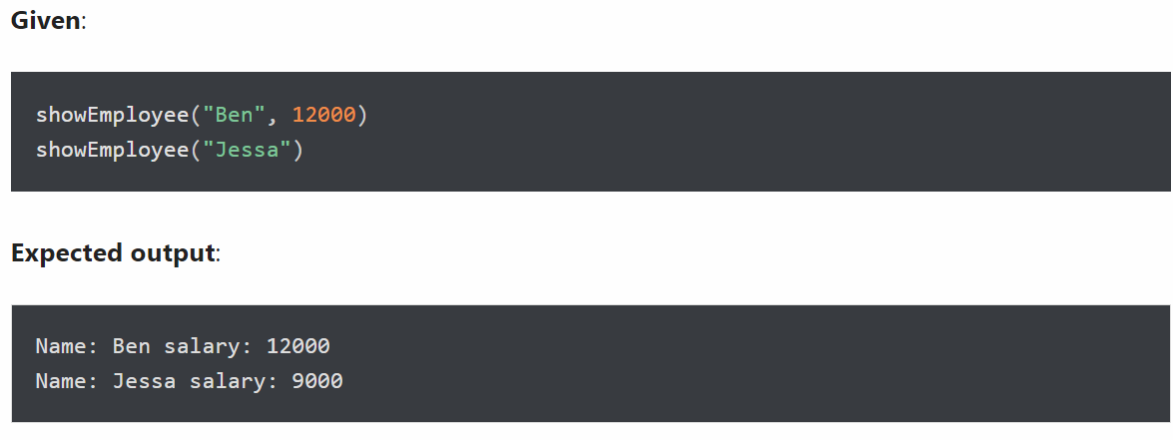
- Create an inner function to calculate the addition in the following way
- Create an outer function that will accept two parameters, a and b
- Create an inner function inside an outer function that will calculate the addition of a and b
- At last, an outer function will add 5 into addition and return it
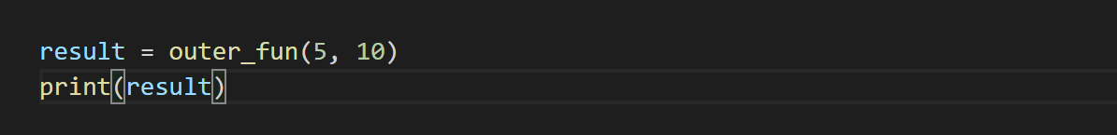

Write a program that performs the following tasks:
- Create a recursive function
Write a program to create a recursive function to calculate the sum of numbers from 0 to 10.
A recursive function is a function that calls itself, again and again.
- Assign a different name to function and call it through the new name
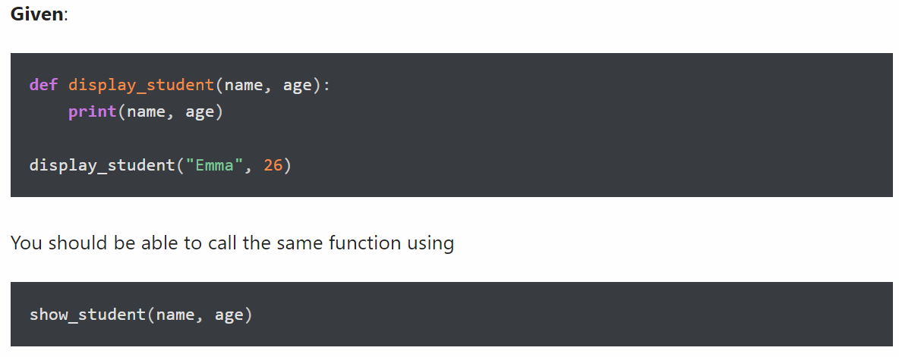
Output:

Write a program that performs the following tasks:
- Check Palindrome Number
A palindrome number is a number that is same after reverse. For example 545, is the palindrome numbers
- Find the largest item from a given list
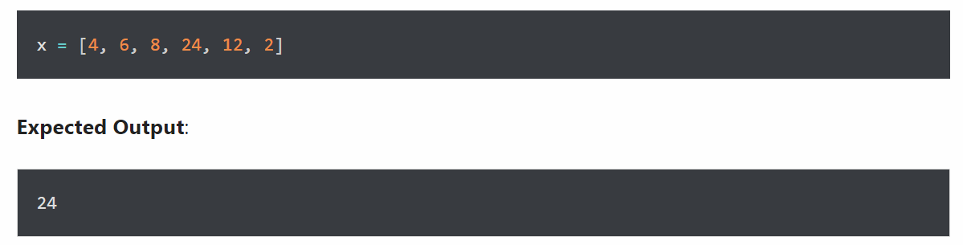
Write a program that performs the following tasks:
- Input an integer number n, where n > 5 (If n≤ 5 then prompt a user to re-enter). Then calculate
- S1 = 1 + 2 + 3 + ... + n.
- S2 = n!
- S3 =1+++...+.
- Re-input n. Check whether n is a prime number or not.

Write a program to accept 2 integer numbers m and n, then:
- Display all common prime dividers of them.
- Find the greatest common divider (GCD) of them.
- Find the least common multiple (LCM) of them.

Write a program that performs the following tasks:
- Input an integer number n (check input validation), then
- Display n in binary number format.
- Re-input n (not check input validation). Calculate the sum of all digits of n.
- Find the number m, which is the reverse of n.

Write a program
to accept 2 integer numbers m and n, where m < n then
Display all palindrom numbers in the interval [m.n]. (A palindromic number or numeral palindrome is a number that remains the same when its digits are reversed, e.g. 16461)

Questions 1

Print the following pattern
Write a program to print the following number pattern using a loop.
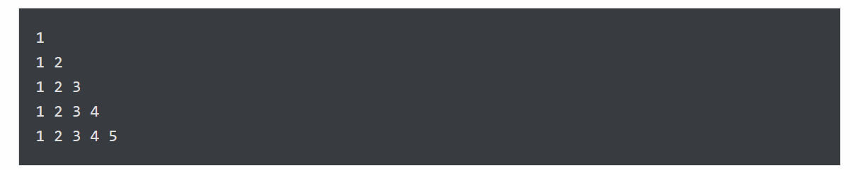
- Calculate the sum of all numbers from 1 to a given number
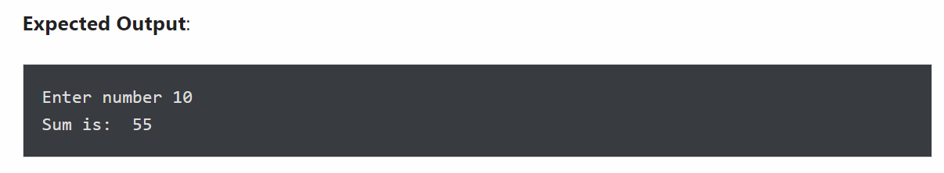

Write a program that performs the following tasks:
- Display numbers from a list using loop
- The number must be divisible by five
- If the number is greater than 150, then skip it and move to the next number
- If the number is greater than 500, then stop the loop
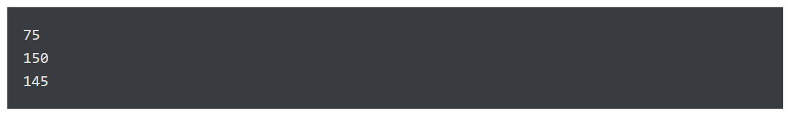
- Count the total number of digits in a number
- Print list in reverse order using a loop
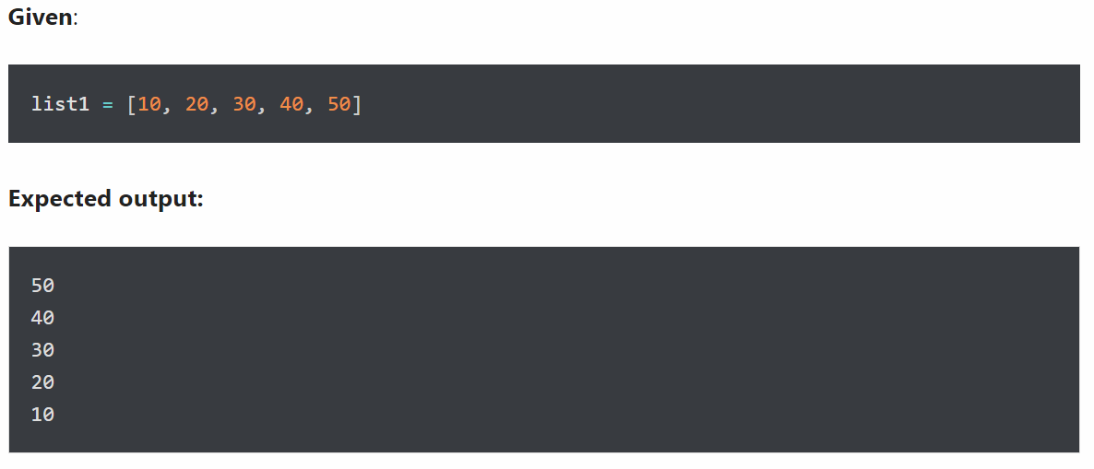

Write a program that create a mixed String using the following rules:
- Create a string made of the middle four characters.
Output:
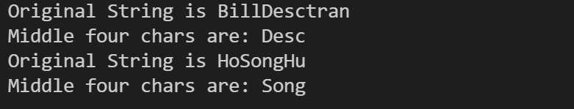
- Append new string in the middle of a given string
Given two strings, s1 and s2. Write a program to create a new string s3 by appending s2 in the middle of s1.
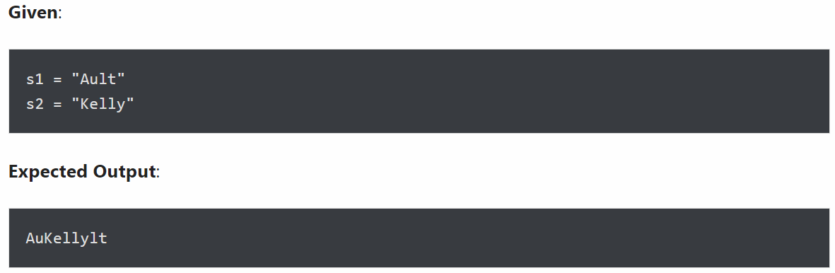
- Create a new string made of the first, middle, and last characters of each input string
Given two strings, s1 and s2, write a program to return a new string made of s1 and s2’s first, middle, and last characters.
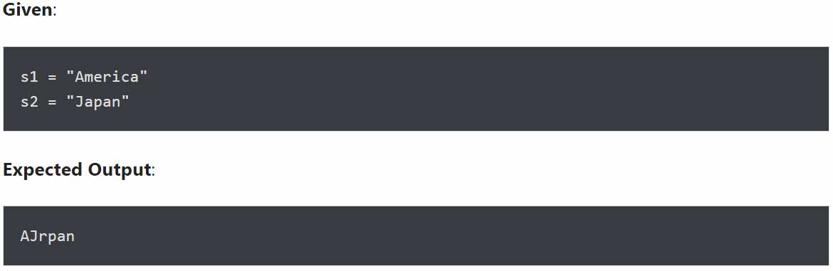
- Arrange string characters such that lowercase letters should come first
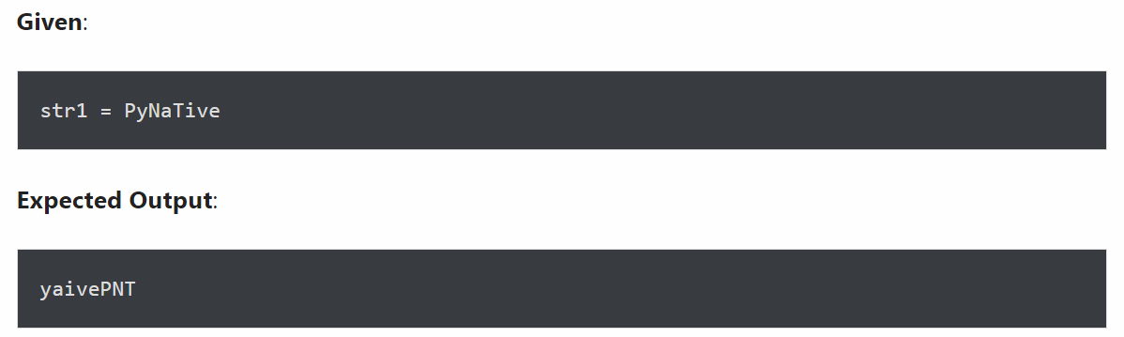
- Count all letters, digits, and special symbols from a given string
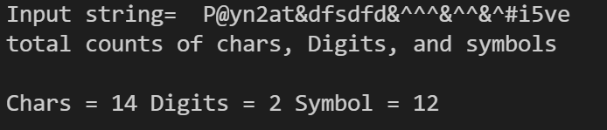
Write a program that performs the following tasks:
- Removal all characters from a string except integers
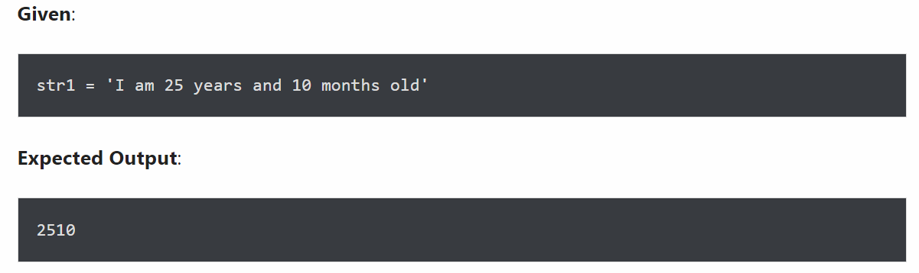
- Remove special symbols / punctuation from a string
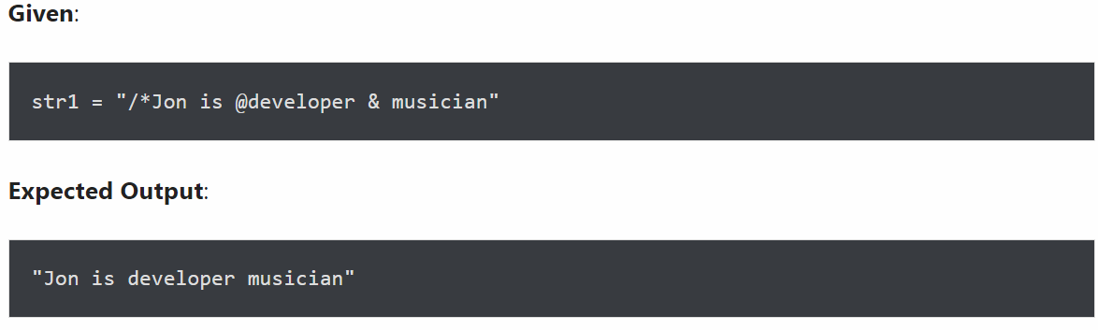
- Remove empty strings from a list of strings
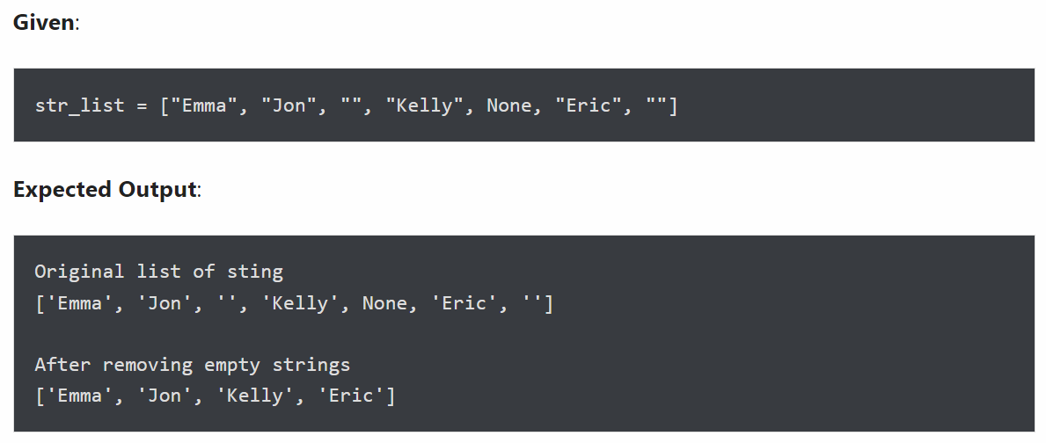
- Split a string on hyphens
