LAB5&6

- You are provided with one file containing data named: database.json in the given directory.
- You must use the solution provided (resource folder) in given folder and install the additional library included in the accompanying request.
Exam results:
- URL: http://localhost:3000
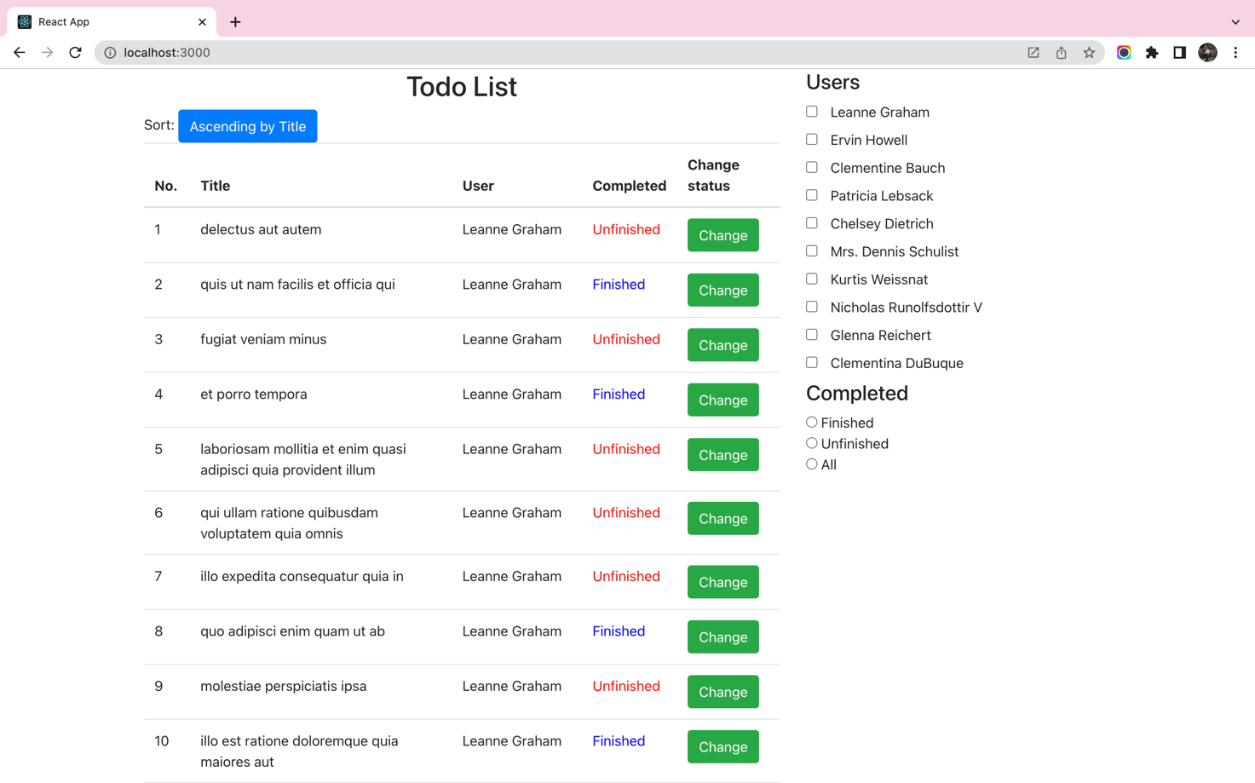
Figure 1 - Exam result screen
Requirements:
- Copy the file “database.json” in the given folder to your exam.
- Open two Terminal Command windows on your exam to execute commands:
1. Create a component named “Index”:
- Fetch data from http://localhost:9999/user to create the "Users" filter.
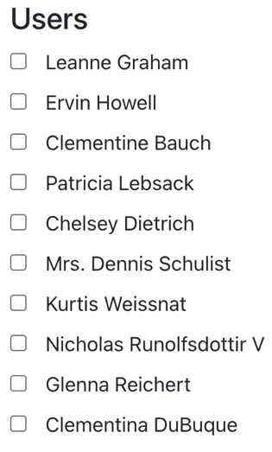
- Design the filter according to the “Completed” state as shown below:
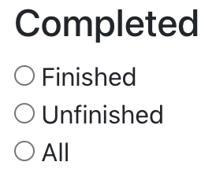

- Fetch all data from http://localhost:9999/todo and http://localhost:9999/user presented in tabular format.
(Reduce by 0.5 points without the "Ascending by Title" and "Change" buttons; Reduce 1 point if the data of 2 columns "User" and "Completed" is not displayed correctly)

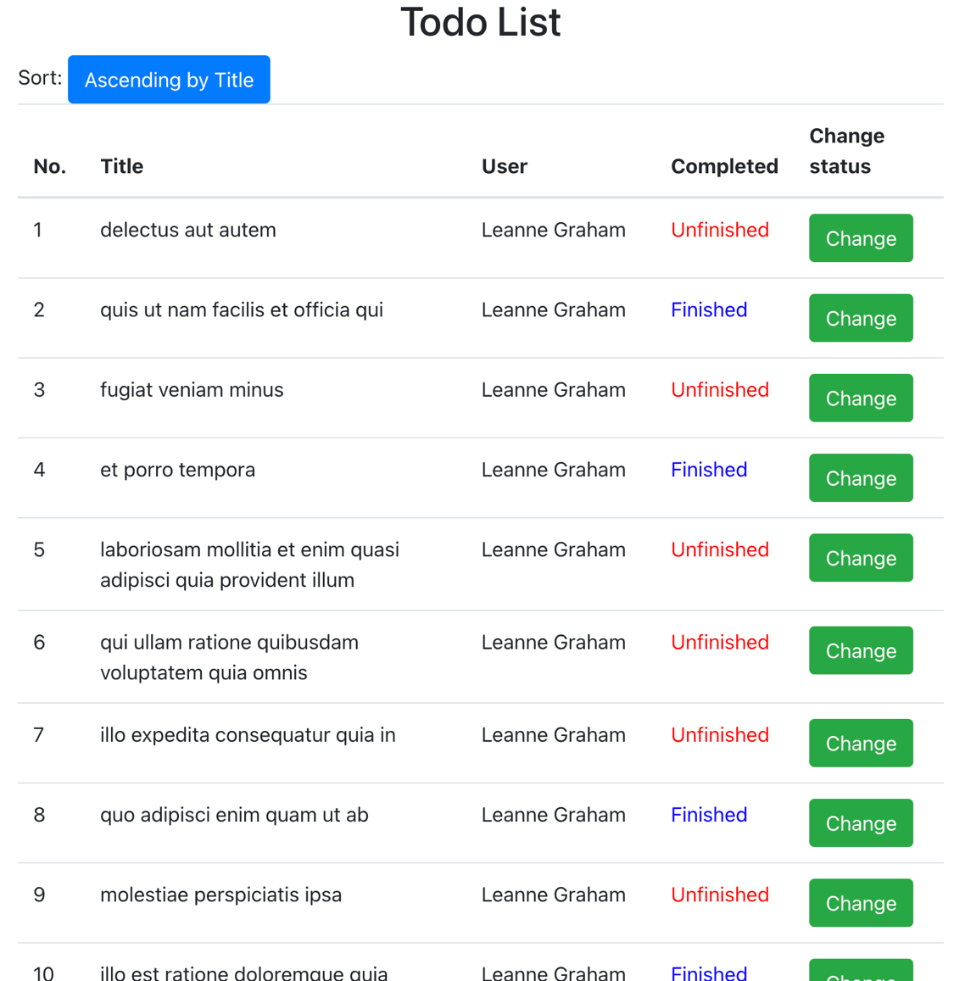

2. Event handing
- When a user clicks into the users checkbox on the “User” filter, the “Todo List” data will filter by users clicked.
- When the user selects both filter criteria on “Users” filter and “Completed”, the data of “Todo List” will be filtered simultaneously by these two criteria.
