Q1.
Context Diagram:
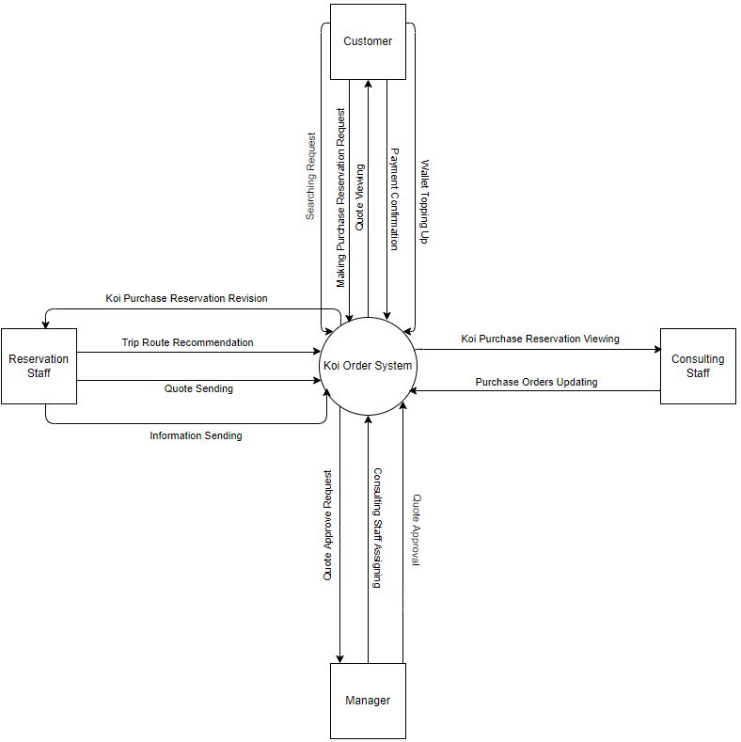

Q2.
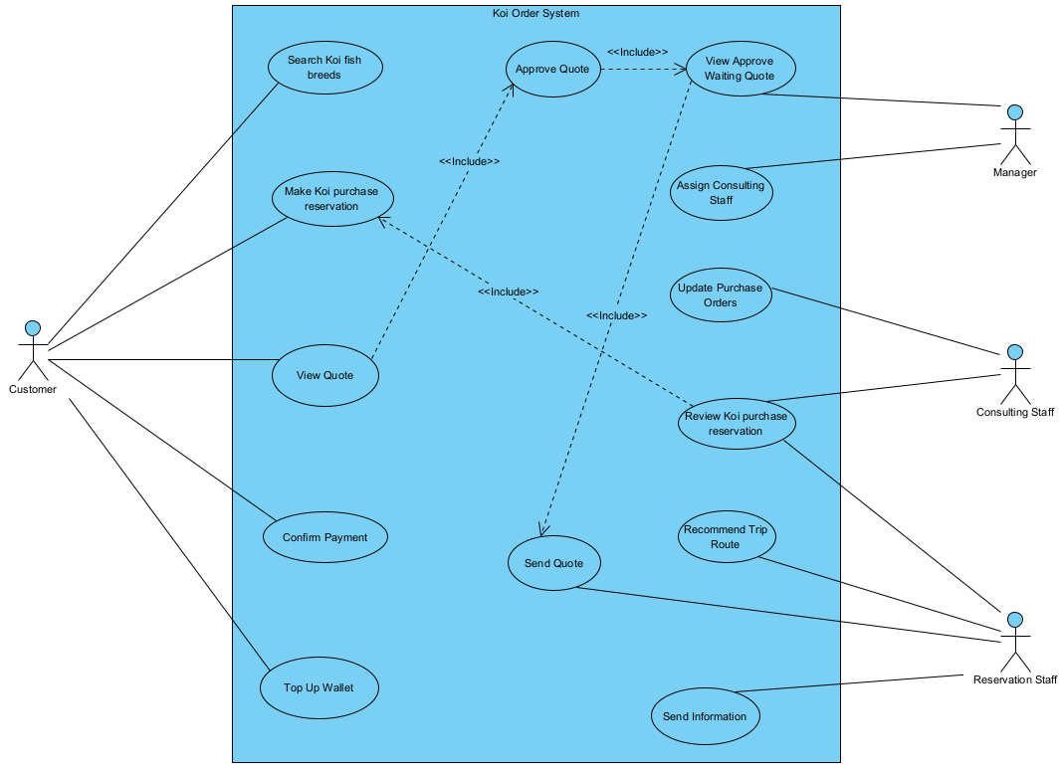
# | Actor | Description
01 | Customer | The customer can perform all tasks related to purchasing and placing orders.
02 | Manager | The manager can handle tasks related to approving content and assigning specific roles for certain actions.
03 | Consulting Staff | The consulting staff can manage tasks related to customer orders and purchase reservations.
04 | Reservation Staff | The reservation staff can assist with providing information to customers.

# | Use Case | Actors | Description
UC-01 | Search Koi fish breeds | Customer | Customer can search for Koi fish breeds (Kohaku, Showa, Ogon, ...) raised by each Koi farm in Japan, with reference selling prices for each breeds, size, age.
UC-02 | Make Koi purchase reservation | Customer | Customer has the ability to make Koi purchase reservation to buy fish at Japanese farms with desired proposals (breeds, farm, expected departure date, total expected budget).
UC-03 | View quote | Customer | Customer can view quote that reservation staff created.
UC-04 | Confirm payment | Customer | The customer needs to confirm the quote and pay the cost through the CHPay online payment system.
UC-05 | Top up wallet | Customer | If the amount of money in the wallet is not enough, the customer needs to top up the wallet through the function in the system.
UC-06 | Assign consulting staff | Admin | The manager has the function of assigning the consulting staff to be in charge of the Koi purchase reservation.
UC-07 | View approves waiting quote | Admin | View quote from reservation staff to approve.
UC-08 | Update purchase orders | Consulting Staff | During a trip to visit Koi farms in Japan, the consulting staff updates customer's fish purchase orders after finalizing the purchase price with the farm owner into the system.
UC-09 | Review Koi purchase reservation | Consulting Staff, Reservation Staff | The consulting staff can only view the Koi purchase reservation assigned to him by the manager.  The reservation staff reviews the Koi purchase reservation.
UC-10 | Recommend trip route | Reservation Staff | Recommends a suitable trip route through the farms
UC-11 | Send quote | Reservation Staff | Send a quote to the customer
UC12 | Send information | Reservation Staff | After the customer has made payment, the system allows the reservation staff to send specific information (airfare, hotel, etc.) to the customer.

Q3.
ID | Rule Definition | Use Cases
BR-01 | The payment must be completed using the CHPay online payment system. | UC-04
BR-02 | Once the customer completes the payment. | UC-12
BR-03 | The customer can cancel the Koi purchase reservation but will be responsible for covering the airfare and hotel costs. | UC-02
BR-04 | The customer is required to make a deposit of 30% of the fish's total value. | UC-02

Q4.
