Workshop #2: Exceptions
Learning Outcomes:
Upon successful completion of this workshop, you will have demonstrated the abilities to:
- Practice handling errors in your program.
- Describe to your instructor what you have learned in completing this workshop.
Requirements:
Part1: [5 points]

Write a Java program to accept a number and print out it. If the number is below 1 then a message “the number is invalid” is printed out. Using do..while to input again, try-catch block to handle errors.

The user interface may be:
Enter the number: - 2
The number is invalid”
Enter the number: world
The number is invalid”
Enter the number: 2
The number is 2
Step by step workshop instructions:
- Create a new project named “workshop2”
- In the project, create a new file named “Part1.java”
- In the method main, you type:

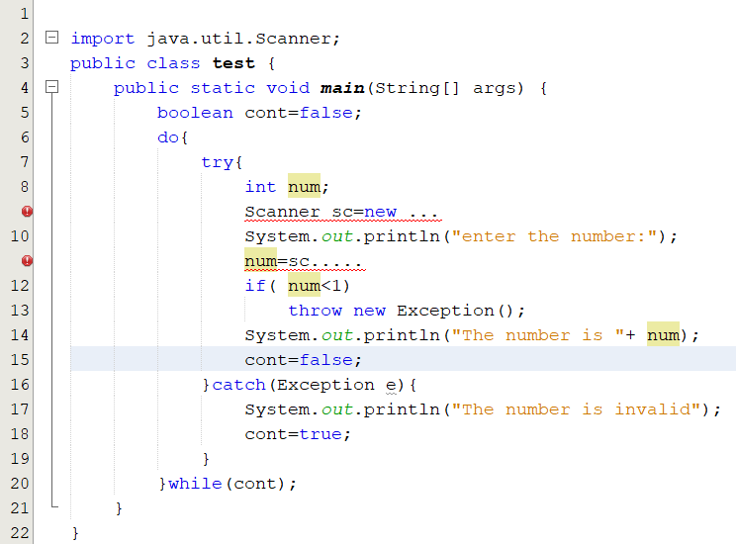

Part 2: [5 points]
Write a Java program to accept a string and print out it. If the string does not match SExxx(x is digit) then a message “the string is invalid” is printed out. Using do..while to input again.
Hint: In library class String, you should use the method matches() to do this, use try-catch block and use throws to handle errors.
The user interface may be:
Input the string 1: I love u
the string is invalid
Input the string 1: SE123
the string is SE123
Step by step workshop instructions:

Background: In this workshop, you will use the pattern string( also called regular expression, see more What is a Regular Expression? - Definition from Techopedia). You should read the document to complete the exercise.

Task 1: use try-catch
- In the project “Workshop2”, create a new file named “Part2.java”
- In the method main, you type:
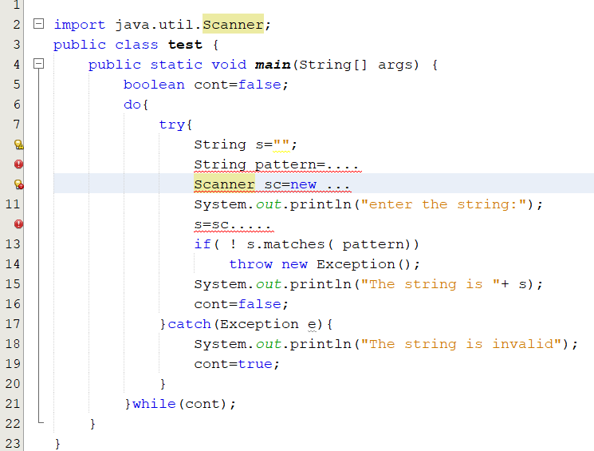
At the row 9, use rules of the regular expression to create a pattern string “SExxx”, x is digit
Task 2: use throws keyword
- create a new file named “Part2_2.java”
- in the method main, type:
