Workshop #3: Class and Object
Learning Outcomes:
Upon successful completion of this workshop, you will have demonstrated the abilities to:
- Design and implement a class.
- Create an object from a class
- Describe to your instructor what you have learned in completing this workshop.
Requirements:
Part 1: [2 points]
To complete this task you should read and study the lecture Encapsulation
-Create a new project named “CarManager”. It contains the file Car.java and Tester.java.
-In the file Car.java, you implement the Car class base on the class diagram as below:
Car
-Colour: String
-EnginePower:int
-Convertible: boolean
-ParkingBrake: boolean
//constructors
+Car()
+Car(String Colour, int EnginePower, boolean Convertible, boolean ParkingBrake )
//getters
+getColour():String
+getEnginePower():int
+getConvertible(): boolean
+getParkingBrake(): boolean
//setters
+setColour(String colour):void
+setEnginePower(int EnginePower):void
+setConvertible(boolean Convertible): void
+setParkingBrake(boolean ParkingBrake): void
//other logic methods
+pressStartButton():void
+pressAcceleratorButton():void
+output(): void
- Default constructor: to assign all fields to empty values
- Constructor with parameters: to assign all fields to input parameters
- Getters: to return the value of a field
- Setters: to change the value of a field
- The method pressStartButton(): print out the message “You have pressed the start button”
- The method pressAcceleratorButton(): print out the message “You have pressed the Accelerator button”
- The method output(): print out values of all fields

- In the file “Test.java”. you type like as follow:
public class Tester {
public static void main(String[] args) {
Car c=new Car();
c.pressStartButton();
c.pressAcceleratorButton();
c.output();

Car c2=new Car("red", 100, true, true);
c2.pressAcceleratorButton();
c2.setColour("black");
System.out.println("Colour of c2:" + c2.getColour());
c2.output();
}
}
- Run the method main to see the output
Part 2: Find classes [3 points] and use UML to draw class structure (optional)

Problem: Mr. Hung is the owner of the shop that sells guitars. He wants you to build him a shop management app. This app is used for keeping track of guitars. Each guitar contains serialNumber, price, builder, model, back Wood, top Wood. The guitar can create a melodious sound. The shop will keep guitars in the inventory. The owner can add a new guitar to it, he search also the guitar by the serialNumber.

Requirement: Write your paper down classes in the problem and use UML draw class structure.

Note: show members of a class: fields and methods

Do it yourself before getting help

Guideline:

Apply design guideline :

- Main nouns: Guitar
- Auxiliary nouns describe details of the guitar:serialNumber, price, builder, model, back Wood, top Wood.
- Verbs describe behaviors of the guitar: create Sound

Continue finding other nouns
- Main nouns: Inventory
- Auxiliary nouns describe details of the inventory: the list(array) of guitars
- Verbs describe behaviors of the inventory: add a new guitar, search the guitar by serialNumber.
Using UML to draw a class diagram

Part 3: only implement the Guitar class [4 points].

Step by step workshop instructions:
- Create a new project named “workshop3”
- In the project, create a new file named “Guitar.java”
  - Declare fields with access modifier as private: String serialNumber, int price, String builder, String model, String backWood, String topWood
  - Declare and implement methods with access modifier as public:
    - public Guitar() {…} : to assign all fields to empty values

    - public Guitar( String serialNumber, int price, String builder, String model, String backWood, String topWood) {…}: to assign all fields by input parameters

    - public String getSerialNumber(){…}: return the value of the field serialNumber.

    - public void setSerialNumber(String serialNumber){…}: if the input parameter is not empty then assign it to the field serialNumber.

    - Implement getter/setter of all other fields

    - public void createSound(){…}: in the method, invoke all getters and use System.out to print out values after getting.

- In the project, create a new file named “Tester.java. Create the method main in here, you type:

public class Tester {
public static void main(String[] args) {
Guitar obj1=new Guitar();
Guitar obj2=new Guitar("G123",2000,"Sony","Model123","hardWood","softWood");
System.out.println("State of obj1:");
obj1.createSound();
System.out.println("State of obj2:");
obj2.createSound();

System.out.println("set price = 3000 of obj1");
obj1.setPrice(3000);
System.out.println("get price of obj1:" + obj1.getPrice() );
}
}
The output is:
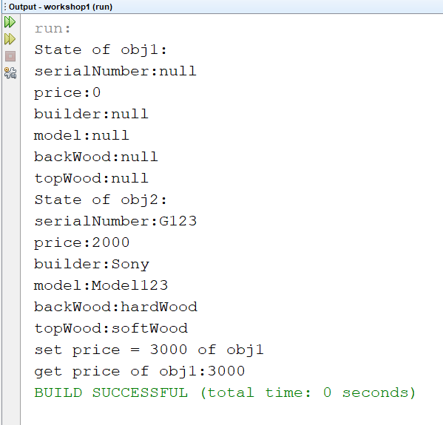

Part 4: Draw the memory map when the program runs [1 point]
Explain step by step what happened when the program runs and answer some questions.
- What is stored in the static heap, stack, dynamic heap?

Java Stack Memory
Bộ nhớ để lưu các biến local trong hàm và lời gọi hàm ở runtime trong một Thread java.
Các biến local bao gồm loại nguyên thuỷ (primitive) và loại tham chiếu tới đối tượng trong heap (reference) khai báo trong hàm, hoặc đối số được truyền vào hàm, thường có thời gian sống ngắn.
Ngắn gọn, mỗi phương thức được gọi sẽ tạo một frame trên stack, và khi phương thức kết thúc, frame đó sẽ bị loại bỏ.
The dynamic heap is used for storing objects created during runtime.
- What are objects in the program?
Obj1, obj2
- What is the state of obj1, obj2?
private
- Do you access all fields of obj1 in the class Tester.java? Why?
You can not access. Because it is private
- What is the current object when the program runs to the line “obj2.createSound();”?
Obj2 is the current object
- In the method main, can you use the keyword “this” to access all fields of obj2? Why?
No. Because “this” just only use in Guitar class

