Workshop #4: Inheritance
Learning Outcomes:
Upon successful completion of this workshop, you will have demonstrated the abilities to:
- Design and implement classes in the “is-a” relationship.
- Practice casting
- Describe to your instructor what you have learned in completing this workshop.
Requirements:
Part 1: [7 points]
To complete this task you should read and study the lecture Inheritance
Step 1: Create a new project named “ItemManager”.
Step 2: Create a package named “DTO”, it contains some files: Item.java, Vase.java, Statue.java, and Painting.java
Step 3: Create another package named “GUI”, it contains the AntiqueShop.java file

Implement the class diagram as follows:
Item
#value: int
#creator: String
+Item()
+Item(int, String)
+getters/setters
+output():void
+input():void

Vase
-height: int
-material: String
+Vase()
+Vase(int, String, int, String)
+getters/setters
+outputVase():void
+InputVase(): void
Statue
-weight: int
-colour: String
+Statue()
+Statue(int, String, int, String)
+getters/setters
+outputStatue():void
+inputStatue():void
Painting
-height: int
-width: int
-isWatercolour: boolean
-isFramed: boolean
+Painting()
+Painting(int, String, int, int, boolean, boolean )
+getters/setters
+outputPaiting():void
+inputPainting():void

AntiqueShop
+main():void

The AntiqueShop class is making use of Vase, Statue, and Painting, in the sense that it has declared references to them, and thus there is a dependency.

Requirement:
1. In the file Item.java,
- The method input(): Using Scanner class to input all fields of the Item class. Verify: value>0, creator is not empty

- The method output(): print out all fields

2. In the file Vase.java,
- The method inputVase(): Using Scanner class to input all fields of the Vase class.
- The method outputVase(): print out all fields of the Vase class
Hint:
public class Vase{
…
//this method is used to input all fileds of a vase object
public void inputVase(){
input(); // call the inherited method to input two fields: value, creator

//TODO: you is required to add more your code to input two fields : height, material
// use try..catch/throws to handle exceptions
}

//this method displays information of a vase object
public void outputVase(){
output(); // call the inherited method to print two fields out: value, creator
System.out.println(“Height:” + height);
System.out.println(“Material:”+ material);
}
…
}

- You do the same for Statue class, Painting class
- In the file “AntiqueShop.java”. you type like as follow:
public class AntiqueShop {

public static void main(String[] args){
Item item=null;
int choice=0;
Scanner sc=….
do{
System.out.println(“1. Create a Vase:”);
System.out.println(“2. Create a Statue:”);
System.out.println(“3. Create a Painting:”);
System.out.println(“4. Display the Item:”);
System.out.println(“Input a choice:”);
Choice=sc.nextInt();
switch(choice) {
case 1:
item=new Vase();
((Vase)item).inputVase();
break;
case 2:
item =new Statue();
((Statue) item).inputStatue();
break;
case 3:
item =new Painting();
((Painting) item).inputPainting();
break;
case 4:
if(item!=null) {
if(item instanceof Vase)
((Vase) item).outputVase();
else if(item instanceof Statue)
((Statue) item).outputStatue ();
else if(item instanceof Painting)
((Painting) item).outputPainting ();
}
else
System.out.println(“ you need to create an object”);
break;
}
}while(choice<=4); }

}

- (Optional) Now, you is required to update the above program. You should create a new class named Menu. This class contains one static method

//use this method to show pre-defined options
//input: an array contains the list of options
//output: return a user’s choice that is inputted from the keyboard.
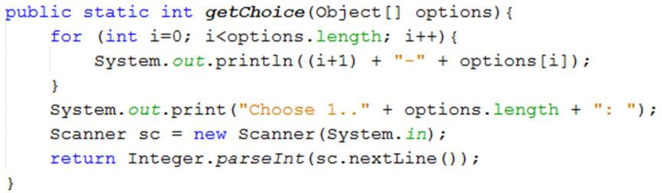

- Update the main method to use the Menu class.

public class AntiqueShop {

public static void main(String[] args){
String[] options={“ Create a Vase “,”Create a Statue”,” Create a Statue”,” display the item”};
Item item=null;
int choice=0;
do{
choice=Menu.getChoice(options);
switch(choice){
case 1:
item=new Vase();
((Vase)item).inputVase();
break;
….
}while(…);
}

Part 2: Draw the memory map when the program runs [3 points]
Explain step by step what happened when the program runs and answer some questions.
Step 1: print the menu and get choice from user
Step 2: With each selection, program will run each method
Step 3: Run step 1

- What is stored in the static heap, stack, dynamic heap?
+ Static heap: the class and static variables are stored
+ Stack: method calls, local variables and reference variables
+ Dynamic heap: the objects are stored
- What are objects in the program?
Item and sc
- What is the item variable storing?
It store the address of object Vase, Statue , Painting
- Why must you cast to call the method inputVase()/outputVase()?
Because the reference variable “item” is defined on Item class
- What is the error thrown when you cast it wrong?
ClassCastException
- What methods can you call if you don’t cast the item variable?
Input and output

