Workshop #6: Collection framework
Learning Outcomes:
Upon successful completion of this workshop, you will have demonstrated the abilities to:
- Practice the ArrayList class.
- Practice some basic functions : add, update, remove, display, search,… in the list
- Describe to your instructor what you have learned in completing this workshop.
Total: [10 points]
In this demonstration, ArrayList is used to store a list of students. Student details include: Code, name, mark. A menu is supported for user choosing one operation at a time:
(1) Add new student
(2) Search a student based on his/her code
(3) Update name and mark of a student based on his/her code
(4) Remove a student based on his/her code
(5) List all students.

Constraints:
Student code must be in format <S000>, 0 is a digit.
Student name can not be blank
Mark: 0..10
Design:
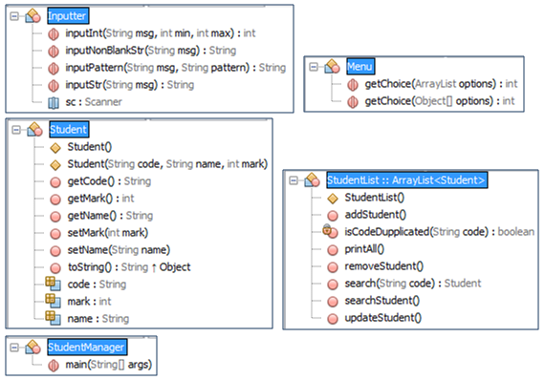
Implement:
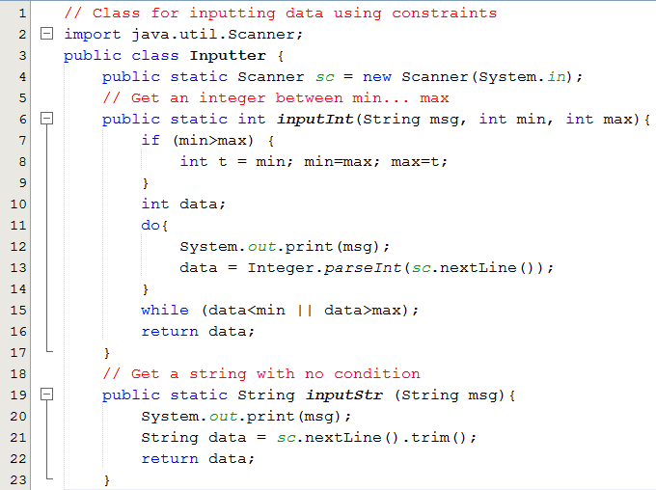

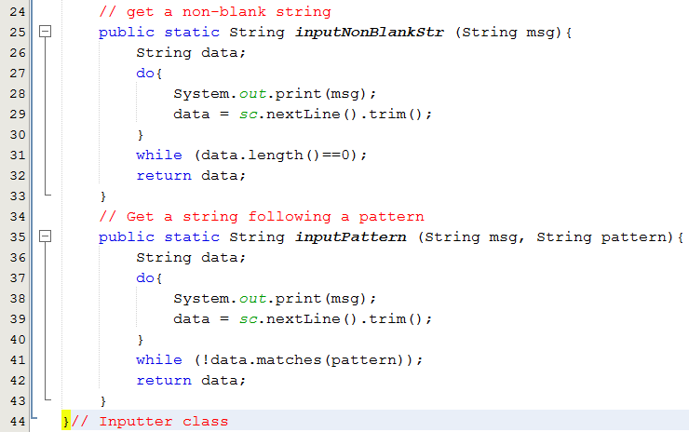
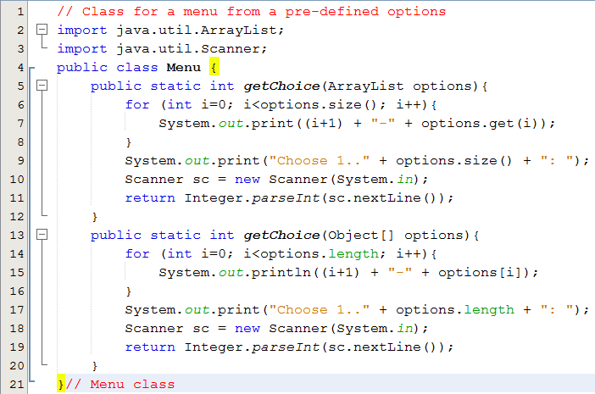

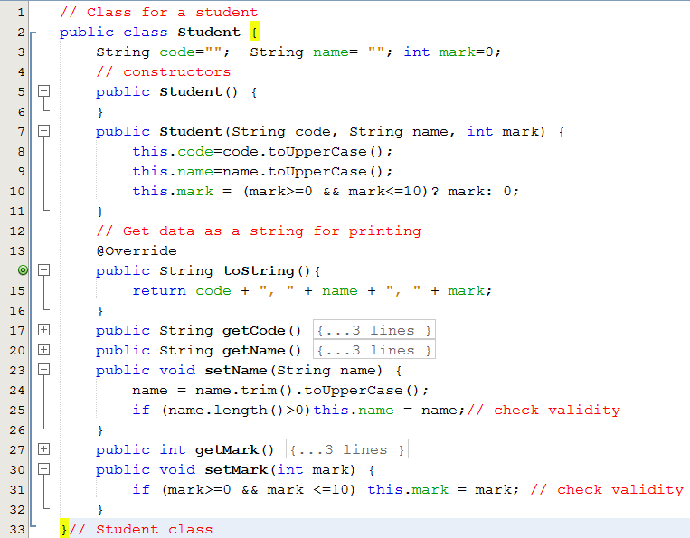
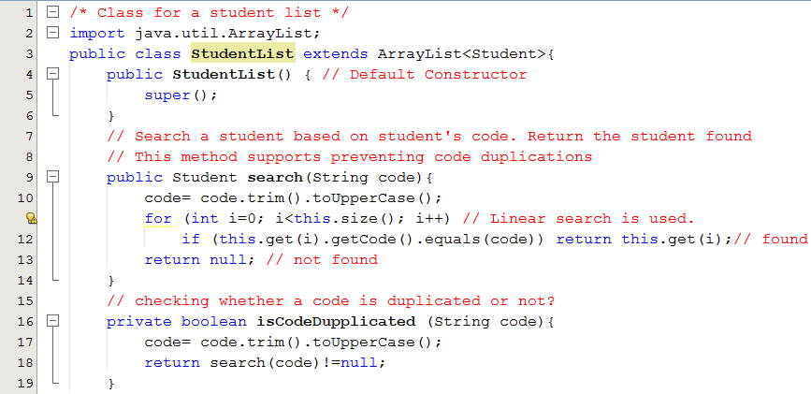
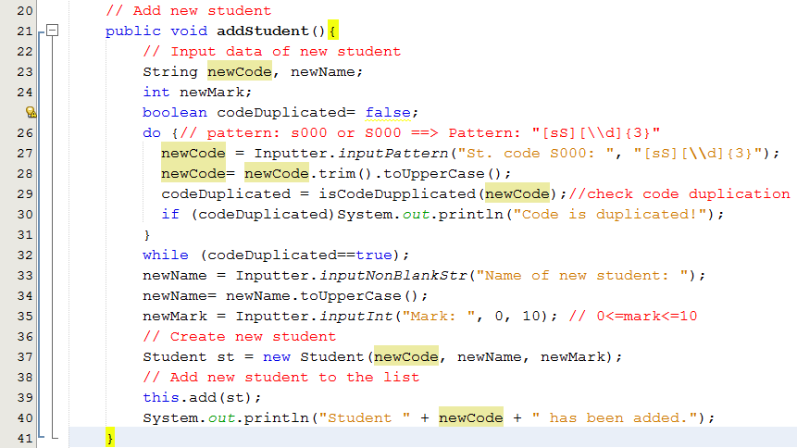

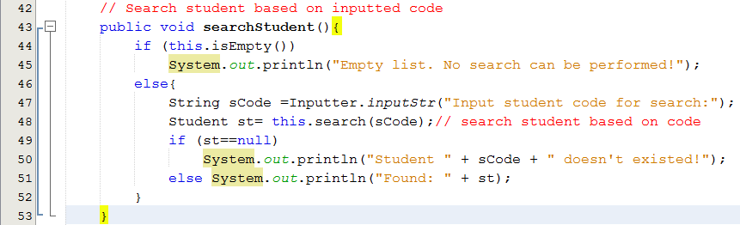
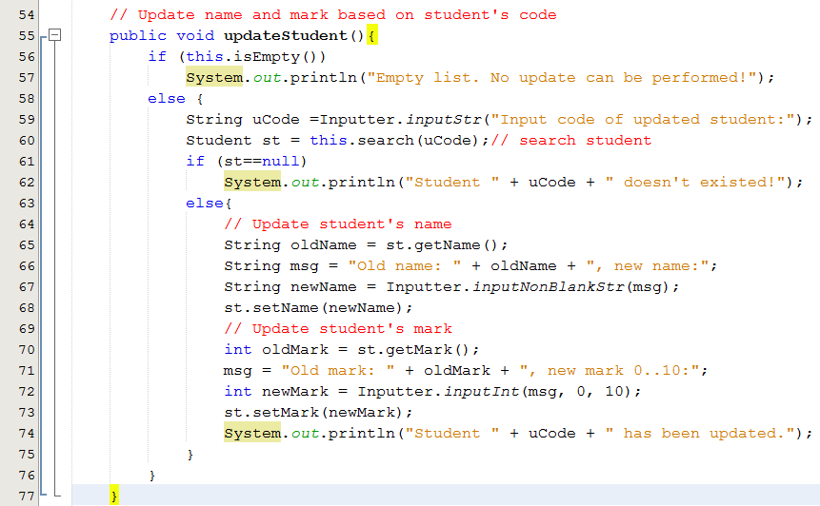
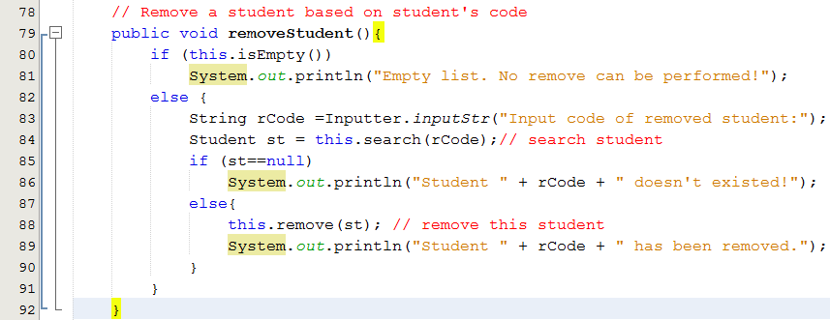
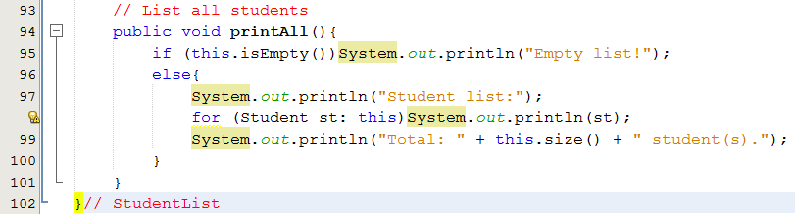
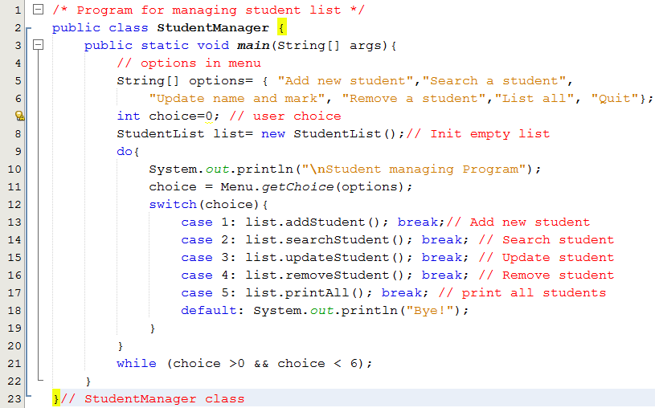
Test cases

Run the program, the following menu allows user to choose one operation at a time:

Student managing Program
1-Add new student
2-Search a student
3-Update name and mark
4-Remove a student
5-List all
6-Quit
Choose 1..6:

Test case | Option | Input and Result
1 | 2 | No input,  Output: Message: Empty list. No search can be performed!
2 | 3 | No input,  Output: Message: Empty list. No update can be performed!
3 | 4 | No input.  Output: Message: Empty list. No remove can be performed!
4 | 5 | No input.  Output: Message: Empty list!
5 | 1 | Input code : ABC/ A1234/ S12345/S001.  Input name: blank/ James  Input mark: -2/12/7  Message: Student S001 has been added.
6 | 2 | Add: S008, Jack, 5
7 | 3 | Add: s004,monica, 8
8 | 5 | Output:  Student list:  S001, JAMES, 7  S008, JACK, 5  S004, MONICA, 8  Total: 3 student(s).
9 | 2 | Input student code for search: Input S123  Output: Student S123 doesn't exist!
10 | 2 | Input student code for search: Input s008  Output: Found: S008, JACK, 5
11 | 3 | Input code of updated student: Input S123  Output: Student S123 doesn't exist!
12 | 3 | Input code of updated student: Input s008  Old name: JACK, new name: input bill  Old mark: 5, new mark 0..10: input 10  Output: Student s008 has been updated.
13 | 5 | Output:  Student list:  S001, JAMES, 7  S008, BILL, 10  S004, MONICA, 8  Total: 3 student(s).
14 | 4 | Input code of removed student: Input s123  Output: Student s123 doesn't exist!
15 | 4 | Input code of removed student: Input s008  Output: Student s008 has been removed.
16 | 5 | Output:  Student list:  S001, JAMES, 7  S004, MONICA, 8  Total: 2 student(s).

