LAB211 Assignment | Type: | Short Assignment
 | Code: | J1.S.P0056
 | LOC: | 120
 | Slot(s): | 1

Title
Program to manage worker information.
Background
N/A
Program Specifications
Create a program to manage worker:
- Add a Worker.
- Increase salary for worker.
- Decrease for worker.
- Show adjusted salary worker information.

Function details:
Function 1: Display a menu and ask users to select an option.
- Users run the program. The program prompts users to select an option.
- Users select an option, perform Function 2.
Function 2: Perform function based on the selected option.
- Option 1: Add an worker
  - Prompt user to input task information (id, name,age, salary, work location)
  - Check data input is valid with following information:
    - Code(id) cannot be null or duplicated with existed Code in DB.
    - Age must be in range 18 to 50
    - Salary must be greater than 0
  - Add Worker to DB.
  - Return to main screen.
- Option 2: Increase salary
  - Prompt user to input Code(id) and amount of money to raise
  - Data must be valid with following conditions
    - Code(id) must be existed in DB.
    - Amount of money must be > 0
  - Add salary to worker and save salary history
  - Return to main screen
- Option 3: Decrease salary
  - Prompt user to input Code(id) and amount of money to cut.
  - Data must be valid with following conditions
    - Code(id) must be existed in DB.
    - Amount of money must be > 0
  - Substract salary to worker and save salary history
  - Return to main screen
- Option 4: Show all worker have been adjusted salary by worker code.
- Option 5: Quit program.
Expectation of User interface:

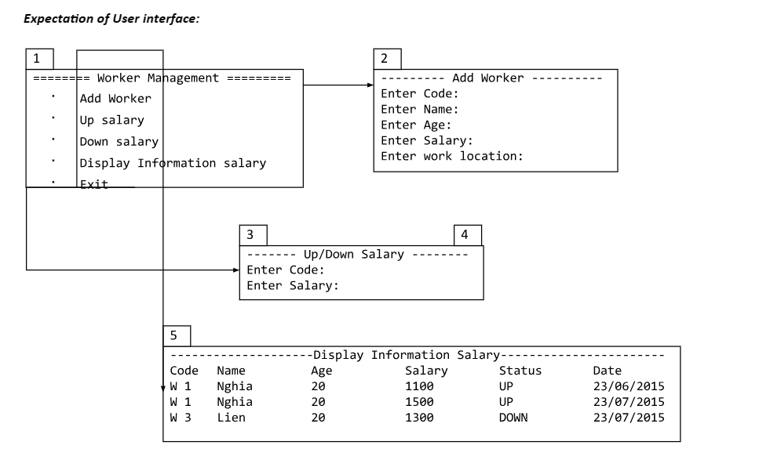
Guidelines
Student must implement methods
- addWorker
- changeSalary
- getInfomationSalary
in startup code.
Example:
Class Management contains functions add, show, increase, decrease salary of workers.
Option 1: Add worker
- Named function: public boolean addWorker(Worker worker) throws Exception
- Input:
- worker: worker information.
- Return values:
- Worker added status.
- Exceptions list.
Option 2 & Option 3: Adjust salary.
- Named function: public boolean changeSalary(SalaryStatus status, String code, double amount)
- Input:
- status: is increase or decrease.
- code: code Worker
- amount: amount of money
- Return values:
- Status of adjusted.
- Exception list.
Option 4: Display the list of adjusted salary workers.
- Named functions: public List<SalaryHistory> getInfomationSalary()
- Input:
- Return value: List of worker sort by id.

