Basic: (5 points)
You are given a NetBeans template project (read more detail in the first page).
You are asked to build a web application using the given database.
User can type /show (/ represents your web application context path) to access Show Instructors Page (0.5 point).
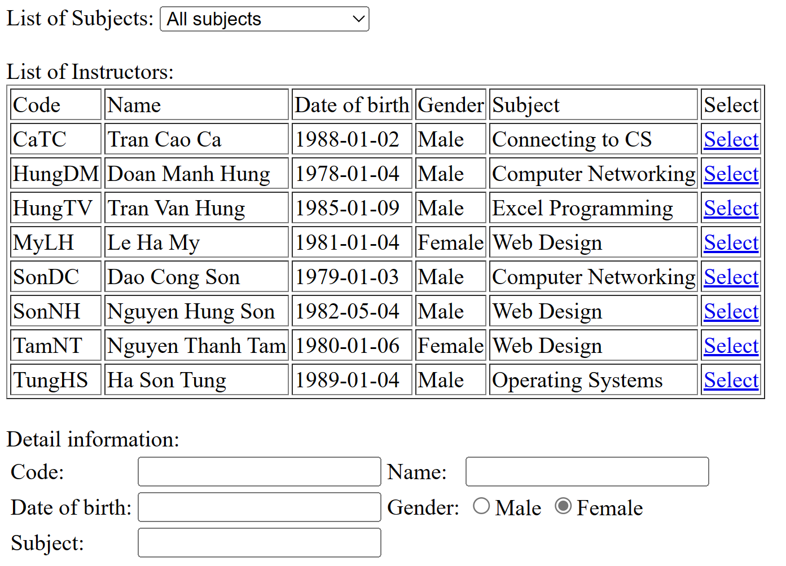
- The Subjects dropdown list must load data from [Subjects] table. (1 point)
Reduce 1 point if cannot display subjects (including All subjects option) to the dropdownlist.
- The table “List of Instructors” must load data from [Instructors] table. (1 point)
Reduce 1 point if cannot display instructors correctly to the table.
- When user selects a subject in [Subjects] dropdownlist, the list of Instructors that teach that subject will be displayed in the Table. (1 point)
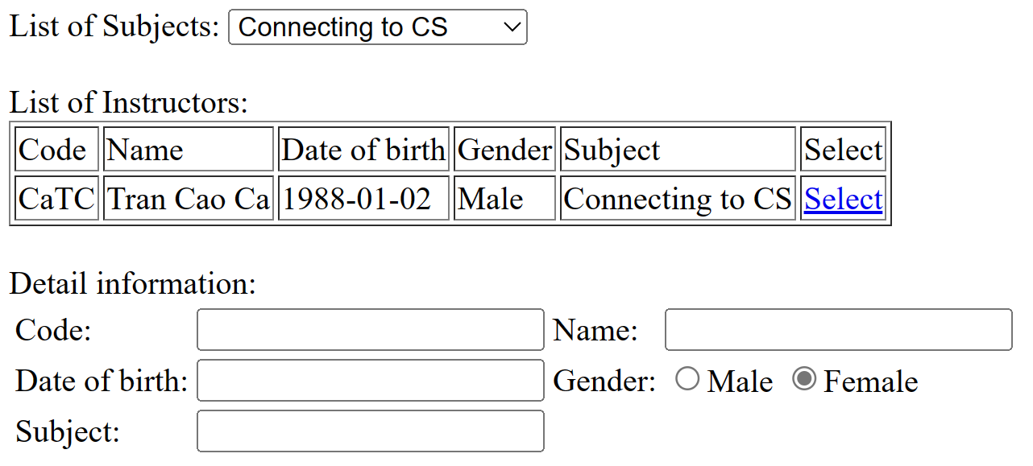
- When user clicks [Select] link, the Instructor information will be displayed in the Detail Information (1.5 point)
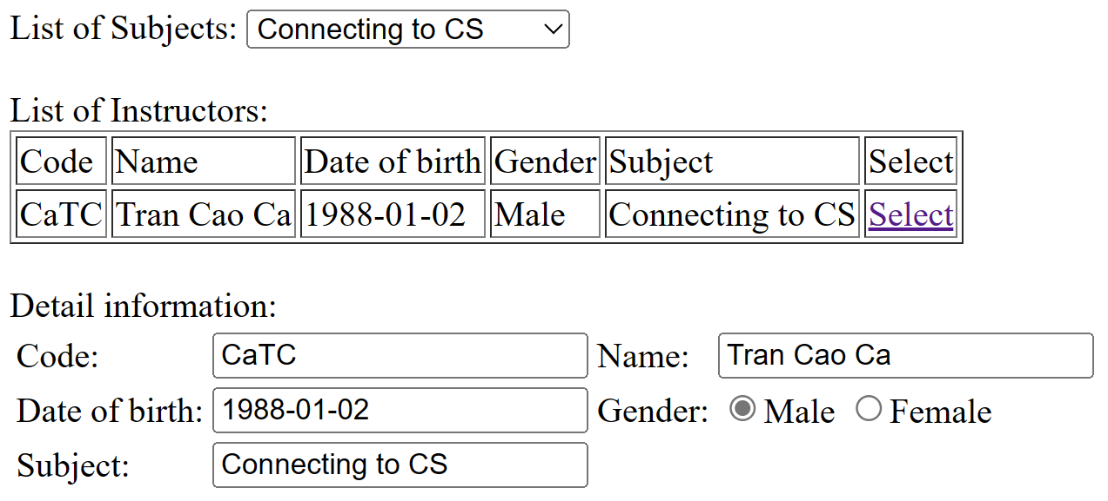

Basic: (5 points)
User can type /students (/ represents your web application context path) to access Show Students Page with these columns: StudentID, StudentName, BirthDate, Age, Gender, SubjectName, Modify (Edit, Delete) and a Create button to add a student to DB.
+ Contruct CRUD Operations with students (1 points).
+ Validate data when create or edit a student(2 points):
- StudentID must have 7 characters.
- Student's age is greater than 18 years old.
- The BirthDate is in YYYY-MM-dd format
- Show notification when the user enters the incorrect format.
+ Filter students with Gender (1 point)
+ Sort students with StudentID or Age (1 point)

