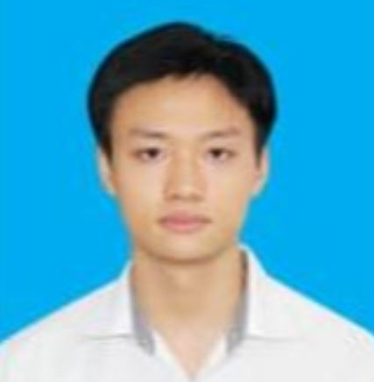 | PHAN TIEN MANH  Java Developer | (+84) 869374650  manhamsterdam2003@gmail.com  DOB: 22/03/2003  linkedin.com/in/phan-tiến-mạnh-61b3771a5

CAREER SUMMARY
Have strong foundation in HTML, CSS, JavaScript, Java, PHP and a passion to solve problems. Familiar with collaborating within Agile teams and creating dynamic web applications.
PROFESSIONAL PROJECTS  Online Course System, Web Developer  Software development project – Team of 4  08.2024 – 11.2024  Developing a system for universities that allow students to study online courses, students can track their progress and instructors can give assignments to the courses.  Achievements:  - Complete task  - Manage 3 people  - Lead team to get success  Technologies:  HTML  JSP-Servlet  JavaScript  CSS  Personal Project  TodoList, Web Developer  04.2023 – 05.2023  Developing an app that keeps track of a person's list of things that need to be  done  Achievements:  - Complete task  - Learn new knowledge  Technologies:  HTML  JavaScript  CSS  React Web Development  Product Rating App  10.2024 – 11.2024  Developing a react App that allow user to view and give feedbacks and rate on products, admin can manage products including creating, updating and deleting a product.  Achievements:  - Complete task  - Learn new knowledge  Technologies:  HTML  CSS  React  Json-server  REFERENCE  Mrs. Nguyen Dieu Linh  Java Developer of FPT Software Academy |  | EDUCATION  FPT Software Academy  01.2025 – Present  Fresher Java Developer  FPT University  09.2021 – Present  Software Engineering, GPA: 3.2/4  CERTIFICATE & AWARD  Computer Communications Specialization  Software Development LifeCycle Specialization  Web Design for Everybody: Basics of Web Development & Coding Specialization  Excellent student in Spring 2023 semester  SKILLS  Frontend:  - React  - JavaScript  - HTML/CSS  Backend:  - Java  - PHP  Other:  - SQL Server  LANGUAGE  English – B2  Japanese – N5  INTEREST  Programming  Cooking  Making videos  Sport

