PROGREST TEST 3

Use the following database schema for doing this exam:
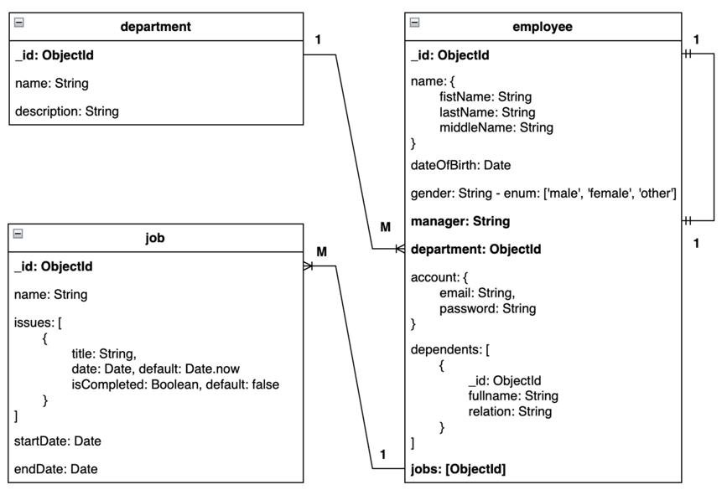

Requirements:
Using MongoDB Compass, create a database named “SDN302_PT3”. Create collections corresponding to the data in the Given data directory. Then, import data into the collections created in the database.
Using the given-app, build a RESTFul API application that performs the requirements of the problem:

Note: 0 will be given to the work that
- Not using connection string to MongoDB in the .env file
- Not configuring the root path of RESTFul API Web App at: http://localhost: 7777

Question 1.
List all movies as following, with the following API endpoint parameters:
- URL: http://localhost:7777/employee/list
- Method: GET
- Example:
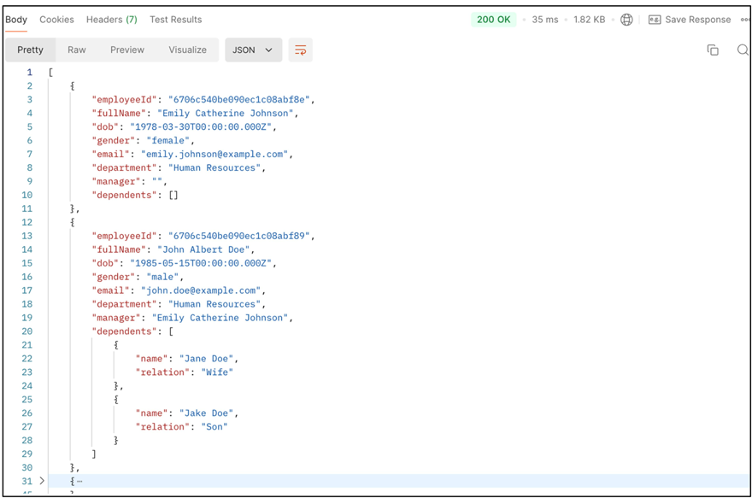
- Returns an array of employees object from the database.
- Display correct number of data fields and formatting as output.
- Display correct data of the fields: fullName, department, manager, dependents.

Question 2.
List employees by department identifier, with the following API endpoint parameters:
- URL: http://localhost:7777/department /:departmentIde
- Method: GET
- Example: List employees with departmentId= “6706c540be090ec1c08abf87”

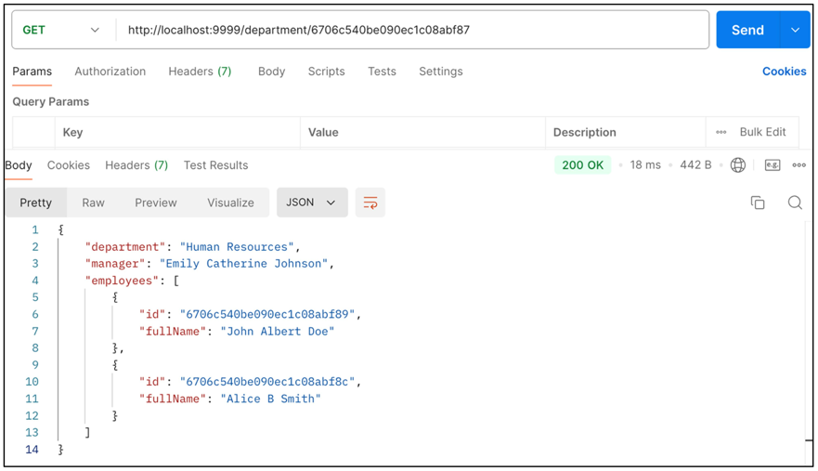
- Display the correct number of data fields and formatting.
- Return correct data of the fields: department, manager,employee.

Question 3.
Based on the employee’s identification, create a new job as following. With the following API endpoint parameters:
- URL: http://localhost:7777/employee/:empoyeeId/add-job
- Method: POST
- Input: Use the downloaded sample data in SampleTest.json of the Given_Data folder to test this functionality
- Example: create a new job for employee with _id= “6706c540be090ec1c08abf89”
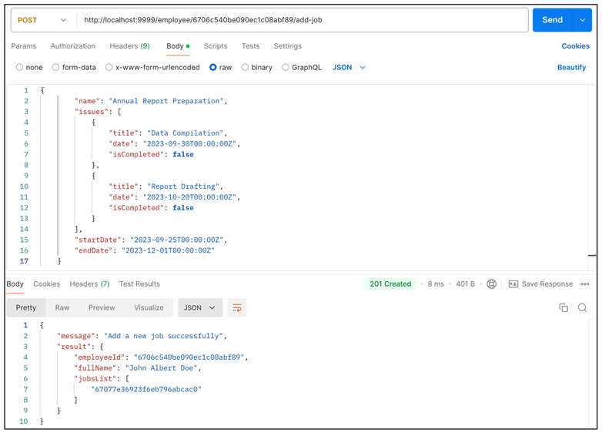
Requirement:
- Create a new job.
- Update data for jobs in employee collection successfully.
- Return the correct format and result after successfully inserted.
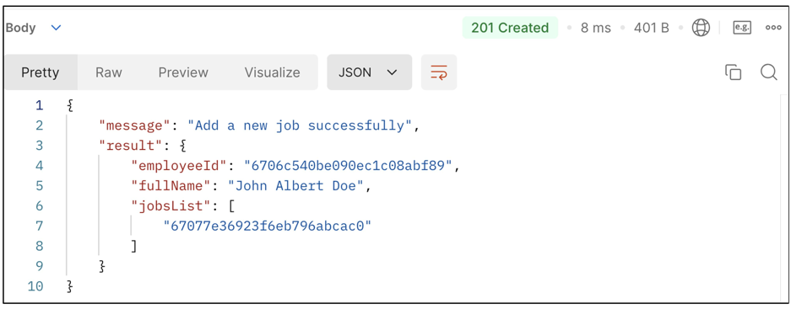
- Using model validation to check data input:
+ No “name, title,date” data fields when creating a new job.
+ Data of Fields with Date type in the wrong format.

