SWD392 – Software Architecture and Design
Practical Exam
Duration: 90 minutes
Format: Submit your answers in a single Markdown file using PlantUML for all diagrams. Do not use ChatGPT, Copilot, or any other AI code generation tools during the exam.
Problem statement
In order to modernize library operations and improve user experience, the university plans to develop a new library management system.
The system enables library users to search for books, borrow and return them efficiently. Users can view book details such as title, author, and availability status. The system keeps track of each user's borrowing history and due dates to ensure timely returns. It manages multiple users and books, ensuring that each book can only be borrowed by one user at a time. Notifications are sent to users for overdue books. The system supports managing user information and book inventory seamlessly.
The system is planned to be developed using a client-server architecture:
- The client will be implemented with React technology.
- The server will be a REST API following the MVC pattern (e.g., ASP.NET Core Web API).
- The database will be Microsoft SQL Server (MS SQL).
- Communication between client and server is done via HTTP requests/responses using JSON data format.

Part 1: Data analysis and design (5 points)
- LIST the main entities and their key attributes based on the problem description. (1 point)
- DRAW the conceptual ERD (PlantUML) for the system. (1 point)
- DRAW the logical ERD (with primary/foreign keys and basic data types) using PlantUML (1.5 points)
- LIST the main states of the Loan entity during the borrow/return process and DRAW the state diagram (PlantUML) for Book. (1.5 points)

User
=> userID , name , email , role
Book
⇒ BookID , title , author , availabilityStatus
Loan
⇒ loanID , borrowDate , dueDate , status
Notification
⇒ notiID , content , sentDate

CONCEPTUAL ===> LOGICAL ⇒ PHYSICAL
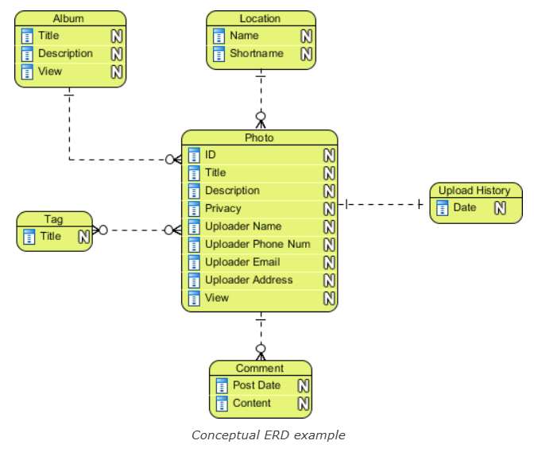

4 entities : User , Book , Loan , Notification
Relationship : User 1- n Loan
Book 1-n Loan
User 1-n Notification
