PFP - Labwork 03

Questions 1 (2.5 marks)
- Print the following pattern
Write a program to print the following number pattern using a loop.
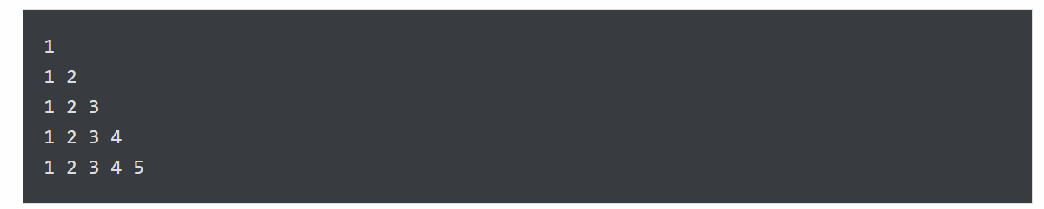
- Calculate the sum of all numbers from 1 to a given number
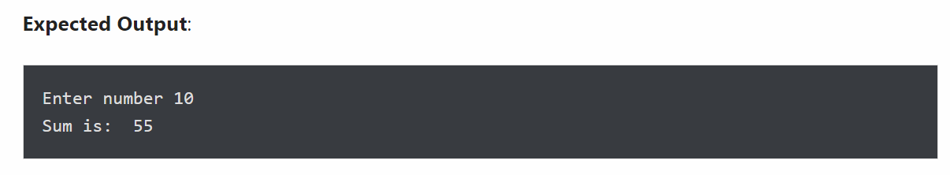

Question 2 (2.5 marks) Write a program that performs the following tasks:
- Display numbers from a list using loop
- The number must be divisible by five
- If the number is greater than 150, then skip it and move to the next number
- If the number is greater than 500, then stop the loop
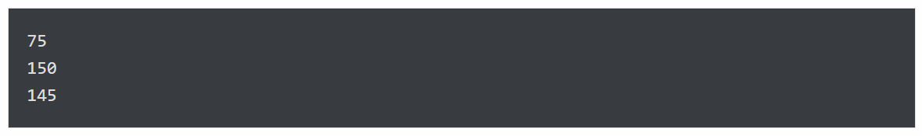
- Count the total number of digits in a number
- Print list in reverse order using a loop
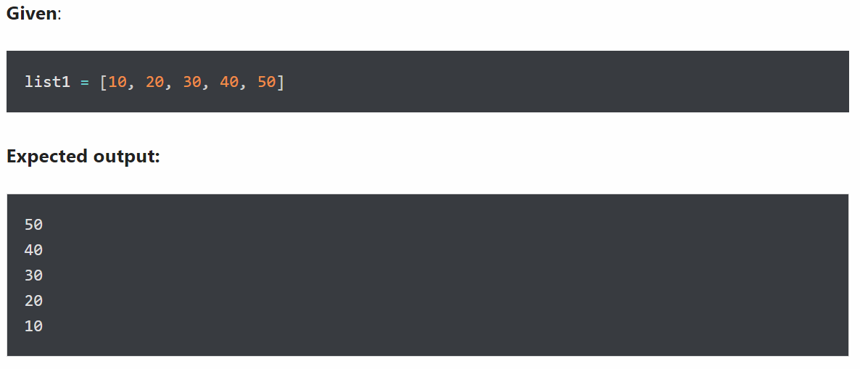

Question 3 (2.5 marks) Write a program that create a mixed String using the following rules:
- Create a string made of the middle four characters.
Output:
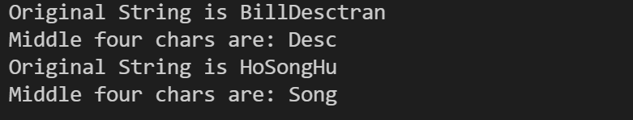
- Append new string in the middle of a given string
Given two strings, s1 and s2. Write a program to create a new string s3 by appending s2 in the middle of s1.
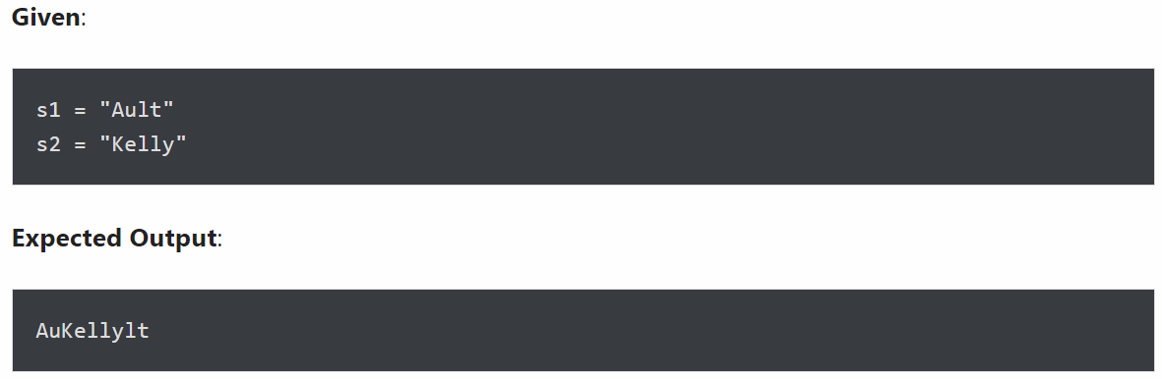
- Create a new string made of the first, middle, and last characters of each input string
Given two strings, s1 and s2, write a program to return a new string made of s1 and s2’s first, middle, and last characters.
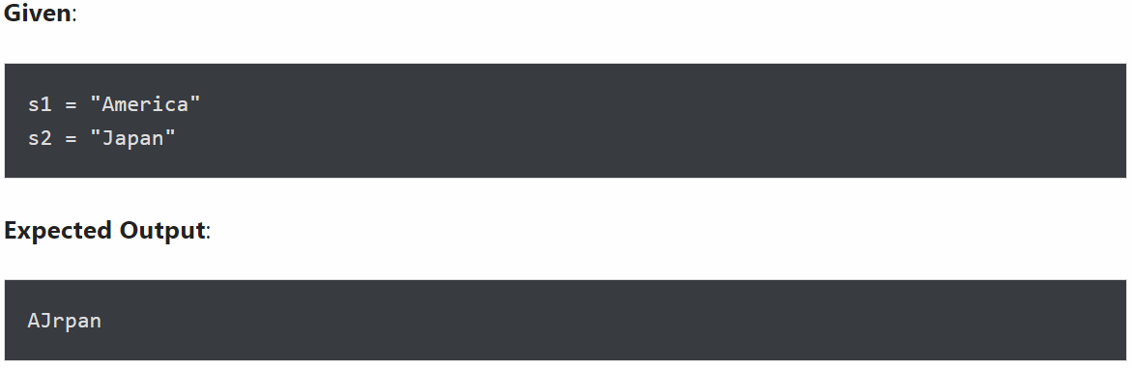
- Arrange string characters such that lowercase letters should come first
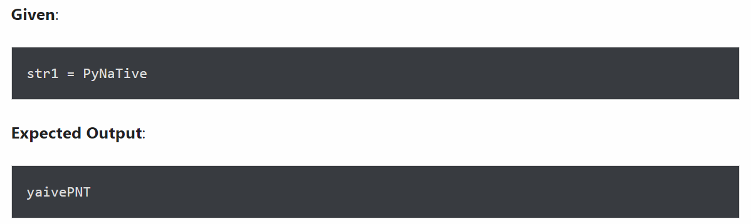
- Count all letters, digits, and special symbols from a given string
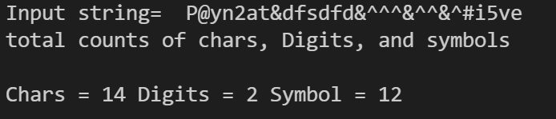
Question 4 (2.5 marks) Write a program that performs the following tasks:
- Removal all characters from a string except integers
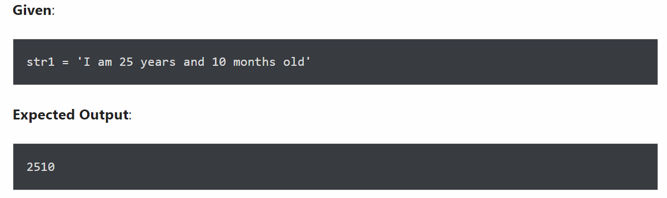
- Remove special symbols / punctuation from a string
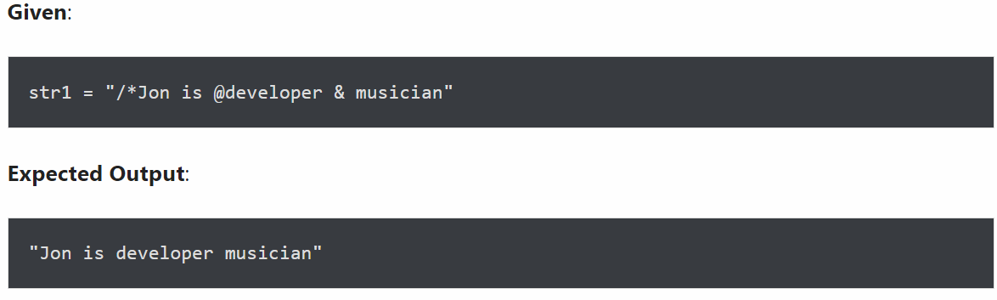
- Remove empty strings from a list of strings
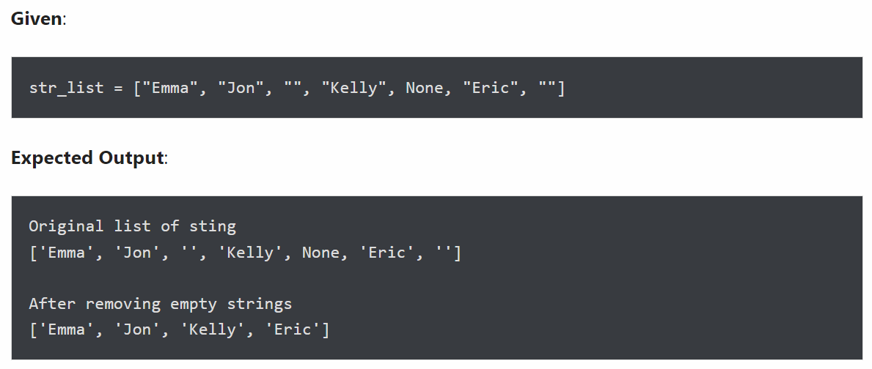
- Split a string on hyphens
