PFP - Labwork 04

Q1 (2.5 marks). Write a program that performs the following tasks:
- Create a new empty text file named ‘sales.txt’
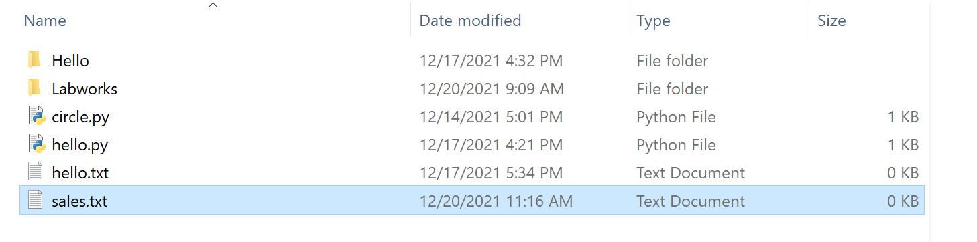
- Create File with a DateTime
- Create a file with Permission.
Q2 (2.5 marks). Write a program that performs the following tasks:
- Write to a new file
  - Open file in write mode
  - Write content into the file
  - Write to a Text file in Python
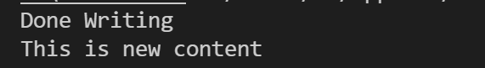
- Writing To An Existing File
- Write a list of lines to a file
Q3. (2.5 marks). Write a program that performs the following tasks:
- Seek the Beginning of the File
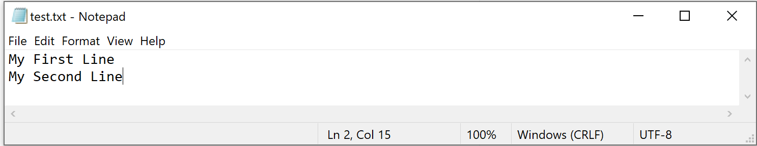
- Seeking The End of File
- Seek From The Current Position
- Seek backward With Negative Offset
- Use tell() Function To Get File Handle Position
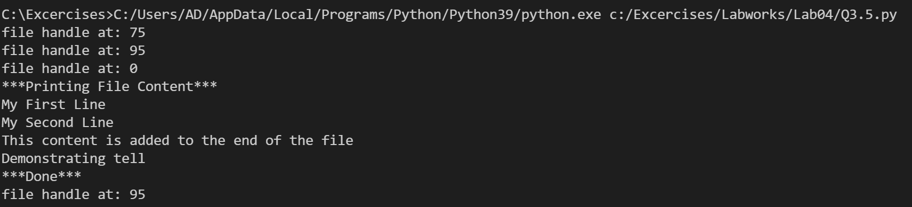
Q4. (2.5 marks). Write a program that performs the following tasks:
- Rename a file after checking whether it exists
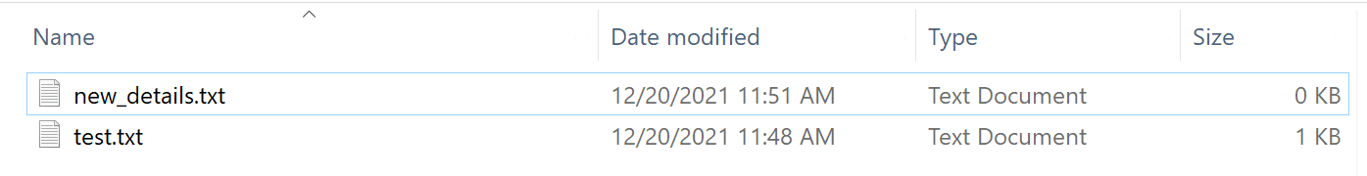
- Rename Multiple Files in Python
- Renaming only a list of files in a folder
- Renaming files with a timestamp
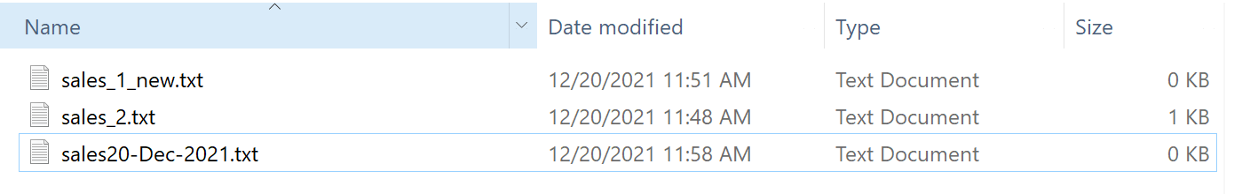
- Renaming the Extension of the Files
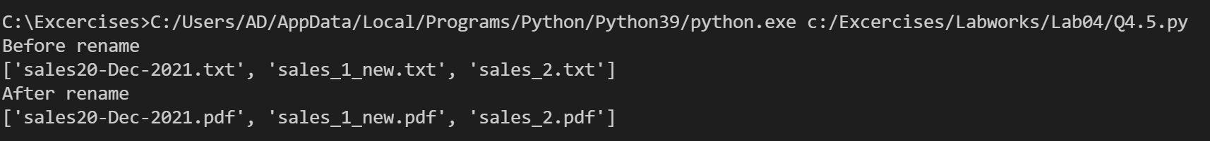
- Renaming and then moving a file to a new location




