EXERCISES

Lesson1.html: Create the HTML Web page as follows:

Lesson2.html: Create the HTML Web page as follows:

Lesson3.html: Create the HTML Web page as follows:



Request:
- Only enter values for 1 <n <100
- Build calculation functions from external Java.js File

Lesson4.html: Create the HTML Web page as follows:



Lesson5.html: Create the HTML Web page as follows:

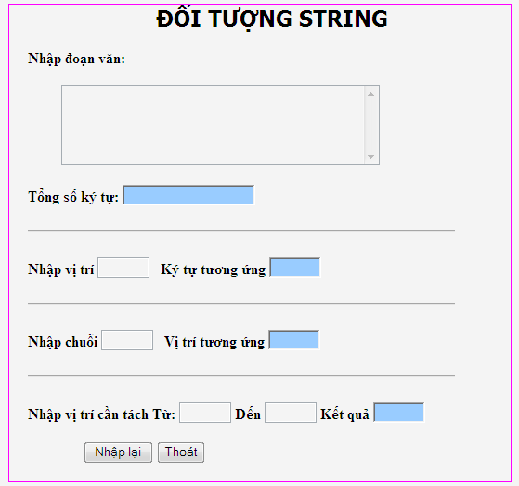

Lesson6.html: Create the HTML Web page as follows:


