ROMAN – EXPLORING by making break-points
- Background:
  - Time Line of New Testament:
  - Background of The Book of Roman:
    - Sumary of Romans Intro (NIV): this letter was written Paul (Saul)
      - Addressing the believers in Rome to Jesus-followers living directly under the shadow of Caesar, he is appealing for help to bring the gospel to the western part of the empire
      - God’s plan for the world has been revealed through a descendant of king David—Jesus the Messiah. This message demonstrates that God has been faithful to his covenant with Israel.
      - The flow of the letter follows the pattern of the ancient Jewish story of slavery and rescue
      - he closing emphasis is on the practical shape of a redeemed humanity’s new way of life.
    - From Bible-Hub – source https://biblehub.com/summary/romans/ :
The book of Romans is a Pauline Epistle (letter from Paul). The Apostle Paul wrote it roughly about 56-57 A.D. The key personalities in the book of Romans are the Apostle Paul, and Phoebe who delivered this letter. Paul wrote the letter to the believers in Rome, hence the name “Romans”. He wrote it to give them a concrete theological foundation on which to construct their faith and to live for and serve God effectively.
The book of Romans reveals the answers to important questions and supplies information on many topics, such as salvation, the sovereignty of God, judgment, spiritual growth, and the righteousness of God. Many scholars also describe it as The Gospel and the Righteousness of God,which can be received only by faith in the atoning death of Jesus Christ.
The focus of the “righteousness of God” is foundational throughout the book of Romans. In fact, it is threaded through every section of the basic outline of this epistle. Paul reiterates this so that the reader may realize that salvation cannot be attained through man’s good deeds but only through faith in God’s righteousness: "I am not ashamed of the gospel, because it is the power of God for the salvation of everyone who believes... For in the gospel a righteousness from God is revealed, a righteousness that is by faith" (1:16-17). You cannot repair your relationship with God through your good deeds; this is only accomplished through faith in the perfect and finished work of Jesus Christ.
- In chapters 1-8, Paul explains the fundamentals and foundations of the Christian faith. This is the Gospel Message, which all believers are commanded to share with the entire world. Some of the most popular and precious memorization passages about Salvation can be found in the first several chapters of Romans, “For the wages of sin is death, but the free gift of God is eternal life in Christ Jesus our Lord” (6:23). Paul teaches about the sinful nature of all men in the eyes of God, justification by faith in Jesus Christ, freedom from sin, and victory in Christ.
Chapters 9-11, Paul explains God’s sovereignty over salvation. He also spells out how an individual may come into a right relationship with God:"if you confess with your mouth Jesus as Lord, and believe in your heart that God raised Him from the dead, you will be saved; for with the heart a person believes, resulting in righteousness, and with the mouth he confesses, resulting in salvation." (10:13). Place your faith and trust only in what Jesus Christ has already done on the cross and make Him the Master of your life and trust He raised Himself from the grave conquering death. His promise is"You will be saved''.
In chapters 12-16, Paul gives instructions for all Christians about how to live a holy lifestyle. In the beginning of chapter 12 he writes, “Present your bodies a living and holy sacrifice”, and “Do not be conformed to this world” (v. 1-2). Much of the errors and trials that Paul dealt with in his “Epistles”, were because the believers had conformed their lives to the world and not to God.

---------------------------------------------------------------------------------------------------------------------------------------
- Chapter 1:
  - Verse 1 – 7:
    - Take break-points:
      - Paul:
        - a Servant of Jesus Christ (verse 1)
        - was called to be an apostle
        - set apart for the Gospel of God
      - The Gospel Of God: (verse 2)
        - Characteristic: God promised beforehand through His prophets in the Holy Scriptures
        - Content: Regarding/Concerning to His Son (Son of God)
      - Son Of God: (verse 3 - 5)
        - Earthly Life: was a descendant of David
        - Through Spirit of Holiness: was appointed the Son of God in power (by his resurrection from the dead)
        - Name: Jesus Christ – Our Lord
        - Benefits from Him:
          - We received grace
          - We received apostleship
=> To call all the Gentiles to the obedience that comes from faith (for his name’s sake)
      - Person who is in Rome (the Gentiles): (verse 6) you also are among those Gentiles who are called to belong to Jesus Christ -> Paul wrote this Letter to all in Rome who are loved by God and called to be his holy people.
    - The Flows of this Chapter:

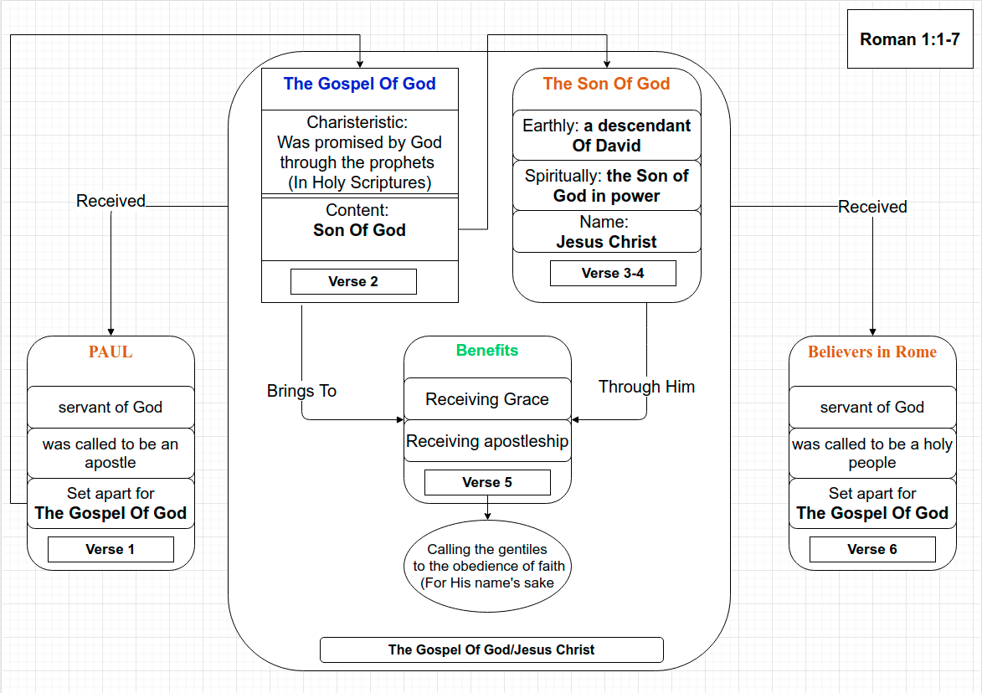
    - Explaining:
The same way with other letter that Paul sent to another churches. He always starts a letter with showing his faith to others to confirm what he believe and trust in. And this is what he writing in this letter for confessing his faith:
Firstly, Paul says that: "I am a servant of Jesus Christ" → He is a servant of Christ, "called to be an apostle" → be chosen by God and "set apart for the Gospel of God" → His mission of what God want him to do.
Secondly, Paul receive the Gospel which is the Gospel was promised by God through His Prophets in Holy Scriptures (This is an Old Testament Scriptures – what the Jews had in this time) (verse 2) and he reveal that this Gospel concerning to Jesus Christ (His Son.
Next, Paul brings to people in Rome What benefits come from the Gospel (through Jesus Christ) → Grace and aspotleship → Received Grace and Received apostleship.
Not just receiving grace of God, but still receiving apostelship from God means you received a responsibility and that is calling the Gentiles to the obedience that comes from faith (for His name's sake). But don't misunderstand here, Paul says in this verse to the people in Rome – he did not confirm that believers in Rome were called to be apostles – but to be a Holy People of God because being apostle is a special calling from God, I remind the responsibility because the Great Commandment from God in Matthew 28:18-20, Acts 1:8. Paul received a special calling to be an apostel for sharing the Gospel of God to the gentiles → that's special calling (from God – He appeared to Him and calling Him) – but even though we (or people in Rome) have no special calling to be a anpostle as Paul – however, for discipleship and make God's Kingdom become larger → so The Great Commandment still need to do for "make disciples of all nations".
Lastly I wanna say, don't just receiving and staying there, keeping it for ourself. But when you received grace of God, you should do what He wants us to do "calling the gentiles to the obedience that comes from faith" means simply that sharing Gospel to them that they can know about Jesus and believe in Him, that's the way to call them to the obedience through faith (same with what Paul want to do to Rome and other Gentiles as well as – verse 14-15). Simpler to say: sharing what you received from God to others.
    - Main idea:
Paul express the Gospel of Jesus Christ by what he received to remind believers in Rome about what they received and what mean to them when they receive it
    - Application:
Confirming our faith – what do we believe? How did you response with the apostleship?
Doing: Standing and sharing Gospel to other for bringing them back to the obedience through faith (For Jesus's name sake)
---------------------------------------------------------------------------------------------------------------------------------------

---------------------------------------------------------------------------------------------------------------------------------------
  - Verse 8 – 17:
    - Take break-points:
      - To God:
        - Giving thanks to Him though Jesus Christ - because your faith is being reported all over the world. (God – who I serve in my spirit in preaching the Gospel of His Son → who is my witness for how constantly I remember you in my prayers – at all the time)
        - Pray that now at last – the way will be opened for me to come to you (by God’s will)
      - To You:
        - I long to see → To impart to you some spiritual gift to make you strong. (meaning you and I may be mutually encouraged be each other’s faith)
        - I wan you to be ware: I planned many times to come to you → I might have a harvest among you, just as I have had among the Gentiles (but have been prevented from doing so (? → have a harvest among the other gentiles) until now)
        - I am obligated (mắc nợ) both to Greeks and non-Greeks, both to the wise and the foolish → That why I am to eager to preach the Gospel to you (who are in Rome)
      - Why preaching the Gospel?:
        - For I am not ashamed of the Gospel → Because it is the power of God that brings salvation to everyone who believes: (first to the Jews, then to the Gentiles)
        - For in the Gospel: The righteousness of God is revealed (That is by faith from first to last) → just as it is written: "the righteous will live by faith"
    - Flows of scriptures:
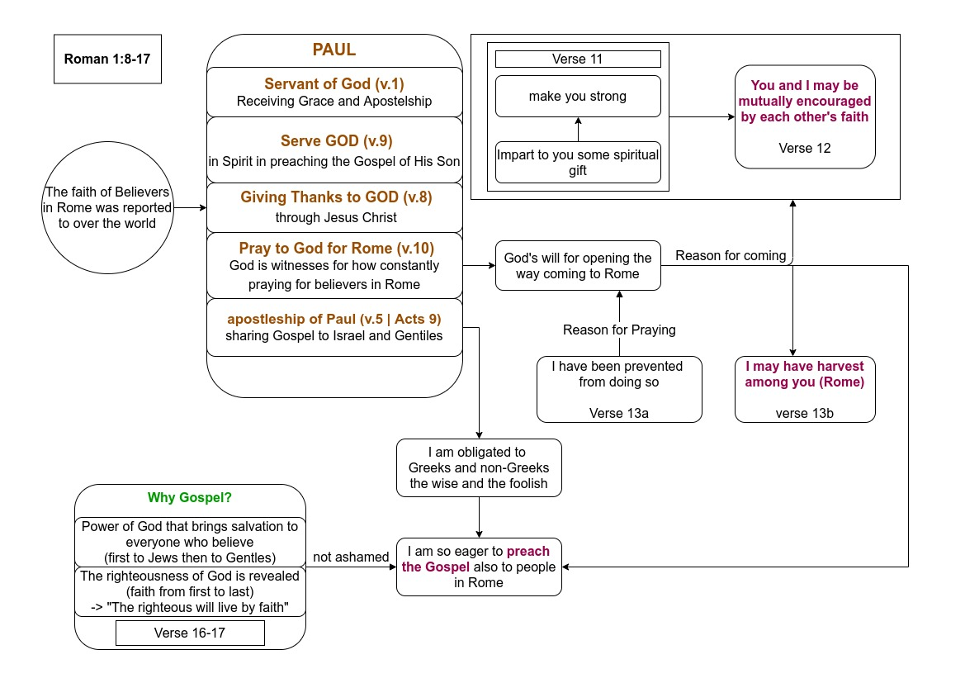
    - Explaining:
Paul starts the letter with the giving thanks to God for the faith of people in Rome | the faith that was reported to over the world. This point express that the people in Rome had the truth faith in Christ. Because of that – Paul always thanks to God and want to meet them as soon as possible like verse 11: "I long to see you ..." and he pray to God for opening the way to come to them (verse 10b)
Verse 11 also reveals that Paul not just coming to see their faith. But he has purposes and objects for what he want to do: "... so that I may impart to you some spiritual gift to make you strong" and "you and I(Paul) may be mutually encouraged by each other’s faith".
Paul continously shows his heart for sharing the Gospel to them (Rome) same with the gentiles that he have to say "I am obligated ...", → Paul eagerly to preach the Gospel because The Gospel is the power of God that brings salvation to everyone and The Gospel reveals the righteousness of God (we can see clearly through His Son – Jesus Christ who lived by faith → the righteousness lives by faith.
So the purpose for coming to people in Rome – not just sharing Gospel but being encourage in each other's faith and having harvest from believers in Rome as well as.
    - Main Idea:
Through what we reviewed by this scripture – we can see clearly the heart of Paul for ministry and people in Rome like what he did for other gentiles.
So this scripture express the careness of Paul to Rome for what he heard from believers in Rome, what he suppose to do for them and his desiring for coming to Rome for doing ministry.
    - Application:
      - Take care our sheeps who God gave us (setting time to meet and sharing on a specific time) by what we can do for.
      - Encourage our brothers and sister in faith that we can be muatually mature together and don't forget to see the harvest – the result that our sheeps gained.
---------------------------------------------------------------------------------------------------------------------------------------

---------------------------------------------------------------------------------------------------------------------------------------
  - Verse 18-32:
Paul start the the point "the wrath of God" toward people and why God have to make it?
    - Break-points:
      - God: - the wrath of God
        - revealing His wrath against all people who is:
          - Godlessness
          - wickedness
          - suppress the truth of God by their wickedness
        - invisible qualities: (verse 20)
          - are eternal power and divine nature
          - was revealed by what has been made
      - People (Who is godlessness and wickedness)
        - Toward God:
          - known about God (because God plainned Himself) – verse 19
          - has been seen clearly God's invisible qualities (by looking at what has been made) – verse 20.
          - Could not excuse the invisible qualities of God
        - Characteristic/doing:
          - Neither glorified God or give thanks to Him (eventhough they know God)
          - Thinking became futile and fool heart was darkened
          - Proclaim to be wise (but being fool) – verse 22
          - Exchanging the glory of the immortal God for images made to look like a mortal human (birds, animals and reptiles) – verse 25
          - Did not think it worthwhile to retain the knowledge of God (v.28)
          - Have become filled with every kind of wickedness, evil, greed and depravity.
          - Being full of envy, murder, strife, deceit and malice. (v.29)
          - Are gossips, slanderers, God-haters, insolent, arrogant and boastful. (v.29b-30)
          - Invent ways of doing evil, disobeying their parents, no understanding, no fidelity, no love, no mercy. (v.30b-31)
          - knowing that God's righteous decree that who du such things (from v.29-31) deserve to death -> not only continue to do but approve of those who practice them
      - God's decisions for working:
        - God ---- gave them over to the sinful desires of their heart → sexual impurity for degarding of their bodies with one another – (v.24)
        - God ---- gave them over the shameful lusts → Woman / men exchange natural sexual relations for unnatural ones. (men committed shameful acts with other men) – (v.26)
        - God ---- gave them over to a depraved mind → they do what ought not to be done – (v.28)
      - Consequence:
→ Deserve to death – receiving in themselves the penalty for their sins
    - Flows of Scripture:
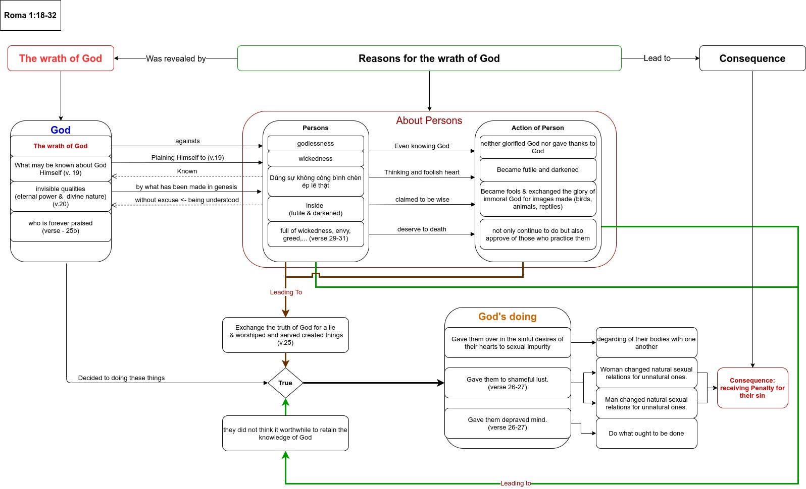

    - Explaining:
In this scripture, Paul express the wrath of God toward all the people because of their godlessness and wickedness. Further more, he points to the characteristics of that persons and what they did to know that why God has punishment for human.
Paul reveals the hardly heart of people because they neither glorify God or give thanks to Him even though they know God. (God already revealed Himself for them and alsong we can see God's invisible qualities such as eternal power and divine nature by what he made from the beginning – creation of the world). Beside that, Paul emphethizes the evil doing of persons – "they exchange the truth of God for a lie and worshipe and served created things" → God who is the One deserving for worshipping but they did not worship Him, they worship created things, instead of God. They know the truth of God – but changing that true to a lie. More, inside their thought and mind are futile and dark → they could not know that the knowlege of God is the thing that they should retain
From all above, God gave them over their desires, shamefull lust and depraved mind → that make them degarding their bodies, badly, they change the sexual relations in natura to unnatura one (men with men, women with women).
So what all they did lead them to the panalty of their sins and that were death because they are the people "..filled with every kind of wickedness, evil, greed and depravity. ... full of envy, murder, strife, deceit and malice. ... gossips, slanderers, God-haters, insolent, arrogant and boastful; ... invent ways of doing evil; ... disobey their parents; ... have no understanding, no fidelity, no love, no mercy." and they know God's decree that who did these things would deserve to death, but they actually doing it, not just that they also approve of those who practice them. → That lead them to the punishment.

We won't just stop here, but discovering more from chapter 2 to chapter 3:20 – all of them are them state of people - not just gentile, but also Jews as Roman 2:17-19:" Now you, if you call yourself a Jew; if you rely on the law and boast in God; 18if you know his will and approve of what is superior because you are instructed by the law; 19if you are convinced that you are a guide for the blind, a light for those who are in the dark, 20an instructor of the foolish, a teacher of little children, because you have in the law the embodiment of knowledge and truth- 21you, then, who teach others, do you not teach yourself? You who preach against stealing, do you steal? 22You who say that people should not commit adultery, do you commit adultery? You who abhor idols, do you rob temples? 23You who boast in the law, do you dishonor God by breaking the law? 24As it is written: “God’s name is blasphemed among the Gentiles because of you.” ". You see what Paul says about Jews? They are boast in the law of God, guider for the blind but they are in darkness and break the law. Lastly, Paul say: "What shall we conclude then? Do we have any advantage? Not at all! For we have already made the charge that Jews and Gentiles alike are all under the power of sin" -> all of people who are under the power of sin
    - Main Idea:
The wrath of God toward the people who derserve to death (penalty of sin).
    - Application:
Awareness of ourself – we are the people who deserve to death → to knowing that we need someone who take us from the death.
---------------------------------------------------------------------------------------------------------------------------------------

---------------------------------------------------------------------------------------------------------------------------------------
- Chapter 3:
- Verse 21-31:

---------------------------------------------------------------------------------------------------------------------------------------
- Chapter 4:

---------------------------------------------------------------------------------------------------------------------------------------
SUMARY OF KEYWORDS (reference) :
The following terms are key to understanding the book. We will define and examine them before we begin the book. Since Romans is a difficult book, remember that none of its teachings will ever contradict the simpler teachings found in other New Testament books.

- “Gospel”
  - The gospel is the message of the good news of salvation through Jesus.
  - Romans 1:16 – The gospel is the power of God unto salvation to all who truly believe.
  - Romans 10:14-17 – Faith in the gospel comes by hearing the word of God, not by a blind “leap of faith” or by direct operation of the Holy Spirit apart from the word.

- “Law”
  - In Romans, “law” refers primarily to the Old Testament system of commands or rules. This is similar to the book of Galatians, so the teaching of Galatians (and other books) confirms and helps us understand the teaching of Romans.
  - Romans 2:17-20,25; 10:5 – In order for one to be considered righteous before God under the law, he had to keep or do it. Note that the “law” here refers to the law that the Jews relied upon, including circumcision (2:17,25; compare 7:7). That law itself had a blessing only for those who did everything it required without ever sinning (compare Galatians 3:10).
  - Romans 3:19-23,28 – What the law could not do was justify sinners. Instead, it gave people the knowledge that they are all guilty of sin (verses 19,20,23). When people violated “the law,” it had no provision to permanently forgive (Hebrews 10:4). So what the law really did was prove that all men are sinners, but then it could not justify them from those sins (compare Galatians 3:11,16,22). This showed how much we need the sacrifice of Jesus that can forgive our sins
  - Romans 7:1-7 – Now that the gospel has come so we can be justified from sin through Jesus, we are no longer under the Old Testament. We are dead to it (verse 4) and have been delivered from it (verse 6). (Compare 6:14f; Hebrews 10:1-10; 7:11-14; 8:6-13; 9:1-4; 2 Corinthians 3:6-11; Galatians 3:24,25; 5:1-6; Ephesians 2:11-16; Colossians 2:13-17.)
  - Note that, when Romans says we are not saved by “law” or “works,” it is talking about the works of the old law, which required sinless perfection in order to have hope. We will see that it is not denying that we must obey the gospel in order to be forgiven by Jesus. The principles taught apply to the Old Testament law, but the same conclusions would apply to any system of justification which, like the Old Testament, offers justification only to those who sinlessly obey the commands (“works of law”), but then has no provision to permanently forgive violations.
- “Grace”:
  - Grace is undeserved favor by which God offers forgiveness to those who have violated His commands and therefore do not deserve His reward.
  - Romans 5:1,2,20,21 – By God’s grace we rejoice in hope and receive righteousness to eternal life through Christ. Since the old law could never justify from sins, everybody who violated it would stand condemned. One had to live a sinless life in order to have hope under “the law.” But the gospel provides the sacrifice of Jesus that can forgive sins. So we now have grace – favor with God that we do not deserve. This is the basic difference between “works of the law” and “grace through faith.” (Compare 3:23f; 4:4f; 6:14f; 11:6.)
- “Faith”:
  - Faith is belief and trust in Jesus and His gospel message.
  - Romans 5:1 – We are justified by faith so we have peace with God through Christ. Faith is essential to salvation (1:16; 3:22,25; 4:5,16,19-25; 10:13-17) because, after man has sinned, he cannot earn salvation by a life of sinless law-keeping. So we need God’s unmerited favor to forgive us through Jesus’ death. This requires us to trust Him since, by our own efforts, we do not deserve eternal life
- “Obedience”
  - Obedience mean keeping God’s commands or instructions. Some people claim Romans proves that, since people are saved by faith and grace, obedience is not necessary. But note:
  - Romans 2:5-11 – In order to receive eternal life, we must continue patiently doing good.
  - Romans 6:3,4,16-18 – To be set free from sin, we must obey from the heart the doctrine delivered to us.
  - Romans teaches, as do many other Scriptures, that obedience to the gospel is essential to salvation (see also 1:5; 4:12; 16:26; 15:18). The difference between the gospel and “the law” is that the law required a lifetime of sinless perfection, which would earn God’s favor. But the gospel offers forgiveness to those who have sinned and therefore can never earn God’s favor. Yet, to receive the forgiveness offered by God’s grace, the gospel requires as a necessary condition that each person recommit himself to serving God obediently. Those who truly trust God and appreciate His grace must willingly submit to His conditions, so they can be saved. Note that these conditions include confession and baptism (10:9,10; 6:3,4).
  - (See also Matthew 7:21-27; 22:36-39; John 14:15,21-24; Acts 10:34,35; 2:38; 22:16; Hebrews 5:9; 10:39; 11:8,30; Galatians 5:6; 2 Thessalonians 1:8,9; James 1:21-25; 2:14-26; Luke 6:46; 1 Peter 1:22,23; 1 John 5:3; 2:3-6. See also other passages about the necessity of baptism.)
  - Obedience to the gospel is essential, but it does not earn salvation. It is a necessary condition to receive forgiveness offered by God’s grace.

Source: Commentary on the Letter to the Romans Bible Study Notes and Comments - by David E. Pratte

