**ENGLISH IN DAILY CONVERSATION**

**Lesson 1**: Sounds and Pronunciation

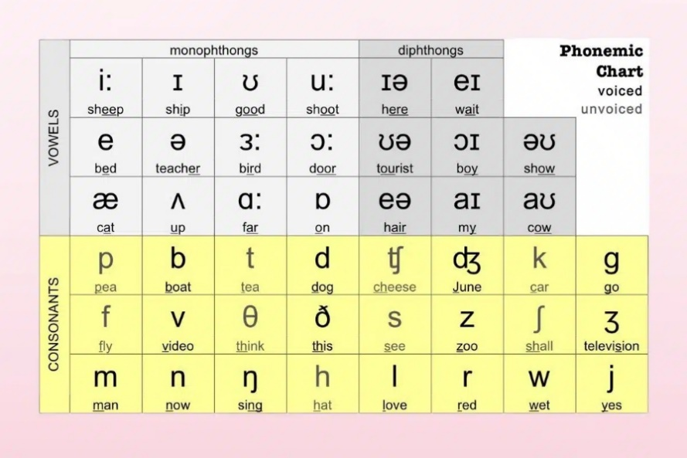In English, we have 20 vowels and 24 consonants.

In my view, the Pronunciation can be improved according to the time of communication and listening to real sound – but it does not mean that we will ignore the sound of them or learning from them.

To start with the communication – in our mindset we must illustrate the sound of the word that we are going to say – especially of the basic words.

Why saying about the basic words – for some reason, some words have the pronunciation kind of different from it spelling.

|  |  |
| --- | --- |
| Giraffe - /dʒəˈræf/ : hưu cao cổ | Shall - /ʃæl/: ~ would / will |

As I mentioned above, in communication – the pronunciation is not the first step to overcome! That would be the mouse opening! What do I mean is we need to start of talking to someone in English to help us using English naturally.

We do not need to start from the very hard thing! Don’t slide it!

Just start from the very simply ones and trying to use variant of them:

Example: Hi / Hello (formal)

=> Variants: “What’s up guy!” – “Oh! Hey guys” – “…” => these make us be natural

|  |
| --- |
| ***Note****: Don’t try to be an expert in word-pronunciation analysist! --- “just try speaking it – if it was wrong, others can correct it” – with every time of correcting – it would be in our hands!* |

|  |  |
| --- | --- |
| **Vocabularies** | |
| Good morning: xin chào (buổi sáng)  Good afternoon: xin chào (buổi chiều)  Good evening: xin chào (buổi tối)  Good night: chúc ngủ ngon | night: đêm / ban đêm  day: ngày / ban ngày  How’s going: có khỏe không? / dạo này thế nào?  What’s up guys/bro/… : chào mọi người -(should be use with friends only) |

**Lesson 2**: Self-expression | self-introduction

Listening video: <https://www.youtube.com/watch?v=sMkzwmMs0jM>

More references:

* Who asks you? – “Ai hỏi bạn?”
* That’s my duty – “đó là trách nhiệm / bổn phận của tôi”
* Spill it – “Khai mau” / “nói ra mau”
* That’s my jam – “Đó là gu của tôi”
* Talk is cheap – “nói thì dễ”
* What a surprise – “Thật bất ngờ”
* Ride or die – “sống chết có nhau”
* No pressure – “Đừng áp lực nhé”
* Are you serious? – “Bạn nghiêm túc chứ?”
* I object – “Tôi phản đối”
* It’s embarrassing – “Thật xấu hổ”
* You are so naïve – “Bạn thật ngay thơ”
* Hold your tongue – “Ngậm miệng lại”
* It doesn’t matter to me – “tôi sao cũng được”
* What’s your take? – “Bạn nghĩ sao?”
* Take a breather – “nghỉ ngơi chút đi”