Prayer Letter
Brief Introduction
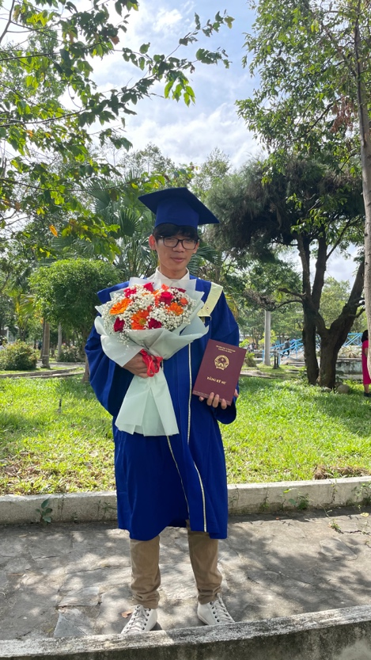
My name is Phan Ngoc Trieu, and I am 26 years old. I hold a degree in Electronics and Telecommunications Engineering from Da Nang University of Science and Technology. During my undergraduate studies, I began working in my fourth year, and since then I have accumulated four years of professional experience in the software industry at two technology companies in Da Nang. I first prayed to receive Jesus Christ in ninth grade, and in the summer of 2017, I experienced a personal encounter with Him during the Basic Bible Course in Quang Nam (Da Nang) organized by the Christian and Missionary Alliance Church (Vietnam Evangelical Church – Southern). Since that time, God has faithfully sustained my faith.
God’s calling
After about four years of working at two companies (FPT Da Nang and LG Da Nang), and with many times the Lord stirring my heart, I have now decided to serve Him full-time. The Lord’s calling upon my life has unfolded through specific stages. It began with the realization that today’s young generation has yet to be fully reached by God’s Word, as there is still division and factionalism within the body of Christ, along with lingering attitudes of disrespect toward ethnic minorities. Yet the Word of God declares: “There is neither Jew nor Greek, there is neither slave nor free, there is no male and female, for you are all one in Christ Jesus” (Galatians 3:28). This verse has served both as a reminder of the unity of God’s children in Christ and as a personal calling for me to help students and young people come to know the Gospel of Jesus Christ, which brings true unity.
In addition, I have also witnessed how members of the majority group often deceive those from minority groups, and I have listened to stories of ethnic minority youths feeling inferior to the Kinh people (the majority ethnicity in Vietnam). These experiences have deepened my burden for young people in the highlands and ethnic communities, that they may come to embrace their true worth in the Gospel of Jesus Christ. Although I sensed the Lord’s calling, it seemed to come too early in my life—when I was only in 11th or 12th grade. At that time, I shared about this calling with my older sister and brother-in-law (as they were the only two in my family who believed in Christ), but their opposition left me discouraged, and I set aside that mission. Yet, the calling of God remained in my heart. I often thought about it, and during the third year of the Basic Bible Course (around grade 12), I made a promise to dedicate my life to serving the Lord in the future.
After that initial calling, through many readings of the Scriptures, the Word of God, and various mission trips (to Kon Tum, Cambodia, India, and others), as well as opportunities to share about Jesus, the fire for this calling was rekindled. While working at LG, I prayed about this matter for about a year, wrestling between continuing in full-time employment—where I was able to share Christ in the workplace and was also blessed by God with favor before company leaders, team managers, and even clients from Korea—or stepping into full-time ministry, dedicating myself completely to God’s Word and the preaching of the Gospel.
The Lord stirred my heart more toward the path of ministry, reminding me of His Word in Philippians 2:13: “For it is God who works in you to will and to act in order to fulfill his good purpose.” I believe that the struggles within me and the burden I carried were truly God’s prompting for my life. Therefore, I made the decision to resign from my job and fully commit my time to serving the Lord—sharing the Gospel and nurturing the spiritual lives of students.
Ministries
After leaving my previous job, I began to devote myself more fully to ministry, spending additional time in God’s Word, in prayer, and in sharing the Gospel with others, often meeting people at cafés to talk about Christ.
1 – Ministry with NTC:
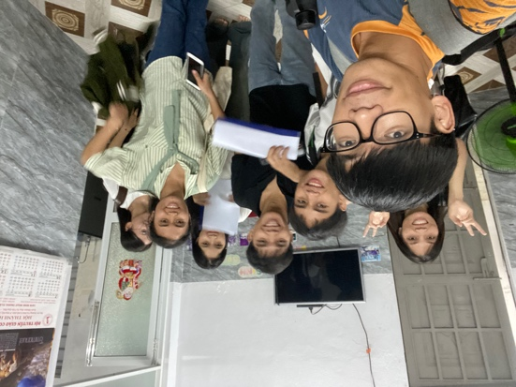
I thank God for the opportunity to serve with NTC (IVFC – InterVarsity Fellowship Christian), where I am currently helping students in small groups at the university to learn and live according to God’s Word. NTC is also the place where I was first nurtured and strengthened by Scripture through the guidance of dedicated staff members, and now I have the privilege to return and help students in the same way. I believe this is the environment where God is calling me to continue building up generations of faithful believers who hold fast to His Word. I am grateful for this calling and humbly ask for prayers that God may grant me grace in this ministry, enabling me to help students draw closer to His Word, and that I myself may live faithfully according to what He has taught me, becoming a source of encouragement and blessing to the students at NTC. Along with supporting the students, I have also been given the chance to join Bible training courses and reconnect with staff and co-laborers in ministry, encouraging one another and experiencing more of God’s transforming power. Returning to NTC feels like coming home—I have met again with many brothers and sisters who once walked alongside me in Christ. Though some have moved on, many remain faithfully serving here.
Currently, I am serving as a part-time collaborator with NTC, but I have also submitted an application to become a full-time staff member. I expect to receive the results around early October. I sincerely ask for your prayers—that I may find favor before God, the staff, and the students, and that I may successfully pass the interviews and probation period (if accepted), so that I may officially serve full-time with NTC and continue the work God has placed on my heart.
2 – Vision Church:
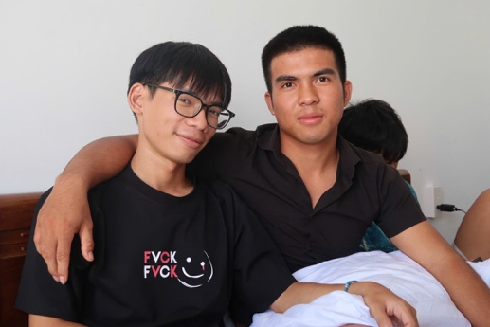
I thank God for the ministry environment at Vision Church, where I continue to reach many students, most of whom come from ethnic minority backgrounds. Here, the Lord has shown me the great need among these young people, who often face difficulties, discouragement, and uncertainty in life, and who desperately need the Gospel of Jesus Christ. At present, I am spending much of my time with the young men in the church, encouraging, supporting, and bringing God’s Word to them.
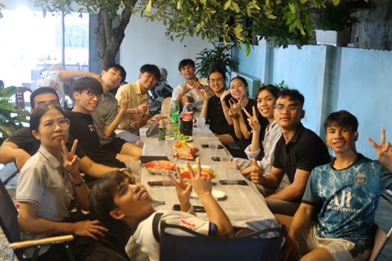
The number of male students in Vision Church is relatively small compared to female students. While my ministry primarily focuses on discipling the young men, from time to time a few young women also approach me to share about their struggles. Please pray that God would grant me wisdom in discipling the young men and discernment in speaking with the young women, so that everything may remain clear, transparent, and above reproach, giving no cause for stumbling.
3 – Vision English Club:
This is a place where I regularly join with the translation team of Vision Church to support hosting the club, connect with newcomers, and share about Jesus with friends at Vision Café. I thank God that during this time, I have been able to reach out to two young men, Nguyen and Gia, with whom I have shared the Gospel. Although they have not yet opened their hearts to accept Christ, Nguyen has started exploring God’s Word. Please continue to pray for Nguyen, that the Lord may touch and transform his heart, and also for Gia, that he may be willing to seek and learn more about the Gospel. In addition, I have shared with a young woman named Truc, who has shown curiosity about Jesus while exploring the idea of the multiverse. Please pray that God will give me further opportunities to meet her and continue sharing the Gospel of Christ with her.
4 – Men’s Ministry, Harvuta Small Group:
This ministry is where I, together with another brother, have daily morning devotions at 6:00 a.m., encouraging one another with the Gospel and practicing awareness of God’s presence in every aspect of our lives. The goal of this ministry is to build up men for Christ—laying the foundation for further discipleship both in the church and at NTC. Please pray for us to remain humble before God, receptive to His teaching, and focused on Him, so that our lives may be continually transformed to become more like Jesus Christ.
Fund Raising
One of the challenges I am currently facing and prayerfully considering is the issue of finances. With the present cost of living in Da Nang, a minimum of about 5.6 million VND per month is required to cover basic expenses such as rent, food, utilities, and other necessities. To live more comfortably and have the flexibility to spend time meeting students in cafés for conversations and ministry, the minimum needed would be around 6.6 million VND per month.
At this point, since I have not yet officially entered full-time ministry, I do not receive any regular financial support or salary. Currently, I am assisting students in the church through part-time work as an English teacher, which provides me with about 2 million VND per month. However, this amount is not sufficient to meet monthly living expenses. Looking ahead, as ministry responsibilities grow and as future needs arise—such as marriage and family care (which I am also prayerfully considering)—the financial gap will likely increase.
Therefore, I humbly ask for your prayers, that God would provide for my basic needs in a steady and faithful way. I continue to trust in the Lord’s provision, as David wrote: “I was young and now I am old, yet I have never seen the righteous forsaken or their children begging bread” (Psalm 37:25).
If you feel led to support me, please feel free to contact me. Any contribution, no matter how small, is deeply valuable to me and precious before God. As Jesus said, “And whoever gives one of these little ones even a cup of cold water because he is a disciple, truly, I say to you, he will by no means lose his reward” (Matthew 10:42). I believe the Lord will use such offerings to sustain me, just as He multiplied five loaves and two fish to feed more than five thousand people (John 6).
Staff’s Name | Phan Ngoc Trieu (John)
Target / month | 6.600.000 đ
Target / year | 80.000.000 đ
Sponsor | 200.000 đ
Part-time job | 2.000.000 đ
Fund Raised | 0 đ

Above all, I humbly ask for your prayers that I may continue to rely on the Lord, trusting in His sovereignty and provision, and learning patience and contentment in every circumstance. Please also pray that God would continue to use my life for His glory.
Finally, thank you very much for taking the time to read this letter. I kindly ask that you continue to remember me in prayer in the following areas:
- Pray that I may grow in discipline and perseverance, working diligently and teaching God’s Word faithfully.
- Pray that I may remain humble before God’s Word and be given wisdom in my relationships with brothers and sisters in Christ.
- Pray for my fundraising efforts, that the Lord would provide for my needs.
- Pray for me to use my time wisely and fruitfully in ministry.
This letter contains personal information, so I respectfully ask that you keep it confidential.
May the Lord Jesus bless you and pour out His grace upon you.
Thank you.

