To my brothers and sisters, children of God, our Father, thank you for your answered prayers and for your support in every way for me over the past month. I kindly ask you, dear children of God, to read the prayer below and continue to pray for me.
New Movement
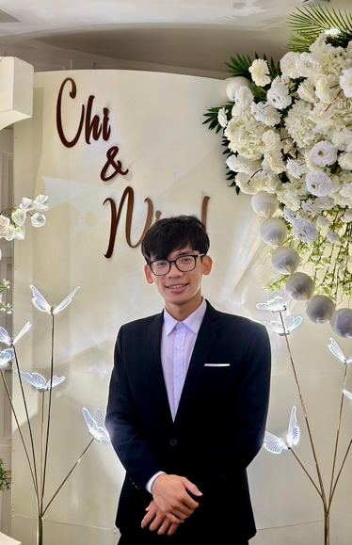
I thank God that more than two months have passed since the time I registered to become a staff member for the student ministry at the Inter-Varsity Christian Fellowship (IVCF) in the Da Nang area. I have now officially begun my 6-month probationary period as a staff member, and it has already been over a month since the official start of the probation (October 13, 2025). I thank God that after much time spent praying, waiting, and interviewing, I have officially stepped into the journey of walking alongside university students in a staff role. Although it is only a probationary period, it is a great joy and a cause for me to give thanks to the Lord.
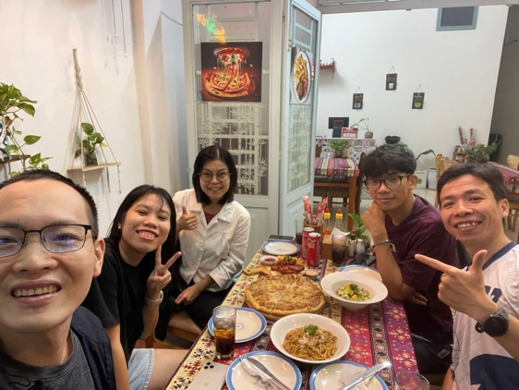
Currently, because I am serving in a probationary staff role, I am not only walking alongside students but also participating in training sessions led by other staff members on the team. Specifically, I am paired with two other male staff members to be trained in Bible study methods and how to develop worship programs based on the foundation of Scripture. After the 6-month probationary period, the staff team and I will have a time of evaluation together to make the next decision for the long journey ahead. At that time, the staff team will recognize and assess me through my probationary process here to see if I am a suitable fit for the ministry at this location. Conversely, I also need to evaluate how the past 6 months of work at the Fellowship (NTC) went, and if the environment is suitable, so that I can make a decision regarding student ministry here. Please pray for me during this probationary period so that everything may align with God's will and bring glory to Him.
Ministry
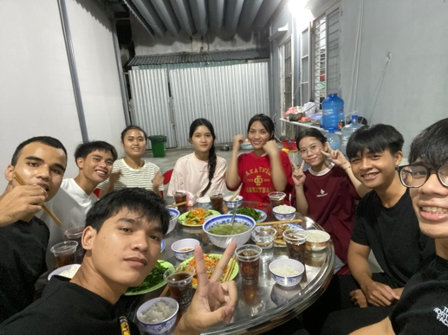
1. Student Small Group: During this time, I am continuing to walk alongside a group of students within the Fellowship community (NTC)—specifically the Luke 2 small group (which consists of students majoring in medicine and pharmacy). I am truly joyful and thankful to God for the journey with the members of this small group, as I am able to reach out to ethnic minority students, aligning with the vision and mission that God has placed in my heart.
Most of the students in this small group are from ethnic minority groups, so their faith is still very simple, but their love for the Lord is immeasurable. They are always eager to spend time learning God's Word and knowing more about Him.
Walking with them, listening to them, and seeing the struggles they are facing is truly a grace God has given me. Looking at what they are dealing with and going through—in their daily life, relationships, emotions, and especially the economic challenges of paying tuition—I am truly moved and want to help them more with what God has provided for me.
I also thank God that even though I have only met these students for less than half a year, I still see God's grace upon me through their sincere affection and trust in me. Please pray for me and for them so that we can continue to strengthen our relationships, draw closer to God's Word daily, love His Word, and that each one of us may be challenged to live out God's Word, so that many people may be touched through the manifestation of His Holy Spirit upon us.
In addition, while serving the small group, I was also able to connect with a friend named Uyên. I had the opportunity to share about Jesus, and the Holy Spirit helped her receive Jesus as her Lord and Savior. However, the path ahead requires further discipleship and support, and since she is female, I transferred her care to two female students in the group for connection and mentorship. Unfortunately, communication between us and her is not stable because her work is too busy or for other reasons, making it very difficult to consistently meet with her to study the Word. Please pray that we will continue to have God’s grace to meet with her more easily, and please pray that God will open her heart to receive the care from the two caregivers and to be open with them.
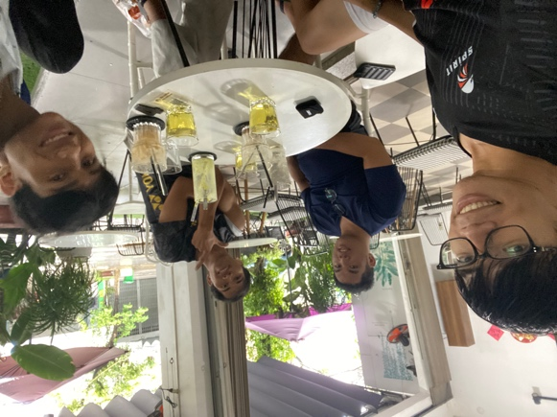
2. Vision Church: I thank God for the recent time and journey spent walking alongside the men in the Church. We have had many opportunities to hang out, share our hearts, talk, and play sports together. I believe that the men's movement in Vietnam will continue to rise in the coming years, and that more strong men living for Jesus will stand up and lead various initiatives to influence others with the Gospel of Jesus and challenge other men to continue living for Jesus.
I am also currently focusing more on connecting with specific young men, including: Ân Tứ, Pơi, Nik, and Tiến Anh from the Vision Church, and A Chuyền and Phiên from the NTC Luke 2 small group. I am dedicating time to be with them, primarily sharing and encouraging one another to continue living by the Gospel of Jesus, relying on God's Word. Please pray that I and my brothers may continue to support and encourage one another on the journey ahead.
3. Havuta Small Group: I thank God that my companion, Xuân Trang, and I have completed three months of discipleship together, committing to come to God's Word every morning, studying it together, and sharing and encouraging one another on our faith journey.
We are now preparing to begin a new journey: Breaking Chains journey, to continue fighting against our personal sins together and become victorious disciples of Jesus. Please pray for us over the next three months so that we can commit and walk together effectively under the guidance of the Holy Spirit.
4. Vision English Club: I thank God for the recent opportunities to visit the club and continue meeting friends (non-believers) to connect and share about the Lord. Although these opportunities were few, I thank God that the people there are always open to receiving and hearing the Gospel of Jesus. I am also thankful that I had the chance to share about Jesus with Mr. Cường and his wife at the club. Although the couple has not yet fully opened their hearts, I believe that the environment at the club will continue to be a place where the Gospel of Jesus is proclaimed and touches the young people in the Da Nang area.
However, due to this training period, I am unable to participate in the club consistently. Please pray that I will continue to see the Lord's harvest field here so that after my training period is complete, I can return to this community to build relationships and share about the Lord.
Finance
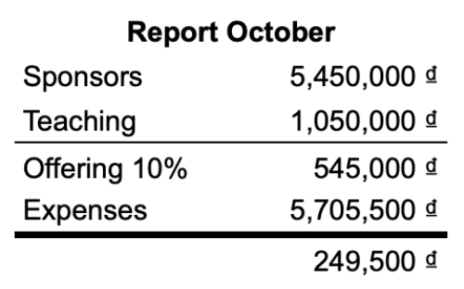
One of the issues I am currently facing and thinking about lately is finances. Given the current needs and cost of living in Da Nang, an individual like me needs 6.6 million VND per month to cover basic expenses like rent, food, utilities, etc. To have a more comfortable living allowance, which would allow me to spend more time having coffee and talking with students, the minimum required cost would be 6.6 million VND. I thank God that last month, I received both non-fixed and fixed support from the Lord through my brothers and sisters around me to help cover my expenses for the past month.
Currently, I also have a part-time job that provides 2.5 million VND/month, along with the training staff support allowance of 4 million VND/month, and fixed support from a donor of 600,000 VND/month. However, finance remains an issue for me because my donor support and part-time job are only secured until January 2026.
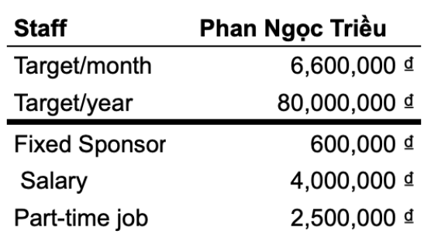
Furthermore, if my workload increases and more expenses arise later, such as taking care of my family or starting a new family (if I get married—which is also something I am considering), there will be greater difficulties. Therefore, please pray that I will continue to trust in the Lord's provision.
If you wish to support me, please feel free to let me know. Any amount is very valuable to me, and any support is precious in the sight of God, just like giving a cup of cold water to a child—the Lord says, 'he will certainly not lose his reward' (Matthew 10:42). He will also use that money to sustain me, just as He used five loaves and two fish to feed more than 5,000 people (John 6).
Above all else, please pray for me to continue relying on God, trusting in His sovereignty and provision, and learning patience and contentment in every circumstance that comes my way. And please remember me in prayer for the following topics:
- Staff Probation: Please pray that the Lord continues to grant grace over the next five months of my probationary period, so that the path ahead is not merely a trial but a time of refining, training, and equipping for the journey ahead.
- Student Ministry: Please pray that the Lord continues to accompany me in student ministry so that I can spend time with the students in a deeper way and guide them toward Jesus Christ the Savior—especially in the journey of discovering God's Word together.
- Victorious Discipleship: Please pray for the Lord's presence and accompaniment on the 3-month 'Victorious Discipleship' journey, so that I may examine myself before the Lord, bravely receive correction, and be strengthened to obey His Word.
- Men's Fellowship: Please pray that the Lord walks with me in fellowship with the young men at Vision Church and NTC, so that we may continue to walk alongside each other and encourage one another to keep advancing and growing in God's Word to become men of God.
- Spiritual Discipline and Training: Please pray that the Lord grants grace over my spiritual life regarding the discipline of reading, studying, and applying His Word. Additionally, please pray for God's wisdom in training many young people in Inductive Bible Study (2-3 courses in the near future).
- Relationships and Finances: Please pray that the Lord grants grace over my community relationships and that the Lord opens doors regarding my financial situation.

This letter contains sensitive and personal information; I kindly ask that you keep it confidential.
May Jesus Christ bless you and fill you with His grace.
Thank you

