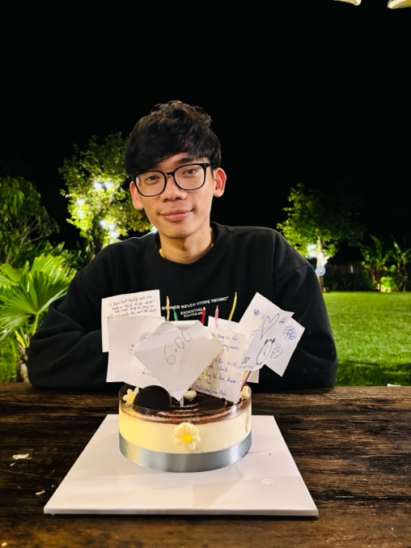
Thanks
Dear Partners and Supporters,
I would like to express my deepest gratitude for your partnership and support during my journey of walking with the Lord in full-time ministry over the past year. Your support and prayers have been vital to both myself and the ministry, ensuring that our work is filled with God’s grace and easing the burdens of the task.
On the occasion of the New Year, I pray that the Lord continues to be with you throughout a 2026 filled with His abundant blessings. May His grace continue to pour over you, and may the Holy Spirit work through you so that your work, your heart, and your service will bring even greater encouragement to many.
Looking back on the past year, I have had time to reflect on everything the Lord has bestowed upon me and all that I have experienced. While my reflections may not capture everything, I can clearly see His overwhelming blessings in my life. Below is a report of my journey over the past year, as well as an update on the current state of my ministry.
Thanksgiving for the Past Year:
- For Provision through Work: I thank God for the job He provided, which has given me the income to support my family, cover my living expenses, and help students in need.
- For Growth and Learning: I am grateful for the opportunities to learn and develop at Church, NTC, and within my company over the past year.
- For the Ministry at Vision Church: I thank the Lord for the opportunity to serve alongside the brothers and sisters at Vision Church and to walk with its various departments.
- For Fellowship through Sports: I thank God for Pickleball, soccer, and badminton-sports that have allowed me to stay fit and connect with many different people.
- For the Mission to Share the Gospel: I am thankful for the chances to share the Gospel. Even when hearts have not yet turned to repentance, I pray for steadfastness to continue sharing about Him, as is the mission I received from Jesus.
- For Mission Trips: I thank God for the visits and short-term mission trips to the highlands. It was a blessing to meet, observe, and share with fellow believers there, receiving so much love and grace from the community.
- For the Full-time Calling: I am deeply grateful for His companionship and the calling He placed on my life to walk the path of a full-time servant of the Lord.
- For Spiritual Transformation: I thank God for the teaching of His Word and the work of the Holy Spirit, which changes me daily-freeing me from sin and transforming me to be more like Christ.
- For Personal Deliverance: I thank the Lord for freeing me from the guilt and shame regarding my physical struggles (nocturnal emissions), helping me view them as a physiological process rather than a doorway to sin. I pray that He continues to preserve me in the years to come.
- For Being Used by God: I am grateful that the Lord uses me for His work. Though my abilities are limited, in His hands, they have brought benefits to many people and places.
- For a Support System: I thank God for the people He brought into my life to lift me up and encourage me, helping me stay firm in my walk with Him.
- For My Parents: I am thankful that my parents are still with us and remain healthy. I'm glad they had the chance to experience owning and driving a car, but my greatest heart's desire remains the opportunity to share the Gospel with them.
- For Daily Necessities: I thank the Lord for His daily provision-clothing, food, time, breath, and finances-ensuring that I am well-provided for every day.
- For International Travel: I am grateful for the trips abroad that allowed me to see new cultures, meet different people, and witness the world around me.
- For the Ultimate Sacrifice: Above all, I thank God for loving me and dying on the cross for me, even though I am a sinner. I thank Him for never abandoning me but always walking with me in my weakness.
There are many more things I wish to thank the Lord for, more than I could conveniently list here, but I am truly grateful for His overflowing grace throughout this past year.
Family
Additional Thanksgiving:
- For Restored Family Relationships: I thank God that over the past year, the bond between my family and me has grown much closer and more joyful. Our time together has been filled with happiness and meaningful connection.
- For Provision through LG Da Nang: I am grateful to the Lord for the opportunity to work at LG Da Nang for the past year. Through this provision, I have been able to support my family in finalizing the payments for our home renovations and assisted my parents with their daily living expenses.
- For a Heart for My Family: I thank God for teaching me to care more deeply for my family than in years past. They have been my constant concern and at the center of my reflections throughout this time.

My Struggle and Prayer Request: Although I have had many opportunities to visit home, I must honestly share that I have often lacked the courage and the right moments to consistently share the Gospel with my family.
Please pray for me in this coming year:
- That God would grant me more opportunities and greater boldness to share the Good News with my family.
- That their hearts would be opened to accept Jesus Christ as their Lord and Savior, so that they may also receive the spiritual blessings and the inheritance promised in Him.

Ministry
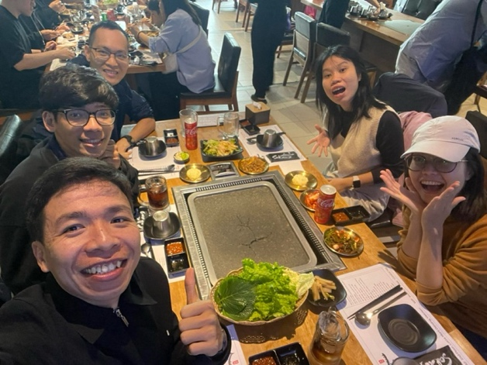
1. IVCF (NTC)
a. NTC Staff Role: It has been two months since I began my probationary period as a staff member at NTC. I am filled with excitement and joy to walk alongside my mentors, who guide, advise, and support me in developing my full potential. Over the past two months, I have had the privilege of participating in various spiritual retreats, listening to God’s Word, and learning from the life experiences of senior staff. This journey has not felt burdensome; rather, I have felt deeply cared for by everyone. Most importantly, I am grateful for the chance to meet many new students and listen to their life stories. Currently, as a probationary staff, my commitment is at least 22 hours per week (including 2 hours of rest).
Prayer Request: Please pray that I remain faithful in my role and ministry, embracing what God has placed on my heart and having intentional time to reflect on the work He is calling me to do.

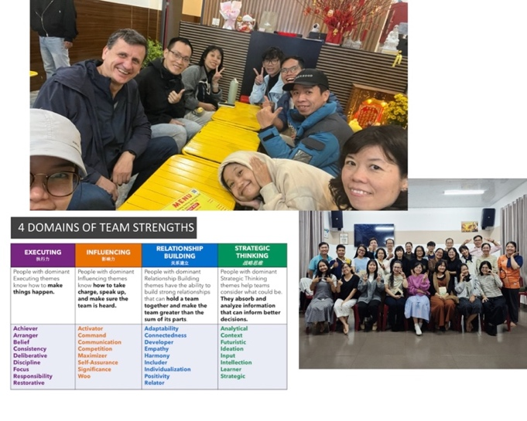
NTC Staff Retreat: I thank the Lord for our retreat in Dalat, which took place shortly after the devastating floods in Central Vietnam. It was a precious time of fellowship despite the somber news of the natural disasters. During this retreat, I met many senior staff members within the NTC community for the first time. I learned so much from their hearts and their diverse approaches to student ministry. Additionally, we took a course on "Gallup Strengths," which helped me identify my innate strengths and behaviors. While these assessments are not 100% definitive, this knowledge has helped me understand different personality types and avoid making assumptions about others.

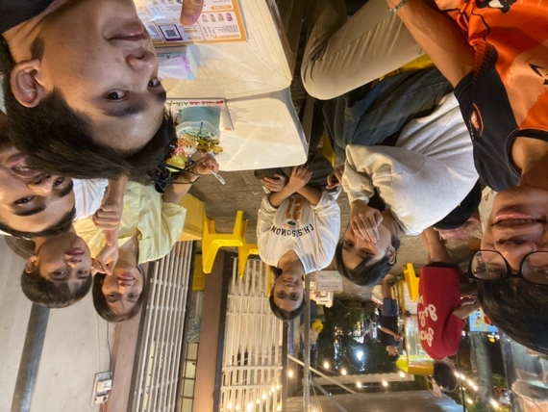
b. Luca Student Small Group
I thank God for the past semester walking with the students in my small group. I can feel the growing intimacy and trust among us. One of the most wonderful sights is seeing their increasing hunger for God’s Word and their spiritual growth. Currently, the group leaders (Diem, Trang, and Chuyen) are becoming familiar with the Inductive Bible Study method (Narrative literature) and are beginning to lead studies on their own—a significant step forward for which I am truly grateful.
Prayer requests for our leaders:
- Trang: Recently, Trang has been exhausted due to the intensity of her hospital internship, studies, and ministry responsibilities. Please pray for physical restoration as she nears the end of her internship.
- Chuyen: Chuyen faces extreme financial hardship. His primary support was cut off after his brother joined a cult and abandoned his faith. He is currently struggling to balance work and studies. Please pray for God's divine provision so he can focus on his education. (If you feel led to encourage or support him financially, please contact me for a connection).
- Diem: Despite facing many challenges, Diem maintains a positive spirit and is very passionate about God's work. Please pray for her to remain steadfast in faith and for grace as she leads the small group.
Personal Prayer Point: Pray that I remain faithful in interceding for these students, studying the Word with them, and drawing closer to Jesus together every day.

c. Gratia Student House
I am currently living at the NTC student house to encourage and disciple the students there. We recently moved to a new house closer to the city center.
- Prayer Request: Please pray that we find favor with our new neighbors and that our lives, under God's sovereignty and guidance, will be a positive influence on those around us.
- Discipleship: Please also pray for my time with the brothers in the house (Trung, Khiem, Tuong, and Gun). May we have quality time together, building each other up under the Holy Spirit's guidance to become more like Jesus every day.

2. Hội Thánh Vision:
a. Translation Ministry
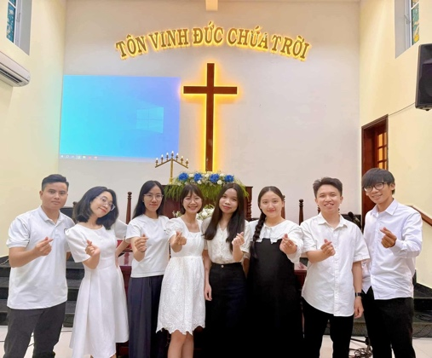
Gratitude for the Opportunity to Serve: I thank the Lord for the privilege of serving in the Translation Team at Vision Church over the past year. This journey has been a source of many blessings. One of the greatest rewards of this ministry is being among the first to receive the Word; as I translate the sermons, I have the opportunity to read and meditate on them deeply before they reach the congregation. This has significantly enriched my own understanding of Scripture.

Growth and Challenges: However, I recognize that my English proficiency is still limited.
- Prayer Request: Please pray that I can dedicate time to studying English more seriously this year, so that I may serve the translation ministry with greater excellence and accuracy.

Team Fellowship and Unity: I am also grateful for the strong bonds within our team. We meet twice a month to study the Word together and share our prayer requests. We also hold occasional spiritual retreats that allow us to share more deeply, fellowship intimately, and intercede for one another.

Prayer for the Team: Please join us in prayer for the entire Translation Ministry:
- That each member would have a deep hunger for the Word, leading to a clearer understanding of the Gospel and a personal, transformative experience with God.
- That we would all grow in our English language skills daily, enabling us to serve the Lord to the best of our abilities.

b. Discipleship & Men’s Ministry
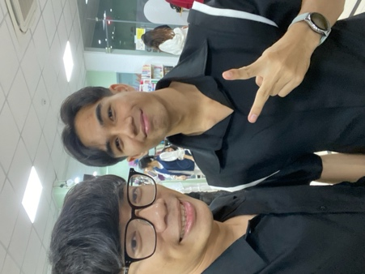
Connecting with Brothers: I thank the Lord for the recent opportunities to connect, converse, and share with many young men, both within and outside of Vision Church. I have met several brothers who desire to embark on a journey of walking together in faith. We have already planned to spend time together in the coming days to encourage and lift one another up in Christ Jesus.
Walking with An Tu: Please pray for the journey of fellowship between An Tu and me. May we experience God’s presence daily as we share and encourage one another in our respective ministries. We plan to meet monthly for Bible study, praying that the Gospel will powerfully impact our lives every day.
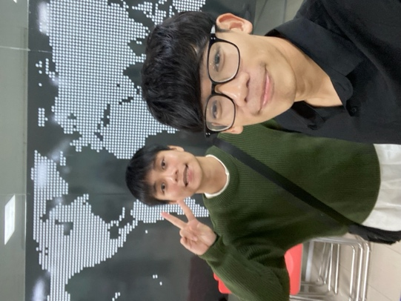
Mentoring Tien Anh: Please also pray for Tien Anh and me as we discern the decision to walk together in a mentorship relationship. Tien Anh is currently praying to seek God’s will in this matter. He is a relatively new believer with a fervent heart for the Lord’s house. As the only Christian in his family, he is seeking a mentor to walk alongside and encourage him in his faith journey.
Prayer Points: Pray for God’s will to be fulfilled in our lives and for me to have the divine wisdom to walk with these two brothers—meeting together, diving into the Word, sharing our lives, and interceding for one another.
Spiritual Warfare & Growth: Lastly, I am currently preparing for the 'Victorious Disciple' course. Together with my brother, Xuan Trang, I aim to continue the battle against the flesh and the temptations of the enemy in my life. By relying on the divine power of the Holy Spirit and the promises of God, we pray that we will no longer be bound by the deceptions of the devil, but instead, live victoriously every day in the name of Jesus Christ.

3. Ministry Website:
Vision and Progress: I am deeply grateful to the Lord for the opportunity to develop a personal ministry website to expand His work. This platform is designed to support and grow the ministries that God has placed on my heart. Currently, the website is about 60% complete and requires further development.
Prayer Request: Please pray that God grants me the wisdom to complete this website in the best way possible, so it can be effectively used for His ministry according to His will.
Key Features (Developed & Upcoming): While some areas require a login/account for ministry-specific content, many pages will be public for everyone to follow.
- Home Page: https://trieuministry.vercel.app/ – The main landing page.
- Profile: https://trieuministry.vercel.app/profile – Information about my journey and calling.
- Prayer Requests: https://trieuministry.vercel.app/prayers – A dedicated space for people to submit prayer concerns and track their status.
- Resources: https://trieuministry.vercel.app/resources – A library containing blogs, Bible studies, sermon notes, and my translated worship songs.
- Ministry Updates: https://trieuministry.vercel.app/ministry – Updates on my work, prayer points, and calls for offerings to support various ministries.
- Ministry Appeals & Reports: https://trieuministry.vercel.app/appeals – This section will host my formal ministry letters and transparent monthly financial reports.

Future Vision and Prayer: As the website is still in its development phase, it has not yet been widely publicized.
- Prayer Request: Please pray that if it is in His perfect will, the Lord would use this platform as a fruitful tool for His Kingdom.
- Provision: I also pray for God’s provision—that He would prepare partners and benefactors to help support the server maintenance and the ongoing development costs as the reach of this ministry expands.

Ministry Support & Financial Stewardship
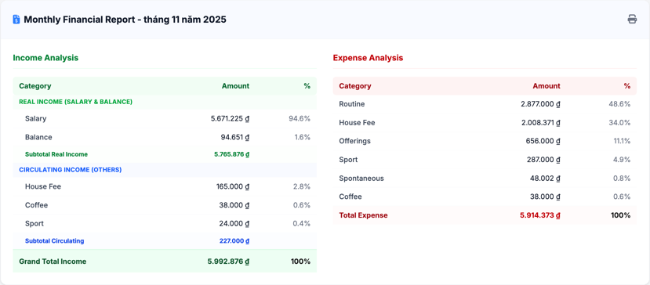
A Heart of Gratitude: I thank the Lord that through my previous ministry updates, several partners have graciously offered their financial support. It encourages me deeply to know that I am being lifted up in prayer and supported by such dedicated brothers and sisters.
Call to Partnership: To fully focus on the ministry that Jesus has called me to, I am still seeking additional monthly partners. If you feel led to support my ministry, you may contribute through the following this link.
Financial Summary (Past 2 Months): (Detailed reports are available in the "Ministry Appeals" section of the website).

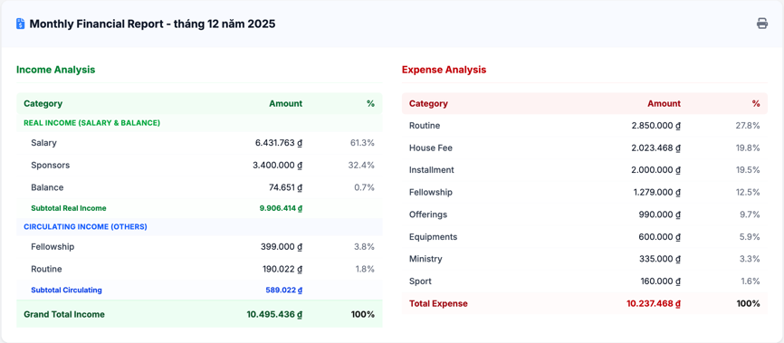
My expenses in December were higher than usual due to several essential purchases, including a new helmet and other necessary equipment (listed under the "Equipment" category). I am so grateful to the Lord for providing timely donations this past month that allowed me to meet these needs.
Prayer Request: Please pray that I will continue to optimize my monthly spending, stewarding these resources wisely and in a way that is pleasing to God.

Closing Thoughts: Thank you, dear partners, for taking the time to read this ministry update and for your faithful prayers.

Confidentiality Note: As this letter contains personal information and sensitive ministry details, I kindly ask that you keep its contents confidential.

May the Lord Jesus bless you and pour His abundant grace upon you.

With sincere gratitude,

Trieu John

