Ministry Update Letter – February 1st 2026
Ministry
1. Staff in IFES (NTC)
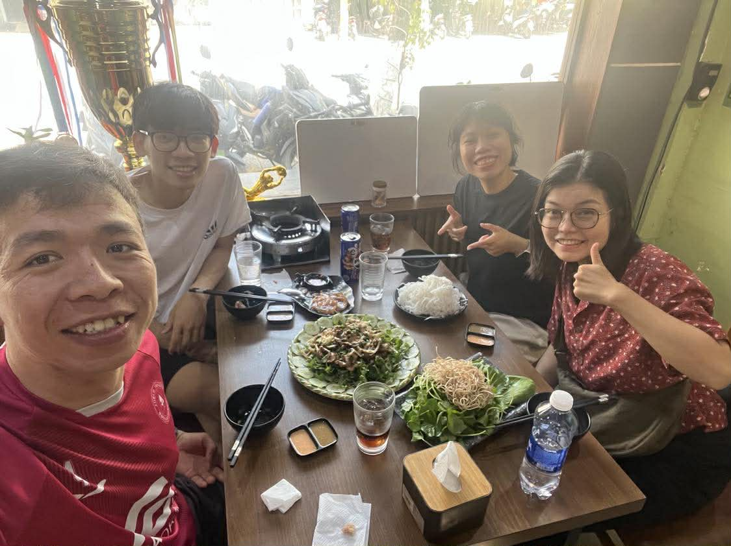
I thank God that after about four months of working at NTC in the role of a staff member, I have gradually adapted to the work, become familiar with the NTC environment as well as the working style of the other staff members, so that I may learn and work together with them for the Lord’s work to be carried out powerfully and fruitfully through the power of His Holy Spirit.

I also thank God that last Friday we had time to clean and organize our office (the place where we work) together before the Lunar New Year holiday in Vietnam. After that, we had a wonderful time of fellowship together, sharing and encouraging one another about the things we have learned and the areas we each need to improve, so that we may understand one another better and be more ready for the journey ahead. After the Lunar New Year holiday, we will certainly return to a heavier workload than the previous season in order to prepare for various plans in this new year.

2. Camping for Student’s Leaders (Da Nang)
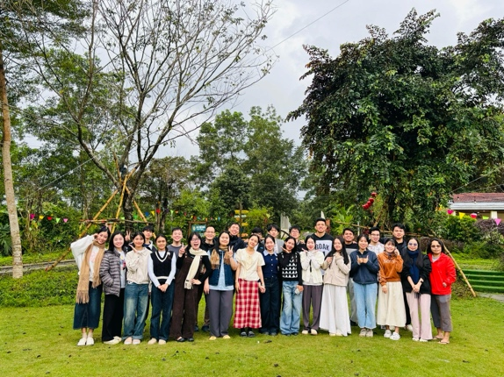
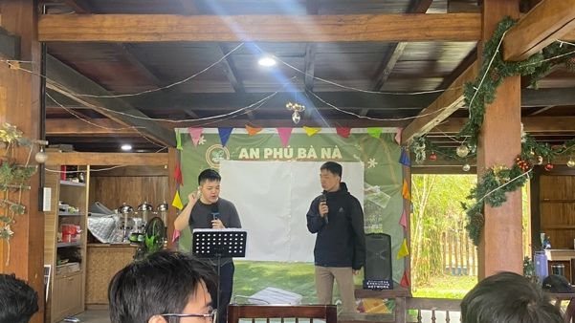
I thank God that recently we completed the camp for leaders from January 22–24, 2026. The camp was truly blessed under God’s gracious favor. Together, we went through the series on “The Sermon on the Mount” by Jesus, based on Matthew 5–7, with the theme “WOW.”

We had the opportunity to study God’s Word and respond to it based on those passages. All of us saw things that were astonishing, wonderful, and truly challenging for each one of us. Each student was amazed, just like the theme “WOW,” and ready to return and take up the challenge of living according to God’s Word.

In addition, we had time for worship and reflection on Friday evening based on what we had learned. Each of us realized that none of us can fully and perfectly live out what Jesus taught. That was also the reason why that evening we spent time looking to the cross of Christ, so that we could continue moving forward despite our failures, relying on the Lord’s strength through the Holy Spirit to overcome temptations and the struggles in our lives.

Furthermore, we thank God that we had time to talk with the small group leaders and assistant leaders, who are serving faithfully, in order to better understand the challenges they are facing as well as their needs. We also had personal conversations with individuals who needed encouragement and support, so that they may continue in what the Lord has entrusted to them.

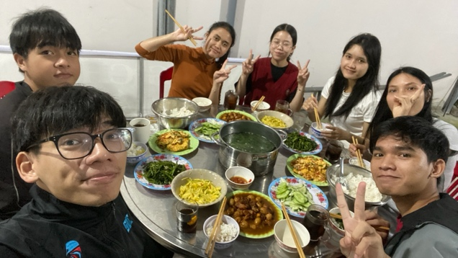
3. Luca 2 – Cell Group: Journeying together with the Luca 2 small group continues to be something that is very close to my heart and something I have been spending much time reflecting on. More than half of the semester has passed, and we have had meaningful time building joyful and strong bonds with one another in the love of Christ

I thank God that near the end of the Lunar New Year season, around February 2, 2026, we had a time of fellowship, sharing, and joy together through a warm meal. We also exchanged small gifts with one another through a “gift exchange” activity. It was a precious time that we were able to share together.

With the love that Christ has placed in my heart, I desire to join the small group in reaching more friends on their campuses. I have also been more intentional in personally sharing about the Lord with students at their schools. That is why I have several plans for the new year:
- To commit to praying weekly for the campuses and even arranging time to visit the schools to pray on-site. Currently, I am praying for three universities: Vietnam–Korea University, University of Medicine and Pharmacy, and University of Medical Technology and Pharmacy.
- To build a ministry platform to meet non-Christian friends and share about Christ with them. At present, I am considering helping the small group members with English, and through that, inviting other students to join so that there may be opportunities to share about the Lord there.
Currently, Vision Church, where I am serving, is also focusing on this area. Therefore, I may partner with the church in prayer and in connecting with students and God’s servants in that region to expand the Lord’s work.
In the new academic year, I will also train the small group in the “Three Stories” evangelism method, a tool that NTC often uses to share about Christ with non-Christian friends. The goal is to equip them with a foundational approach in communication and conversation, and to help them lead naturally into sharing the story of Jesus.

1-1 Bible Reading:
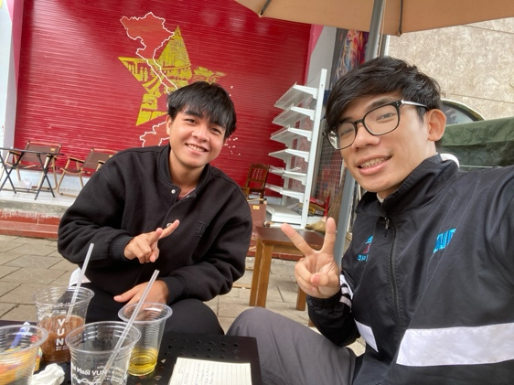
One encouraging thing I would like to share is our practice of reading the Bible one-on-one within the small group. We set a common goal to read God’s Word together and to encourage one another to stay committed to it. As a result, the members have been very active in participating in this practice. I firmly believe that coming to God’s Word weekly will help them become more deeply rooted in it and experience the powerful work of the Holy Spirit through His Word.

Currently, I am journeying one-on-one with Suel, a male student. From my observation during our time in the small group, he is quite introverted and does not share much with others. Although I have tried many times to initiate conversations, I was not able to hear much from him. However, through reading the Bible one-on-one with him, the Lord has begun to work, and I am starting to hear more of his story. I truly believe that through God’s Word and through these personal times together, many hidden stories will be opened up, and his life will be touched more deeply.

4. NTC – Worship Team:
After the Lunar New Year holiday in Vietnam, I will officially begin serving and supporting the worship team in the role of an advisor at NTC. The goal is to help the worship team grow in studying God’s Word and to guide them in selecting songs that are grounded in Scripture.

5. NTC - Frisbee:
In addition, after the Lunar New Year season, I will also take on the role of advising and supporting the Frisbee team. The purpose is to encourage them to continue developing what they are already doing and to intentionally use this sport as a means to reach more non-Christian friends.

6. NTC – Gratia Man House:
Currently, I am still living together with NTC students, serving in the role of mentoring, supporting, and providing academic guidance for the students in the house, as well as overseeing their daily living arrangements. Living together with students is always a challenging experience for me. I still experience personal failures and have made many mistakes while living with them, yet I am thankful to receive their understanding and grace.

We moved to a new place about a month ago. At present, the household is gradually settling in, and after the Lunar New Year holiday we will resume our regular rhythms of community life, such as house gatherings, sharing, studying God’s Word, and assigning household responsibilities.

In addition, I am planning to study the Bible one-on-one with Gun (a male student in the house) in order to help him grow in God’s Word and to share more deeply about the stories and experiences of our lives together.

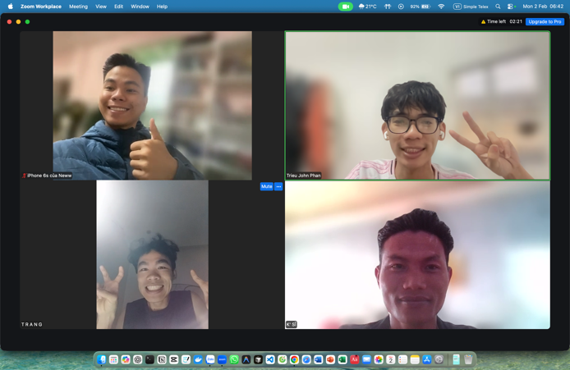
Unchained Leaders
I thank God that after a season of waiting, I have begun the “Victory Discipleship” journey together with several brothers: Xuân Trang, Ka Sĩ, and Viết Tân. This journey will likely involve many challenges and struggles, as well as intentional times of quiet reflection to look back on our past, to recognize the areas in which we have been deceived by the enemy, and to fix our eyes on the promises of God. By relying on His promises, we seek freedom from the chains of the enemy so that each of us may become a free disciple of God.

At this stage, we have only just begun one week ago, so we have not yet entered into the more intense phases that require deeper confrontation and struggle. However, we trust that the Lord will help us set aside time to sit down faithfully and complete the assignments given in each lesson we are studying.

Currently, the men’s ministry: Victory Discipleship continues to help many men in NTC and in the church to look to the promises of God in order to be set free from deception and bondage. This ministry originates from CMN (Christian Men’s Network) founded by Dr. Cole. I believe that through this ministry, I will have the opportunity to confront my own sin, respond in repentance, and speak God’s promises into the areas of my life that need freedom.

Lunar New Year Holiday in Vietnam
From February 16–21 is the Lunar New Year holiday in Vietnam. I returned to my hometown on February 9 to spend a longer time celebrating the New Year with my family and to have some rest before returning to work. During this time, I will help my family with various tasks such as cooking, cleaning the house, and other small household responsibilities. Please remember me in your prayers, that I may have a warm and meaningful time with my family and grow closer to them.
My family has not yet come to know the Lord, so facing traditional ancestral worship and ceremonial gatherings is unavoidable. Please pray that the Lord would guard my heart to remain faithful before Him, help me to honor my parents in a proper way, and protect me from spiritual pitfalls, temptations, and worldly influences during this New Year season.

In addition, during this holiday I will continue a short travel journey with several brothers from the church and visit the homes of believers at Vision Church, as well as some members of my small group (though I may not be able to visit many of the NTC small group members due to travel routes). Please pray for our safety, for God’s blessing upon the trip, and that it would bring encouragement to others, as well as encouragement to us through the people we meet and the experiences we share together.

Other Ongoing Ministries
In addition to the updates mentioned above, I am also journeying individually with several brothers: Ân Tứ (one-on-one discipleship), Tiến Anh (who will begin after the Lunar New Year), and a Bible reading time with a non-Christian friend (which has not yet started). I am also preparing Bible training materials on Inductive Bible Study.
Please remember me in your prayers, that I may faithfully complete the Bible training lessons and that these discipleship journeys with the brothers may be fruitful and blessed.

Prayer Requests
Ministry
1. Please pray that the Lord would grant grace in my ministry at NTC. In my role as a staff member, may I increasingly serve with God’s grace as I work alongside fellow coworkers, growing in humility, gentleness, and a teachable spirit.
2. Please pray for my ministry with the small group at NTC, especially in training and helping the Luke 2 small group members to walk with the Lord through His Word and encouraging them to share the gospel through the 3-Story method.
3. Please pray for my involvement with the Frisbee club and the worship team.
4. Please pray for grace in discipling the male students in the men’s house.

Personal
1. Please pray for my journey in the Conqueror’s Discipleship program, that I would grow in discipline and focus, and faithfully fight against the lies of the enemy by standing on the Word of God.
2. Please pray for me regarding relationships as I seek a future life partner. May I remain in a posture of learning, preparation, and readiness to take responsibility for love and marriage.

Closing letter
Thank you for taking the time to read and pray for me. As this update includes personal matters, I kindly ask that you keep it confidential.

May the Lord bless your work, your health, and your walk with Him. I also wish you a joyful and blessed Lunar New Year with your family.

Blessing!

Phan Ngoc Trieu (John)

