Ministry Update Letter, April 2026
Tet Holiday (Lunar New Year)
Family During the Lunar New Year
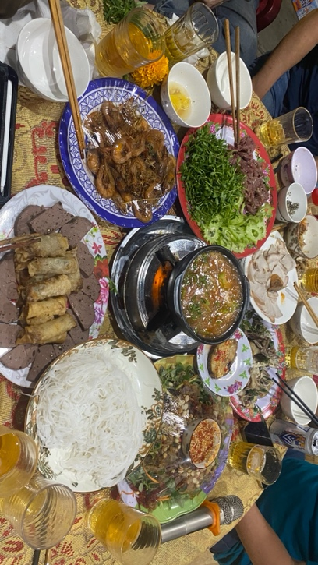
I thank God that after a period of working and living in Da Nang, the time to reunite with my family has finally come. The Lunar New Year (Tet) is a major holiday in Vietnam, when families gather together and enjoy one another’s company after a year of being away, working, and building their lives. Returning home is filled with joy, yet it also brings moments of reflection about my own life.
I am grateful to God that while being at home with my family, I was able to help my parents more than in previous years—cooking, cleaning, and preparing for Tet together. I also experienced warm and meaningful moments with them through delicious meals. My parents often wait for me to come back before holding our year-end family celebration. Alongside these meals were joyful times when our family spent time with neighbors and shared in the festive atmosphere together.
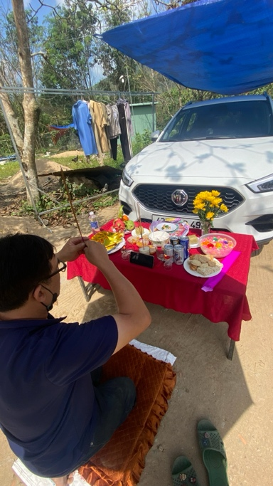
In addition, one of the moments that made me reflect the most was when my father asked me to help him by holding an umbrella to shield him from the sun. At first, I thought it was just a simple task, and I didn’t know what he was about to do. Later, I realized that I was helping him perform a ritual of offering for the car. It was the first time I had observed such a scene so clearly (although I had seen my parents perform acts of worship many times before), especially for something as significant as a car that our family had worked hard to purchase.
Many thoughts came to my mind as I witnessed this: “What is this car, really?” “Why does my father kneel before it?” “Why do we spend money to buy something, yet elevate it to such a high place?” “Why are their prayers accompanied by the words ‘A Di Da Phat’? Is this simply culture, or does it reflect a deeper system of belief that has taken root?” Alongside these thoughts was a deep concern in my heart for my family—how I might help my parents turn away from what I believe to be a misguided faith. These questions and reflections remained in my heart throughout this past Tet season.

A Trip to Gia Lai with a Stop in Kon Tum
After the Tet season, on the third day of the Lunar New Year, I set out to return to Da Nang and then travel to Kon Tum. My original plan was to stop by Gia Lai to visit some brothers and sisters there before continuing on to see friends in Kon Tum. However, during the journey, I had an accident on the way to Kon Tum, which forced me to stay there for the entire week.
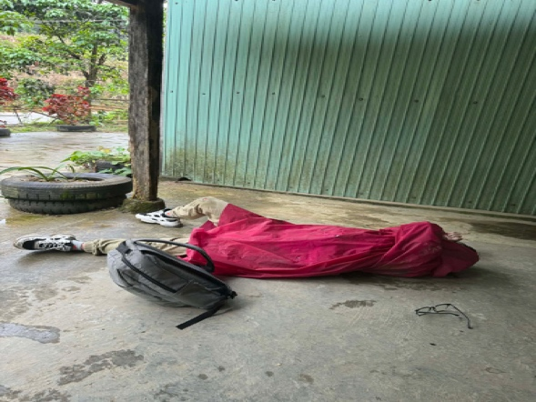
I thank God that even though the accident happened and I could not continue as planned, He still allowed me to experience many things I had rarely seen before—especially the love and care from fellow believers and the Gie people. I am deeply grateful for the wholehearted support and kindness I received during that difficult time. Ân Tứ and A Ngào, two brothers from the church, immediately left their homes and came to the place where I had the accident. Since I was no longer able to ride my motorbike, I had to lie there and wait for help.
After they brought me back to the Kon Tum area, we went straight to the hospital for an X-ray check. However, because it was still during the Tet holiday, the hospital services were not operating, so I was unable to get the X-ray done. As a result, I had to leave it untreated for a whole week, and my right arm could not be fully straightened. Even so, I thank God that my body gradually recovered, and the pain slowly decreased. During my time in Kon Tum, I was still able to visit several homes and meet with many brothers, sisters, and local people in the area.
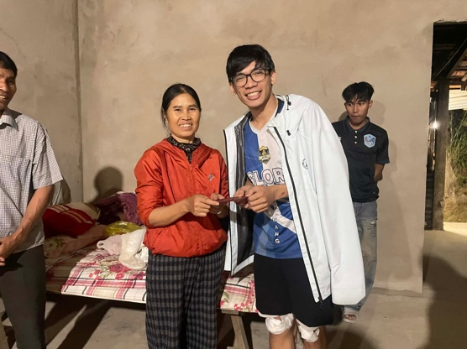
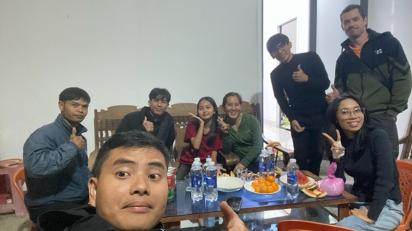
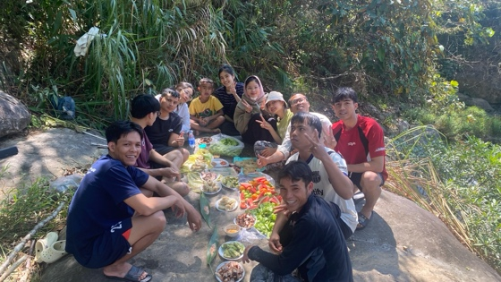
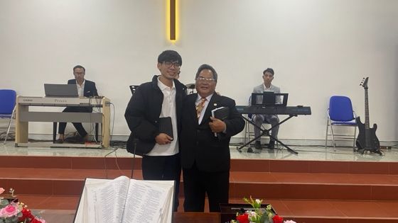
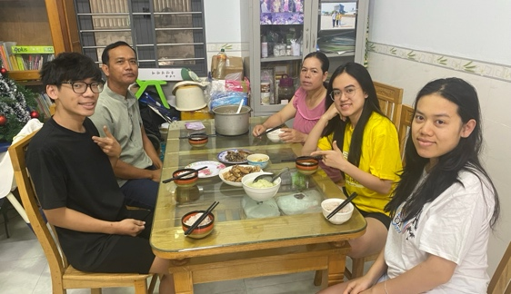
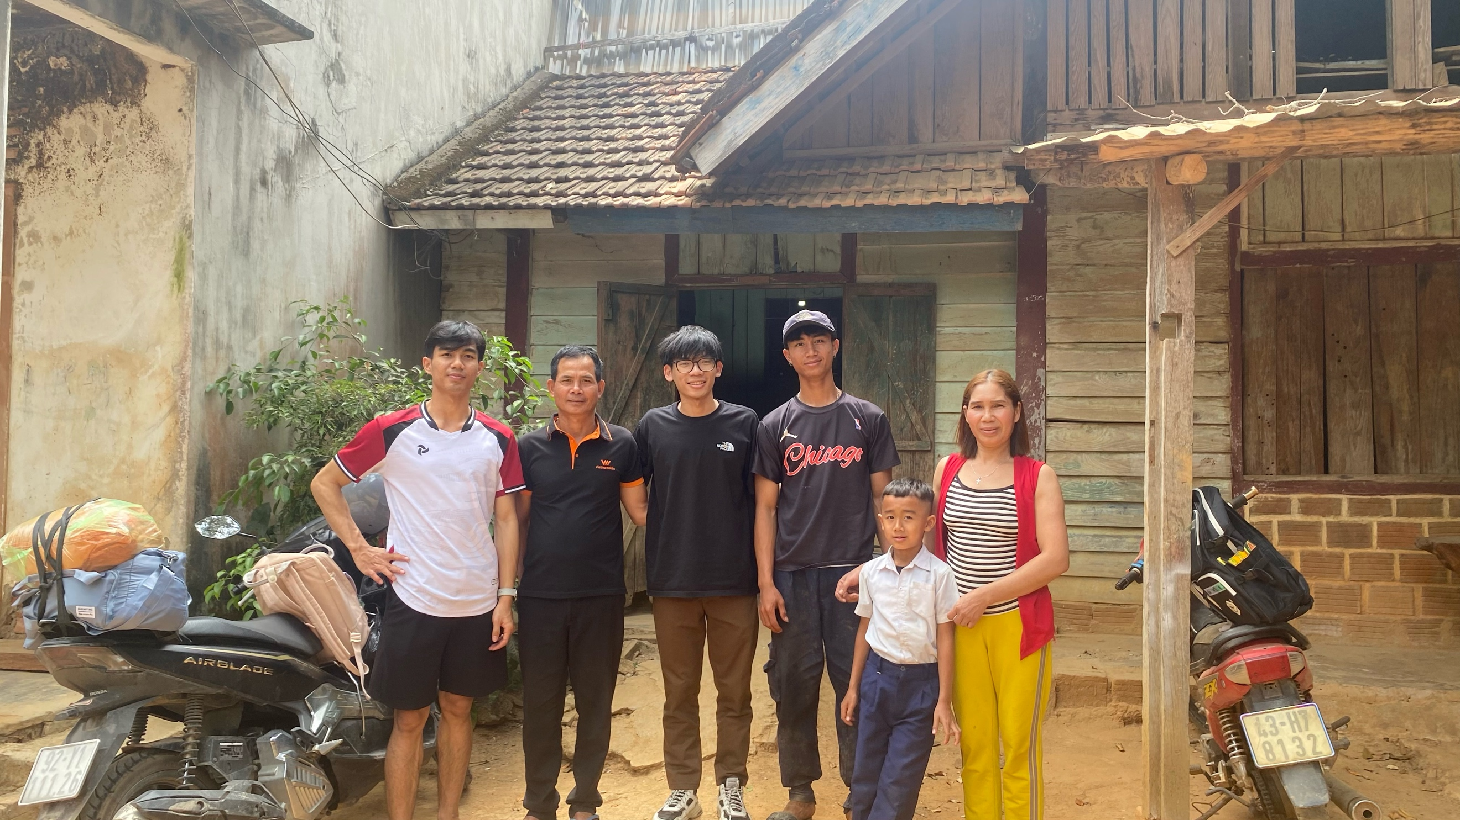
I am truly thankful to God for the love shown to me by the brothers, sisters, and families in Kon Tum. They welcomed me with joy and never complained about helping me, even though I was not physically well at the time.

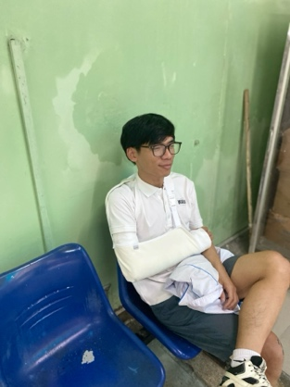
Finally, after returning to Da Nang, I went to have my arm properly examined to understand why I could not straighten it. It turned out that I had a fracture near the shoulder joint, causing the bone to be misaligned. Because of this, I needed to have my arm in a cast for about two to three weeks before beginning rehabilitation exercises.
During the time my arm was in a cast, I continued to receive care and concern from brothers and sisters in Christ. This made me realize even more how much God loves me through the people around me. Up to now, it has been about a month since I first had the cast. It has been removed, and I have gradually regained movement—my arm has now recovered about 98%. I truly thank God for that.
I am grateful for a Tet season that, although it included unexpected accidents, was still filled with joy. Through it all, God revealed Himself to me in meaningful ways, giving me new experiences and deeper reflections on my life.

Ministry Update
1. Campus Ministry – NTC:
a. Staff Role:
I thank God that I am nearing the end of my six-month probation period at NTC as a trainee staff member. During this time, I have experienced many joyful and meaningful moments, as well as opportunities to observe, learn, receive feedback, and grow while serving alongside the NTC team.
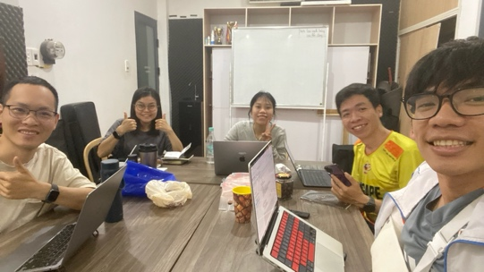
Throughout this probation period, I have been especially grateful to continue pursuing the vision God has placed in my heart—to reach out to young people from ethnic minority communities, those who need to hear the Gospel, to be prayed for, and to be transformed by God’s Word. At the same time, serving together with the NTC staff has helped me become more disciplined and intentional about this calling.
As I have observed and learned, I have also come to recognize many of my own shortcomings. I see my immaturity and realize that I do not yet have the same level of passion and burden for students as the other staff members do. These are areas where I truly need to grow and learn from their example. Despite my many weaknesses, each of the staff members has been willing to support and walk alongside me throughout this journey in every area where I needed help. I had the opportunity to be mentored by two brothers—Anh An, who has guided and trained me in studying the Bible, and Anh Hải, who has walked with me in ministry, encouraging me, helping train the worship team, and discipling young men. Walking alongside these two brothers, together with the other staff sisters, has truly been a blessed season in my life.

Moving forward, I am seeking God in prayer regarding whether I will continue serving with the NTC staff in the next season.
Please pray for me that I would remain open and sensitive to God’s will in making this decision, and to understand what He desires for me if I am to become an official staff member. I also ask for prayer for the NTC team, that they would have clarity and discernment from God in evaluating me, so that together we may come to unity—whether to continue serving together or to take a different direction. Please pray that I may find favor in their eyes. The decision from both sides will be made during this month of April.

b. Luca 2 – Cell Group:
I continue to walk alongside the Luca 2 life group. I thank God that after a long holiday break and my accident—which kept me from attending for a time—I have now recovered and been able to return to the group. It has been a joy to reconnect with the members and to be encouraged by the many conversations we’ve shared.
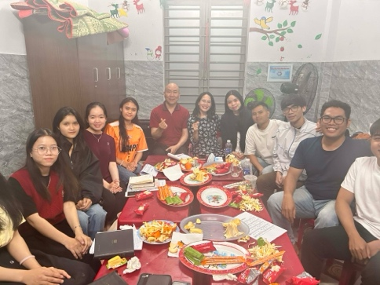
I am also grateful that recently our life group had the opportunity to meet, connect, and study God’s Word together with members of Vision Church, where I am currently involved. This time of fellowship was meant to encourage the students in our group to continue pursuing the vision and burden they carry for sharing the Gospel with students in the FPT area. The gathering was filled with joy and mutual encouragement for both the student group and Vision Church. Opportunities like this help build meaningful fellowship and connection, allowing the students to partner with faithful servants of God in advancing His Kingdom.
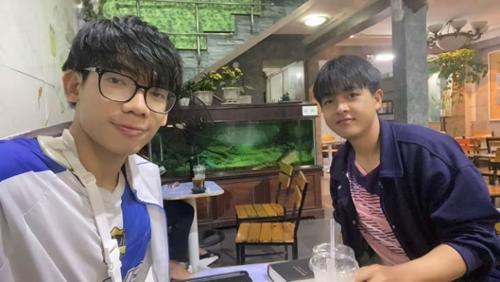
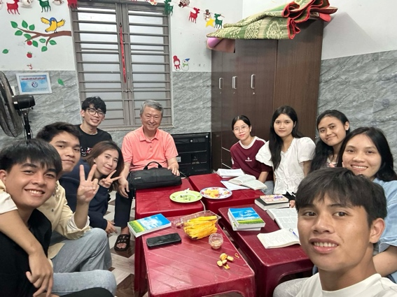
In addition, our life group had the opportunity, for the first time, to meet Pastor Lim, a Korean-American pastor from Los Angeles, affiliated with the Reformed tradition at Fuller in California. He desired to meet and encourage the students to continue in their journey of discipleship—building one another up in community and sharing God’s Word with those around them. Although the meeting happened only once, it was truly impactful, and everyone was encouraged and learned valuable lessons from him, especially on the topic of discipleship.
Through these times of connection, fellowship, and encouragement, the life group has become more active and engaged, with a growing excitement for God’s Word. I believe that each day, the students are being challenged to live for God and to boldly share the Gospel with others.

Please pray for our life group—that each member would be stirred with a hunger for God’s Word, and that His Word would touch and transform their lives as they put it into practice and live out the Gospel.
Please also pray for me as I continue to walk with them—that I would receive God’s grace and guidance to faithfully teach His Word, to stand with them in their most difficult moments, and to be ready to fight alongside them in their spiritual battles.

c. Other Areas of Ministry
In addition, I continue to be involved with the NTC worship team and the NTC frisbee ministry. At this stage, I have not yet been able to spend much time with these two groups, as I was only recently assigned to them and the period after Tet has limited more consistent involvement.

Please pray that in the coming time, I will have more opportunities to meet, walk alongside, and encourage the members of both teams. In particular, the NTC frisbee team is currently experiencing a lack of motivation and spiritual momentum. Please pray that they would be strengthened, and that God’s will would be clearly revealed to them regarding the purpose of this ministry, so they may move forward in alignment with His calling.

Please also pray for me—that I may continue to listen to God and faithfully proclaim His Word to them, so that His Word may bring freedom and transformation in their lives, shaping them into people who live in the freedom found in Him.

In addition, I have been entrusted with the responsibility of managing the NTC office. Please pray for me in this role—that God would grant me wisdom to organize and manage things carefully and effectively. Pray that I may help build a well-structured system for managing office resources, such as equipment, books, and meeting spaces. Above all, pray that I would find joy and experience God deeply in every aspect of my service.

2. Vision Church:
I thank God that Vision Church continues to be the place where I carry a burden for the young people from ethnic communities whom I long to support. I am grateful that I can still walk alongside them and study God’s Word together.

a. Man Ministry:
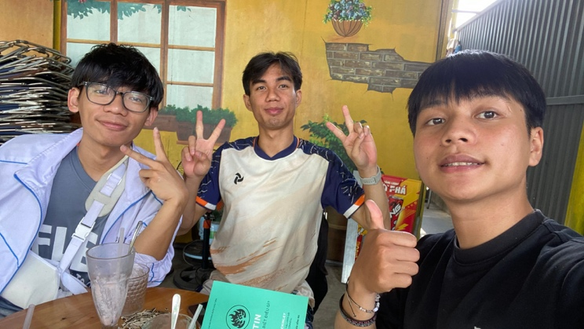
In the coming season, I will continue discipling Ân Tứ, and now Tiến Anh has officially joined this journey as well. Tiến Anh is a new believer, so he needs much encouragement, support, and prayer—especially to be firmly grounded in the truth of the Gospel, to live it out, and to reflect it in his life.

Please pray for Ân Tứ, who is preparing for his marriage on May 2, 2026. Pray that God would pour out His grace upon him during this preparation time, that everything would go smoothly, and that he would continue to grow in his walk with God—having a heart that receives truth and is shaped daily by the power of the Gospel.

Please also pray for Tiến Anh, who is in a season of seeking to know God more deeply. Pray that he would grow in grace as he receives God’s Word, and that he would have clarity in his questions, reflections, and faith journey. As the only believer in his family, he will likely face many challenges, so please lift him up in prayer.

Please pray for me as I walk alongside these two brothers—that I would find favor with them, that God would use me to faithfully proclaim His truth, and that together we would be encouraged, learn, and grow in faith through His Word.

b. Vision Worship Team:
This year, I will continue serving with the Vision Church worship team, mainly by supporting with musical instruments when needed. In addition, I have been invited to walk alongside the team in guiding them in inductive Bible study, as they desire to go deeper in understanding Scripture rather than only listening to others share.

Please pray that God would give them hearts that are faithful in receiving His Word, eager to learn, and willing to dig deeper into Scripture.
Please also pray for me—that God would grant me grace in studying His Word, applying it to my own life, and preparing lessons to study together with the team.

At the same time, I am planning to invest time in studying, researching, and writing about worship under the theme “From the Temple to the Body.” My desire is to better understand worship personally and also to help the worship team gain a deeper, Word-based understanding of worship—not only as singing before the congregation, but as a lifestyle of worship lived out daily.

3. Works & Personal Plans:
After the events that took place in my hometown during this past Tet, I have been reflecting on investing time in studying the area of “culture, Buddhism, and Christ.” My desire is to better understand Vietnamese culture and the influence of Buddhism within it, so that I may respond from a biblical perspective. Through this, I hope to help myself and fellow co-workers better understand cultural beliefs, engage meaningfully with Vietnamese people, and ultimately share the Gospel more effectively.
Please pray for me—that I may clearly discern God’s will regarding whether I should invest in this area.
Pray also that I would approach this matter with wisdom, seriousness, and faithfulness if it is truly aligned with His purpose.

In the near future, I am also planning to invest in two areas:
First, studying for a car driver’s license:
I believe this is a suitable time, as I still have some flexibility, to prepare myself by obtaining a driver’s license. This would allow me to be ready if God calls me to serve in areas that require travel, such as short-term mission trips, or even to serve my family and other needs. I feel it is better to prepare early rather than wait until later.
Please pray for me to discern God’s will in this decision, and for His provision regarding the finances needed for this training.

Second, continuing to improve my English:
I am working on strengthening my English through sermons, study materials, and focused IELTS preparation, with the goal of taking the IELTS exam in the future. Having an IELTS certificate would open opportunities for me to pursue theological studies abroad, if God leads in that direction. In addition, I am serving in translation ministry, so I desire to improve my English in order to study God’s Word more deeply and faithfully translate it for His people.
Please pray that God would grant me wisdom, good memory, and discipline in learning and using English. Also, please pray for financial provision so that I may enroll in courses and take the exam in the coming time (with a plan to take the test next year).

Acknowledgment& Financial Need
I thank God for the partnership of all dear supporters during this past season—both in prayer and financial support. Your generosity has helped bring stability to my journey of serving God full-time. I pray that God will continue to bless your lives abundantly, that His grace may overflow in you, and that He will sustain and strengthen your faith so that you may continue to grow in the love of Christ.

At present, I am continuing to raise financial support for the journey ahead. There are increasing needs due to changes in the cost of living, as well as upcoming responsibilities such as personal development, supporting students, and spending time meeting and ministering to them. If you feel led to give or support, please feel free to contact me, send me an email, or refer to the information on my page.

In the coming time, if it is God’s will and I am officially accepted as a full-time staff member at NTC, there may be changes regarding my support-raising approach. I will provide updates to all supporters accordingly.

Thank you again for taking the time to read and to pray for me. As this letter contains personal information, I kindly ask that you keep it confidential.

Thank you very much.

Phan Ngoc Trieu

Note: If anyone of supporters who need to acknowledge my financial expenses, you can access to my financial report according to this link.

