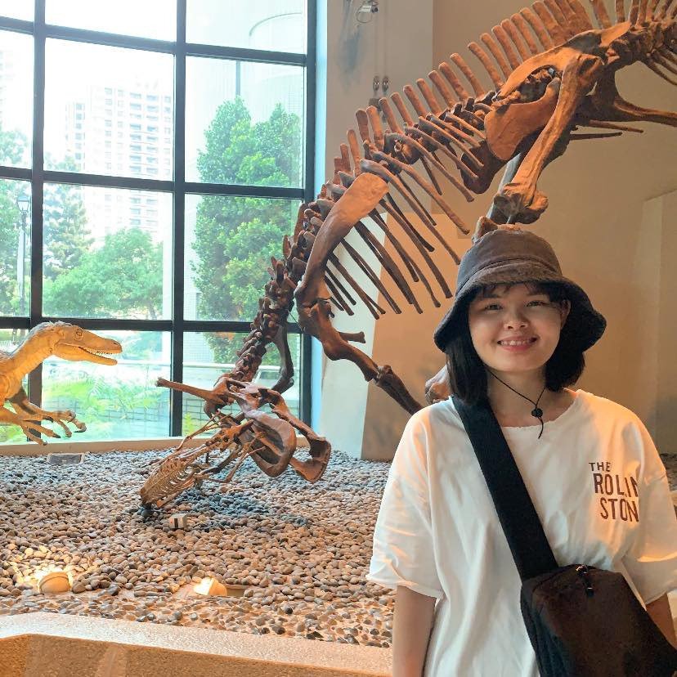

**Ngoc Phan (Jennie)**

I'm currently pursuing my Master of Engineering degree at the Department of Geodesy and Geomatics Engineering at the University of New Brunswick. This semester marks the culmination of my academic journey. Alongside my studies, I've been engaged as a part-time Geomatics Analyst, contributing to the development of a Historical Database covering the principal cities of New Brunswick: Fredericton, Saint John, and Moncton. Additionally, I've been actively involved in the Esri Canada Centre of Excellence Student Associate program for the past two years. Beyond academics and professional endeavors, I have a keen interest in travel, literature, music, sports, as well as technology and its innovative applications.



**Hossein Amini**

My name is Hossein Amini, and I originate from Iran. Previously, I held the position of Assistant Geomatics Engineer at Global Raymac Surveys Inc., where I contributed to the 'West Calgary Ring Roads (WCRR)' project. Currently, I am actively involved as a Research Assistant at Natural Resources Canada, focusing on the 'Flood Mapping & Climate Change' initiative. Throughout my journey, I've gained extensive experience utilizing a diverse range of software tools such as ArcGIS Pro, QGIS, Google Earth Engine, ENVI, Catalyst, CloudCompare, PIX4D, and more. My aspiration is to further excel in the field of geospatial analysis, leveraging my expertise to address complex challenges and drive innovation.

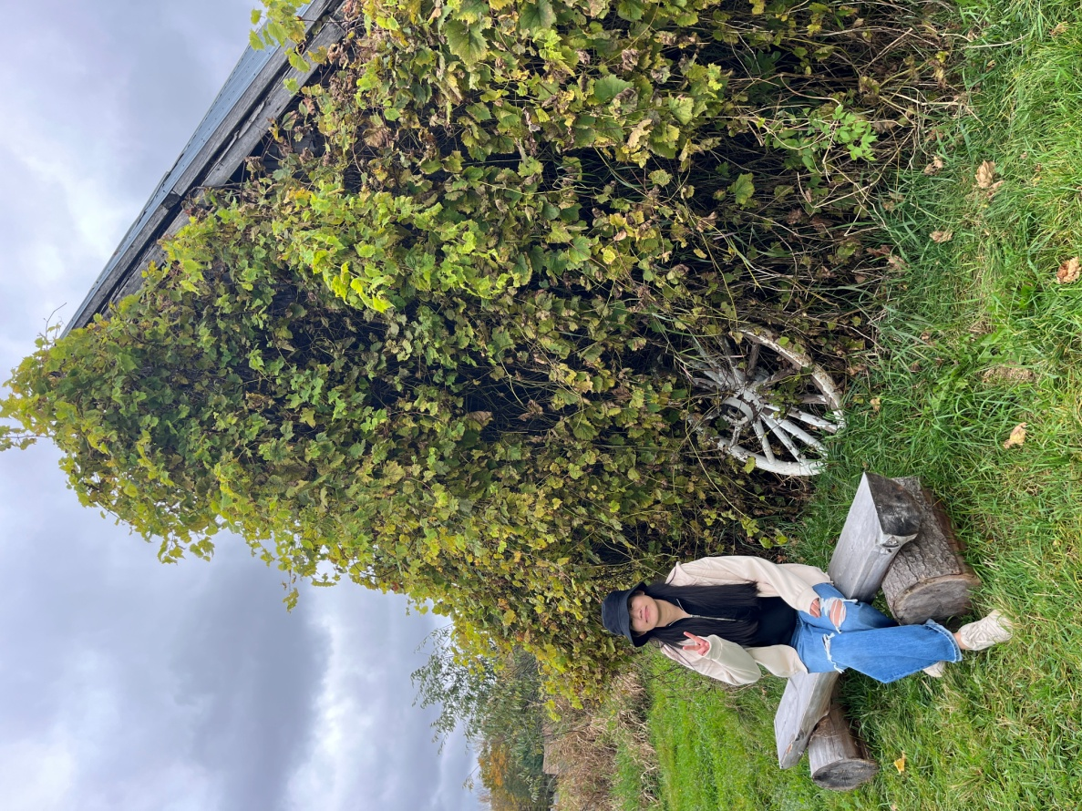

**Dechen Wangmo**

I am currently pursuing a Master of Science degree in the Department of Geomatics and Geodesy Engineering at UNB. Through a work-study program, I served as a Geomatic Analyst, contributing to the establishment of a historical database for Fredericton city. Presently, I am utilizing the UNB SHGeo software to compute precise geoidal heights using terrestrial gravimetric data. Additionally, I am in my second year of participation in the Esri Canada Centre of Excellence Student Associate program.

|  |  |  |
| --- | --- | --- |
|  |  |  |
|  |  |  |
|  |  |  |
|  |  |  |