Group1:

Group Members:

* Ha Kim Quy
* Tran Dang Quan
* Tran Thanh Ngoan
* Phan Nhat Anh

1. System Introduction
   1. System Overview
      1. Purpose

* This system help make shop and customer closer.
* Shop can more understand about their customer, something good, something bad. Also, this system may be PR for shop to have more customer.
* Customer can have more information about shop and have many choice to buy a product. And they can discuss or report and rating a shop. They can subcribe shop to remember a shop
  1. System Architecture
     1. MVC:

This system use MVC2

* + 1. Singleton:

1. System Design
   1. Use Case:

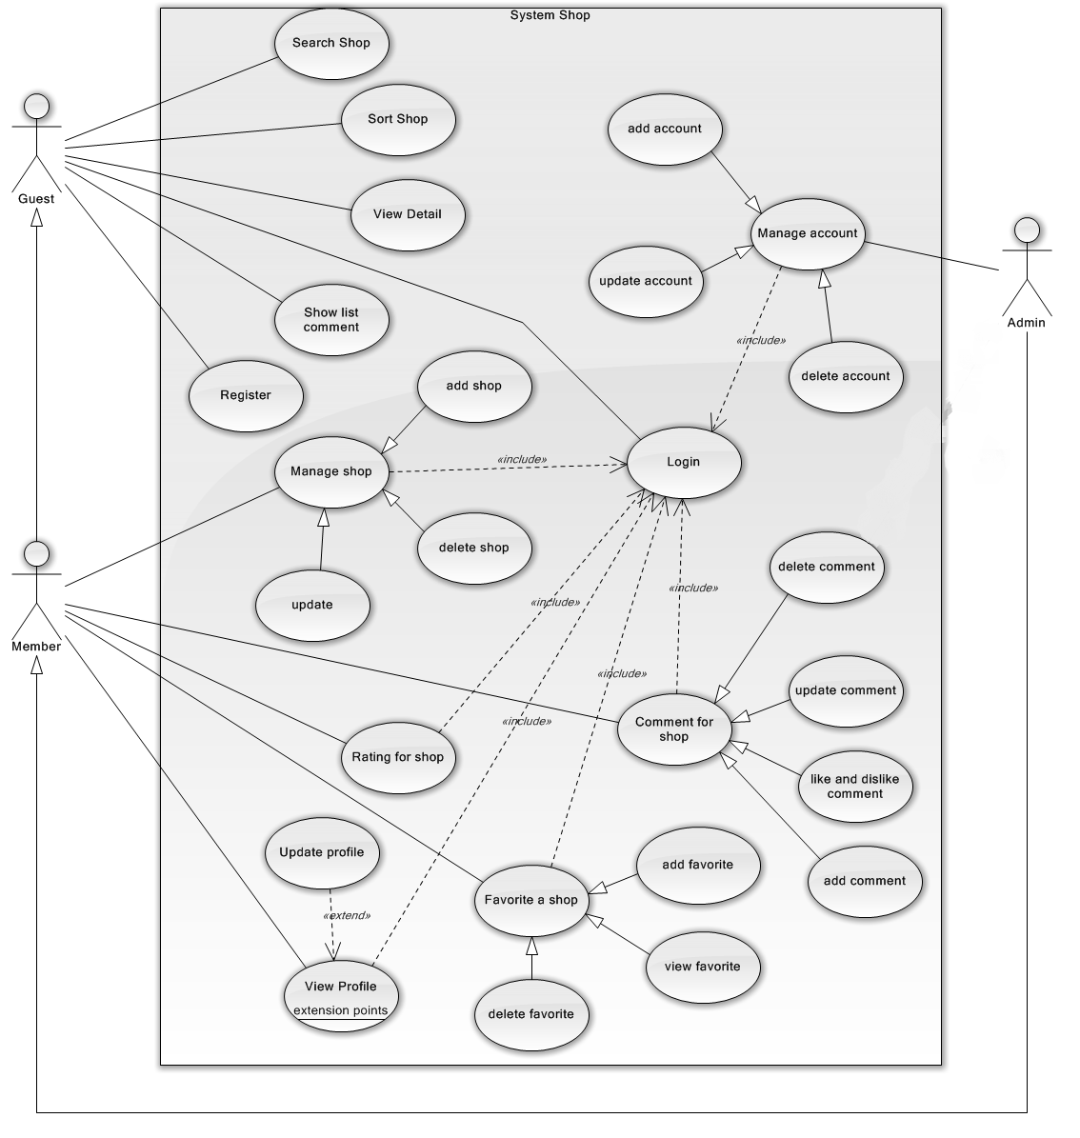

* 1. Class Diagram.

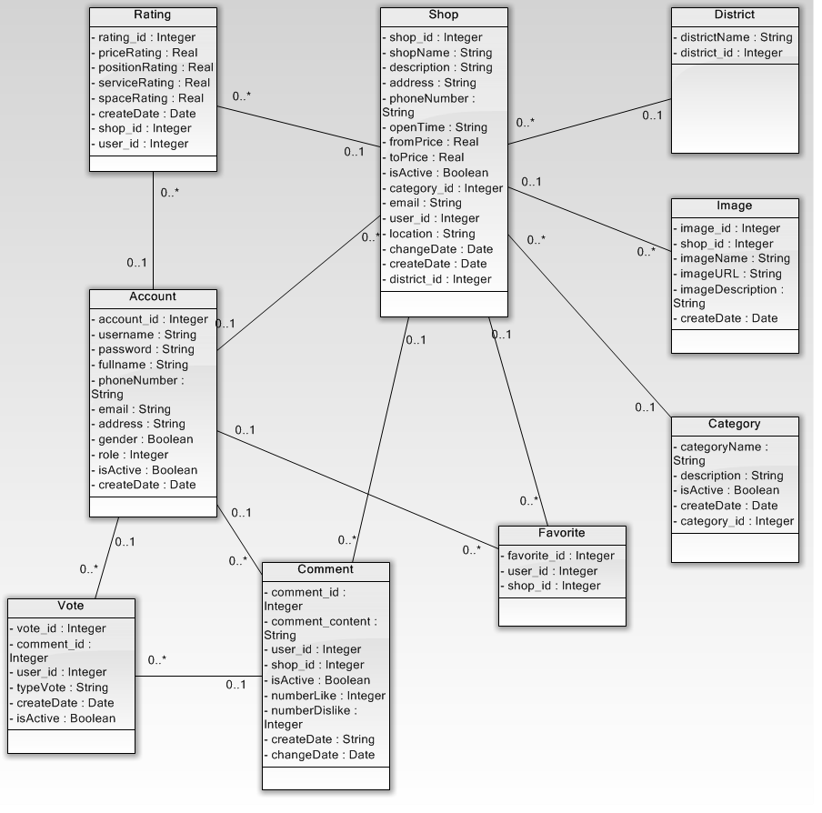

* 1. Sequence Diagram.
     1. Member, Admin.

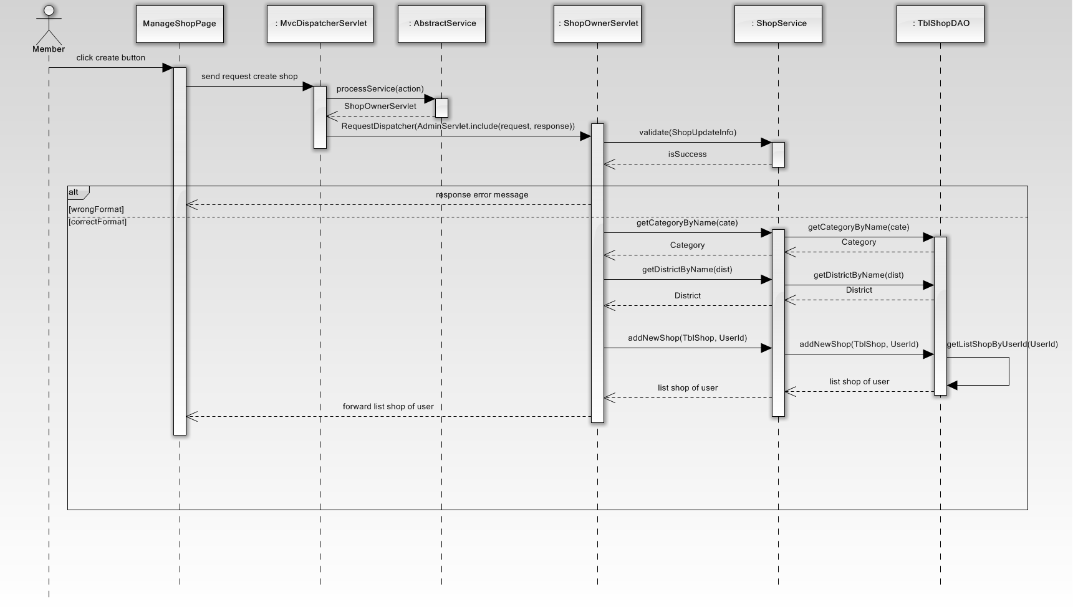

Create New Shop

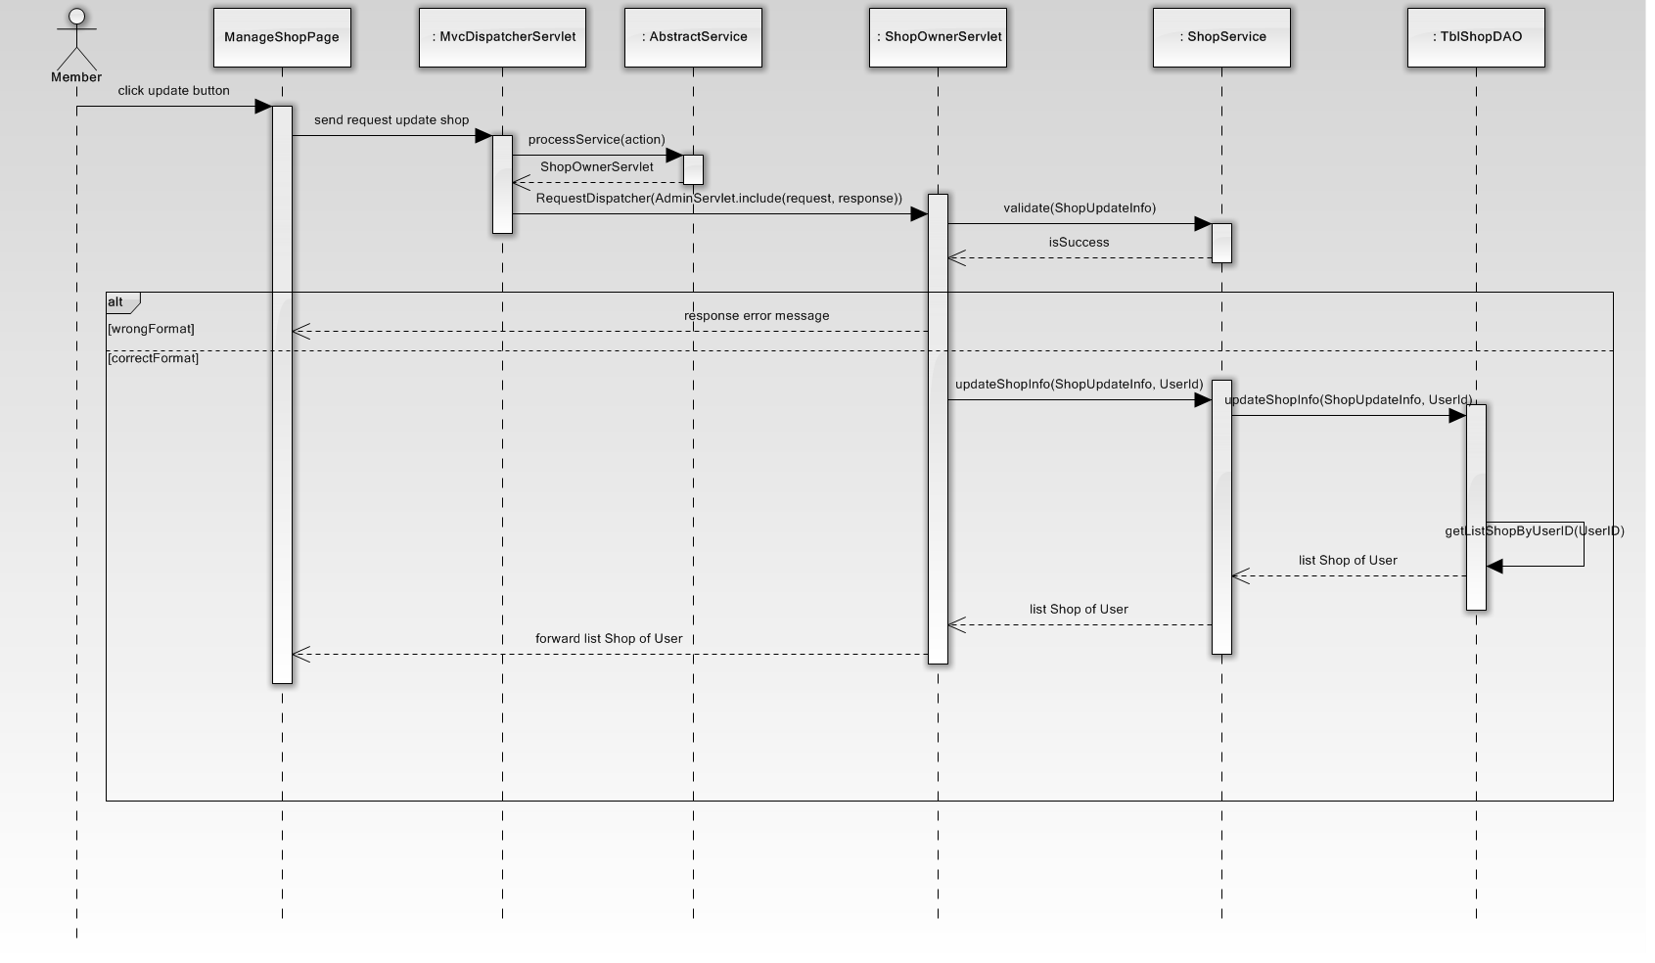

Update Shop

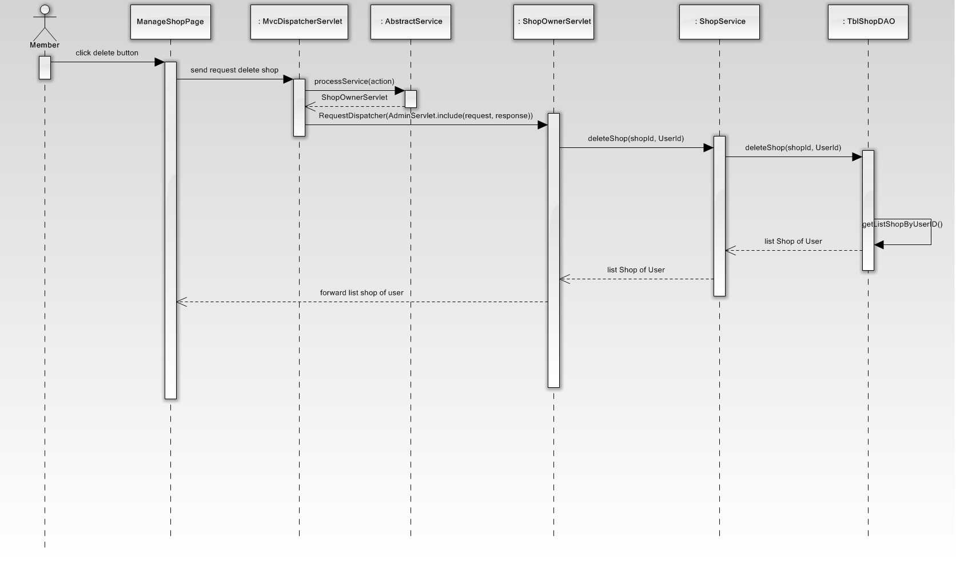

Delete Shop

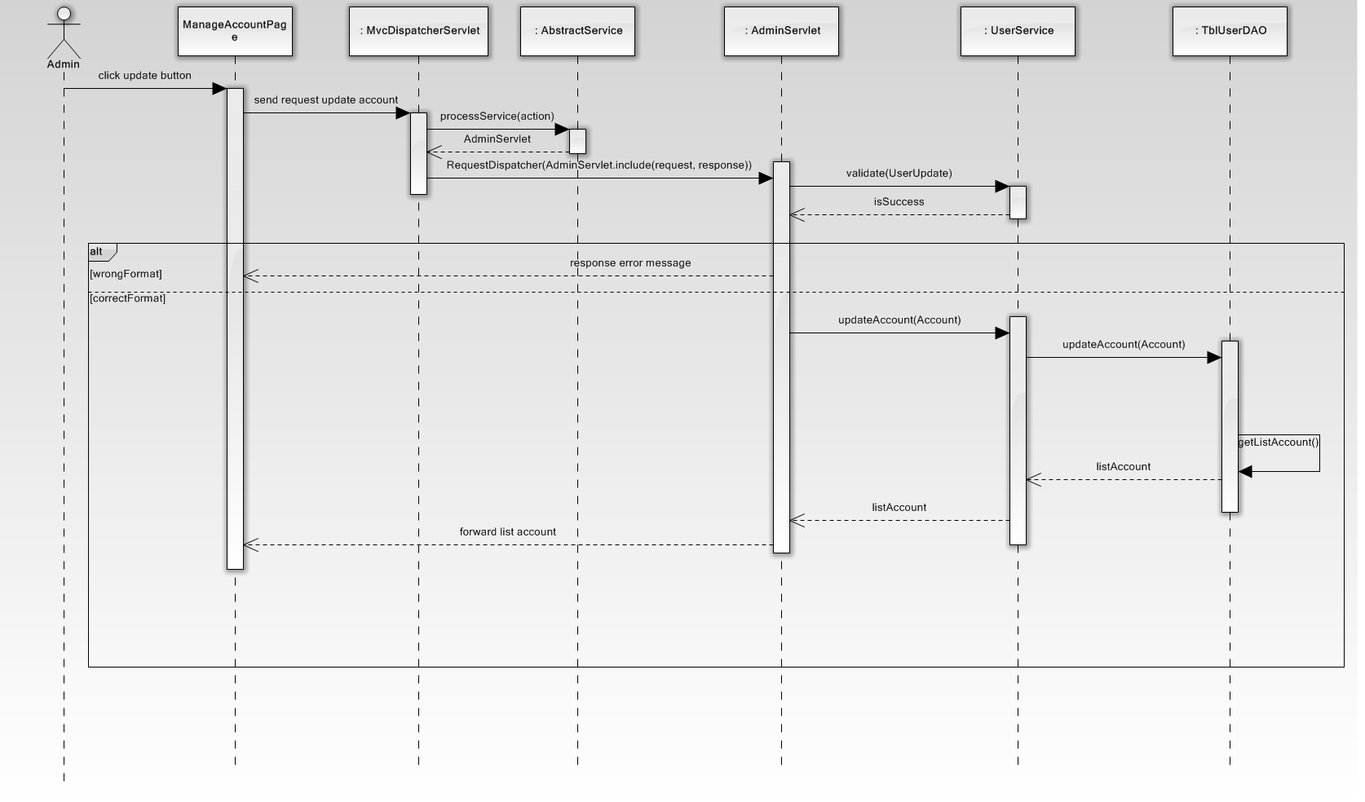

Update User

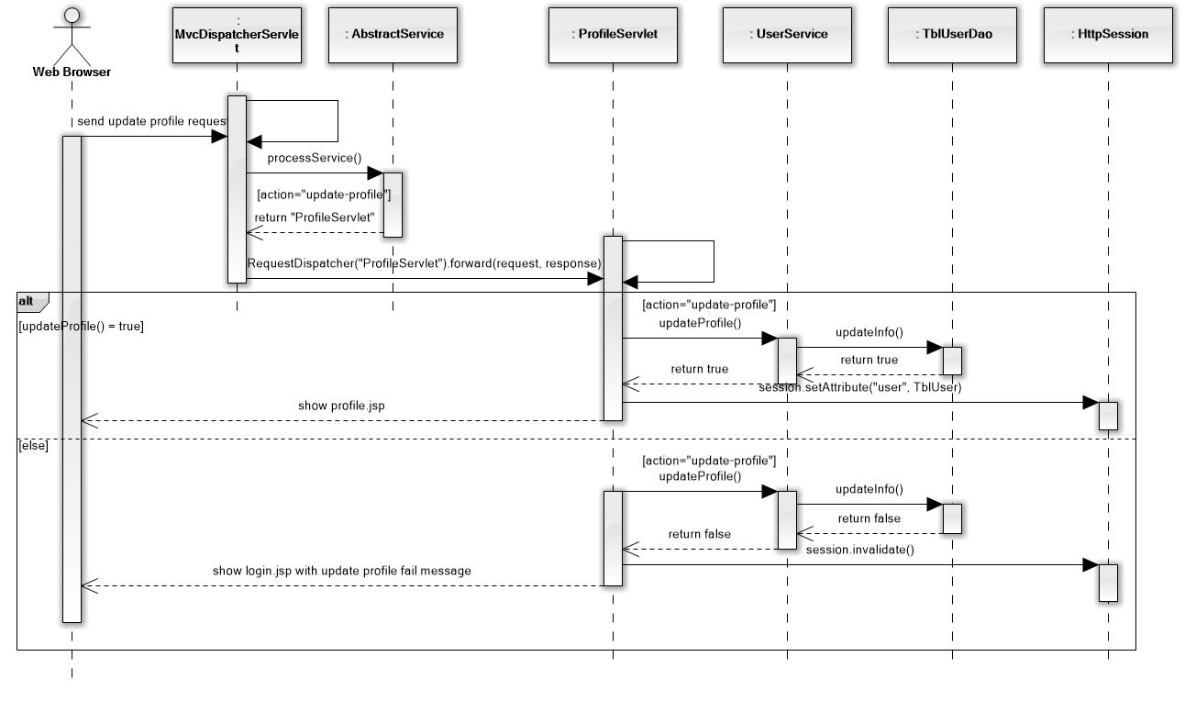

Update Profile

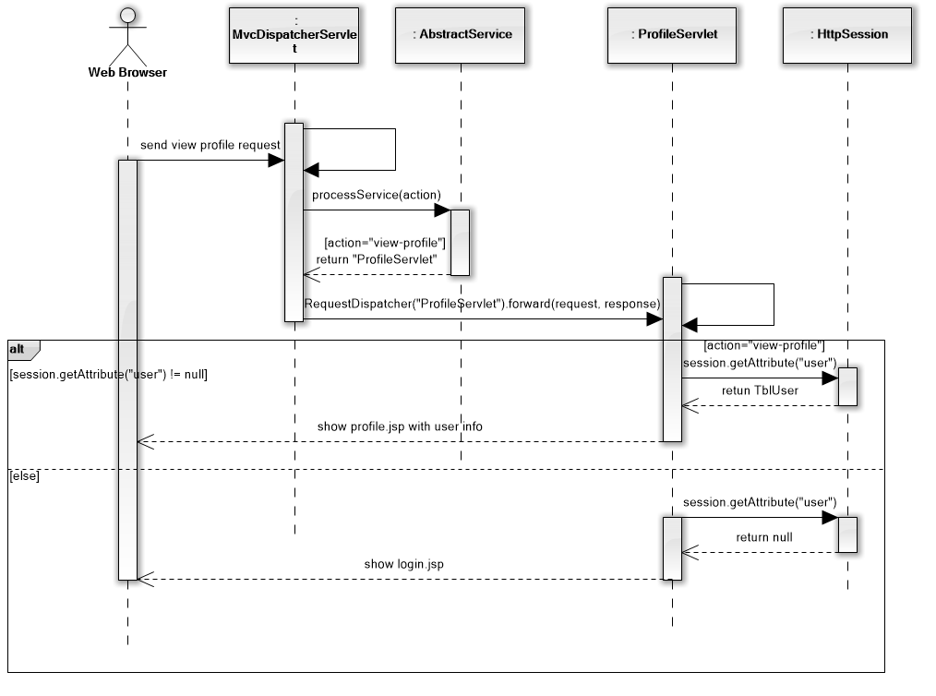

View Profile

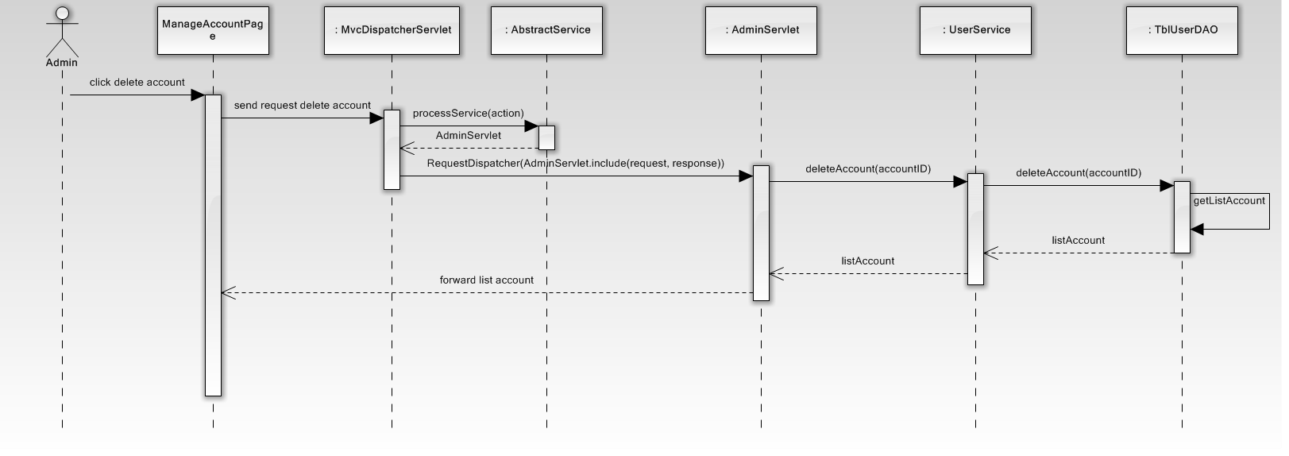

Delete Account

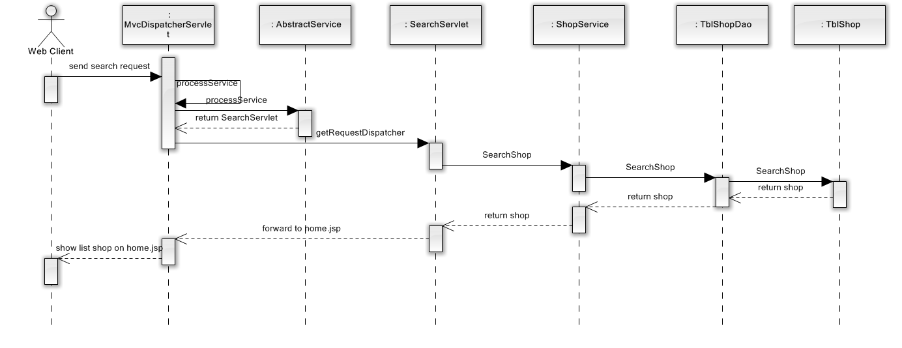

Search Shop

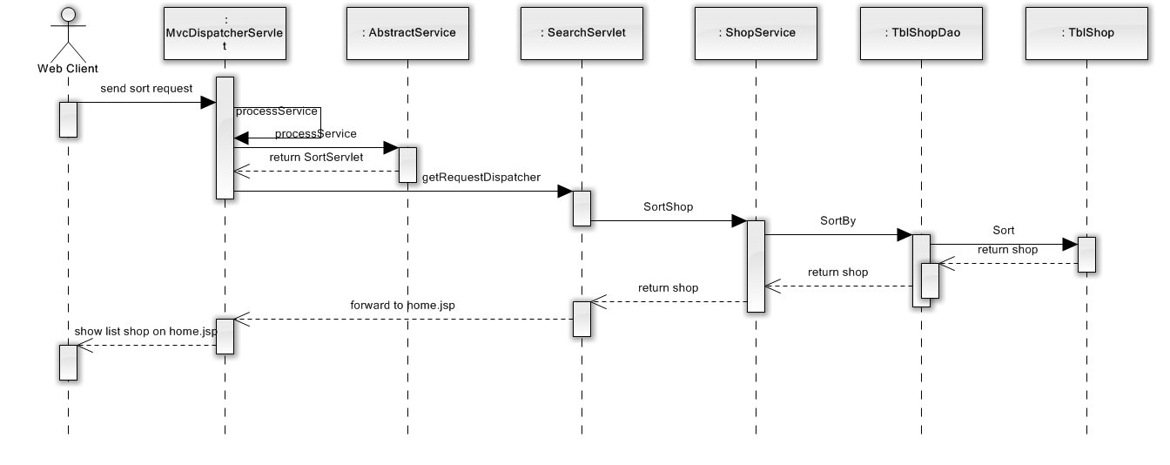

Sort Shop

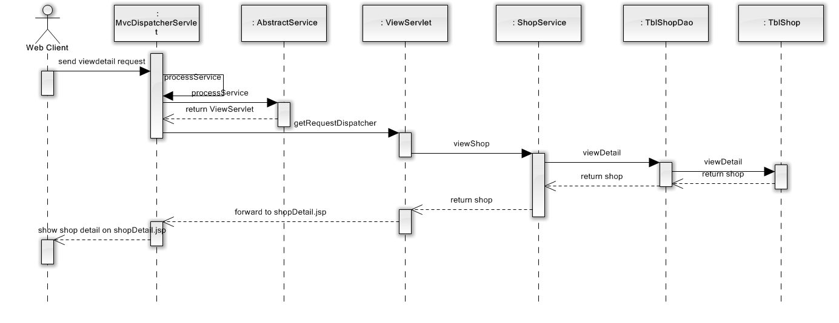

View Detail

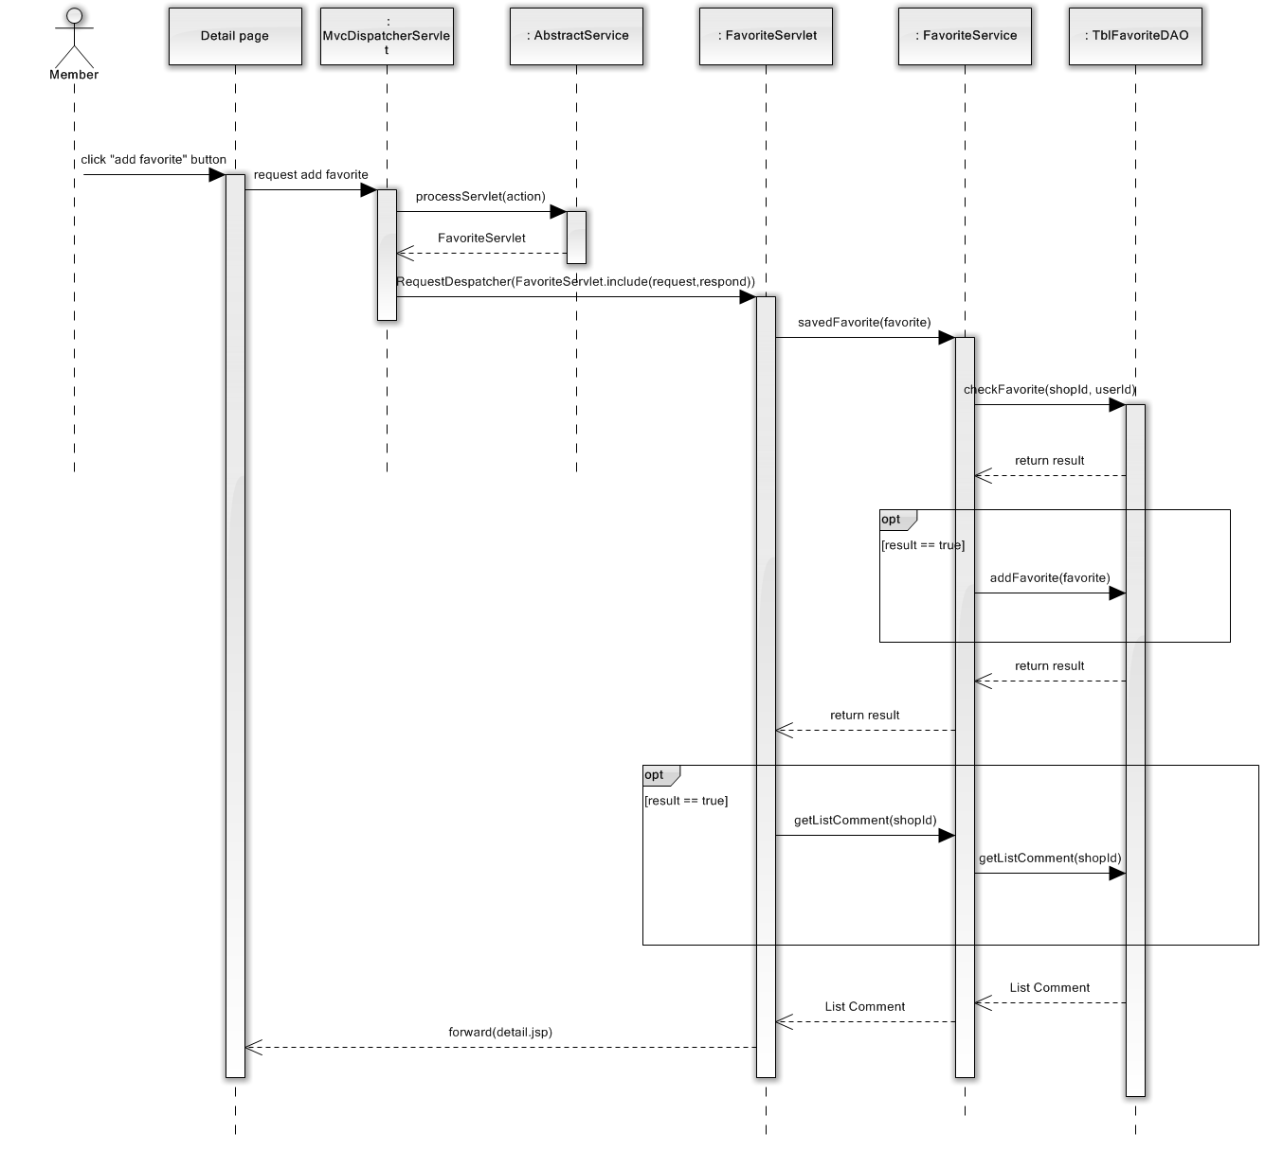

Add favorite

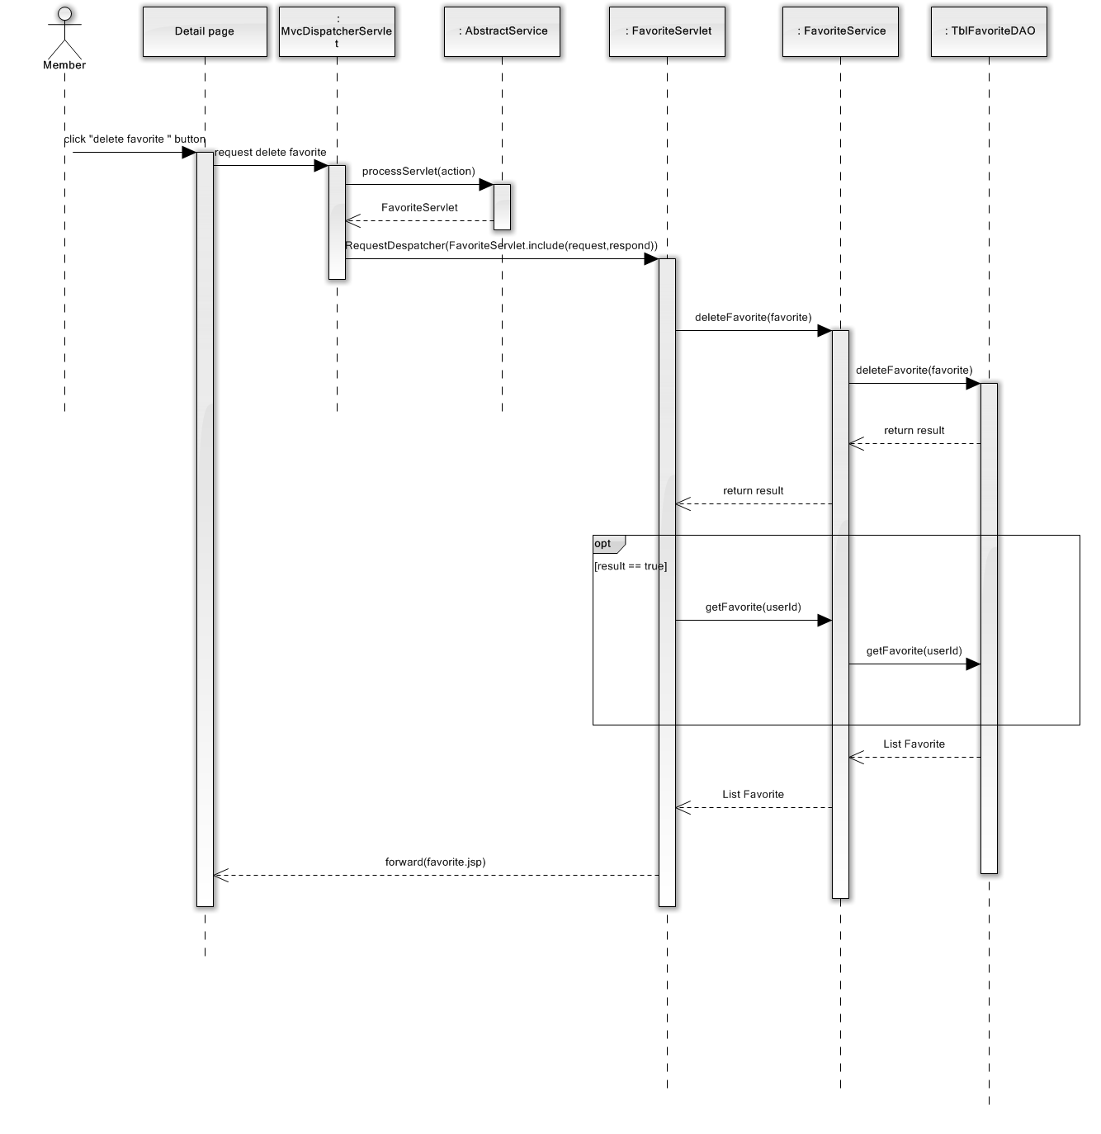

Delete Favorite

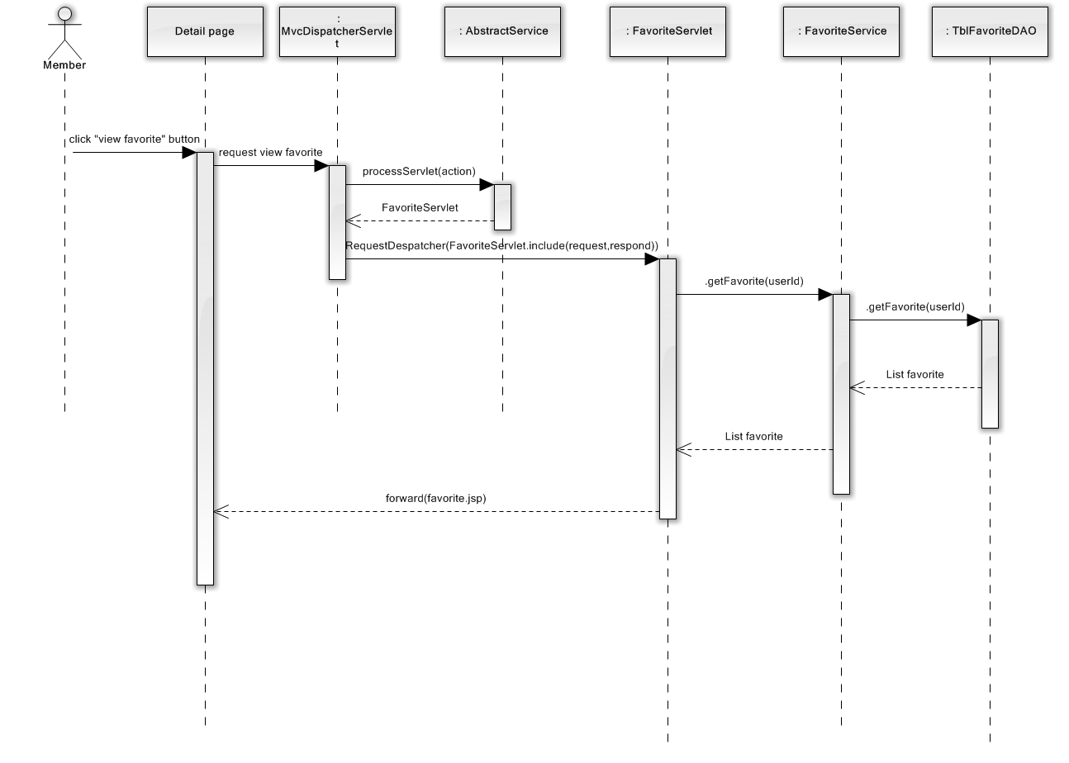

View Favorite

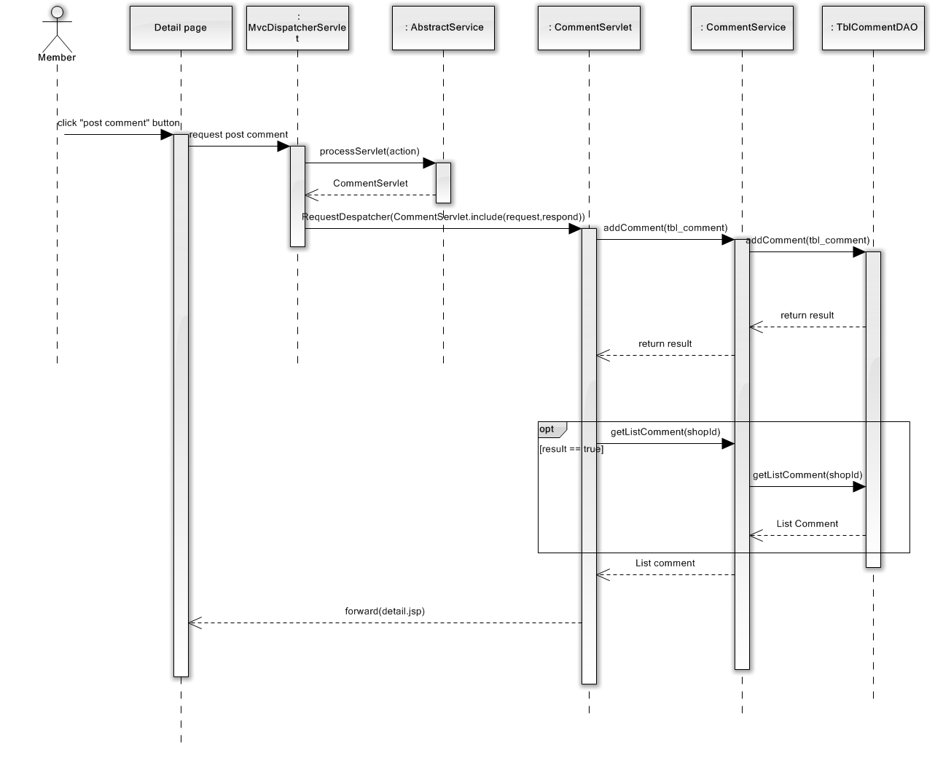

Post Comment

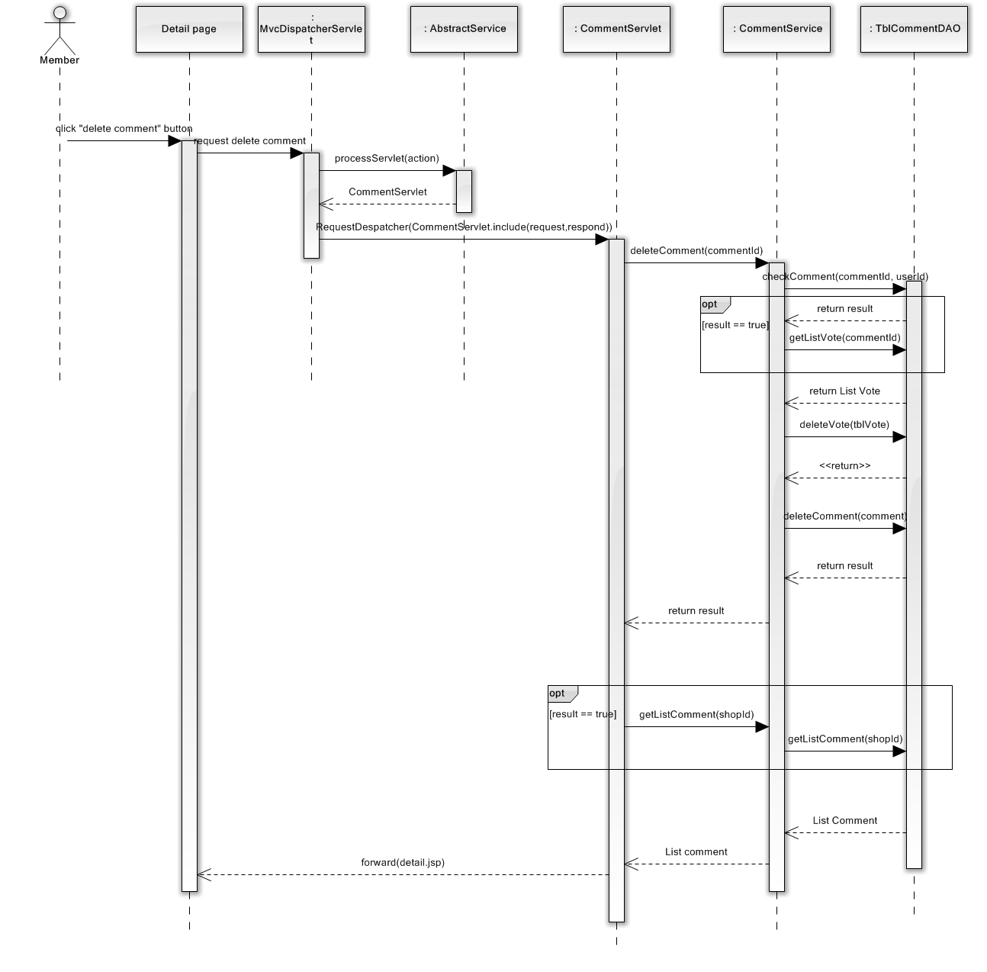

Delete Comment

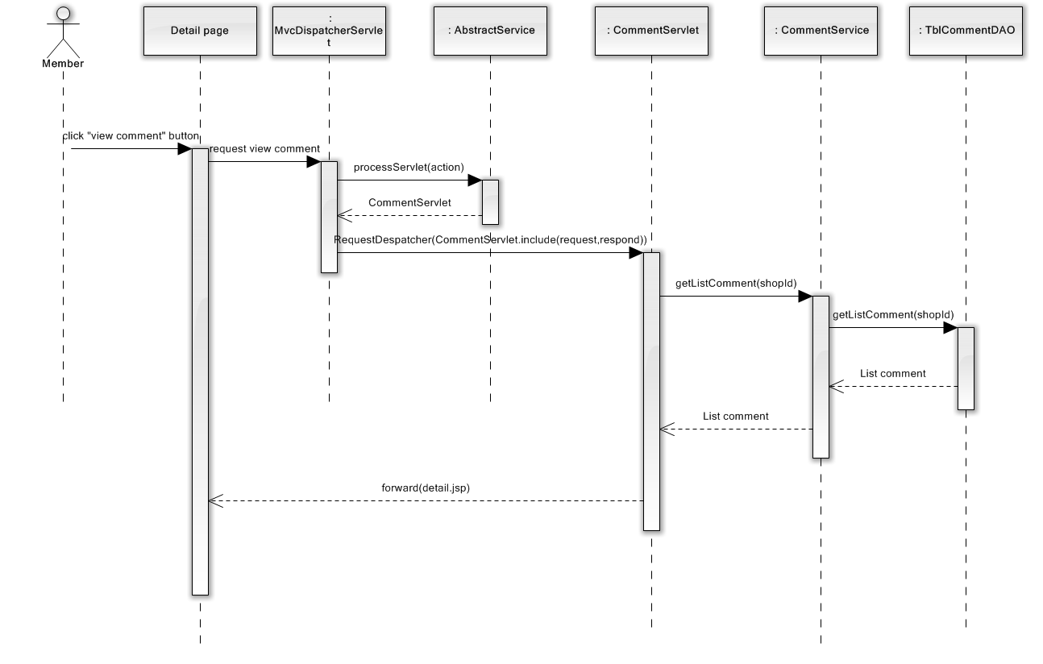

View Comment

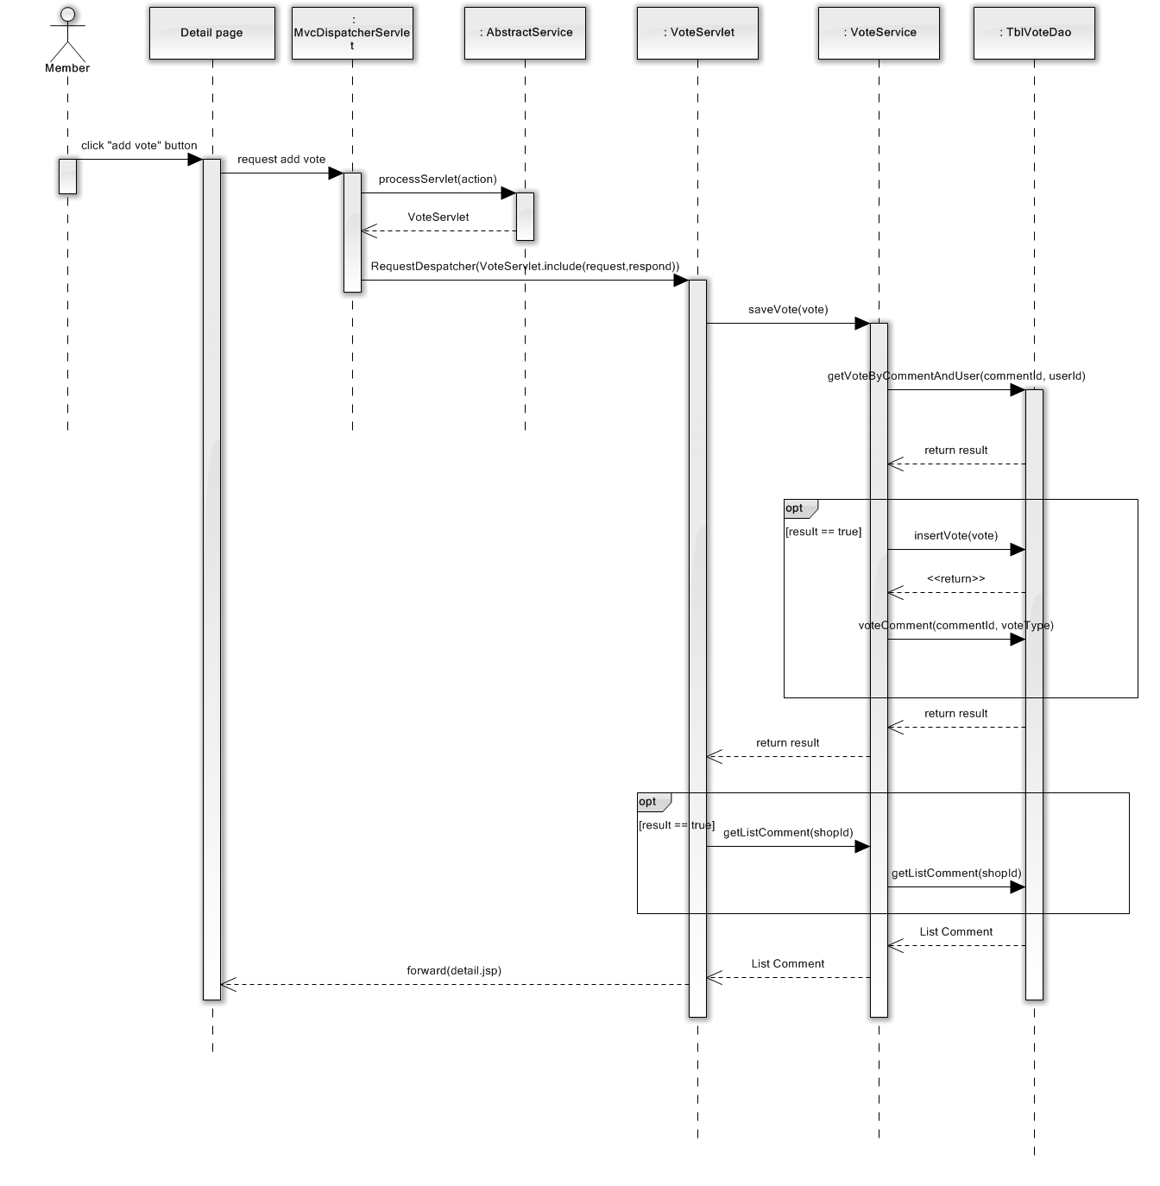

Add Vote

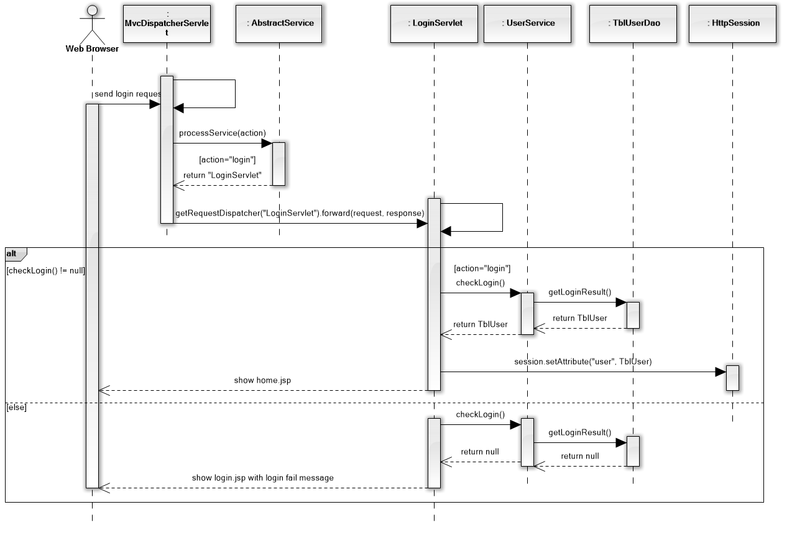

Login

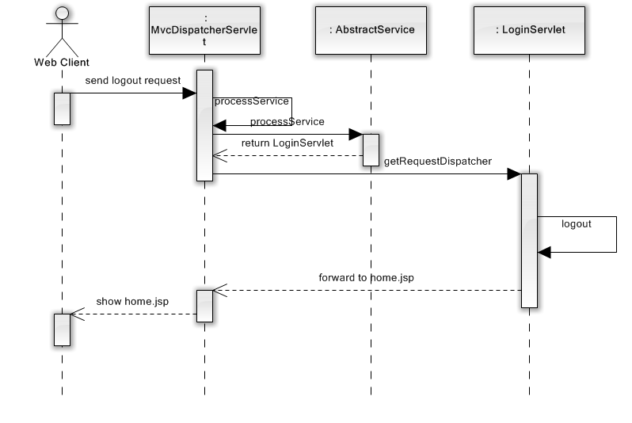

Logout