Trang thegioididong.com

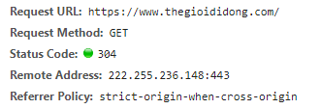

* Request line: