

**Online learn**

**Software Design Specification**

– Hanoi, August 2022 –

Record of changeS

|  |  |  |  |
| --- | --- | --- | --- |
| Date | A* M, D | In charge | Change Description |
| 18/02 | Add | ThangPM | Add code designs(feature,function) |
| 02/03 | Add | ThangPM | Add code designs(feature,function) |
| 08/03 | Add | ThangPm | Add code designs(feature,function) |
| 12/03 | Add | ThangPM | Add code designs(feature,function) |
| 17/03 | Add | ThangPM | Add code designs(feature,function) |
| 22/03 | Modify | ThangPM | Modify code design(sequence diagram) |
|  |  |  |  |
|  |  |  |  |
|  |  |  |  |
|  |  |  |  |
|  |  |  |  |
|  |  |  |  |
|  |  |  |  |

*A - Added M - Modified D - Deleted

Contents

I. Overview 5

1. Code Packages 5

2. Database Design 6

a. Database Schema 6

II. Code designs 6

1. Home Page 6

2.Chooses class 10

3. Choice Course 10

4. Choice Module 10

5. Choice lesson 10

6. View video 10

7. View content 10

8. Complete Payment 14

9. Ranking 17

10. Change password 18

11. View user profile 21

12. Change User Profile 22

13. Quiz Management 25

13. Login 31

14. Signup 34

15. ForgetPassword 39

16. UserManagement 41

17. Match Game Page 46

18. Quiz Page 49

19. Choose to add lesson for content page 51

20. Admin content page 54

21. Add match game image page (admin) 57

22. Add module  page (admin) 61

# I. Overview

## 1. Code Packages

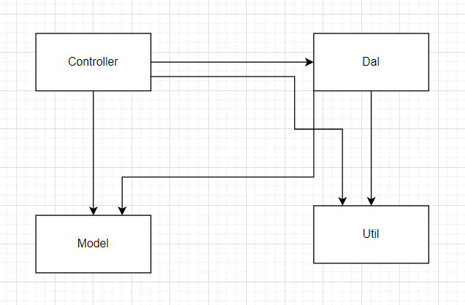

***Package descriptions***

|  |  |  |
| --- | --- | --- |
| **No** | **Package** | **Description** |
| 01 | Controller | Handle back-end, drive flow of code |
| 02 | Dal | Handle database |
| 03 | Model | Create object suitable database |
| 04 | Util | Support date |

## 2. Database Design

### a. Database Schema

# II. Code designs

## 1. Home Page

a. Class Diagram

b. Class Specifications

#### HomeController

***Class Methods***

|  |  |  |
| --- | --- | --- |
| **No** | **Method** | **Description** |
| 01 | doPost(HttpServletRequest, HttpServletResponse): void | Call itself |
| 02 | doGet(HttpServletRequest, HttpServletResponse): void | req.getRequestDispatcher("./home.jsp").forward(req, resp); |

#### AccountDBContext

***Class Methods***

|  |  |  |
| --- | --- | --- |
| **No** | **Method** | **Description** |
| 01 | updatePassword(String username, String newpassword) | Update password |
|  | insertRoll(int role_id, String username) | Insert roll for account |
|  | updateRollAccount(String username) | Update roll |
|  | login(String username, String password) | User login |
|  | checkAccountExisted(String username) | Check account existed or not |
|  | signup(String username, String password) | Sign up username and password |
|  | fillin4(String username, String password) | Insert information of user |
|  | get(String username) | Get account with username |
|  | updateClassifyAccount(Account model) | Update classify of account |
|  | getNumberOfTotalUser() | Get total user of web |
|  | getNumberOfNormalUser() | Get total account normal |
|  | getNumberOfPremiumUser() | Get total account premium |

#### DBContext

***Class Methods***

|  |  |  |
| --- | --- | --- |
| **No** | **Method** | **Description** |
| 01 | DBContext() | To connect with database |
| 02 | main(String[]) | Call DBContext() |

c. Sequence Diagram(s)

d. Database Queries

//update password account

UPDATE [dbo].[Account

SET [password] = ?,

WHERE username = ?

//insert roll account

INSERT INTO [dbo].[Role_Account

([role_id],

[username])

VALUES

(?,?)

// updateRollAccount

UPDATE [dbo].[Role_Account]

SET [role_id] = 1

WHERE username = ?

//login(String username, String password)

SELECT a.username,a.classify_account

+ ",r.role_id, r.role_name,

+ "f.fe_id,f.fe_name,f.[url]

+ "FROM Account a

+ "LEFT JOIN Role_Account ra ON a.username = ra.username

+ "LEFT JOIN [Role] r ON r.role_id= ra.role_id

+ "LEFT JOIN Role_Feature rf ON rf.role_id = r.role_id

+ "LEFT JOIN Feature f ON f.fe_id = rf.fe_id

+ "WHERE a.username = ? AND a.password = ?

// checkAccountExisted(String username)

SELECT * FROM Account

WHERE username = ?

// signup(String username, String password)

INSERT INTO [dbo].[Account]

+ " ([username]

+ " ,[password]

+ " ,[classify_account])

+ " VALUES

+ " (?,

+ " ?,

+ " 'normal')

//fillin4(String username, String password)

INSERT INTO [dbo].[Account]

([username]

,[password]

,[classify_account])

VALUES

(?,

?,

'nomal')"

// get(String username)

SELECT a.username,a.classify_account

r.role_id, r.role_name,

f.fe_id,f.fe_name,f.[url]

FROM Account a

LEFT JOIN Role_Account ra ON a.username = ra.username

LEFT JOIN [Role] r ON r.role_id= ra.role_id

+ "LEFT JOIN Role_Feature rf ON rf.role_id = r.role_id

+ "LEFT JOIN Feature f ON f.fe_id = rf.fe_id

+ "WHERE a.username = ?

// updateClassifyAccount(Account model)

UPDATE [Account]

SET

[classify_account] = 'premium'

WHERE username = ?

// getNumberOfTotalUser()

SELECT COUNT(*) AS total FROM [User] u

// getNumberOfNormalUser()

SELECT COUNT(*) AS normal FROM [User] u

JOIN Account a ON a.username = u.username AND a.classify_account = 'normal'

// getNumberOfPremiumUser()

SELECT COUNT(*) AS premium FROM [User] u

JOIN Account a ON a.username = u.username AND a.classify_account = 'premium'

## Chooses class

1. Class diagram:

1. Class specification

Class method

* classesController:

|  |  |  |
| --- | --- | --- |
| **No** | **Method** | **Description** |
| 01 | doPost(HttpServletRequest, HttpServletResponse): void | Call itself |
| 02 | doGet(HttpServletRequest, HttpServletResponse): void | Get list classes and req.getRequestDispatcher("./classes.jsp").forward(req, resp); |

* ClassDBContext:

|  |  |  |
| --- | --- | --- |
| * **No** | **Method** | **Description** |
| 01 | + insert(T model, update(T Model), delete(T moel) | Abstract method |
| 02 | list(): | Get list classes |

1. Sequence Diagram

1. Database queries

* // list():

SELECT * FROM Class

## 3. Choice Course

* 1. Class diagram

* 1. Class specification

Class method

* CourseController:

|  |  |  |
| --- | --- | --- |
| **No** | **Method** | **Description** |
| 01 | doPost(HttpServletRequest, HttpServletResponse): void | Call itself |
| 02 | doGet(HttpServletRequest, HttpServletResponse): void | Get list course and req.getRequestDispatcher("./course.jsp").forward(req, resp); |

* CourseDBContext:

|  |  |  |
| --- | --- | --- |
| * **No** | **Method** | **Description** |
| 01 | + insert(T model, update(T Model), delete(T moel) | Abstract method |
| 02 | list() : | Get list course |
| 03 | listCoursebyClassId(int class_id) | Get list course by class id |
| 04 | numberOfLessonLearned(int course_id, int user_id) | Get number of lesson learned |
| 05 | numberOfLesson(int course_id, int user_id) | Get number of lesson |
| 06 | registeredCourse(int user_id) | Register course |
| 07 | get(int course_id) | Get course by id |

* 1. Sequence diagram

* 1. Database queries

-// get(int course_id):

SELECT * FROM Course WHERE course_id = ?

// list():

SELECT * FROM Course

// listCoursebyClassId(int class_id):

SELECT * FROM Course WHERE class_id = ?

// numberOfLessonLearned(int course_id, int user_id):

SELECT COUNT(*) AS numberOfLessonLearned

FROM Lession l

JOIN Module m ON m.module_id = l.module_id

JOIN Course c ON c.course_id = m.course_id

JOIN Class cl ON cl.class_id = c.class_id

JOIN Lession_Learn ll ON ll.lession_id = l.lession_id

WHERE c.course_id = ? AND ll.llearn = 'true' AND ll.[user_id] =?

// numberOfLesson(int course_id, int user_id):

SELECT COUNT(*) AS numberOfLessonLearned\

FROM Lession l

JOIN Module m ON m.module_id = l.module_id

JOIN Course c ON c.course_id = m.course_id

JOIN Class cl ON cl.class_id = c.class_id

JOIN Lession_Learn ll ON ll.lession_id = l.lession_id

WHERE c.course_id = ? AND ll.[user_id] =?

// registeredCourse(int user_id):

SELECT DISTINCT c.course_id, c.course_name,c.class_id, cl.class_name FROM Course c

JOIN Class cl ON cl.class_id = c.class_id

JOIN Module m ON m.course_id = c.course_id

JOIN Lession l ON l.module_id = m.module_id

JOIN Lession_Learn ll ON l.lession_id = ll.lession_id

WHERE ll.[user_id] = ?

## 4. Choice Module

1. Class diagram

1. Class specification

Class method

* ModuleController:

|  |  |  |
| --- | --- | --- |
| **No** | **Method** | **Description** |
| 01 | doPost(HttpServletRequest, HttpServletResponse): void | Call itself |
| 02 | doGet(HttpServletRequest, HttpServletResponse): void | Get list classes and req.getRequestDispatcher("./classes.jsp").forward(req, resp); |
| 03 | getProcessOfModule(int module_id, int user_id) | Get process module |

* ModuleDBContext:

|  |  |  |
| --- | --- | --- |
| * **No** | **Method** | **Description** |
| 01 | insert(Module model) | Abstract method |
| 02 | update(Module model) | Get list classes |
|  | delete(Module model) |  |
|  | get(int module_id) | Get module by id |
|  | list() |  |
|  | listModuleByCourseID(int course_id) | Get list module by course id |
|  | numberOfLessonLearned(int module_id, int user_id) | Get lesson learned |
|  | numberOfLesson(int module_id, int user_id) | Get lesson |

1. Sequence diagram

1. Database queries

// insert(Module model)

INSERT INTO [dbo].[Module]

([module_name]

,[course_id]

,[status])

VALUES

(?

,?

,?)

// update(Module model)

UPDATE [dbo].[Module]

SET [module_name] = ?

,[course_id] = ?

,[status] = ?

WHERE module_id = ?

// get(int module_id):

SELECT * FROM Module WHERE module_id = ?

// list():

SELECT * FROM Module

// listModuleByCourseID(int course_id):

SELECT * FROM Module WHERE course_id = ?

// numberOfLessonLearned(int module_id, int user_id):

SELECT COUNT(*) AS numberOfLessonLearned FROM Lession_Learn ll

JOIN Lession l ON ll.lession_id = l.lession_id

WHERE l.module_id = ? AND ll.llearn = 'true' AND ll.[user_id] = ?

// numberOfLesson(int module_id, int user_id):

SELECT COUNT(*) AS numberOfLessonLearned FROM Lession_Learn ll

JOIN Lession l ON ll.lession_id = l.lession_id

WHERE l.module_id = ? AND ll.[user_id] = ?

## 5. Choice lesson

1. Class diagram

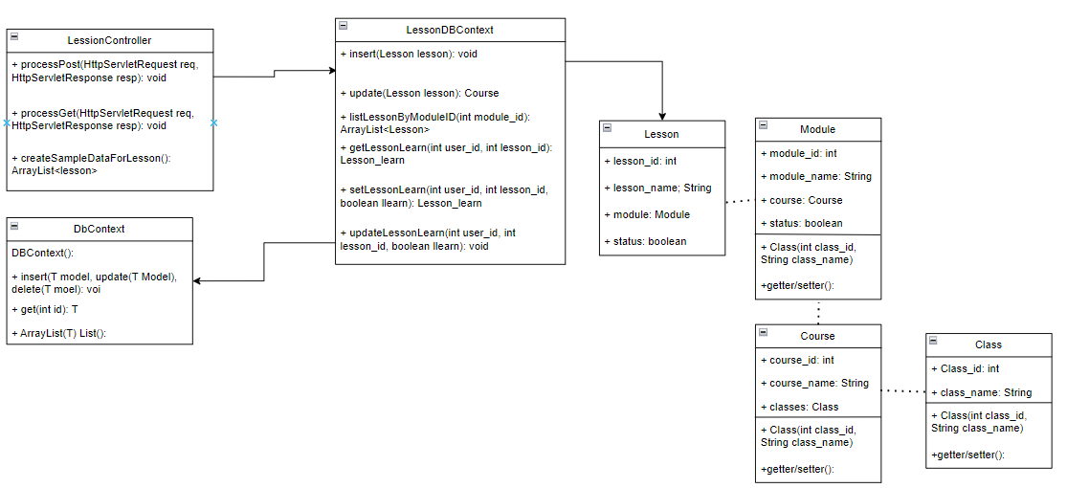

1. Class specification

Class method

* LessonController:

|  |  |  |
| --- | --- | --- |
| **No** | **Method** | **Description** |
| 01 | doPost(HttpServletRequest, HttpServletResponse): void | Call itself |
| 02 | doGet(HttpServletRequest, HttpServletResponse): void | Get list classes and req.getRequestDispatcher("./classes.jsp").forward(req, resp); |
| 03 | createSampleDataForLesson() | Create Sample Data forl |

* LessonDBContext:

|  |  |  |
| --- | --- | --- |
| * **No** | **Method** | **Description** |
| 01 | insert(Lesson model) | Abstract method |
| 02 | update(Lesson model) | Get list classes |
|  | delete(Lesson model) |  |
|  | get(int lesson_id) | Get lesson by id |
|  | ArrayList<Lesson> list() | Get list lesson |
|  | listLessonByModuleID(int module_id) | Get list lesson by module id |
|  | listLessonByCourseID(int course_id) | Get list lesson by course id |
|  | getLessonLearn(int user_id, int lesson_id) | Get list lesson learned |
|  | setLessonLearn(int user_id, int lesson_id, boolean llearn) | Set up lesson learn |
|  | updateLessonLearn(int user_id, int lesson_id, boolean llearn) | Update lessonlearn |

1. Sequence diagram

1. Database queries

// insert(Lesson model)

INSERT INTO [dbo].[Lession]

([lession_name]

,[module_id]

,[status])

VALUES

(?

,?

,?)

// update(Lesson model):

UPDATE [dbo].[Lession]

SET [lession_name] = ?

,[module_id] = ?

,[status] = ?

WHERE lession_id = ?

// get(int lesson_id):

SELECT * FROM Lession WHERE lession_id = ?

// list():

SELECT * FROM Lession WHERE module_id = ?

// listLessonByCourseID(int course_id):

SELECT l.lession_id,l.lession_name,l.module_id,l.[status],

m.module_id,m.module_name,m.course_id,m.[status],

c.class_id,c.course_id,c.course_name,

cl.class_id,cl.class_name

FROM Lession l

JOIN Module m ON m.module_id = l.module_id

JOIN Course c ON c.course_id = m.course_id

JOIN Class cl ON cl.class_id = c.class_id

WHERE c.course_id = ?

// getLessonLearn(int user_id, int lesson_id):

SELECT ll.[user_id], ll.lession_id,ll.llearn \n"

+ "FROM Lession_Learn ll WHERE ll.[user_id] = ? AND ll.lession_id = ?

// setLessonLearn(int user_id, int lesson_id, boolean llearn):

INSERT INTO [dbo].[Lession_Learn]

([user_id]

,[lession_id]

,[llearn])

VALUES

(?

,?)

,?)

// updateLessonLearn(int user_id, int lesson_id, boolean llearn):

UPDATE [dbo].[Lession_Learn]

SET [llearn] = ?

WHERE [lession_id] = ? AND [user_id] = ?

## 6. View video

1. Class diagram

1. Class specification

Class method

* VideoController:

|  |  |  |
| --- | --- | --- |
| **No** | **Method** | **Description** |
| 01 | doPost(HttpServletRequest, HttpServletResponse): void | Call itself |
| 02 | doGet(HttpServletRequest, HttpServletResponse): void | Get video of lesson and req.getRequestDispatcher("./videoLesson.jsp").forward(req, resp); |
|  |  |  |

* VideoDBContext:

|  |  |  |
| --- | --- | --- |
| * **No** | **Method** | **Description** |
| 1 | insert(Video model) | Insert video db |
| 2 | insertLessonVideo(int lesson_id, int video_id) | Insert video for lesson |
| 3 | update(Video model) | Update video db |
| 4 | get(int id) | Get video by id |
| 5 | getVideoByUrl(String url) | Get video by url |
| 6 | getVideoByLessonID(int lesson_id) | Get video by lesson id |

1. Sequence diagram

1. Database queries

// insert(Video model):

INSERT INTO [dbo].[Video]

([url]

,[video_title])

VALUES

(?

,?)

// insertLessonVideo(int lesson_id, int video_id):

INSERT INTO [dbo].[Lession_Video]

([lession_id]

,[video_id])

VALUES

(?

,?)

// update(Video model):

UPDATE [dbo].[Video]

SET [url] = ?

,[video_title] = ?

WHERE video_id = ?

// get(int id):

SELECT * FROM Video WHERE video_id = ?

// getVideoByUrl(String url):

SELECT * FROM Video WHERE [url] = ?

// getVideoByLessonID(int lesson_id):

SELECT v.video_id,v.[url],v.video_title FROM Video v

JOIN Lession_Video lv ON lv.video_id = v.video_id

WHERE lv.lession_id = ?

## 7. View content

1. Class diagram

1. Class specification

Class method

* ModuleController:

|  |  |  |
| --- | --- | --- |
| **No** | **Method** | **Description** |
| 01 | doPost(HttpServletRequest, HttpServletResponse): void | Call itself |
| 02 | doGet(HttpServletRequest, HttpServletResponse): void | Call itself |
| 03 | doGetProcess(HttpServletRequest req, HttpServletResponse resp) | Get content lesson by id and req.getRequestDispatcher("./contentLesson.jsp").forward(req, resp); |

* ContentDBContext:

|  |  |  |
| --- | --- | --- |
| * **No** | **Method** | **Description** |
| 01 | insert(Content model) | Abstract method |
| 02 | update(Content model) |  |
|  | delete(Content model) |  |
|  | deleteLessonContent(int content_id) | Delete content in lesson |
|  | insert(Content model, int lession_id) | Insert content for lesson |
|  | get(int id) | Get content by id |
|  | getContentID(Content model) | Get content |
|  | list() |  |
|  | getContentListByLessionID(int lesson_id) | Get list content by lesson id |
|  | insertLessionContent(int content_id, int lession_id) | Insert content for lesson |

1. Sequence diagram

1. Database queries

// delete(int content_id):

DELETE FROM [dbo].[Content]

WHERE content_id = ?

// deleteLessonContent(int content_id):

DELETE FROM [dbo].[Lession_Content]

WHERE content_id = ?

// update(Content model):

UPDATE [dbo].[Content]

SET [reading_content] = ?

WHERE content_id = ?

// insert(Content model, int lession_id):

INSERT INTO [dbo].[Content]

([reading_content])

VALUES\n"

(?)

// get(int id):

SELECT * FROM Content WHERE content_id = ?

// getContentID(Content model):

SELECT content_id FROM Content WHERE reading_content = ?

// list():

SELECT * FROM Content

// getContentListByLessionID(int lesson_id):

SELECT c.content_id, c.reading_content

FROM Content c

inner join Lession_Content lc on lc.content_id = c.content_id

inner join Lession l on l.lession_id = lc.lession_id

WHERE l.lession_id = ?

// getContentByLessonId(int lesson_id):

SELECT c.content_id,c.reading_content

FROM Content c, Lession_Content lc

WHERE lc.lession_id = ? AND c.content_id = lc.content_id

// insertLessionContent(int content_id, int lession_id) :

INSERT INTO [dbo].[Lession_Content]

([lession_id]

,[content_id])

VALUES

(?

,?)

## **8. Complete Payment**

a. Class diagram

b. Class Specifications

#### completePaymentController

***Class Methods***

|  |  |  |
| --- | --- | --- |
| **No** | **Method** | **Description** |
| 01 | processGet(HttpServletRequest, HttpServletResponse): void | To handle request, set attribute and send redirect to CompletePayment.jsp. |
| 02 | processPost(HttpServletRequest, HttpServletResponse): void | Get data and check format, if the format is correct send redirect to EmailAcception.jsp. |

#### enterMailController

#### **Class Methods**

|  |  |  |
| --- | --- | --- |
| **No** | **Method** | **Description** |
| 01 | processGet(HttpServletRequest, HttpServletResponse): void | To handle request, set attribute and send redirect to EmailAcception. |
| 02 | processPost(HttpServletRequest, HttpServletResponse): void | Get data, get random string from function getRandomString() and message from messageProcess(, check format email, if the format is correct send redirect to EncodeEmail.jsp. Otherwise, back to EmailAcception.jsp. |
| 03 | getRandomNumberString() String | Random 1 string consisting of 6 digits, return this string |
| 04 | messageProcess(String, HttpServletRequest) | Returns 1 message, this message will be used as the body of the email |

#### VerifyCodeController

***Class Methods***

|  |  |  |
| --- | --- | --- |
| **No** | **Method** | **Description** |
| 01 | processRequest(HttpServletRequest, HttpServletResponse): void | To handle request, get verifyCode from session name “verifyCode”  And verifyCode from input of user. If it matches, update classify_account to “premium”, update Roll_Account send redirect to PaymentSuccesful.html. On the other hand, send redirect to paymentfail.html |
| 02 | processPost(HttpServletRequest, HttpServletResponse): void | Call processRequest() |
| 03 | processGet(HttpServletRequest, HttpServletResponse): void | Call processRequest() |

#### AccountDBContext

***Class Methods***

|  |  |  |
| --- | --- | --- |
| **No** | **Method** | **Description** |
| 01 | updateClassifyAccount(Account model) | Update classify_account from normal to premium |
| 02 | Get(String name) | Get an Account by userName |

#### DBContext

***Class Methods***

|  |  |  |
| --- | --- | --- |
| **No** | **Method** | **Description** |
| 01 | DBContext() | To connect with database |
| 02 | insert(T Model) | Abstract class (insert a model) |
| 03 | update(T Model) | Abstract class (update a model) |
| 02 | delete(T Model) | Abstract class (delete a model) |
| 02 | T get(int id) | Abstract class (get a model by id of this model) |
| 02 | ArrayList<T> list() | Abstract class (get an ArrayList model) |

c. Sequence Diagram(s)

d. Database Queries

// Update classify account

UPDATE [Account]

SET

[classify_account] = 'premium'

WHERE username = ?

//Select top 8 of promotional product

SELECT a.username,a.classify_account

,r.role_id, r.role_name,

f.fe_id,f.fe_name,f.[url]

FROM Account a

LEFT JOIN Role_Account ra ON a.username = ra.username

LEFT JOIN [Role] r ON r.role_id= ra.role_id

LEFT JOIN Role_Feature rf ON rf.role_id = r.role_id

LEFT JOIN Feature f ON f.fe_id = rf.fe_id

WHERE a.username = ?

## **9. Ranking**

a. Class diagram

b. Class Specifications

#### rankingController

***Class Methods***

|  |  |  |
| --- | --- | --- |
| **No** | **Method** | **Description** |
| 01 | processGet(HttpServletRequest, HttpServletResponse): void | Load data from DB and display to jsp |
| 02 | processPost(HttpServletRequest, HttpServletResponse): void | Get data, load data from DB display to jsp |

#### RankingDBContext

***Class Methods***

|  |  |  |
| --- | --- | --- |
| **No** | **Method** | **Description** |
| 01 | List() | Load ranking of all student and sort by point |
| 02 | getRankingByName (String keyName) | Load ranking of student (contain keyName in Name) and sort by point |

#### DBContext

***Class Methods***

|  |  |  |
| --- | --- | --- |
| **No** | **Method** | **Description** |
| 01 | DBContext() | To connect with database |
| 02 | insert(T Model) | Abstract class (insert a model) |
| 03 | update(T Model) | Abstract class (update a model) |
| 02 | delete(T Model) | Abstract class (delete a model) |
| 02 | T get(int id) | Abstract class (get a model by id of this model) |
| 02 | ArrayList<T> list() | Abstract class (get an ArrayList model) |

c. Sequence Diagram(s)

d. Database Queries

// Load ranking of all student and sort by point

SELECT ROW_NUMBER() OVER(ORDER BY r.points DESC) AS [rank], r.ranking_id,r.[user_id],r.full_name,r.points

FROM Ranking r

## **10. Change password**

a. Class diagram

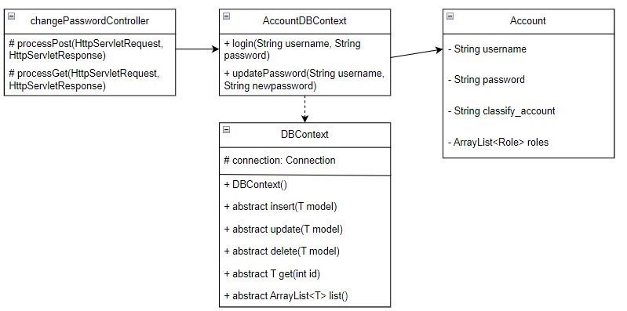

b. Class Specifications

#### changePasswordController

***Class Methods***

|  |  |  |
| --- | --- | --- |
| **No** | **Method** | **Description** |
| 01 | processGet(HttpServletRequest, HttpServletResponse): void | send redirect to changePassword.jsp |
| 02 | processPost(HttpServletRequest, HttpServletResponse): void | Check account with old pass existed, check input new password and repeat password, update password for this account. Other, throw error message to changePassword.jsp |

#### AccountDBContext

***Class Methods***

|  |  |  |
| --- | --- | --- |
| **No** | **Method** | **Description** |
| 01 | login(String username, String password) | check in the DB if there is an account with this username and password |
| 02 | updatePassword(String username, String newpassword) | Update password for this account |

#### DBContext

***Class Methods***

|  |  |  |
| --- | --- | --- |
| **No** | **Method** | **Description** |
| 01 | DBContext() | To connect with database |
| 02 | insert(T Model) | Abstract class (insert a model) |
| 03 | update(T Model) | Abstract class (update a model) |
| 02 | delete(T Model) | Abstract class (delete a model) |
| 02 | T get(int id) | Abstract class (get a model by id of this model) |
| 02 | ArrayList<T> list() | Abstract class (get an ArrayList model) |

c. Sequence Diagram(s)

d. Database Queries

// Update password

UPDATE [dbo].[Account]

SET [password] = ?

WHERE username = ?

//get an account with this info

SELECT a.username,a.classify_account

,r.role_id, r.role_name,

f.fe_id,f.fe_name,f.[url]

FROM Account a

LEFT JOIN Role_Account ra ON a.username = ra.username

LEFT JOIN [Role] r ON r.role_id= ra.role_id

LEFT JOIN Role_Feature rf ON rf.role_id = r.role_id

LEFT JOIN Feature f ON f.fe_id = rf.fe_id

WHERE a.username = ? and a.password = ?

## **11. View user profile**

**

b. Class Specifications

#### viewUserProfileController

***Class Methods***

|  |  |  |
| --- | --- | --- |
| **No** | **Method** | **Description** |
| 01 | processGet(HttpServletRequest, HttpServletResponse): void | Load data from DB and display to jsp |
| 02 | processPost(HttpServletRequest, HttpServletResponse): void |  |

#### CourseDBContext

***Class Methods***

|  |  |  |
| --- | --- | --- |
| **No** | **Method** | **Description** |
| 01 | registeredCourse(int user_id) | Load all course user registered |

#### DBContext

***Class Methods***

|  |  |  |
| --- | --- | --- |
| **No** | **Method** | **Description** |
| 01 | DBContext() | To connect with database |
| 02 | insert(T Model) | Abstract class (insert a model) |
| 03 | update(T Model) | Abstract class (update a model) |
| 02 | delete(T Model) | Abstract class (delete a model) |
| 02 | T get(int id) | Abstract class (get a model by id of this model) |
| 02 | ArrayList<T> list() | Abstract class (get an ArrayList model) |

c. Sequence Diagram(s)

d. Database Queries

// Load all course user registered

SELECT DISTINCT c.course_id, c.course_name,c.class_id, cl.class_name FROM Course c

JOIN Class cl ON cl.class_id = c.class_id

JOIN Module m ON m.course_id = c.course_id

JOIN Lession l ON l.module_id = m.module_id

JOIN Lession_Learn ll ON l.lession_id = ll.lession_id

WHERE ll.[user_id] = ?

## **12. Change User Profile**

a. Class diagram

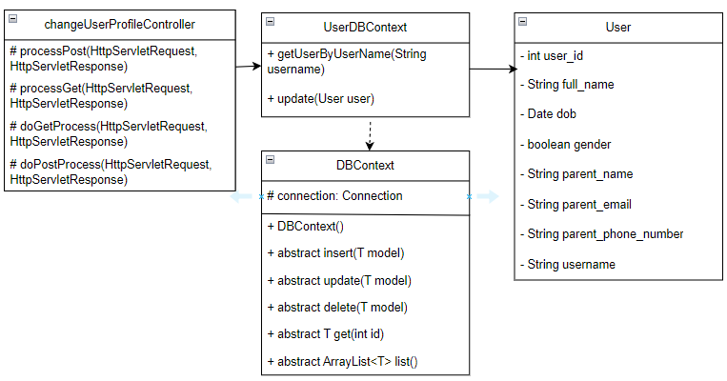

b. Class Specifications

#### changeUserProfileController

***Class Methods***

|  |  |  |
| --- | --- | --- |
| **No** | **Method** | **Description** |
| 01 | processGet(HttpServletRequest, HttpServletResponse): void | Call doGetProcess(HttpServletRequest, HttpServletResponse) |
| 02 | processPost(HttpServletRequest, HttpServletResponse): void | Call doPostProcess(HttpServletRequest, HttpServletResponse) |
| 03 | doGetProcess(HttpServletRequest, HttpServletResponse) | Send redirect to changeuserprofile.jsp |
| 04 | doPostProcess(HttpServletRequest, HttpServletResponse) | Get data and update to DB |

#### UserDBContext

***Class Methods***

|  |  |  |
| --- | --- | --- |
| **No** | **Method** | **Description** |
| 01 | getUserByUserName(String username) | Get User by User name |
| 02 | update(User user) | Update profile of this user |

#### DBContext

***Class Methods***

|  |  |  |
| --- | --- | --- |
| **No** | **Method** | **Description** |
| 01 | DBContext() | To connect with database |
| 02 | insert(T Model) | Abstract class (insert a model) |
| 03 | update(T Model) | Abstract class (update a model) |
| 02 | delete(T Model) | Abstract class (delete a model) |
| 02 | T get(int id) | Abstract class (get a model by id of this model) |
| 02 | ArrayList<T> list() | Abstract class (get an ArrayList model) |

c. Sequence Diagram(s)

d. Database Queries

// Get an user by username

SELECT * FROM [User] WHERE username = ?

// update user to db

UPDATE [dbo].[User]

SET [full_name] = ?

,[dob] = ?

,[gender] = ?

,[parent_name] = ?

,[parent_email] = ?

,[parent_phone_number] = ?

WHERE [username] = ?

## **13. Quiz Management**

b. Class Specifications

#### choiceClassToAddQuiz

***Class Methods***

|  |  |  |
| --- | --- | --- |
| **No** | **Method** | **Description** |
| 01 | processGet(HttpServletRequest, HttpServletResponse): void | Load all class from DB send redirect to choiceQuizLession.jsp |
| 02 | processPost(HttpServletRequest, HttpServletResponse): void | Load all course base on class_id (user seleted) |

#### ClassDBContext

***Class Methods***

|  |  |  |
| --- | --- | --- |
| **No** | **Method** | **Description** |
| 01 | List() | List all Class |

#### CourseDBContext

***Class Methods***

|  |  |  |
| --- | --- | --- |
| **No** | **Method** | **Description** |
| 01 | listCoursebyClassId() | List all course base on class_id (user selected) |

#### choiceCourseToAddQuiz

***Class Methods***

|  |  |  |
| --- | --- | --- |
| **No** | **Method** | **Description** |
| 01 | processGet(HttpServletRequest, HttpServletResponse): void | Load all modules from DB base on course_id (user seleted) |
| 02 | processPost(HttpServletRequest, HttpServletResponse): void | Load all lessons base on module_id (user seleted) |

#### ModuleDBContext

***Class Methods***

|  |  |  |
| --- | --- | --- |
| **No** | **Method** | **Description** |
| 01 | Get(module_id) | Get module by module_id |
| 02 | listModuleByCourseID(course_id) | List module by course_id (user seleted) |

#### LessonDBContext

***Class Methods***

|  |  |  |
| --- | --- | --- |
| **No** | **Method** | **Description** |
| 01 | listLessonByModuleID(module_id) | Load all class from DB base on module_id (User seleted) |

#### actionQuizController

***Class Methods***

|  |  |  |
| --- | --- | --- |
| **No** | **Method** | **Description** |
| 01 | login(String username, String password) | check in the DB if there is an account with this username and password |
| 02 | updatePassword(String username, String newpassword) | Update password for this account |

#### choiceClassToAddQuiz

***Class Methods***

|  |  |  |
| --- | --- | --- |
| **No** | **Method** | **Description** |
| 01 | processGet(HttpServletRequest, HttpServletResponse): void | Load all question class from DB, set attribute, send redirect to addQuiz.jsp |
| 02 | processPost(HttpServletRequest, HttpServletResponse): void | Add/edit/delete base on (user selected) |

#### AddQuizController

***Class Methods***

|  |  |  |
| --- | --- | --- |
| **No** | **Method** | **Description** |
| 01 | processGet(HttpServletRequest, HttpServletResponse): void | Load data, set attribute, send redirect to addQuiz.jsp |
| 02 | processPost(HttpServletRequest, HttpServletResponse): void | Get data, set attribute, send redirect to choiceQuizLession.jsp |

c. Sequence Diagram(s)

d. Database Queries

// Select all class

SELECT * FROM Class

// Select all course by class_id user selected

SELECT * FROM Course WHERE class_id = ?

// Select all module by course_id user selected

SELECT * FROM Module WHERE course_id = ?

// get all lesson by module_id user selected

SELECT * FROM Lession WHERE module_id = ?

// get all quesion by lession_id user selected

SELECT qu.[index], qu.question_id, qu.question, qu.option1, qu.option2,

qu.option3,qu.option4,qu.true_answer, qu.points

FROM Question qu

inner join Lession_Question lq on lq.question_id = qu.question_id

inner join Lession l on l.lession_id = lq.lession_id

WHERE l.lession_id = ?

// insert new question into lesson

INSERT INTO [dbo].[Question]

([question]

,[option1]

,[option2]

,[option3]

,[option4]

,[true_answer]

,[points]

,[index])

VALUES

(?

,?

,?

,?

,?

,?

,?

,?)

// Update a question

UPDATE [dbo].[Question]

SET [question] = ?

,[option1] = ?

,[option2] = ?

,[option3] = ?

,[option4] = ?

,[true_answer] = ?

,[points] = ?

,[index] = ?

WHERE question_id = ?

**Video Management**

b. Class Specifications

*ChoiceClassToAddVideo*

***Class Methods***

|  |  |  |
| --- | --- | --- |
| **No** | **Method** | **Description** |
| 01 | processGet(HttpServletRequest, HttpServletResponse): void | Load all class from DB send redirect to choiceAddLession.jsp |
| 02 | processPost(HttpServletRequest, HttpServletResponse): void | Load all course base on class_id (user seleted) |

#### ClassDBContext

***Class Methods***

|  |  |  |
| --- | --- | --- |
| **No** | **Method** | **Description** |
| 01 | List() | List all Class |

#### CourseDBContext

***Class Methods***

|  |  |  |
| --- | --- | --- |
| **No** | **Method** | **Description** |
| 01 | listCoursebyClassId() | List all course base on class_id (user selected) |

#### ChoiceCourseToAddVideo

***Class Methods***

|  |  |  |
| --- | --- | --- |
| **No** | **Method** | **Description** |
| 01 | processGet(HttpServletRequest, HttpServletResponse): void | Load all modules from DB base on course_id (user seleted) |
| 02 | processPost(HttpServletRequest, HttpServletResponse): void | Load all lessons base on module_id (user seleted) |

#### ModuleDBContext

***Class Methods***

|  |  |  |
| --- | --- | --- |
| **No** | **Method** | **Description** |
| 01 | Get(module_id) | Get module by module_id |
| 02 | listModuleByCourseID(course_id) | List module by course_id (user seleted) |

#### LessonDBContext

***Class Methods***

|  |  |  |
| --- | --- | --- |
| **No** | **Method** | **Description** |
| 01 | listLessonByModuleID(module_id) | Load all class from DB base on module_id (User seleted) |

*actionVideoController*

***Class Methods***

|  |  |  |
| --- | --- | --- |
| **No** | **Method** | **Description** |
| 01 | processGet(HttpServletRequest, HttpServletResponse): void | Load all question class from DB, set attribute, send redirect to addQuiz.jsp |
| 02 | processPost(HttpServletRequest, HttpServletResponse): void | Add/edit/delete base on (user selected) |

#### AddQuizController

***Class Methods***

|  |  |  |
| --- | --- | --- |
| **No** | **Method** | **Description** |
| 01 | processGet(HttpServletRequest, HttpServletResponse): void | Load data, set attribute, send redirect to addQuiz.jsp |
| 02 | processPost(HttpServletRequest, HttpServletResponse): void | Get data, set attribute, send redirect to choiceQuizLession.jsp |

c. Sequence Diagram(s)

d. Database Queries

// Select all class

SELECT * FROM Class

// Select all course by class_id user selected

SELECT * FROM Course WHERE class_id = ?

// Select all module by course_id user selected

SELECT * FROM Module WHERE course_id = ?

// get all lesson by module_id user selected

SELECT * FROM Lession WHERE module_id = ?

## 13. Login

a. Class Diagram

b. Class Specifications

#### controller.auth

***SignupController***

|  |  |  |
| --- | --- | --- |
| **No** | **Method** | **Description** |
| 01 | processRequest(HttpServletRequest, HttpServletResponse): void | To handle request, get data from database and display to jsp |
| 02 | doPost(HttpServletRequest, HttpServletResponse): void | Call processRequest(HttpServletRequest, HttpServletResponse) |
| 03 | doGet(HttpServletRequest, HttpServletResponse): void | Call processRequest(HttpServletRequest, HttpServletResponse) |

#### dal

***Class AccountDBContext***

|  |  |  |
| --- | --- | --- |
| **No** | **Method** | **Description** |
| 01 | login(String username, String password): Account | check username and password is correct or not |

***Class UserDBContext***

|  |  |  |
| --- | --- | --- |
| **No** | **Method** | **Description** |
| 01 | getUserByUsername(String username): User | Get an user base on username |

***Class DBContext***

|  |  |  |
| --- | --- | --- |
| **No** | **Method** | **Description** |
| 01 | DBContext() | To connect with database |

c. Sequence Diagram(s)

d. Database Queries

// Select an account has username and password correct

SELECT a.username,a.classify_account\n"

+ ",r.role_id, r.role_name,\n"

+ "f.fe_id,f.fe_name,f.[url]\n"

+ "FROM Account a\n"

+ "LEFT JOIN Role_Account ra ON a.username = ra.username\n"

+ "LEFT JOIN [Role] r ON r.role_id= ra.role_id\n"

+ "LEFT JOIN Role_Feature rf ON rf.role_id = r.role_id\n"

+ "LEFT JOIN Feature f ON f.fe_id = rf.fe_id\n"

+ "WHERE a.username = ? AND a.password = ?"

//Select user base on username

SELECT * FROM [User] WHERE username = ?

## 14. Signup

a. Class Diagram

b. Class Specifications

#### controller.auth

#### **Class** SignupController

|  |  |  |
| --- | --- | --- |
| **No** | **Method** | **Description** |
| 01 | processRequest(HttpServletRequest, HttpServletResponse): void | To handle request, get data from database and display to jsp |
| 02 | doPost(HttpServletRequest, HttpServletResponse): void | Call processRequest(HttpServletRequest, HttpServletResponse) |
| 03 | doGet(HttpServletRequest, HttpServletResponse): void | Call processRequest(HttpServletRequest, HttpServletResponse) |

Class Fillin4.Controller

|  |  |  |
| --- | --- | --- |
| **No** | **Method** | **Description** |

|  |  |  |
| --- | --- | --- |
| 01 | processRequest(HttpServletRequest, HttpServletResponse): void | To handle request, get data from database and display to jsp |
| 02 | doPost(HttpServletRequest, HttpServletResponse): void | Call processRequest(HttpServletRequest, HttpServletResponse) |
| 03 | doGet(HttpServletRequest, HttpServletResponse): void | Call processRequest(HttpServletRequest, HttpServletResponse) |

Class sendmail.Controller

|  |  |  |
| --- | --- | --- |
| No | Method | Description |
| 01 | getRandomNumberString(): String | Create OTP code |
| 02 | doPost(HttpServletRequest, HttpServletResponse): void | Call processRequest(HttpServletRequest, HttpServletResponse) |
| 03 | doGet(HttpServletRequest, HttpServletResponse): void | Call processRequest(HttpServletRequest, HttpServletResponse) |

Class verifyCode.Controller

|  |  |  |
| --- | --- | --- |
| No | Method | Description |
| 01 | processRequest(HttpServletRequest, HttpServletResponse): void | To handle request, get data from database and display to jsp |
| 02 | doPost(HttpServletRequest, HttpServletResponse): void | Call processRequest(HttpServletRequest, HttpServletResponse) |
| 03 | doGet(HttpServletRequest, HttpServletResponse): void | Call processRequest(HttpServletRequest, HttpServletResponse) |

Class sercurityProcessorCore

|  |  |  |
| --- | --- | --- |
| No | Method | Description |
| 01 | SHA1EncodePassword(String inputPassword): String. | Change a string to SHA1 code. |
| 02 | md5EncodePassword(String inputPassword): String. | Change a string to md5 code. |

#### dal

***Class AccountDBContext***

|  |  |  |
| --- | --- | --- |
| No | Method | Description |
| 01 | signup(String username, String password): void | Add new account into database. |
| 02 | checkAccountExisted(String username): Account | Check account has in database yet or not. |

***Class UserDBContext***

|  |  |  |
| --- | --- | --- |
| **No** | **Method** | **Description** |
| 01 | getUserByUsername(String username): User | Get an user base on username |

***Class DBContext***

|  |  |  |
| --- | --- | --- |
| **No** | **Method** | **Description** |
| 01 | DBContext() | To connect with database |

c. Sequence Diagram(s)

d. Database Queries

// Insert an account into database

"INSERT INTO [dbo].[Account]\n"

+ " ([username]\n"

+ " ,[password]\n"

+ " ,[classify_account])\n"

+ " VALUES\n"

+ " (?,\n"

+ " ?,\n"

+ " 'normal')"

//Insert information for new user

"INSERT INTO [dbo].[Account]\n"

+ " ([username]\n"

+ " ,[password]\n"

+ " ,[classify_account])\n"

+ " VALUES\n"

+ " (?,\n"

+ " ?,\n"

+ " 'nomal')"

//Update roll-account

"UPDATE [dbo].[Role_Account]\n"

+ " SET [role_id] = 1\n"

+ " WHERE username = ?"

//Select user base on username

SELECT * FROM Account \n"

+ "WHERE username = ?

## 15. ForgetPassword

a. Class Diagram

b. Class Specifications

#### controller.forgetPassword

Class ForgetPassword

|  |  |  |
| --- | --- | --- |
| **No** | **Method** | **Description** |
| 01 | processRequest(HttpServletRequest, HttpServletResponse): void | To handle request, get data from database and display to jsp |
| 02 | doPost(HttpServletRequest, HttpServletResponse): void | Call processRequest(HttpServletRequest, HttpServletResponse) |
| 03 | doGet(HttpServletRequest, HttpServletResponse): void | Call processRequest(HttpServletRequest, HttpServletResponse) |

Class SendMail

|  |  |  |
| --- | --- | --- |
| **No** | **Method** | **Description** |

|  |  |  |
| --- | --- | --- |
| 01 | getRandomNumberString(): String | Create OTP code |
| 02 | doPost(HttpServletRequest, HttpServletResponse): void | Call processRequest(HttpServletRequest, HttpServletResponse) |
| 03 | doGet(HttpServletRequest, HttpServletResponse): void | Call processRequest(HttpServletRequest, HttpServletResponse) |

Class verifyCode

|  |  |  |
| --- | --- | --- |
| No | Method | Description |
| 01 | processRequest(HttpServletRequest, HttpServletResponse): void | To handle request, get data from database and display to jsp |
| 02 | doPost(HttpServletRequest, HttpServletResponse): void | Call processRequest(HttpServletRequest, HttpServletResponse) |
| 03 | doGet(HttpServletRequest, HttpServletResponse): void | Call processRequest(HttpServletRequest, HttpServletResponse) |

#### dal

***Class AccountDBContext***

|  |  |  |
| --- | --- | --- |
| No | Method | Description |
| 01 | updatePassword(String username, String newpassword) | Update new password for account. |

***Class DBContext***

|  |  |  |
| --- | --- | --- |
| **No** | **Method** | **Description** |
| 01 | DBContext() | To connect with database |

c. Sequence Diagram(s)

d. Database Queries

// Update new password

"UPDATE [dbo].[Account]\n"

+ " SET [password] = ?\n"

+ " WHERE username = ?" + " 'normal')"

## 16. UserManagement

a. Class Diagram

b. Class Specifications

#### controller.admin.viewUser

Class UserManagerment

|  |  |  |
| --- | --- | --- |
| **No** | **Method** | **Description** |
| 01 | doPost(HttpServletRequest, HttpServletResponse): void | Call processRequest(HttpServletRequest, HttpServletResponse) |
| 02 | doGet(HttpServletRequest, HttpServletResponse): void | Call processRequest(HttpServletRequest, HttpServletResponse) |

Class NomalUserManager

|  |  |  |
| --- | --- | --- |
| **No** | **Method** | **Description** |
| 01 | doPost(HttpServletRequest, HttpServletResponse): void | Call processRequest(HttpServletRequest, HttpServletResponse) |
| 02 | doGet(HttpServletRequest, HttpServletResponse): void | Call processRequest(HttpServletRequest, HttpServletResponse) |

Class PremiumManager

|  |  |  |
| --- | --- | --- |
| **No** | **Method** | **Description** |
| 01 | doPost(HttpServletRequest, HttpServletResponse): void | Call processRequest(HttpServletRequest, HttpServletResponse) |
| 02 | doGet(HttpServletRequest, HttpServletResponse): void | Call processRequest(HttpServletRequest, HttpServletResponse) |

Class TotalManager

|  |  |  |
| --- | --- | --- |
| **No** | **Method** | **Description** |
| 01 | doPost(HttpServletRequest, HttpServletResponse): void | Call processRequest(HttpServletRequest, HttpServletResponse) |
| 02 | doGet(HttpServletRequest, HttpServletResponse): void | Call processRequest(HttpServletRequest, HttpServletResponse) |

#### dal

***Class AccountDBContext***

|  |  |  |
| --- | --- | --- |
| No | Method | Description |
| 01 | getNumberOfPremiumUser(): int | Return number of premium user |
| 02 | getNumberOfNormalUser(): int | Return number of premium user |
| 03 | getNumberOfTotalUser(): int | Return number of total user |

ClassUserDBContext

|  |  |  |
| --- | --- | --- |
| **No** | **Method** | **Description** |
| 01 | getPremiumUserByKey(String keyRAW): List<User> | Return a list of premium user |
| 02 | getNormalUserByKey(String keyRAW): List<User> | Return a list of nomal user |
| 03 | getTotalUserByKey(String keyRAW): List<User> | Return a list of total user |

***Class DBContext***

|  |  |  |
| --- | --- | --- |
| **No** | **Method** | **Description** |
| 01 | DBContext() | To connect with database |

c. Sequence Diagram(s)

d. Database Queries

// Get a list of premium user

"SELECT u.full_name,u.dob,u.gender,u.parent_email,u.parent_name,u.parent_phone_number,u.username FROM [User] u \n"

+ "JOIN Account a ON a.username = u.username\n"

+ "WHERE u.full_name LIKE ? AND a.classify_account = 'premium'"

// Get a list of nomal user

"SELECT u.full_name,u.dob,u.gender,u.parent_email,u.parent_name,u.parent_phone_number,u.username FROM [User] u \n"

+ "JOIN Account a ON a.username = u.username\n"

+ "WHERE u.full_name LIKE ? AND a.classify_account = 'normal'"

// Get a list of total user

"SELECT u.full_name,u.dob,u.gender,u.parent_email,u.parent_name,u.parent_phone_number,u.username FROM [User] u \n"

+ "JOIN Account a ON a.username = u.username\n"

+ "WHERE u.full_name LIKE ?"

// Get number of total user

"SELECT COUNT(*) AS total FROM [User] u"

// Get number of premium user

"SELECT COUNT(*) AS premium FROM [User] u\n"

+ "JOIN Account a ON a.username = u.username AND a.classify_account = 'premium'"

// Get number of nomal user

"SELECT COUNT(*) AS normal FROM [User] u \n"

+ "JOIN Account a ON a.username = u.username AND a.classify_account = 'normal’’’

17. Match Game Page

a.Class Diagram

b.Class Specifications

#### matchgameController

***Class Methods***

|  |  |  |
| --- | --- | --- |
| **No** | **Method** | **Description** |
| 01 | processPost(HttpServletRequest req, HttpServletResponse resp, Account account): void | To handle request, get data from database and display to jsp and get authorization |
| 02 | processGet(HttpServletRequest req, HttpServletResponse resp, Account account): void | To handle request, get data from database and display to jsp and get authorization |

#### MatchGameDBContext

***Class Methods***

|  |  |  |
| --- | --- | --- |
| **No** | **Method** | **Description** |
| 01 | getMatchGamePairsByLessionID(int) ArrayList<MatchGame> | Get a list of match game based on: what is id of lesson_id |

#### 

#### DBContext

***Class Methods***

|  |  |  |
| --- | --- | --- |
| **No** | **Method** | **Description** |
| 01 | DBContext() | To connect with database |

c. Sequence Diagram(s)

d. Database Queries

//Select match game by lesson id

SELECT m.match_game_id, m.img_id, m.ans_img_id, m.[index],

                        i.img_name, i.img_url,

                     a.ans_img_name, a.ans_img_url

                     FROM MatchGame m

                   Inner join Img i on i.img_id = m.img_id

                   Inner join AnsImg a on a.ans_img_id = m.ans_img_id

                   Inner join Lession_MatchGame lm on lm.match_game_id = m.match_game_id

                   Inner join Lession l on l.lession_id = lm.lession_id

                   WHERE l.lession_id = ?

18. Quiz Page

a.Class Diagram

b.Class Specifications

#### quizController

***Class Methods***

|  |  |  |
| --- | --- | --- |
| **No** | **Method** | **Description** |
| 01 | processPost(HttpServletRequest req, HttpServletResponse resp, Account account): void | To handle request, get data from database and display to jsp and get authorization |
| 02 | processGet(HttpServletRequest req, HttpServletResponse resp, Account account): void | To handle request, get data from database and display to jsp and get authorization |

#### QuestionDBContext

***Class Methods***

|  |  |  |
| --- | --- | --- |
| **No** | **Method** | **Description** |
| 01 | getQuestionByLessionID(int):ArrayList<Question> | Get a list of question based on: what is id of lesson_id |

#### 

#### DBContext

***Class Methods***

|  |  |  |
| --- | --- | --- |
| **No** | **Method** | **Description** |
| 01 | DBContext() | To connect with database |

c. Sequence Diagram(s)

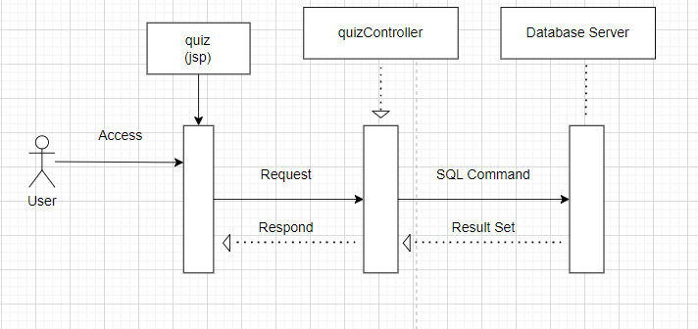

d. Database Queries

//Select question by lesson id

SELECT qu.[index], qu.question_id, qu.question, qu.option1, qu.option2,

                    qu.option3, qu.option 4, qu.true_answer, qu.points

                   FROM Question qu

                    inner join Lession_Question lq on lq.question_id = qu.question_id

                   inner join Lession l on l.lession_id = lq.lession_id

                    WHERE l.lession_id = ?

19. Choose to add lesson for content page

a, Class Diagram

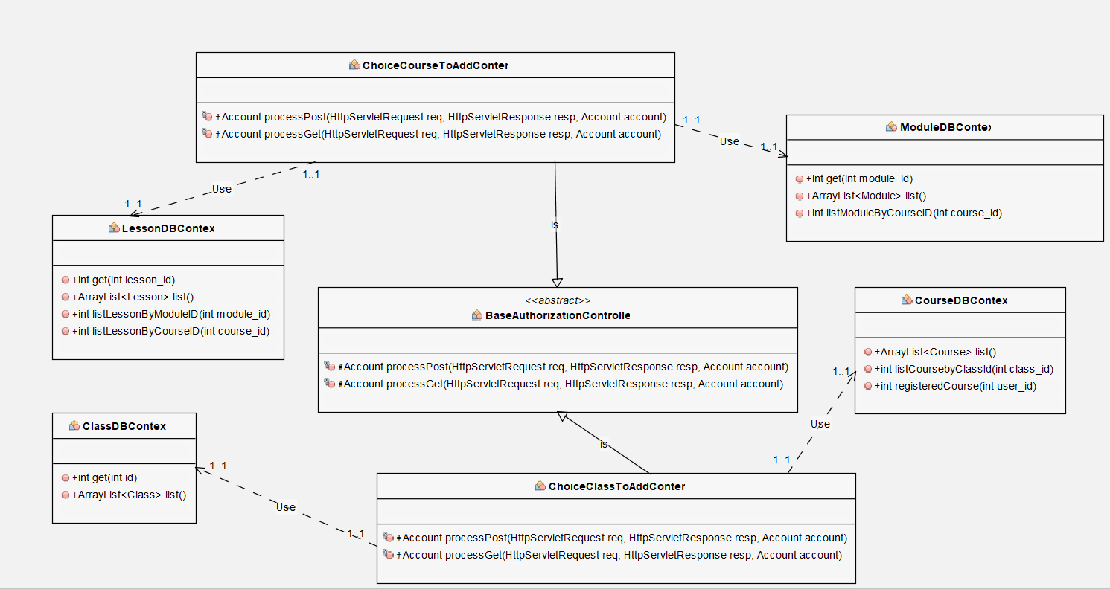

b.Class Specifications

***ChoiceClassToAddContent***

|  |  |  |
| --- | --- | --- |
| **No** | **Method** | **Description** |
| 01 | processPost(HttpServletRequest req, HttpServletResponse resp, Account account): void | To handle request, get data from database and display to jsp and get authorization |
| 02 | processGet(HttpServletRequest req, HttpServletResponse resp, Account account): void | To handle request, get data from database and display to jsp and get authorization |

***ClassDBContext***

|  |  |  |
| --- | --- | --- |
| **No** | **Method** | **Description** |
| 01 | list(): ArrayList<Class> | Get list of classes |

***CourseDBContext***

|  |  |  |
| --- | --- | --- |
| **No** | **Method** | **Description** |
| 01 | listCoursebyClassId(int class_id): ArrayList<Class> | Get list of courses by class id |

***ChoiceCourseToAddContent***

|  |  |  |
| --- | --- | --- |
| **No** | **Method** | **Description** |
| 01 | processPost(HttpServletRequest req, HttpServletResponse resp, Account account): void | To handle request, get data from database and display to jsp and get authorization |
| 02 | processGet(HttpServletRequest req, HttpServletResponse resp, Account account): void | To handle request, get data from database and display to jsp and get authorization |

***ModuleDBContext***

|  |  |  |
| --- | --- | --- |
| **No** | **Method** | **Description** |
| 01 | listModuleByCourseID(int course_id): ArrayList<Module> | Get list of modules by course id |

***LessonDBContext***

|  |  |  |
| --- | --- | --- |
| **No** | **Method** | **Description** |
| 01 | listLessonByModuleID(int module_id): ArrayList<Lesson> | Get list of lessons by module id |

c.Sequence diagram

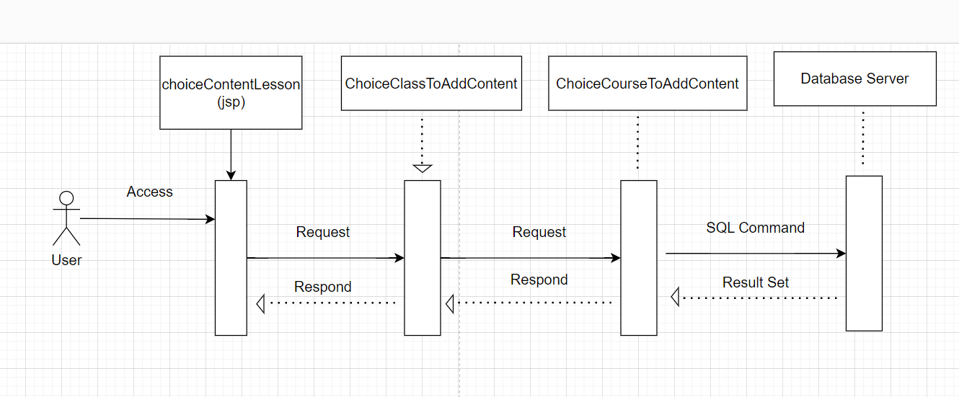

d. Database Queries

//Select list of classes

SELECT * FROM Class

//Select list of courses by class Id

SELECT * FROM Course WHERE class_id = ?

//Select list of modules by course id

SELECT * FROM Module WHERE course_id = ?

//Select list of lesson by module id

SELECT * FROM Lession WHERE module_id =

## 20. Admin content page

a. Class Diagram

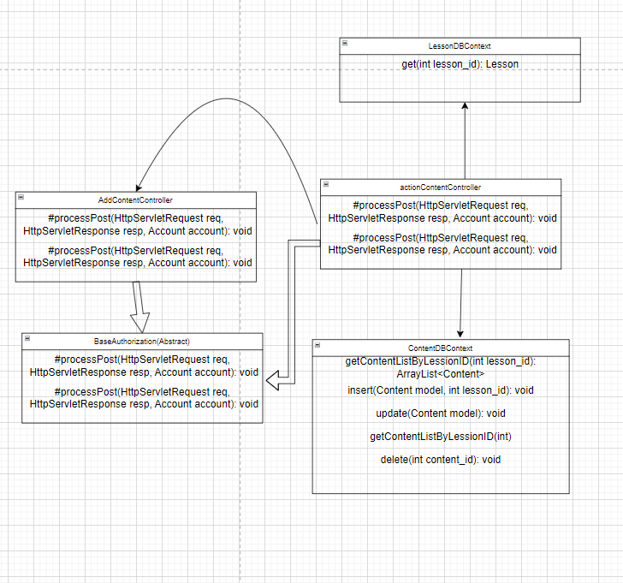

b.Class Specifications

***AddContentController***

|  |  |  |
| --- | --- | --- |
| **No** | **Method** | **Description** |
| 01 | processPost(HttpServletRequest req, HttpServletResponse resp, Account account): void | To handle request, get data from database and display to jsp and get authorization |
| 02 | processGet(HttpServletRequest req, HttpServletResponse resp, Account account): void | To handle request, get data from database and display to jsp and get authorization |

***ContentDBContext***

|  |  |  |
| --- | --- | --- |
| **No** | **Method** | **Description** |
| 01 | getContentListByLessionID(int lession_id): ArrayList<Content> | Get list of contents by lesson id |
| 02 | insert(Content model, int lesson_id): void | Insert new content into database |
| 03 | update(Content model): void | Update content into database |
| 04 | deleteLessonContent(int content_id): void | Delete table that have foreign key of content id in database |
| 05 | delete(int content id): void | Delete content in database |

***LessonDBContext***

|  |  |  |
| --- | --- | --- |
| **No** | **Method** | **Description** |
| 01 | get(int lesson_id): Lesson | Get lesson by lesson id |

***actionContentController***

|  |  |  |
| --- | --- | --- |
| **No** | **Method** | **Description** |
| 01 | processPost(HttpServletRequest req, HttpServletResponse resp, Account account): void | To handle request, get data from database and display to jsp and get authorization |
| 02 | processGet(HttpServletRequest req, HttpServletResponse resp, Account account): void | To handle request, get data from database and display to jsp and get authorization |

c. Sequence Diagram(s)

d. Database Queries

// Delete content

DELETE FROM [dbo].[Content]  WHERE content_id = ?

//Delete lesson content

 DELETE FROM [dbo].[Lession_Content]   WHERE content_id = ?

//Update content

UPDATE [dbo].[Content]

                SET [reading_content] = ?

                WHERE content_id = ?

// Insert content

INSERT INTO [dbo].[Content]

                    ([reading_content])

                 VALUE (?)

//Get list of contents by lesson id

SELECT c.content_id, c.reading_content

                   FROM Content c

                  inner join Lession_Content lc on lc.content_id = c.content_id

                inner join Lession l on l.lession_id = lc.lession_id

                 WHERE l.lession_id = ?

21. Add match game image page (admin)

a. Class Diagram

b.Class Specifications

***AddPairsOfImageController***

|  |  |  |
| --- | --- | --- |
| **No** | **Method** | **Description** |
| 01 | processPost(HttpServletRequest req, HttpServletResponse resp, Account account): void | To handle request, get data from database and display to jsp and get authorization |
| 02 | processGet(HttpServletRequest req, HttpServletResponse resp, Account account): void | To handle request, get data from database and display to jsp and get authorization |

***MatchGameDBContext***

|  |  |  |
| --- | --- | --- |
| **No** | **Method** | **Description** |
| 01 | insertImg(Img model): void | Insert new image into Database |
| 02 | insertAnsImg(AnsImg model): void | Insert new answer image content into database |
| 03 | updateImg(Img model): void | Update image into database |
| 04 | updateAnsImg(AnsImg model): void | Update answer image into database |
| 05 | insertMatchGame(MatchGame model, int lesson_id, Img model, AnsImg model): void | Insert new match game pairs into database |
| 06 | getMatchGamePairsByLessionID(int lesson_id):ArrayList<MatchGame> | Get list of match game image pairs |

***actionMatchGameController***

|  |  |  |
| --- | --- | --- |
| **No** | **Method** | **Description** |
| 01 | processPost(HttpServletRequest req, HttpServletResponse resp, Account account): void | To handle request, get data from database and display to jsp and get authorization |
| 02 | processGet(HttpServletRequest req, HttpServletResponse resp, Account account): void | To handle request, get data from database and display to jsp and get authorization |

c. Sequence Diagram(s)

d. Database Queries

// Get match game pairs by lesson id

SELECT m.match_game_id, m.img_id, m.ans_img_id, m.[index],

                       i.img_name, i.img_url,

                       a.ans_img_name, a.ans_img_url

                      FROM MatchGame m

                     inner join Img i on i.img_id = m.img_id

                     inner join AnsImg a on a.ans_img_id = m.ans_img_id

                    + "     inner join Lession_MatchGame lm on lm.match_game_id =m.match_game_id

                   inner join Lession l on l.lession_id = lm.lession_id

                   WHERE l.lession_id = ?

// Update Match game

"UPDATE [dbo].[MatchGame]\n"

                + "   SET [img_id] = ?\n"

                  ,[ans_img_id] = ?

                  ,[points] = ?"

                  ,[index] = ?

                 WHERE match_game_id = ?

// Insert Match Game

INSERT INTO [dbo].[MatchGame]

                 ([img_id]

                 ,[ans_img_id]

                 ,[points]

                 ,[index])

                 VALUES (?, ?, ?, ?)

// Insert Lesson Match Game

"INSERT INTO [dbo].[Lession_MatchGame]\n"

                                ([lession_id]

                         ,[match_game_id])

                    VALUES

                         (?\

                           ,?)

// Insert image

"INSERT INTO [dbo].[Img]

                           ([img_name]

                           ,[img_url])

                    VALUES

                         (?

                          ,?)

//Insert answer image

"INSERT INTO [dbo].[AnsImg]\n"

                      ([ans_img_name]

                       ,[ans_img_url])

                        VALUES

                         (?

                        ,?)

22. Add module  page (admin)

a. Class Diagram

b.Class Specifications

***actionModuleController***

|  |  |  |
| --- | --- | --- |
| **No** | **Method** | **Description** |
| 01 | processPost(HttpServletRequest req, HttpServletResponse resp, Account account): void | To handle request, get data from database and display to jsp and get authorization |
| 02 | processGet(HttpServletRequest req, HttpServletResponse resp, Account account): void | To handle request, get data from database and display to jsp and get authorization |

***ModuleDBContext***

|  |  |  |
| --- | --- | --- |
| **No** | **Method** | **Description** |
| 01 | get(int module_id): Module | Get a module by module id |
| 02 | listModuleByCourseID(int course_id): ArrayList<Module> | Get list of modules by course id |
| 03 | insert(Module model): void | Insert new module into database |
| 04 | update(Module model): void | Update module into database |

c. Sequence Diagram(s)

d. Database Queries

// insert

"INSERT INTO [dbo].[Module]

                     ([module_name]

                    ,[course_id]

                      ,[status])

                   VALUES

                          (?

                         ,?

                         ,?)

// Update

"UPDATE [dbo].[Module]\n"

                 SET [module_name] = ?

                     ,[course_id] = ?

                     ,[status] = ?

                WHERE module_id = ?

// Get list of modules by course id

SELECT * FROM Module WHERE course_id = ?