

**Online learn**

**Software Design Specification**

– Hanoi, August 2022 –

Record of changeS

|  |  |  |  |
| --- | --- | --- | --- |
| Date | A* M, D | In charge | Change Description |
|  |  |  |  |
|  |  |  |  |
|  |  |  |  |
|  |  |  |  |
|  |  |  |  |
|  |  |  |  |
|  |  |  |  |
|  |  |  |  |
|  |  |  |  |
|  |  |  |  |
|  |  |  |  |
|  |  |  |  |
|  |  |  |  |

*A - Added M - Modified D - Deleted

**Table of Contents**

I. Overview 4

1. Code Packages 4

2. Database Design 4

a. Database Schema 4

b. Table Description 4

II. Code Designs 5

1. <Feature/Function Name1> 5

a. Class Diagram 5

b. Class Specifications 5

c. Sequence Diagram(s) 5

d. Database queries 6

2. <Feature/Function Name2> 6

# I. Overview

## 1. Code Packages

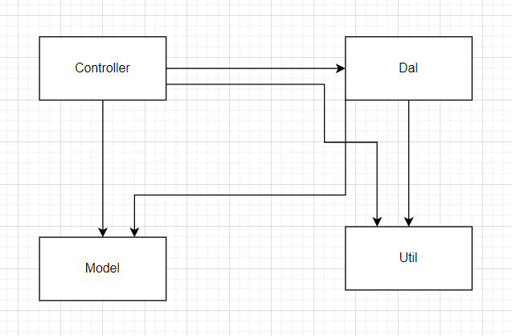

***Package descriptions***

|  |  |  |
| --- | --- | --- |
| **No** | **Package** | **Description** |
| *01* | *Controller* | *Handle back-end, drive flow of code* |
| *02* | *Dal* | *Handle database* |
| *03* | *Model* | *Create object suitable database* |
| *04* | *Util* | *Support* |
|  |  |  |
|  |  |  |
|  |  |  |

## 2. Database Design

### a. Database Schema

*[Provide the tables relationship like example below – following MySQL database naming convention]*

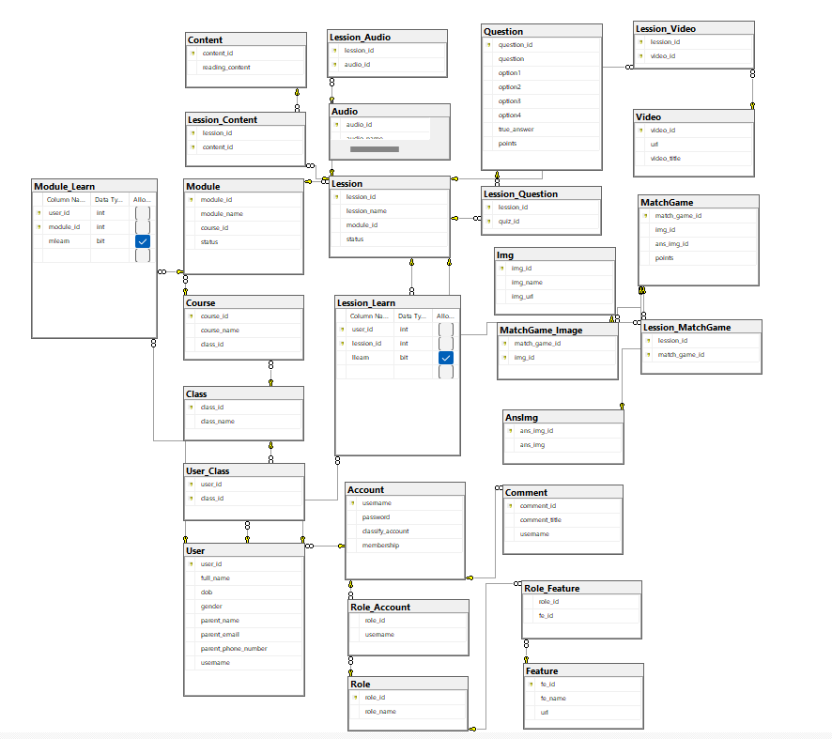

### b. Table Description

|  |  |  |
| --- | --- | --- |
| **No** | **Table** | **Description** |
| *01* | *<Table name>* | *<Description of the table>* |

# II. Code Designs

## 1. <Feature/Function Name1>

### a. Class Diagram

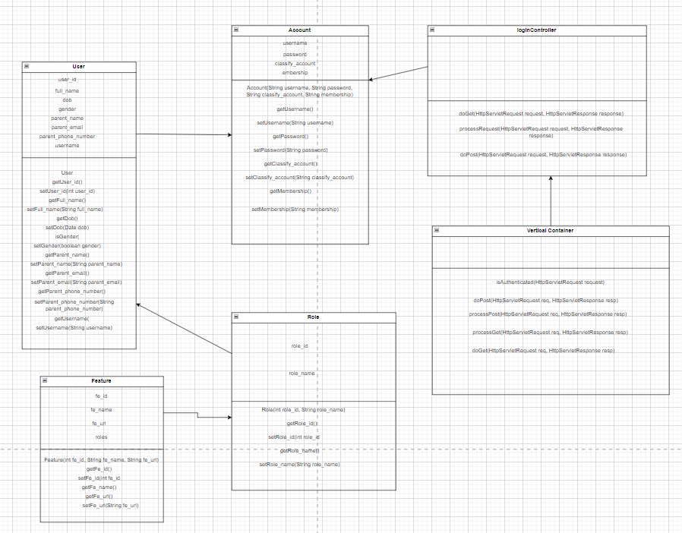

### b. Class Specifications

|  |  |  |
| --- | --- | --- |
| **No** | **Method** | **Description** |
| *01* | *<method name>* | *<Description of the method, including the inputs, outputs & internal method processing>* |
|  |  |  |

***Class Methods***

|  |  |  |
| --- | --- | --- |
| **No** | **Method** | **Description** |
| *01* | *<method name>* | *<Description of the method, including the inputs, outputs & internal method processing>* |
|  |  |  |

### c. Sequence Diagram(s)

### d. Database Queries

## 2. <Feature/Function Name2>

…