# SOFTWARE DEVELOPMENT LIFE CYCLE

for

# ONLINE SURVEY SOFTWARE

Throughout our project building process we will be using **Scrum framework of Agile**.

## SCRUM DEVELOPMENT PROCESS :

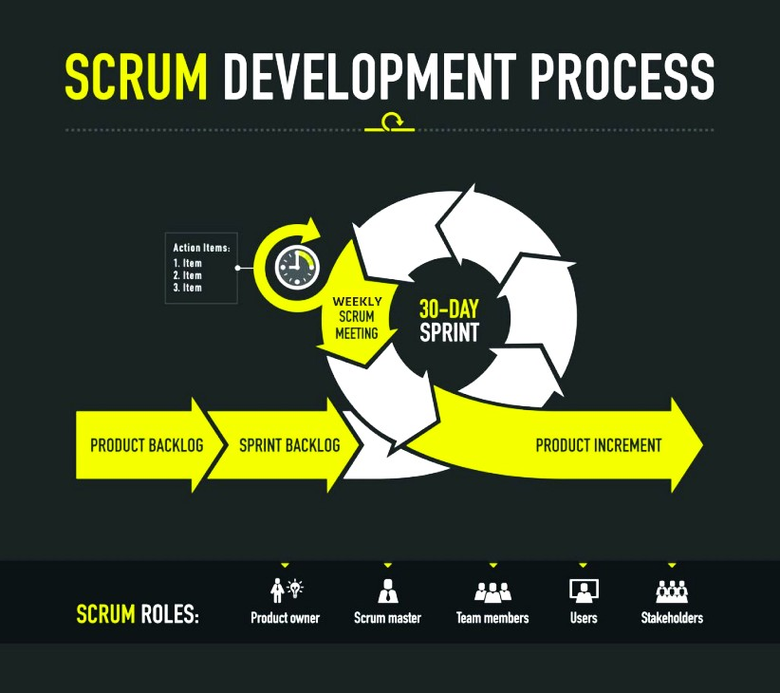

**How we follow SCRUM :**

* We gather the user experience from the user in the form of a feedback.
* We will have a weekly scrum meeting to ensure about the builds and fixes of user issues.
* We discuss about what new things can be implemented to make our software stand out.

## Why SCRUM :

* Basically Scrum is used when frequent changes in the software is required.
* Since we require more and more users to use our software so that survey results are accurate, we need to boost our UX so that users attracted.
* Whenever a new user registers, after some times of usage of our software we ask our users to give feedback of the software, so that we could discuss about it in Scrum meetings and fix the issue with the users.