FOUNDATIONS OF AI LAB -1
State space and combinatorial explosion
Name : Tanala Phanendra
Roll_No: CB.SC.P2CSE26029

My Approach:
I represented each jug reading as a state (x, y) and wrote a successors() function that lists all 6 states reachable by one move. I explored outward from (0,0) level by level, using a seen set to skip any state I'd already found, so I never re-count a repeated state. This turned an exploding 6-branch tree into the true, much smaller state graph — only 14 of the 20 possible (x,y) pairs are actually reachable, since every move forces at least one jug to become fully empty or fully full.

My code file has been uploaded in my github:
https://github.com/Phanendra24111/AI---LAB1---State-space-and-combinatorial-explosion

Output code snippet:
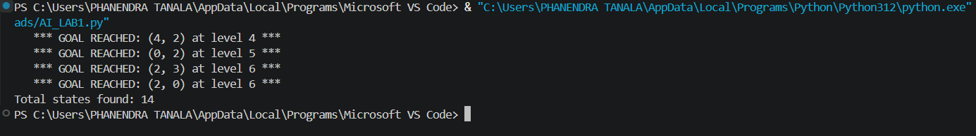
My chatgpt research:
https://chatgpt.com/share/6a70c823-82f8-83ee-a123-b6921bdbd585
