Trinadh Phani Ginjupalli (002117493)

Program Structures and Algorithms (Fall 2021)

Assignment 1

Link to the assignment’s repository - <https://github.com/Phani56/INFO6205-Assignments>  
  
**Tasks performed**

* Updated RandomWalk.java code from forked repo to run it for 22 different tests from number of steps spanning from 4 to 1000.
* Successfully ran the unit tests.
* Recorded the output values in a spreadsheet and plotted a graph between number of steps and the euclidean distance from origin.
* Deduced a functional relationship between n and d from the observations.

The code for getting distance for n random steps has been updated here in the repository *src/main/java/edu/neu/coe/info6205/randomwalk/RandomWalk.java*.

**Relationship conclusion**

Let **n** be the number of steps taken and **d** is the euclidean distance covered, the based on the analysis the relationship can be approximately expressed as

As shown below, I have updated the main func and ran the code for respective values of n,

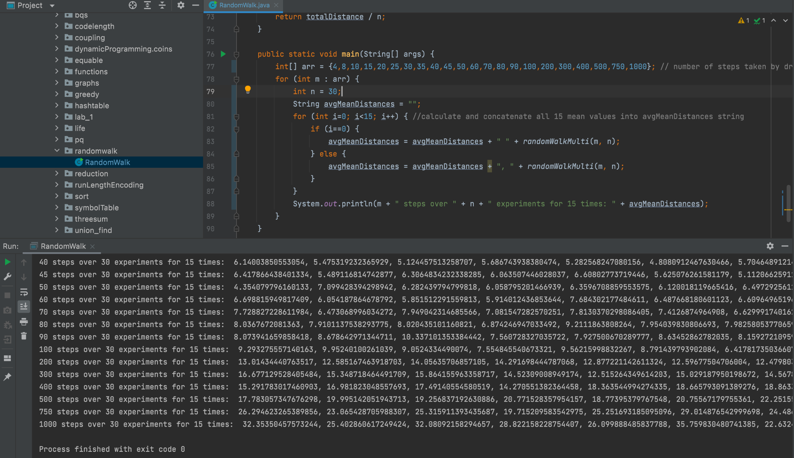

Graphical relationship between d and n.

Link to the spreadsheet - [Randomwalk assignment](https://docs.google.com/spreadsheets/d/1W2GFkicX6RKndTDAqYM1Me4Uf6-Ds4L7mDRS-4EE2Hg/edit?usp=sharing)

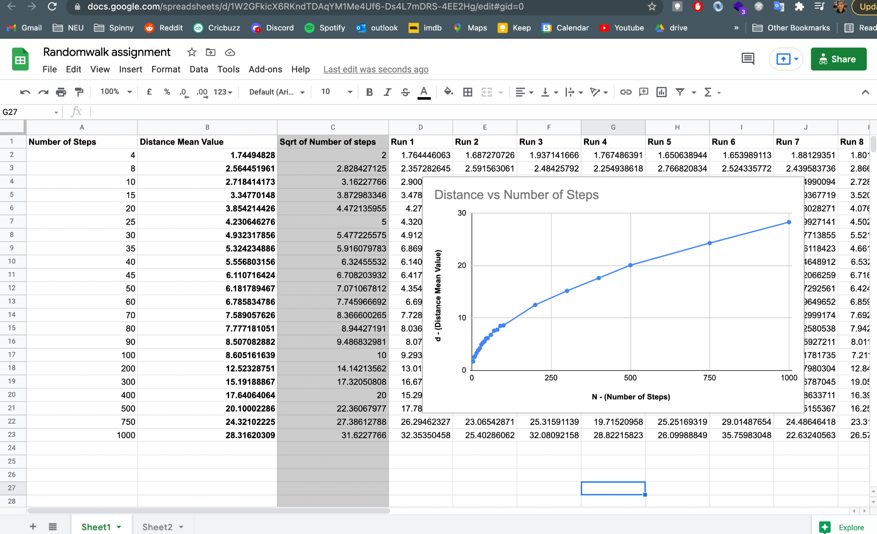

The graph plotted here is similar to that of the equation from which the conclusion was deduced. The corresponding mean value of euclidean distance for the results obtained are close to the sqrt of the number of steps in almost every case.

The unit tests passed, attaching screenshot for the same

