Trinadh Phani Ginjupalli (002117493)

Program Structures and Algorithms (Fall 2021)

Assignment 2

Link to the assignment’s repository - <https://github.com/Phani56/INFO6205-Assignments>  
  
**Tasks performed**

* Updated code for missing methods in Timer and InsertionSort classes.
* Successfully ran the unit tests for Timer and InsertionSort classes after updating the code.
* Created a new java class InsertionSortBenchmark to test the timings of insertion sort class and deduce a result. Path for it - *edu/neu/coe/info6205/sort/elementary/InsertionSortBenchmark.java*
* Ran tests for random, ordered and half ordered arrays. Recorded output for different values of n doubling it each time and plotted graphs for each scenario.

**Link for observations recorded -** [Insertionsort assignment](https://docs.google.com/spreadsheets/d/16wIW2UvZH_M3MIU9jNm0tZPGHaKm9uiHP1ttBxg_Jj0/edit?usp=sharing)

**Screenshots for Unit tests ran for InsertionSort and Timer classes**-> Timer unit tests

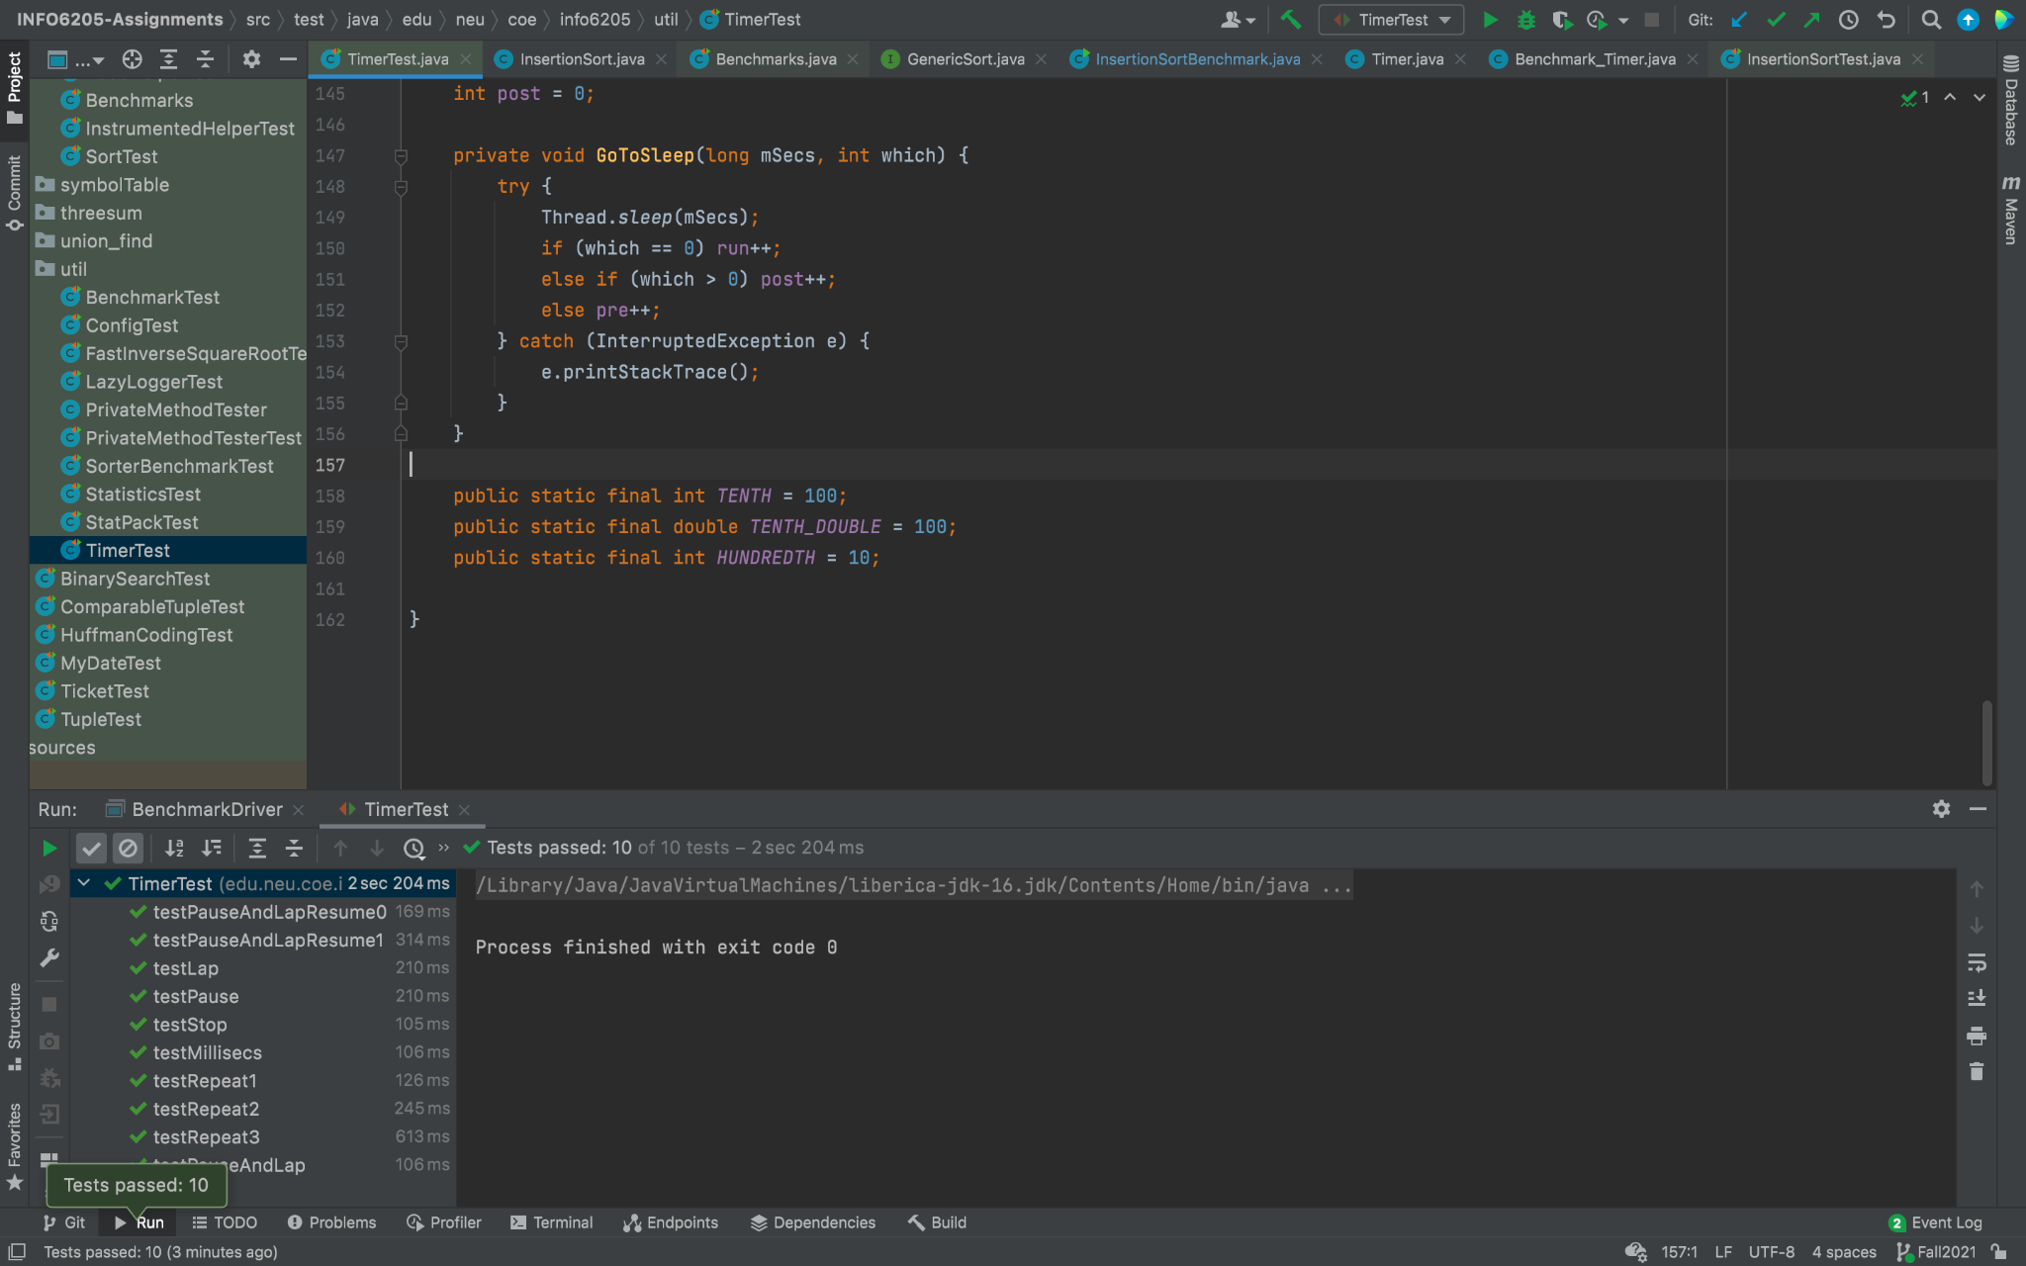

-> InsertionSort unit tests  
