|  |
| --- |
| **Abstract**  This document provides a reusable PeopleCode solution to publish, fetch and email BI-Publisher reports to users dynamically in Oracle Cloud Infrastructure (OCI) from either Windows (PSNT) or Unix (PSUNX) Process Scheduler servers using a single Application Engine program without hard coding the Process Scheduler server name or reports file path. |

|  |  |  |  |
| --- | --- | --- | --- |
| Document No. |  | Ver. Rev.: | **1.0** |
| Authored by: | |  | | --- | | **Phani Bhushan Alampalli** | | Date: | **18-02-2022** |
| Reviewed by: | |  | | --- | | **Tapan Vakil** | | Date: | **25-02-2022** |

**Table of Contents**

1. Problem Overview 2

2. Solution 2

i. AE Program section - Code to **generate and publish** the BI- Publisher reports 3

ii. AE program section - Code to fetch the BI Publisher reports and email them to users 4

3. Benefits 5

1. **Problem Overview**

There was a business requirement to generate BI-Publisher reports from PeopleSoft and email them to users. To accomplish the business need, two Application Engine (AE) programs had been created. One AE program to publish/generate the reports and the second AE program to fetch the generated BI-Publisher reports and email them to users.

In the second AE program, the PSREPORTS folder path from where the BI-Publisher reports were fetched to email to users, was hard coded.

Output files would get posted to PSREPORTS path upon successful completion of the first AE program.

The code specified below was used to fetch the BI-Publisher reports in the second AE program.

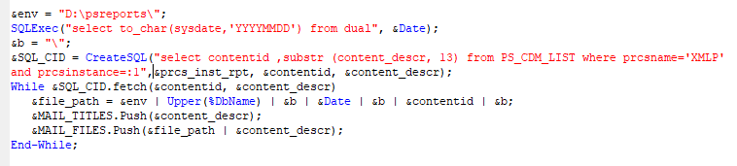

The PeopleSoft application was migrated from on-premises architecture to Oracle Cloud Infrastructure (OCI). The cloud PeopleSoft Process Scheduler server runs on both, Windows and Unix operating systems. The second AE program was not able to fetch the BI-Publisher reports from the PSREPORTS path as the reports repository folder (PSREPORTS) changed in OCI.

1. **Solution**

Before posting the output files into PSREPORTS folder, they get stored in XMLP folder which is in PSHOME. If the reports can be fetched from XMLP folder, then the reports can be published and fetched using a single AE program. The XMLP folder path is available in PeopleSoft record PS_CDM_LIST.

Windows servers use back slash ‘\’ in the file path, whereas Unix servers use forward slash ‘/’ in the file path. On this basis the Process Scheduler server, PSNT or PSUNX, can be identified.

The below code is used to get the BI-Publisher reports from XMLP folder before they are moved and posted to PSREPORTS folder and to find the Process Scheduler server, PSNT or PSUNX, on which the process is run.

**Single AE Program**

Below is the extract of the relevant code to publish, fetch and email the BI-Publisher reports to users using a single AE Program

1. AE Program section - Code to **generate and publish** the BI- Publisher reports

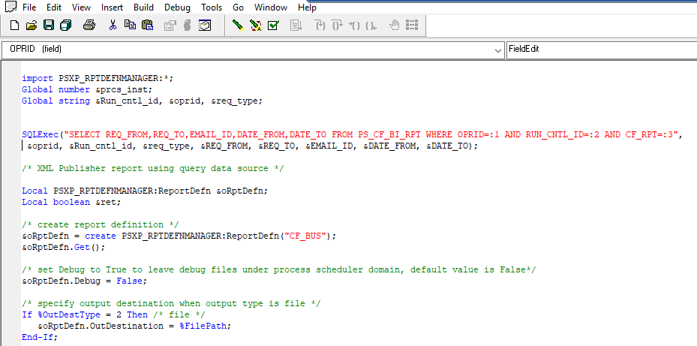

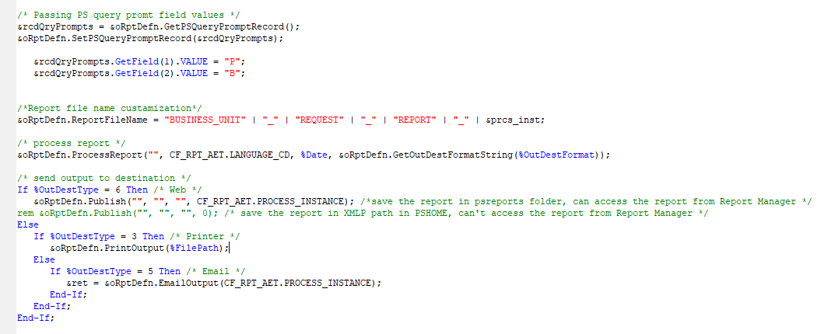

1. AE program section - Code to fetch the BI Publisher reports and email them to users

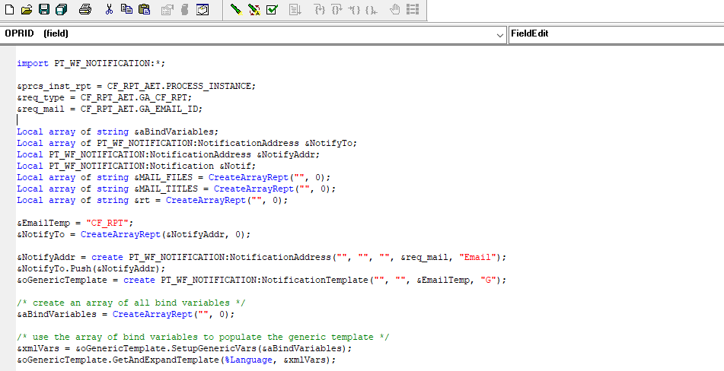

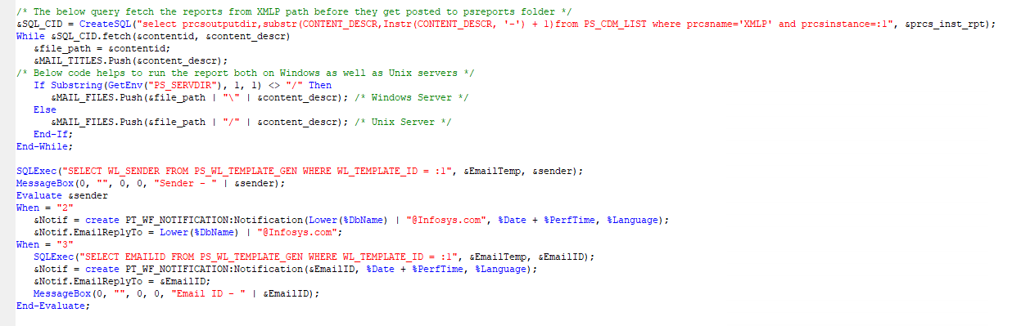

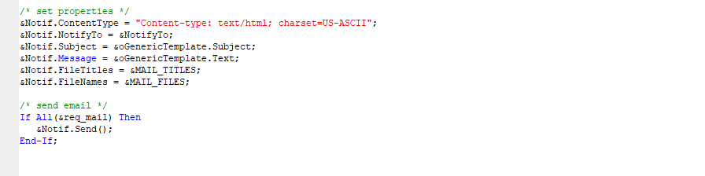

1. **Benefits**

* Process to publish, fetch and email BI-Publisher reports can be run either on Windows or Unix Process Scheduler servers dynamically
* No need of hard coding to identify the Process Scheduler server - Windows or Unix
* No need of hard coding of path to identify the PSREPORTS folder
* Single application engine can publish, fetch and email Bi-Publisher reports generated by any of the multiple Process Scheduler servers in use
* Reusable code