Run docker-compose up –build to start all the services, create images and containers

Image and containers on the docker desktop:

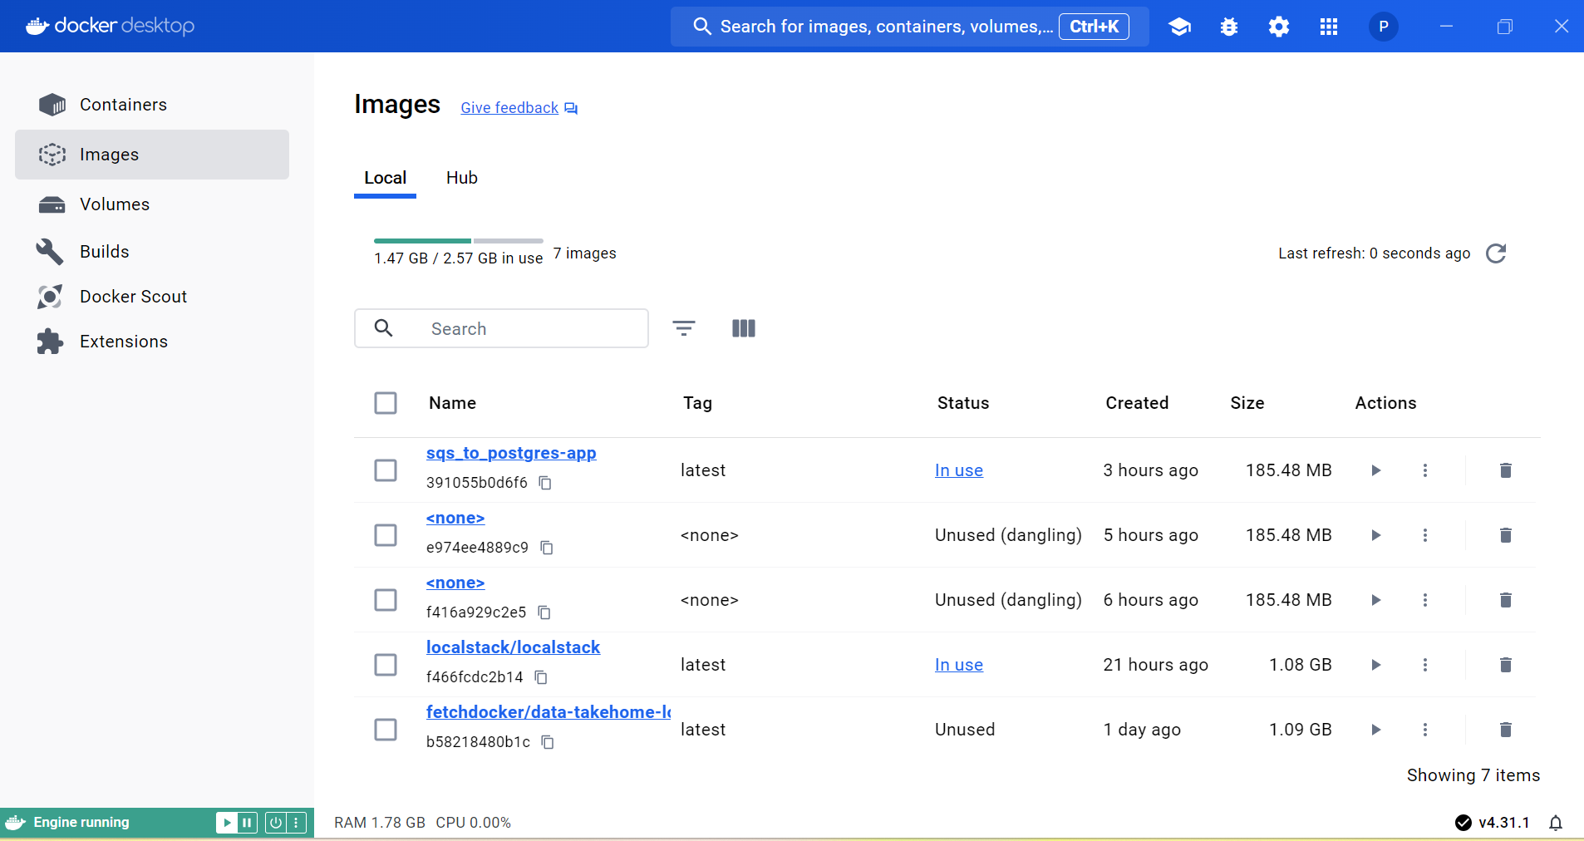

There is no predefined data, verified using the below command:

So sent data to queue, I have created message.json and sent it using the below command:

Output verification: User_login data stored in postgres: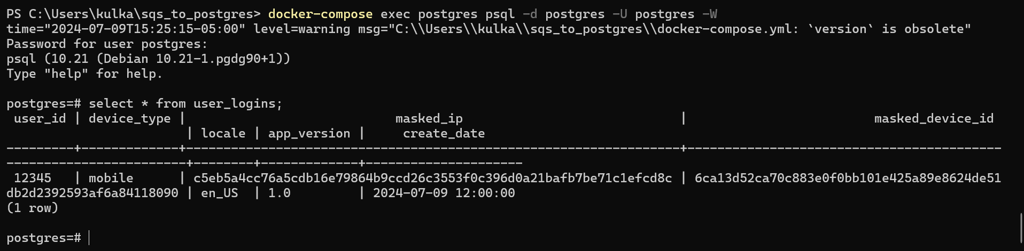

Questions:

1. How would you deploy this application in production?

Cloud Deployment: Deploy the application on a cloud platform like AWS or GCP.

Container Orchestration: Use Kubernetes or ECS to manage and scale containers efficiently.

2. What other components would you want to add to make this production ready?

Monitoring & Logging: Implement tools like Prometheus for monitoring and ELK stack for logging.

Security: Use services like AWS Secrets Manager for secure key management and ensure data encryption.

3. How can this application scale with a growing dataset?

Horizontal Scaling: Add more application instances to handle increased load.

4. How can PII be recovered later on?

Secure Storage: Store original PII in a secure, encrypted database.

Access Control: Implement strict access controls to ensure only authorized people can access and decrypt PII.

5. What are the assumptions you made?

Message Format: Assumed the JSON messages have a consistent structure.