PROJECT REPORT
Hospital Patient Record and
Treatment Tracking System
A Flask-Based Hospital Management and Analytics Application

Student Name | Phani Sri Morampudi
Degree | B.Tech – Computer Science and Engineering
Project Type | Backend-Centric Web Application
Database | MySQL
Primary Framework | Flask (Python)

Academic Project Documentation

Abstract
The Hospital Patient Record and Treatment Tracking System is a web-based hospital management application developed using Flask, Python and MySQL. The system provides a centralized platform for managing patient records, doctor information and appointments. It supports authentication, role-based access, CRUD operations, appointment scheduling, treatment-status tracking, analytics and report generation.
The application combines a Jinja2-based web interface with REST API endpoints. Pandas and NumPy are used to process appointment data and generate hospital analytics, including diagnosis frequency, recovery-time information, doctor performance, status distribution and appointment trends. CSV upload and CSV/Excel export capabilities make the system useful for data management and reporting.

Table of Contents
1. Introduction
2. Project Objective
3. Project Scope
4. Technologies Used
5. System Features
6. System Architecture
7. Database Design
8. Application Modules
9. REST API
10. Analytics and Reporting
11. User Interface and Output Screens
12. Testing and Validation
13. Results
14. Conclusion
15. Future Enhancements

1. Introduction
Hospitals need an organized way to maintain patient records, doctor details and treatment information. Manual record handling can make it difficult to retrieve information, monitor appointments and understand treatment outcomes. This project addresses these requirements through a centralized web application.
The Hospital Patient Record and Treatment Tracking System allows authorized users to manage hospital data through a browser-based interface while also exposing REST API endpoints for programmatic access. The application stores persistent data in MySQL and uses Flask-SQLAlchemy for database interaction.

2. Project Objective
- Develop a Flask web application for hospital patient and treatment management.
- Store patient, doctor and appointment information in a relational MySQL database.
- Provide complete CRUD operations for hospital records.
- Implement JWT-based authentication and role-based access control.
- Allow doctors to view and update their own appointments while administrators manage the system.
- Use Pandas and NumPy for treatment and hospital-performance analytics.
- Provide CSV upload and CSV/Excel report export facilities.
- Provide both a user-friendly web interface and REST API endpoints.

3. Project Scope
The system covers the core record-management activities required for a small hospital environment. It focuses on patients, doctors, appointments, authentication, analytics and reporting. The project is designed as an extensible foundation that can later be connected to additional hospital services.

4. Technologies Used
Technology | Purpose | Usage in Project
Python | Programming language | Backend logic and data processing
Flask | Web framework | Routes, web application and REST API
MySQL | Relational database | Persistent hospital records
Flask-SQLAlchemy | ORM | Database models and queries
Flask-JWT-Extended | Authentication | JWT login and role-based API protection
Pandas | Data analysis | Appointment and treatment analytics
NumPy | Numerical analysis | Recovery-rate calculations
OpenPyXL | Excel handling | Excel report generation
Jinja2 | Templating | Dynamic HTML pages
Bootstrap / CSS | UI design | Responsive hospital interface
Chart.js | Visualization | Analytics charts

5. System Features
Feature | Description
Authentication | Secure login page with authenticated dashboard access.
Patient Management | Add, view, edit and delete patient records.
Doctor Management | Add, view, edit and delete doctor records.
Appointment Management | Schedule appointments and maintain diagnosis, status and recovery date.
Role-Based Access | Administrators manage all records; doctors are restricted to their own appointments.
REST API | JSON-based API endpoints for patients, doctors, appointments and analytics.
Analytics Dashboard | Charts and summary indicators for treatment and appointment data.
CSV Upload | Import appointment data into the hospital database.
Report Export | Download appointment records in CSV and Excel formats.
Validation | Required fields and controlled treatment-status values.

6. System Architecture
The application follows a layered web architecture. The browser communicates with Flask routes. Web routes render Jinja2 templates, while REST routes return JSON responses. Flask-SQLAlchemy connects the application to MySQL. The analytics module converts appointment records into Pandas DataFrames and uses NumPy for numerical calculations.
- Presentation Layer – Jinja2 templates, Bootstrap/CSS and Chart.js.
- Application Layer – Flask routes, authentication and business logic.
- API Layer – REST endpoints returning JSON responses.
- Data Layer – SQLAlchemy models connected to MySQL.
- Analytics Layer – Pandas and NumPy processing.
- Reporting Layer – CSV import and CSV/Excel export.

7. Database Design
The main database entities are:
- users – stores login credentials, roles and optional doctor association.
- patients – stores patient name, age, gender and unique contact information.
- doctors – stores doctor name and medical specialization.
- appointments – connects patients and doctors and stores date, diagnosis, treatment status and recovery date.
Key relationships:
- One patient can have multiple appointments.
- One doctor can have multiple appointments.
- Each appointment references one patient and one doctor through foreign keys.
- A doctor login can be linked to a doctor record for role-based appointment access.

8. Application Modules

8.1 Login and Authentication
Users sign in through the hospital login page. The backend validates credentials and creates an authenticated session for the web interface. JWT authentication is used for API access.

8.2 Dashboard
The dashboard provides quick access to Patients, Doctors, Appointments, Analytics and Reports.

8.3 Patient Management
Administrators can register patients and manage their personal information including name, age, gender and contact number.

8.4 Doctor Management
Administrators can register doctors and maintain their names and specializations.

8.5 Appointment Management
Appointments can be scheduled by selecting a patient and doctor, specifying the appointment date, diagnosis, status and optional recovery date.

8.6 Analytics
The analytics dashboard presents treatment status, diagnosis frequency, recovery information and appointment trends using charts.

8.7 Reports
Appointment records can be imported from CSV files and exported as CSV or Excel reports.

9. REST API
Endpoint | Method | Purpose
/api/login | POST | Authenticate a user and return a JWT token.
/api/patients | GET / POST | List or create patient records.
/api/doctors | GET | Retrieve doctor records.
/api/appointments | GET / POST | Retrieve or create appointments.
/api/appointments?doctor_id=2 | GET | Filter appointments for a doctor.
/api/<resource>/<id> | GET / PUT / PATCH / DELETE | Retrieve, fully update, partially update or delete a resource.
/api/analytics | GET | Return analytics data as JSON.
/api/reports/appointments.csv | GET | Export appointments to CSV.
/api/reports/appointments.xlsx | GET | Export appointments to Excel.
/api/reports/upload | POST | Upload appointment CSV data.

10. Analytics and Reporting
The analytics module reads appointment records from the database and constructs a Pandas DataFrame. It calculates treatment statistics and returns them as JSON for visualization.
- Most common diagnoses – counts the frequency of recorded diagnoses.
- Average recovery time – calculates the average number of days between appointment and recovery for recovered cases.
- Doctor performance – calculates unique patients treated, recovered patients and recovery rate.
- Status distribution – summarizes Recovered, Under Treatment and Critical appointments.
- Appointment trends – groups appointments by date to show time-series activity.
- CSV and Excel reporting – provides downloadable appointment records for analysis and documentation.

11. User Interface and Output Screens
The following screenshots show the implemented application pages and the working output of the hospital management system.
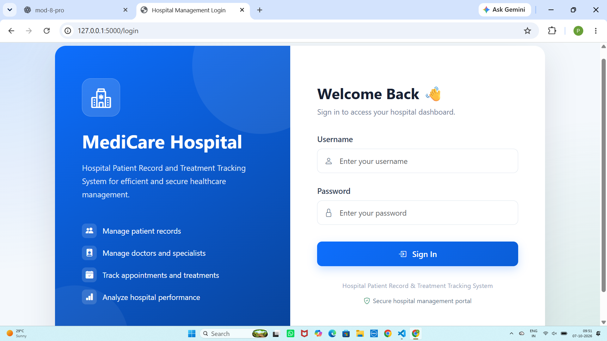
Figure 1: Hospital Management Login Page

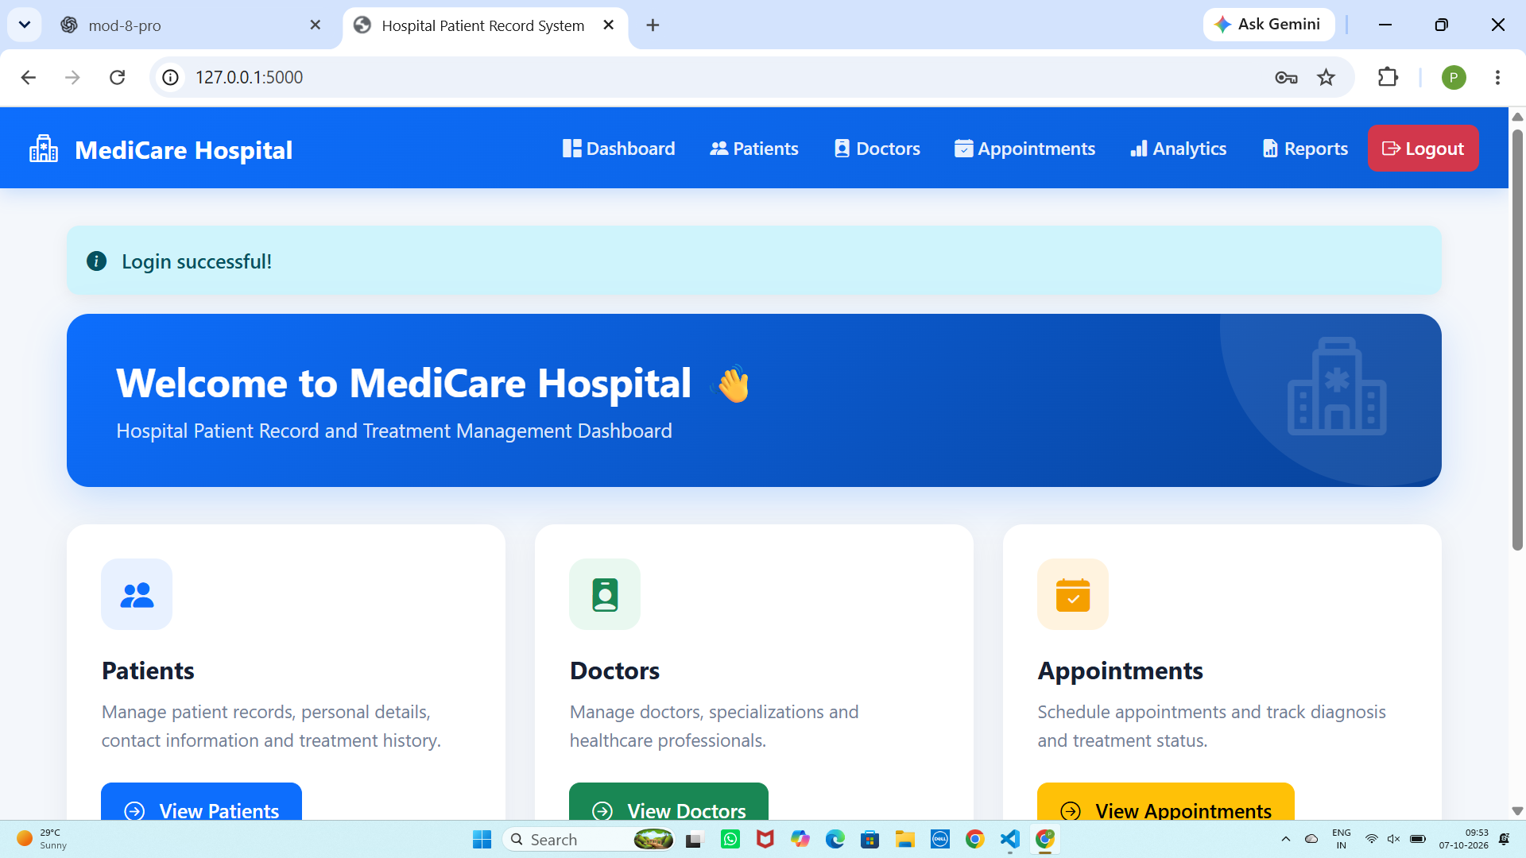
Figure 2: Hospital Dashboard

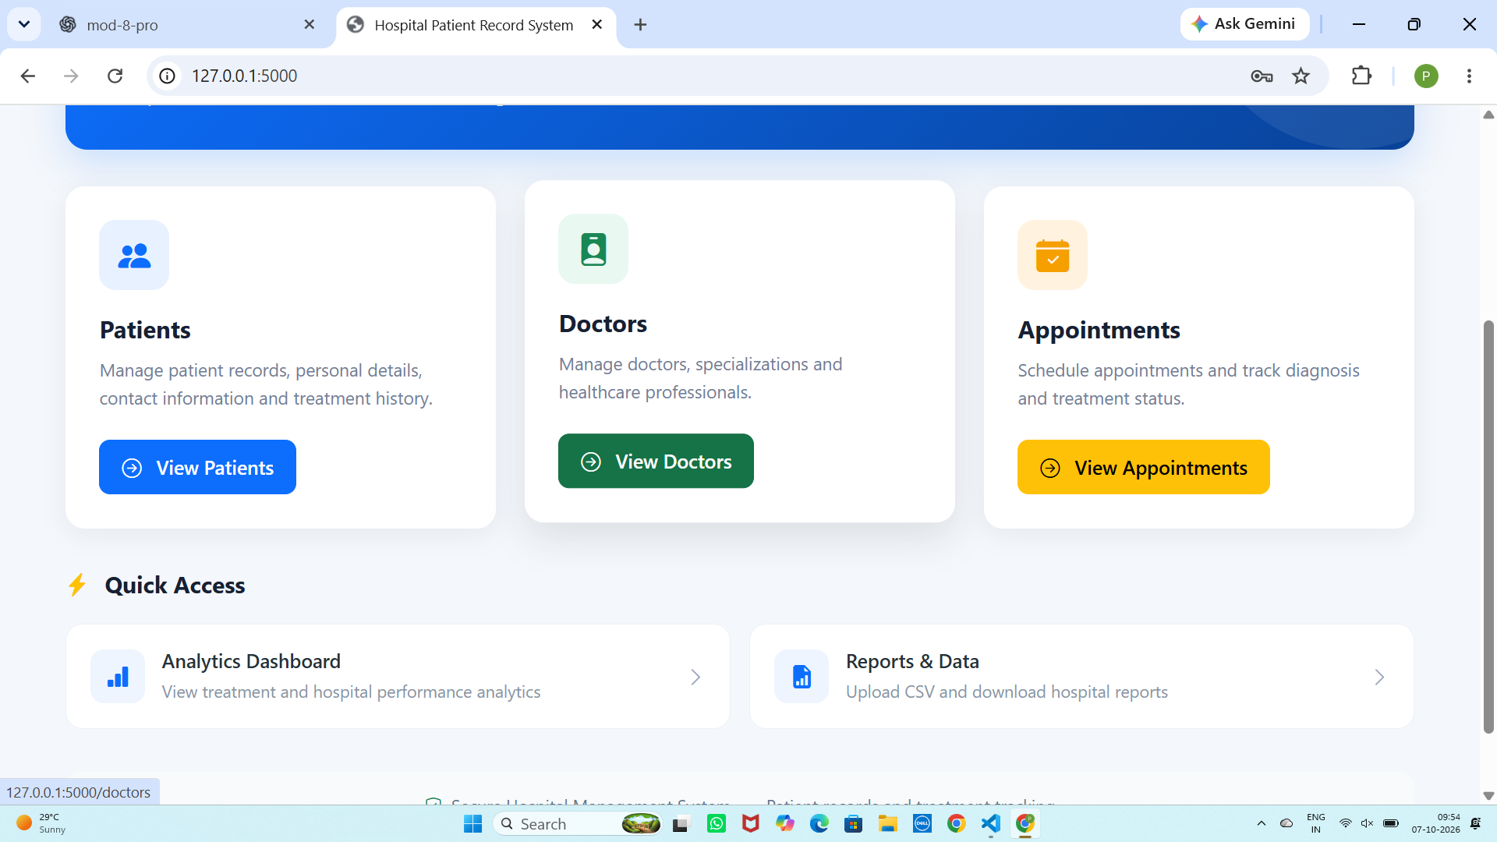
Figure 3: Patient Records Page

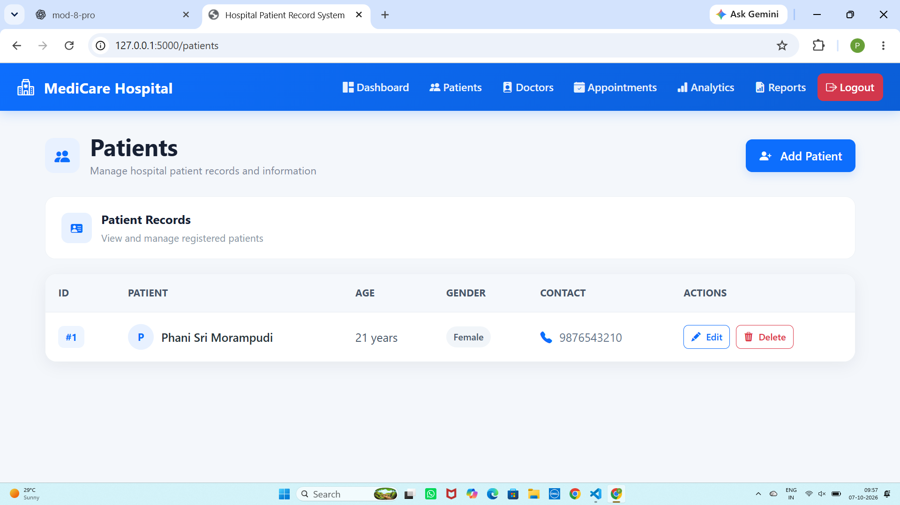
Figure 4: Add New Patient Form

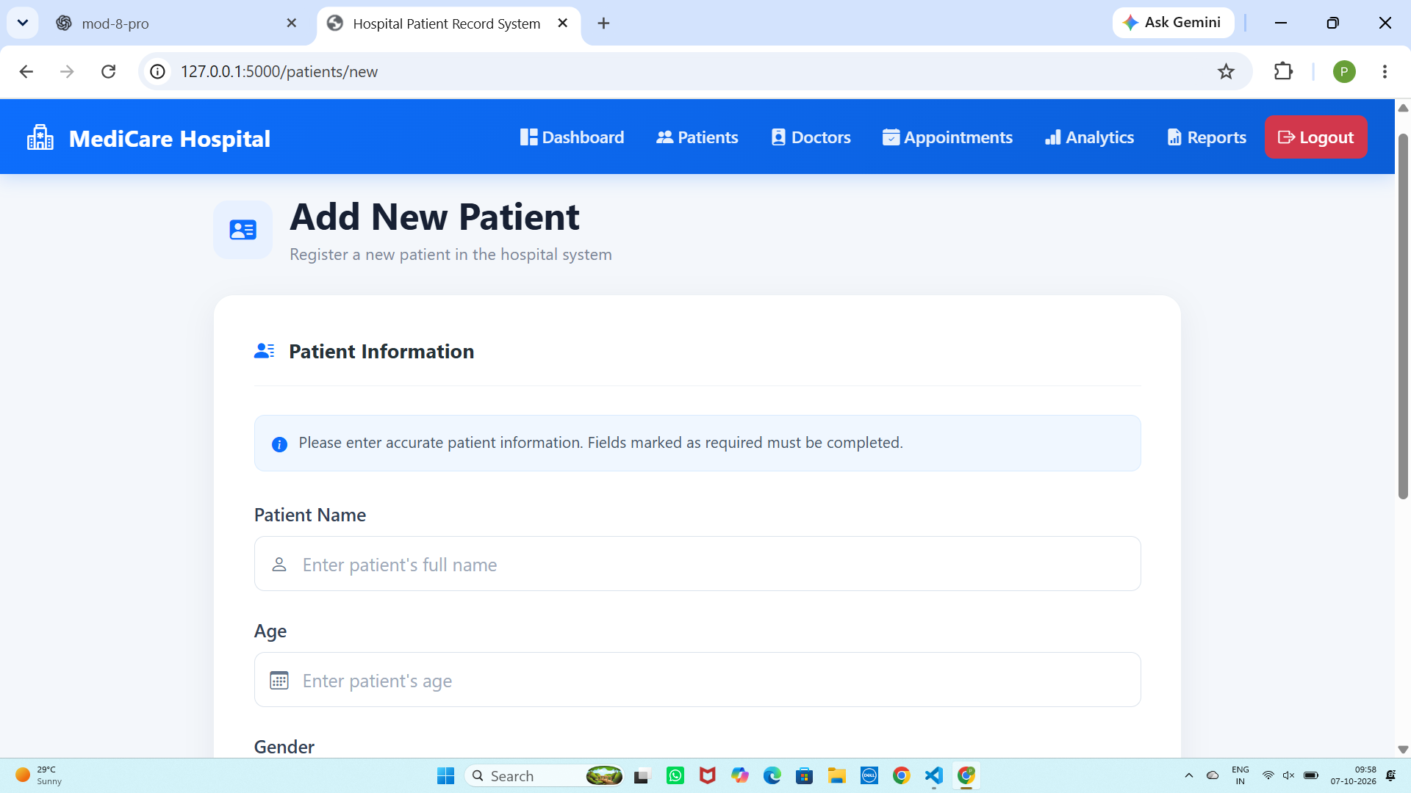
Figure 5: Doctor Directory

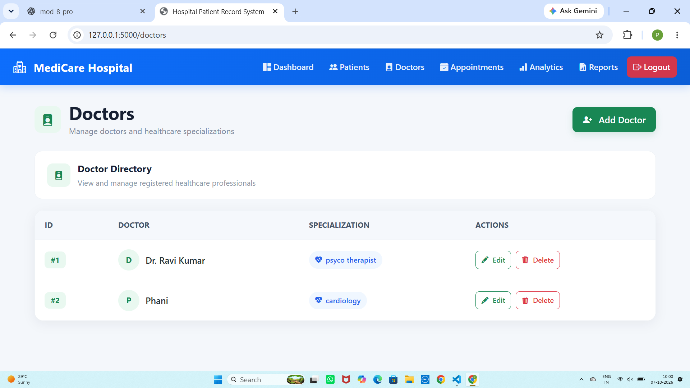
Figure 6: Add New Doctor Form

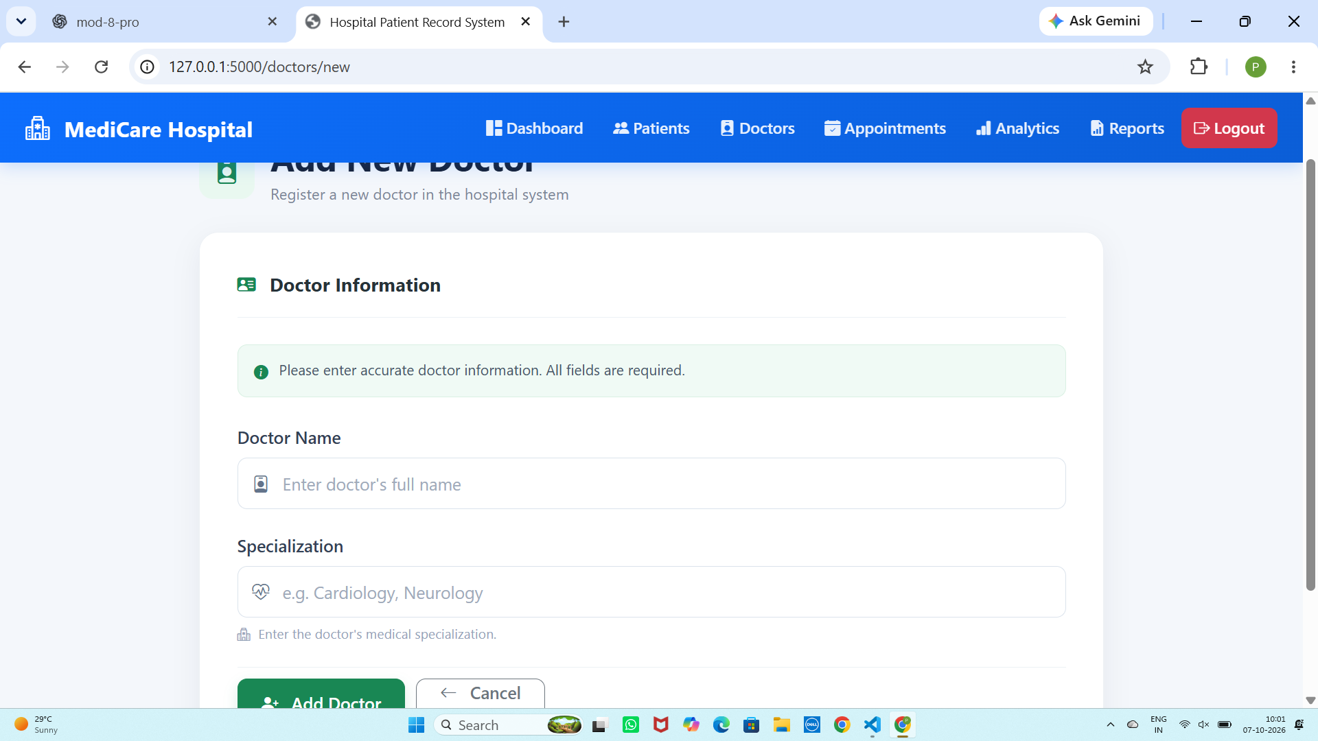
Figure 7: Appointment Records

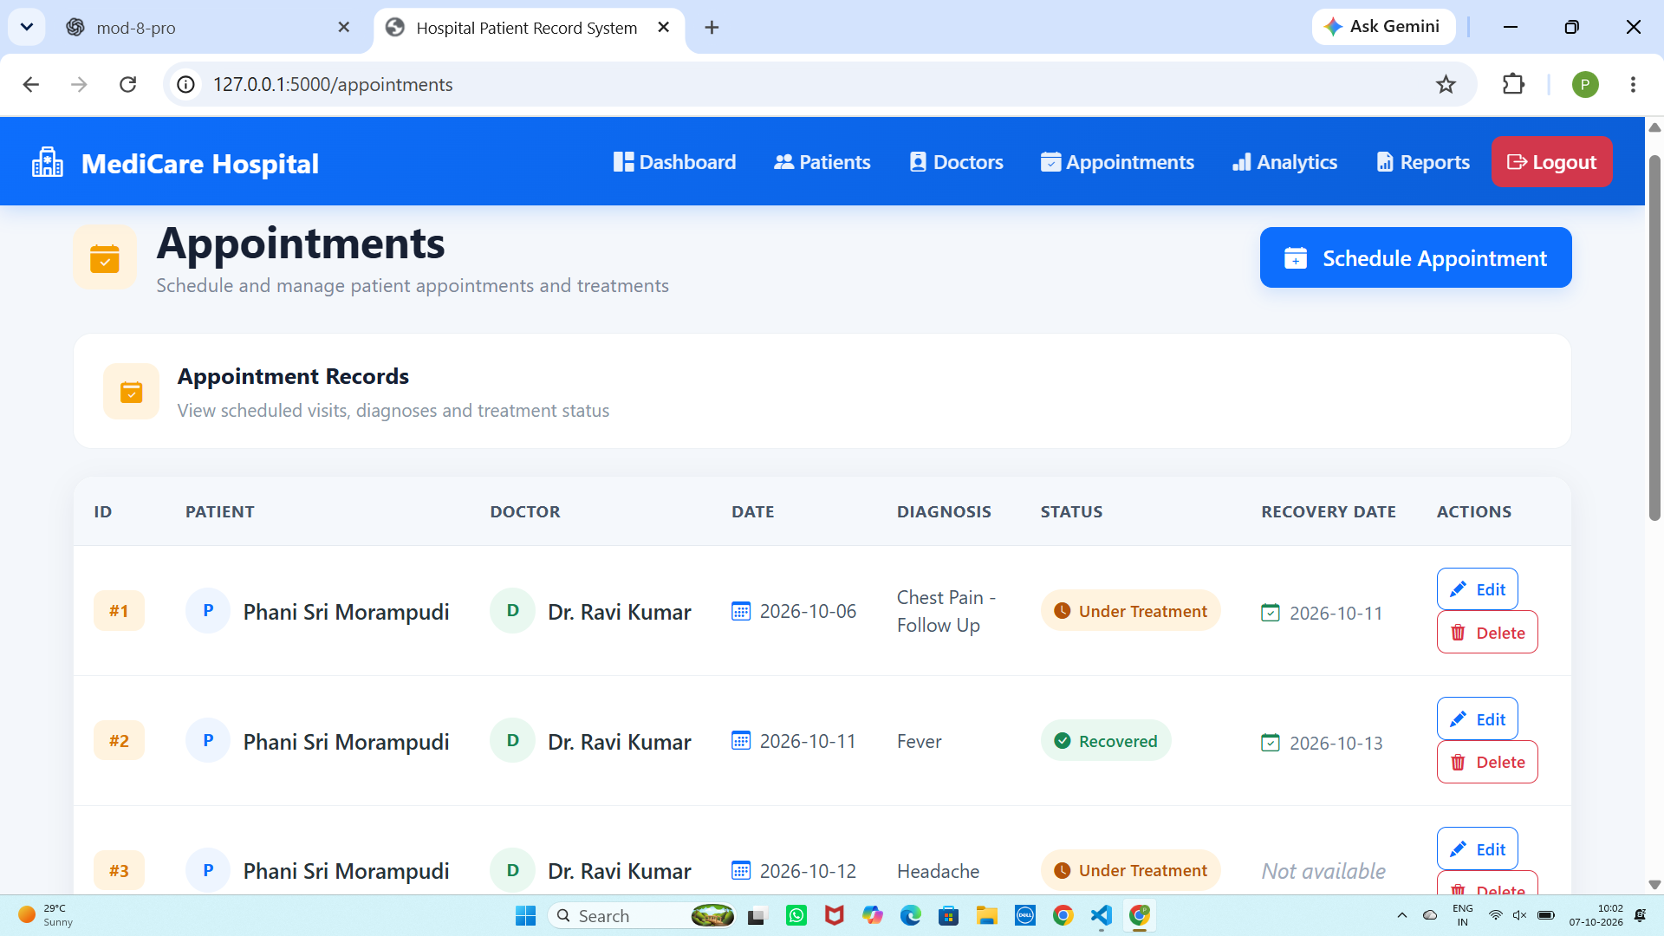
Figure 8: Schedule Appointment Form

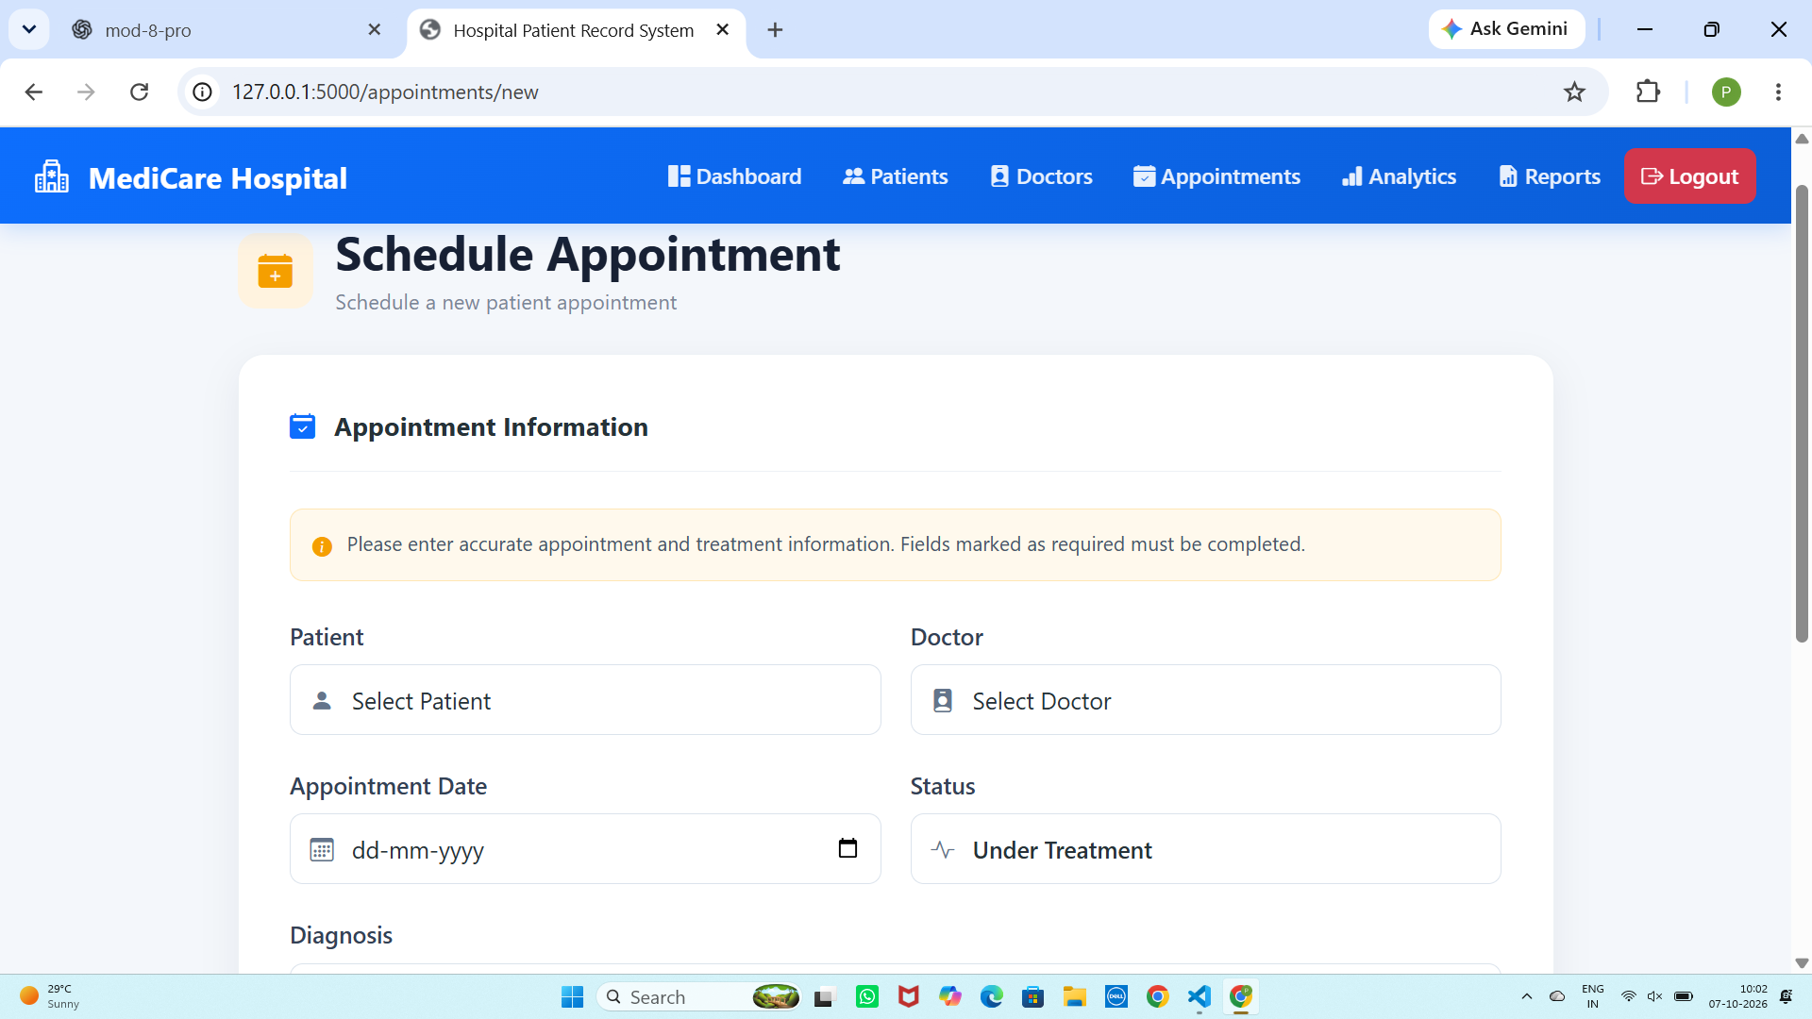
Figure 9: Hospital Analytics Dashboard

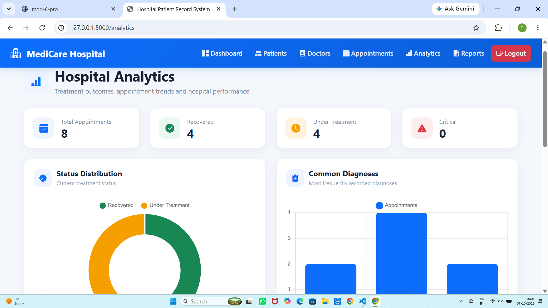
Figure 10: Reports and Data Page

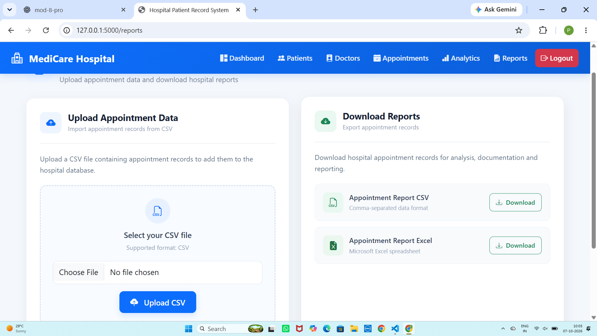
Figure 11: Reports and Data Page / Upload and Download Interface

12. Testing and Validation
The application was tested through the browser interface and API endpoints. The following functional areas were verified during development:
Test Area | Test Description | Result
Login | Admin login and authenticated dashboard access | Passed
Patient CRUD | Create, view, edit and delete patient records | Passed
Doctor CRUD | Create, view, edit and delete doctor records | Passed
Appointment Management | Schedule, view, edit and delete appointments | Passed
Role-Based Access | Admin and doctor access restrictions | Passed
Analytics | Analytics API and browser dashboard charts | Passed
CSV Upload | Appointment CSV import | Passed
CSV Export | Appointment report download | Passed
Excel Export | Appointment Excel report download | Passed

13. Results
The completed system provides a functional hospital record and treatment-tracking workflow. The screenshots demonstrate successful login, dashboard navigation, patient and doctor management, appointment scheduling and management, analytics visualization, and report upload/download functionality.
The analytics dashboard displayed eight appointment records in the tested dataset, including four recovered appointments and four appointments under treatment. The interface also provided diagnosis and appointment-trend visualizations.

14. Conclusion
The Hospital Patient Record and Treatment Tracking System successfully demonstrates how Flask, MySQL, SQLAlchemy, Pandas, NumPy and web technologies can be integrated to build a practical hospital management application. The project combines database management, authentication, CRUD operations, REST APIs, analytics and reporting in a single system.
The implemented solution provides a clear and maintainable foundation for managing hospital records and analyzing treatment information. It also demonstrates the use of both web-based and API-based access to the same backend data.

15. Future Enhancements
- Add patient medical-history and prescription modules.
- Add appointment reminders and notification services.
- Add advanced doctor-performance filters and date-range analytics.
- Add stronger password hashing and production-grade secret management.
- Add audit logs for important record changes.
- Add deployment support for a cloud environment.
- Add more interactive dashboards and downloadable analytics summaries.

— End of Project Report —

