STUDENT PERFORMANCE
ANALYTICS SYSTEM
Project Documentation

Technologies Used
Python • Flask • MySQL • SQLAlchemy • Pandas • NumPy • HTML • CSS • Jinja2 • JavaScript • JWT

Submitted By
Phani Sri Morampudi
Department of Computer Science and Engineering
Academic Year: 2026

1. Abstract
The Student Performance Analytics System is a full-stack web application developed to manage and analyze student academic performance efficiently. The system provides a centralized platform for managing students, courses, and grades using a Flask-based backend and a MySQL database.
The application supports complete CRUD operations for student, course, and grade records. It also provides JWT-based authentication and role-based access control. Administrators can manage academic records, while students can access permitted information.
Pandas and NumPy are used to perform statistical analysis such as average score, median, standard deviation, course-wise performance, and student rankings. The system also supports CSV grade uploads and CSV/Excel report generation.

2. Introduction
Student performance data is an important part of academic management. Maintaining student information, course details, and grades manually can be time-consuming and may lead to inconsistencies. The Student Performance Analytics System provides a centralized web-based solution for storing, managing, and analyzing academic records.
The application combines database management, web development, authentication, CRUD operations, and data analytics into one platform. It provides administrators with tools to manage academic records and generate meaningful performance insights.

3. Problem Statement
- Difficulty maintaining large amounts of academic data manually.
- Possibility of duplicate or inconsistent records.
- Time-consuming grade management and report preparation.
- Difficulty calculating performance statistics manually.
- Lack of centralized academic data access.
- Limited ability to compare course and student performance.

4. Objectives
- Develop a centralized student performance management system.
- Implement CRUD operations for students, courses, and grades.
- Store academic information using MySQL.
- Provide secure JWT-based authentication.
- Implement role-based access control.
- Calculate statistical performance measures using Pandas and NumPy.
- Provide course-wise performance analysis.
- Generate student rankings based on average scores.
- Support CSV-based grade uploads.
- Generate CSV and Excel reports.
- Provide a user-friendly and responsive web interface.

5. Scope of the Project
The system covers the following major areas:
- Student Management – add, view, update, delete, and search student records.
- Course Management – add, view, update, delete, and search courses.
- Grade Management – add, edit, delete, and search grade records.
- Analytics – average, median, standard deviation, course averages, rankings, and filtering.
- Reports – CSV and Excel export.
- Bulk Data – CSV grade upload.

6. Technologies Used
Technology | Purpose
Python | Backend programming and application logic
Flask | Web framework and routing
MySQL | Relational database
SQLAlchemy | Object-relational database mapping
PyMySQL | MySQL database connectivity
Pandas | Data processing and analytics
NumPy | Statistical calculations
Flask-JWT-Extended | JWT authentication and authorization
HTML / Jinja2 | Dynamic web page structure
CSS | Responsive and professional UI styling
JavaScript | Search and interactive features
GitHub | Source-code hosting and version control
VS Code | Development environment

7. System Architecture
The application follows a layered architecture in which the browser communicates with Flask routes, the backend interacts with the MySQL database through SQLAlchemy, and the analytics layer processes grade data using Pandas and NumPy.
User → Web Browser → Flask Application → Authentication & Authorization → Routes/APIs → SQLAlchemy → MySQL Database → Pandas/NumPy Analytics → Reports/Dashboard

8. Database Design
The system contains four major tables:
Table | Important Fields | Purpose
users | id, name, email, password, role | Authentication and user roles
students | id, name, email | Student information
courses | id, name, code | Academic course information
grades | id, student_id, course_id, score, date | Student academic performance
Relationships:
- One student can have multiple grade records.
- One course can have multiple grade records.
- student_id and course_id in grades act as foreign keys.

9. Authentication and Authorization
The application uses JWT (JSON Web Token) based authentication. During login, the system verifies the user's email and password and generates an access token containing the user's identity and role. Protected API endpoints require a valid token.
- Admin users can manage students, courses, and grades and access analytics.
- Student users can access permitted student-related information.
- Role-based checks prevent unauthorized management operations.

10. Student Management Module
The Student Management module provides complete CRUD functionality for student records. Users can add, view, update, delete, and search student information. The interface displays student ID, name, email, status, and action buttons.

11. Course Management Module
The Course Management module manages academic courses. Each course has a unique course code and course name. Users can add, view, edit, delete, and search course records.

12. Grade Management Module
The Grade Management module records student academic performance. Each grade is associated with a student and course. Scores are validated within the 0–100 range.
Score Range | Performance
90–100 | Excellent
75–89 | Good
50–74 | Pass
Below 50 | Needs Improvement

13. CSV Upload
The application supports uploading grades using CSV files. The expected columns are student_id, course_id, and score. Pandas reads the uploaded file, validates student and course references, checks the score range, and inserts valid records into the database.

14. Performance Analytics
The Analytics module uses Pandas for data processing and NumPy for statistical calculations. It provides an overall performance summary, course-wise averages, student rankings, and a course filter.
- Average Score – overall mean of the selected grade data.
- Median Score – middle value of the score dataset.
- Standard Deviation – measure of score variation.
- Course-wise Average – average score calculated for each course.
- Student Ranking – students ordered by their average score.
- Course Filter – allows analytics to be viewed for a selected course.

15. Report Generation
The system can generate grade reports in CSV and Excel formats. Reports contain student ID, student name, course ID, course name, score, and date. This makes the data suitable for record keeping and further analysis.

16. User Interface
The system provides a professional and responsive interface with a dark navigation sidebar, dashboard cards, search fields, tables, forms, status badges, action buttons, and confirmation dialogs. The interface is organized into Dashboard, Students, Courses, Grades, and Analytics sections.

17. API Endpoints
Module | Methods / Endpoints
Authentication | POST /api/auth/login
Students | GET, POST /api/students; GET, PUT, PATCH, DELETE /api/students/<id>
Courses | GET, POST /api/courses; GET, PUT, PATCH, DELETE /api/courses/<id>
Grades | GET, POST /api/grades; GET, PUT, PATCH, DELETE /api/grades/<id>

18. Testing
The following functionality was tested during development:
- Admin login and JWT authentication.
- Student creation, update, deletion, and retrieval.
- Course creation, update, deletion, and retrieval.
- Grade creation, update, deletion, and retrieval.
- CSV grade upload.
- CSV and Excel report generation.
- Analytics calculations and course filtering.
- Search functionality on management pages.
- Input validation and unauthorized-access handling.
- Delete confirmation behavior.

19. Project Structure
Module-7-pro/
├── app/
│ ├── models/
│ │ ├── course.py
│ │ ├── grade.py
│ │ ├── student.py
│ │ ├── user.py
│ │ └── __init__.py
│ ├── routes/
│ │ ├── analytics.py
│ │ ├── auth.py
│ │ ├── courses.py
│ │ ├── grades.py
│ │ ├── students.py
│ │ ├── web_courses.py
│ │ ├── web_grades.py
│ │ ├── web_students.py
│ │ └── __init__.py
│ ├── static/
│ │ └── css/style.css
│ ├── templates/
│ │ ├── courses/
│ │ ├── grades/
│ │ ├── students/
│ │ ├── analytics.html
│ │ ├── base.html
│ │ └── dashboard.html
│ └── __init__.py
├── create_admin.py
├── requirements.txt
└── run.py

20. Advantages
- Centralized academic data management.
- Secure authentication and role-based access control.
- Easy CRUD operations.
- Automated statistical analysis.
- Course-wise performance analysis.
- Student ranking based on average scores.
- Bulk grade upload through CSV.
- CSV and Excel report generation.
- User-friendly and responsive interface.
- Reduced manual work and improved data accessibility.

21. Future Enhancements
- Add graphical charts and visual dashboards.
- Add attendance tracking.
- Add faculty management.
- Provide automated email notifications.
- Generate PDF reports.
- Add machine-learning-based performance prediction.
- Develop mobile application support.
- Deploy the system to a cloud platform.

22. OUTPUT
The following screenshots demonstrate the completed Student Performance Analytics System and its major functional modules.
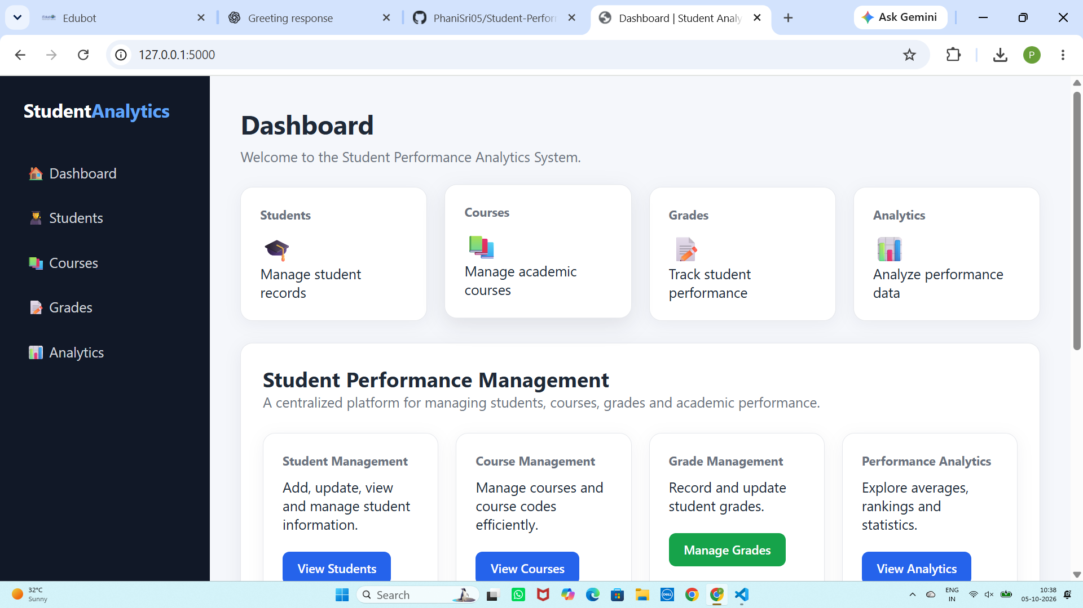
Figure 1: Student Performance Analytics Dashboard

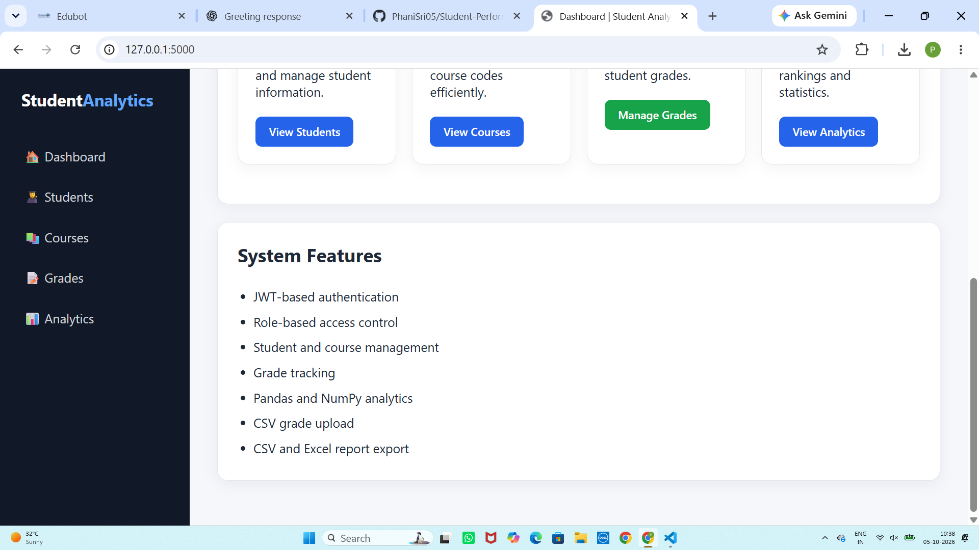
Figure 2: Dashboard System Features and Management Options

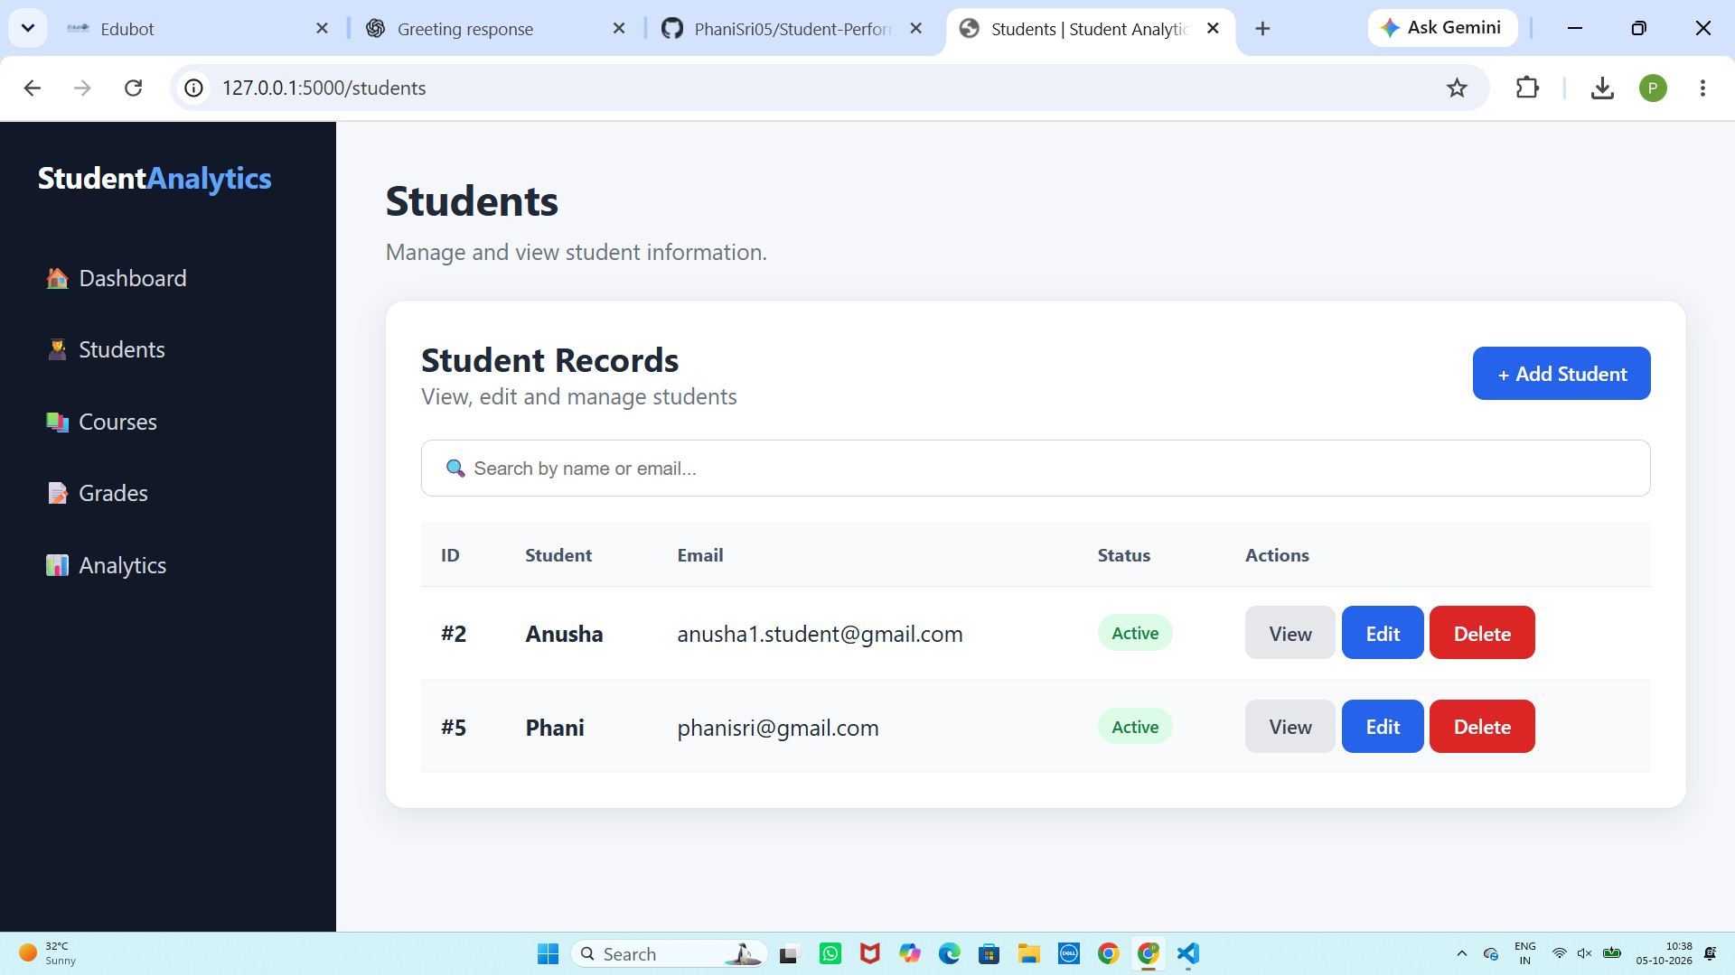
Figure 3: Student Management Page

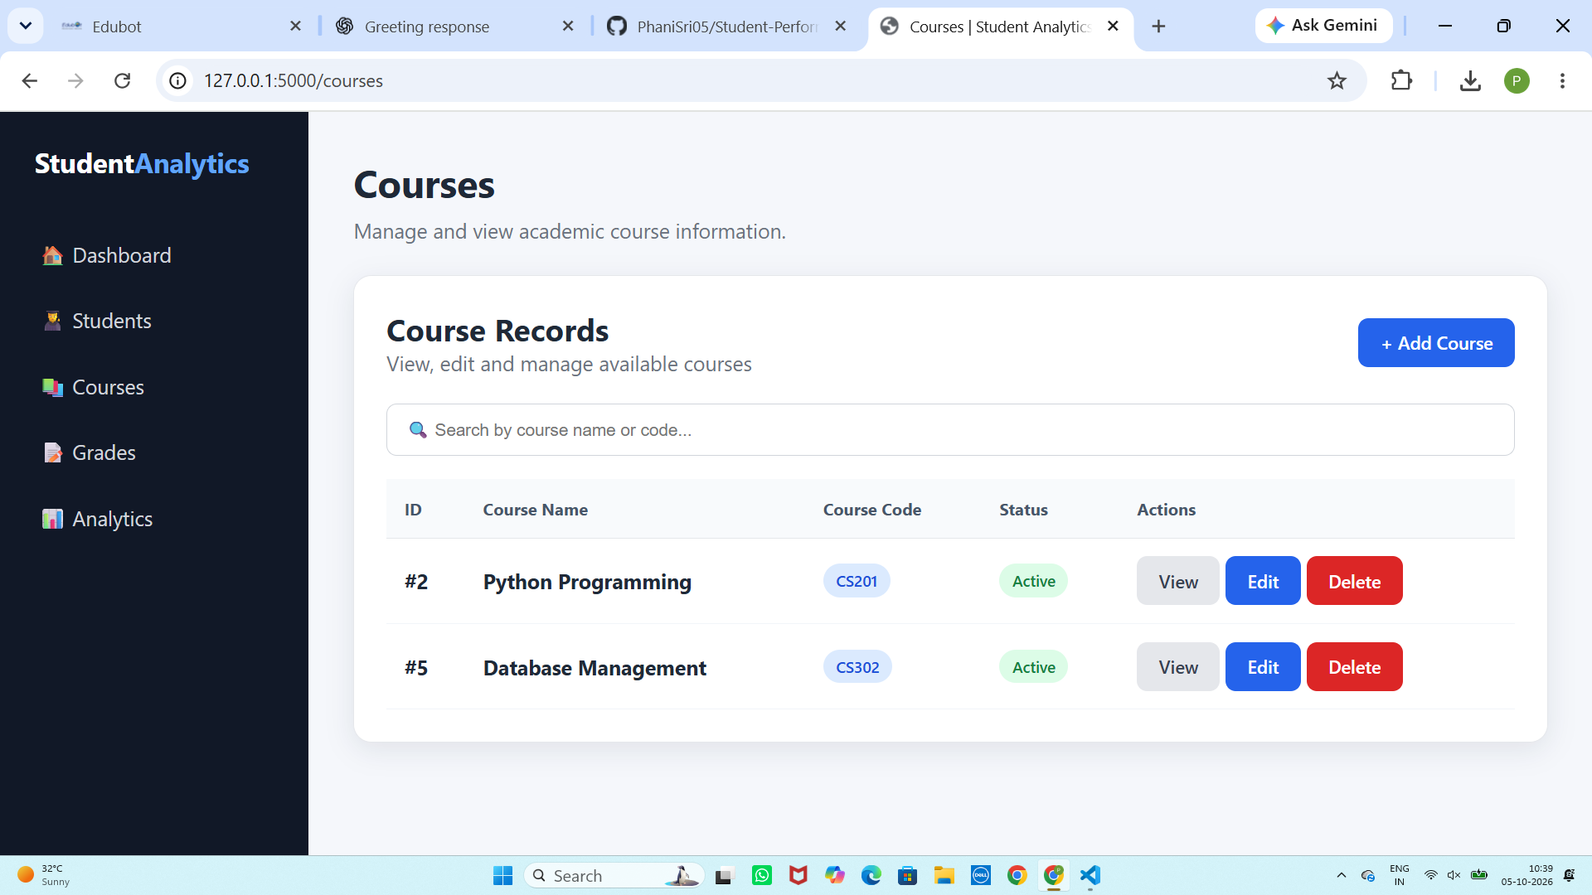
Figure 4: Course Management Page

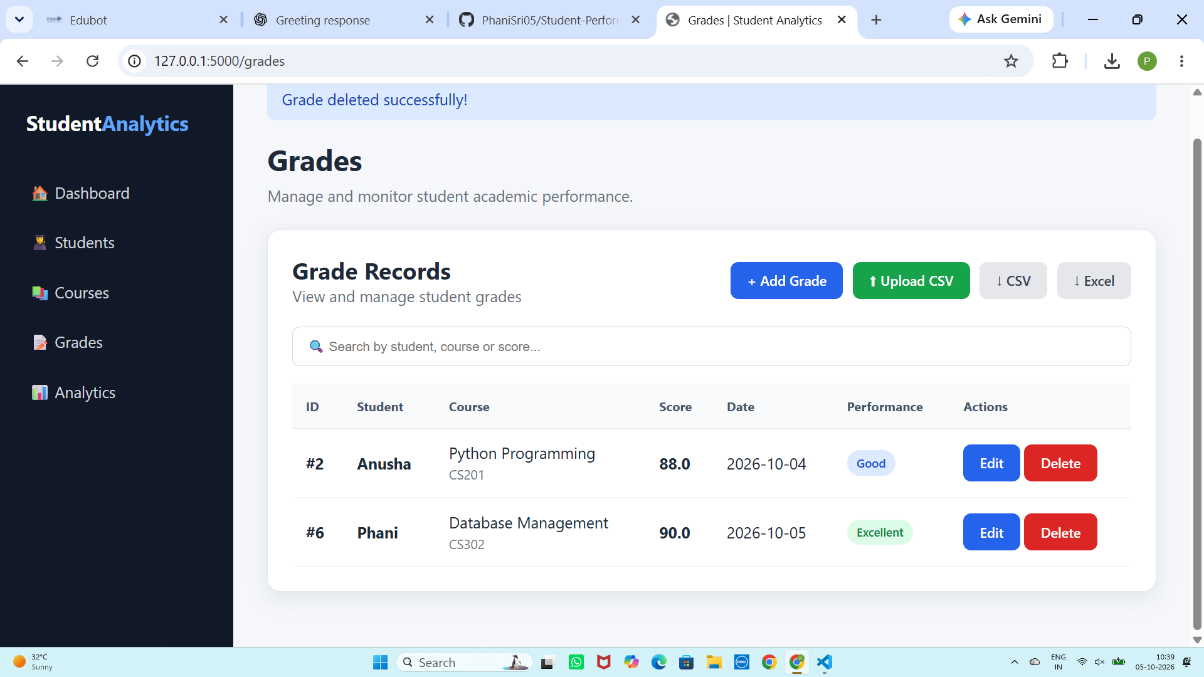
Figure 5: Grade Management Page

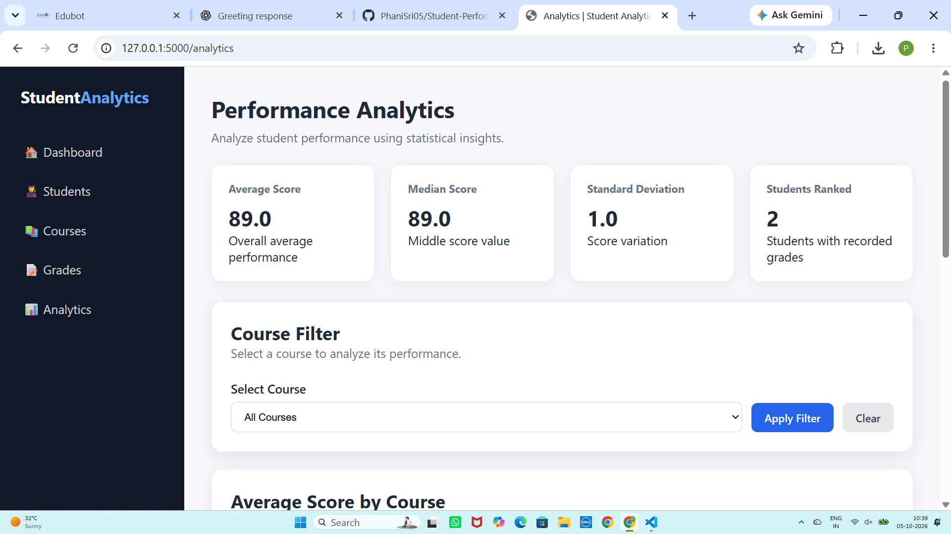
Figure 6: Performance Analytics Summary and Course Filter

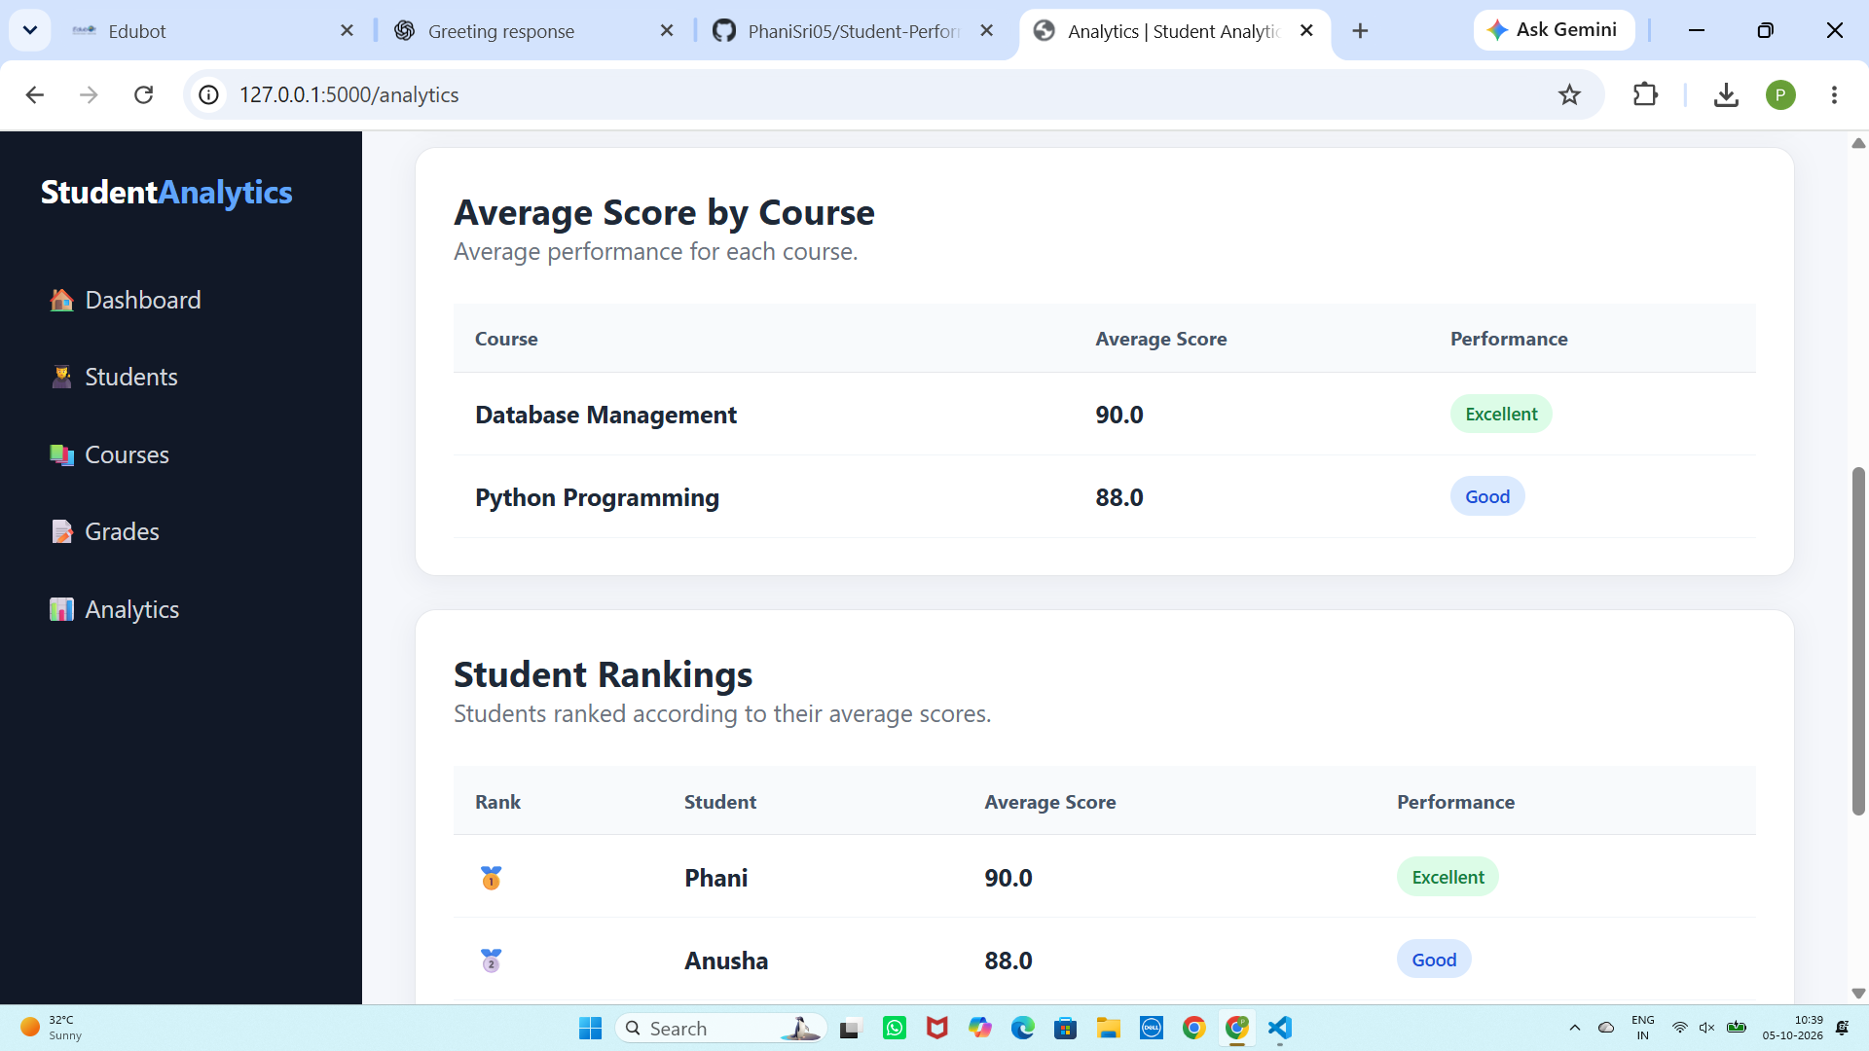
Figure 7: Course-wise Average Scores and Student Rankings

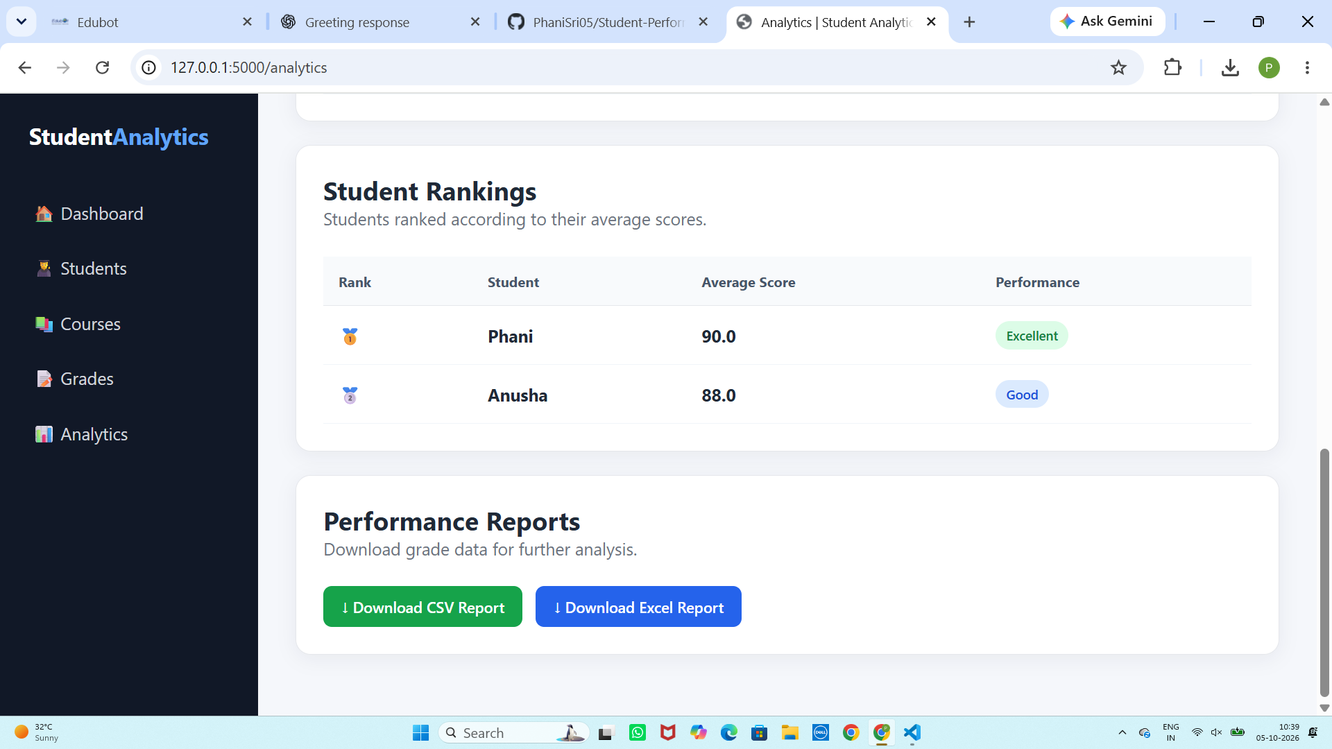
Figure 8: Student Rankings and Performance Report Downloads

23. Conclusion
The Student Performance Analytics System successfully provides a centralized platform for managing and analyzing academic performance. The system combines Flask, MySQL, SQLAlchemy, Pandas, and NumPy to provide database management, secure authentication, CRUD operations, and statistical analysis.
The application supports student, course, and grade management along with CSV upload and CSV/Excel report generation. The analytics module provides useful insights through average scores, median, standard deviation, course-wise averages, and student rankings.
The professional web interface improves usability, while JWT authentication and role-based authorization provide security. Overall, the project demonstrates practical implementation of full-stack web development, database management, REST APIs, authentication, data processing, and analytics in a single academic application.

