Credit Card Approval Prediction
The Credit Card Approval Prediction System is a machine learning-based web application that predicts whether a credit card application is likely to be approved or rejected based on an applicant's personal and financial information.
The system uses a Random Forest Classifier trained on historical credit card application data. It analyzes 12 important features such as age, annual income, employment, education, family status, and housing type to make predictions. Users enter their details through a Flask-based web interface, and the application displays the prediction along with a confidence score and applicant summary.
Technologies Used
- HTML5
- CSS3
- Flask
- Python
- Pandas
- NumPy
- Scikit-learn
- Random Forest Classifier
Feature Analysis
The Credit Card Approval Prediction model uses 12 important features to determine whether an applicant is likely to be approved or rejected. Each feature contributes differently to the final prediction.

1. Gender (CODE_GENDER)
Description:
Represents the applicant's gender.
Values:
Value | Meaning
0 | Female
1 | Male
Analysis:
Gender is included as a demographic feature. Although it has relatively low influence compared to financial attributes, it provides additional information for the prediction model.

2. Own Car (FLAG_OWN_CAR)
Description:
Indicates whether the applicant owns a car.

Values:
Value | Meaning
0 | No
1 | Yes
Analysis:
Owning a vehicle generally reflects better financial stability and may positively influence approval.

3. Own Real Estate (FLAG_OWN_REALTY)
Description:
Shows whether the applicant owns a house or other real estate.
Values:
Value | Meaning
0 | No
1 | Yes
Analysis:
Applicants owning real estate usually have stronger financial security, increasing their probability of credit approval.

4. Number of Children (CNT_CHILDREN)
Description:
Total number of dependent children.
Example Values:
- 0
- 1
- 2
- 3
Analysis:
Applicants with more dependent children may have higher monthly expenses, which can affect repayment capability.

5. Annual Income (AMT_INCOME_TOTAL)
Description:
Applicant's yearly income.

Example Values:
- ₹150,000
- ₹300,000
- ₹600,000
- ₹900,000
Analysis:
Annual income is one of the most important features. Higher income generally increases the likelihood of approval because it indicates better repayment ability.

6. Income Type (NAME_INCOME_TYPE)
Description:
Represents the applicant's source of income.
Encoded Values
Value | Income Type
0 | Commercial Associate
1 | Pensioner
2 | State Servant
3 | Student
4 | Working
Analysis:
Stable employment categories such as Working and State Servant usually have higher approval rates than Student.

7. Education Level (NAME_EDUCATION_TYPE)
Description:
Highest education qualification.
Encoded Values
Value | Education
0 | Academic Degree
1 | Higher Education
2 | Incomplete Higher
3 | Lower Secondary
4 | Secondary / Secondary Special
Analysis:
Applicants with higher education generally have better employment opportunities and income stability, improving approval chances.
8. Family Status (NAME_FAMILY_STATUS)
Description:
Marital status of the applicant.

Encoded Values
Value | Status
0 | Civil Marriage
1 | Married
2 | Separated
3 | Single / Not Married
4 | Widow
Analysis:
Family status provides information about the applicant's household responsibilities and financial commitments.

9. Housing Type (NAME_HOUSING_TYPE)
Description:
Current housing arrangement.
Encoded Values
Value | Housing Type
0 | Co-op Apartment
1 | House / Apartment
2 | Municipal Apartment
3 | Office Apartment
4 | Rented Apartment
5 | With Parents
Analysis:
Applicants owning or living in permanent housing are generally considered financially more stable than those living in rented accommodation.

10. Age (DAYS_BIRTH)
Description:
Applicant's age stored in days.

Example
- 25 Years → -9125 Days
- 35 Years → -12775 Days
- 45 Years → -16425 Days
Analysis:
Age indicates maturity and financial experience. Middle-aged applicants often have stable employment and income.
11. Employment Duration (DAYS_EMPLOYED)
Description:
Number of employment days.
Example
- 2 Years → -730 Days
- 5 Years → -1825 Days
- 10 Years → -3650 Days
Analysis:
Applicants with longer employment history are generally considered more reliable and financially stable.

12. Family Members (CNT_FAM_MEMBERS)
Description:
Total number of family members.
Example Values
- 1
- 2
- 3
- 4
- 5
Analysis:
Family size affects household expenses. Larger families may have greater financial obligations, which can influence the approval decision.

Credit Card Approval Prediction - UI Features
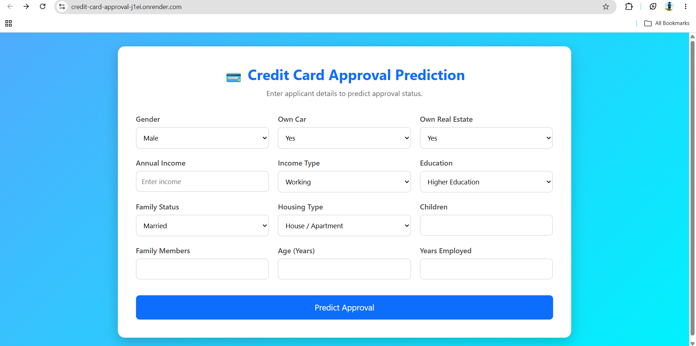
Home Page
1. Professional Landing Form
- Clean card-based interface
- Gradient background
- Center-aligned responsive design

2. Applicant Details Form
The form collects the following information:
- Gender
- Own Car
- Own Real Estate
- Annual Income
- Income Type
- Education
- Family Status
- Housing Type
- Number of Children
- Family Members
- Age
- Years Employed

3. Dropdown Menus
Dropdowns are used for categorical features:
- Gender
- Own Car
- Own Real Estate
- Income Type
- Education
- Family Status
- Housing Type
This reduces user input errors.

4. Input Validation
The application validates user inputs before prediction.
Examples:
- Annual income must be greater than 0.
- Age must be at least 18 years.
- Employment years cannot exceed age.
- Family members cannot be less than the number of children.
If validation fails, an appropriate error message is displayed.

5. Responsive Layout
The UI automatically adjusts for:
- Desktop
- Tablet
- Mobile devices

6. Interactive Buttons
- Predict Approval
- Predict Again
Hover effects improve the user experience.

Prediction Result Page
7. Prediction Result
Displays one of the following:

- Credit Card Approved
- Credit Card Rejected
Different colors are used for easy identification.

8. Prediction Confidence
Displays the model's confidence score.
Example:
Prediction Confidence : 91.45%

9. Applicant Summary
Displays all entered information in a structured table.
Example:
- Gender
- Own Car
- Own Real Estate
- Annual Income
- Income Type
- Education
- Family Status
- Housing Type
- Children
- Family Members
- Age
- Employment

10. Prediction Timestamp
Displays the date and time when the prediction was generated.
Example:
Prediction Generated On:
05-Jul-2026 12:30 AM

11. Predict Again Button
Allows users to return to the input form without refreshing the application.

Sample test cases
Test ID | Gender | Own Car | Own Real Estate | Annual Income | Income Type | Education | Family Status | Housing Type | Children | Family Members | Age | Years Employed | Expected Output
TC-01 | Male | Yes | Yes | 900000 | Working | Higher Education | Married | House / Apartment | 1 | 3 | 35 | 10 | Approved
TC-02 | Female | No | No | 80000 | Student | Secondary / Secondary Special | Single / Not Married | With Parents | 0 | 1 | 20 | 0 | Rejected
TC-03 | Male | Yes | No | 500000 | State Servant | Higher Education | Married | House / Apartment | 2 | 4 | 42 | 15 | Approved
TC-04 | Female | Yes | Yes | 350000 | Commercial Associate | Incomplete Higher | Married | House / Apartment | 1 | 3 | 30 | 6 | Approved
TC-05 | Male | No | No | 120000 | Student | Lower Secondary | Single / Not Married | Rented Apartment | 1 | 2 | 21 | 0 | Rejected
TC-06 | Female | No | Yes | 250000 | Pensioner | Secondary / Secondary Special | Widow | House / Apartment | 0 | 1 | 65 | 2 | Approved
TC-07 | Male | Yes | Yes | 1200000 | Working | Academic Degree | Married | House / Apartment | 2 | 4 | 45 | 20 | Approved
TC-08 | Female | No | No | 100000 | Student | Secondary / Secondary Special | Single / Not Married | With Parents | 2 | 4 | 19 | 0 | Rejected

Invalid Test Cases
Test ID | Description | Input | Expected Output
TC-09 | Invalid Income | Annual Income = 0 | Annual income must be greater than 0
TC-10 | Invalid Age | Age = 16 | Age must be at least 18 years
TC-11 | Invalid Employment | Age = 25, Employment = 30 | Employment years cannot exceed age
TC-12 | Invalid Family Details | Children = 4, Family Members = 2 | Family members cannot be less than children

Conclusion
This project demonstrates how Machine Learning and Flask can be integrated to automate the credit card approval process. The Random Forest model helps predict approval decisions quickly and consistently based on applicant data. The application also provides a user-friendly interface with input validation, prediction confidence and an applicant summary, making it practical and easy to use.
Overall, the project showcases the complete machine learning workflow, including data preprocessing, model training, prediction, and web deployment, making it a suitable mini project and a strong addition to a resume.

