**Name:** Phani Kumar

**Batch:** June 01, 2022

**Tutor:** Raham Shaik

**Project: Static Web Hosting**

**Static Web Hosting using AWS S3:**

1. Created the S3 bucket with the name (project-aws).
2. After the S3 Bucket was created enabled the Static website hosting and allowed block public access and added two Html files (index.html and error.html).

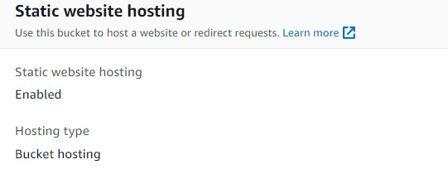

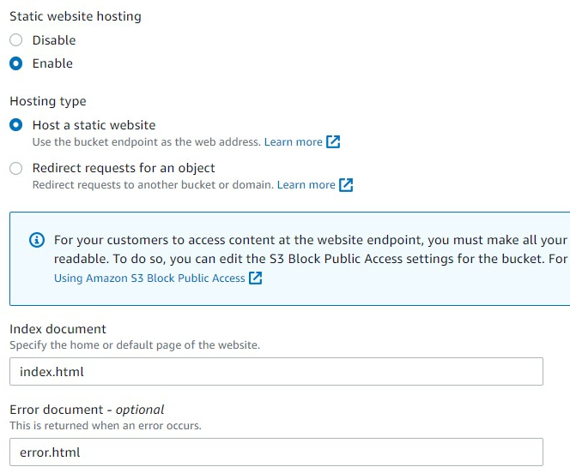

1. Then went to Permissions tab and Edited the S3 bucket policy to access the s3 bucket public read access. By following Json code below and saving the policy:

{

"Version": "2012-10-17",

"Statement": [

{

"Sid": "AllowPublicReadAccess",

"Effect": "Allow",

"Principal": "*",

"Action": "s3:GetObject",

"Resource": "arn:aws:s3:::projects-aws/*"

}

}

1. Once the policy is saved the s3 bucket is showing publicly accessible

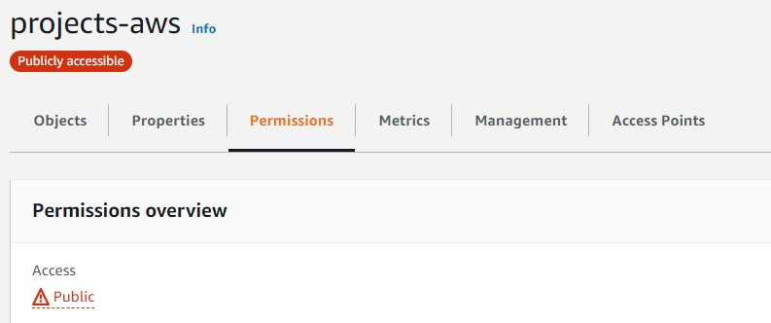

1. Taken the Url: <http://projects-aws.s3-website-us-east-1.amazonaws.com/> which is available at Static web hosting

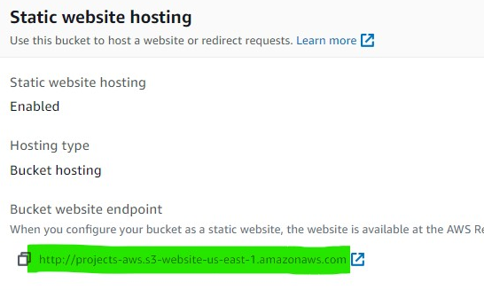

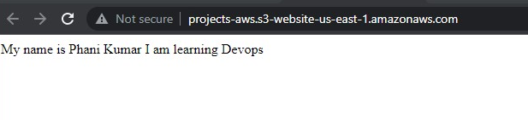

1. As I have also uploaded the Errorpage.html when the wrong URL is entered it has to display with an error message

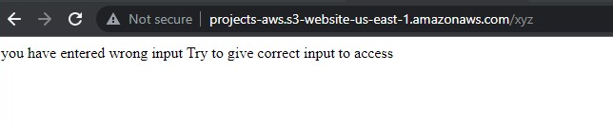

**NOTE**: HTTPD, IIS, Nginx hosting is completed in first project itself

https://github.com/phanikumar916/Devops-projects